***ST ANTHONY***

***NURSERY AND***

***PRIMARY SCHOOL-***

***KAJJANSI.***

***PRIMARY SEVEN, MATHEMATICS***

***LESSON NOTES.***

***TABLE OF CONTENT***

|  |  |  |
| --- | --- | --- |
| ***NO*** | ***TOPIC/SUBTOPIC*** | ***PAGE*** |
| ***1*** | ***SETS*** | ***1-27*** |
| ***2*** | ***OPERATION ON WHOLE NUMBERS*** | ***28-33*** |
| ***3*** | ***STANDARD FORM*** | ***34-37*** |
| ***4*** | ***INDICES*** | ***38-48*** |
| ***5*** | ***FINITE SYSTEM*** | ***49-68*** |
| ***6*** | ***FRACTIONS*** | ***69-105*** |
| ***7*** | ***PROPORTIONS*** | ***105-114*** |
| ***8*** | ***PERCENTAGES*** | ***115-155*** |
| ***9*** | ***SIMPLE INTEREST*** | ***156-167*** |
| ***10*** | ***CIRCLES*** | ***168-205*** |
| ***11*** | ***REVOLUTIONS*** | ***206-212*** |
| ***12*** | ***APPLICATION OF LENGHT*** | ***213-221*** |
| ***13*** | ***COMPARING AREAS*** | ***222-225*** |
| ***14*** | ***PYTHAGORAS THEOREM*** | ***226-229*** |
| ***15*** | ***RHOMBUS*** | ***230-237*** |
| ***16*** | ***KITE*** | ***238-243*** |
| ***17*** | ***TRIANGULAR PRISM*** | ***243-249*** |
| ***18*** | ***CYLINDERS*** | ***250-255*** |
| ***19*** | ***VOLUME AND CAPACITY*** | ***256-268*** |
| ***20*** | ***COMPARING VOLUME*** | ***268-274*** |
| ***21*** | ***PARKING (AREA)*** | ***275-279*** |
| ***22*** | ***PARKING (VOLUME)*** | ***279-282*** |
| ***23*** | ***PARKING (CAPACITY)*** | ***283-285*** |
| ***24*** | ***ALGEBRA*** | ***286-321*** |
| ***25*** | ***INEQUALITY*** | ***322-327*** |
| ***26*** | ***GEOMETRY*** | ***328-363*** |
| ***27*** | ***POLYGONS*** | ***364-375*** |
| ***28*** | ***PERPENDICULAR LINES*** | ***376-381*** |
| ***29*** | ***BISECTING ANGLES*** | ***382-383*** |
| ***30*** | ***CONSTRUCTION OF TRIANGLES*** | ***384-388*** |
| ***31*** | ***CONSTRUCTION OF SQUARES*** | ***389-390*** |
| ***32*** | ***CONSTRUCTION OF RHOMBUS*** | ***390-394*** |
| ***33*** | ***CONSTRUCTION OF PARALLELOGRAM*** | ***394-396*** |
| ***34*** | ***CONSTRUCTION OF TRAPEZIUM*** | ***396-398*** |
| ***35*** | ***CONSTRUCTION OF A KITE*** | ***399-401*** |
| ***36*** | ***BEARING*** | ***401-426*** |
| ***37*** | ***COORDINATE GRAPH*** | ***427-440*** |
| ***38*** | ***TRAVAL GRAPH*** | ***441-460*** |
| ***39*** | ***FINDINGS AND CORRECTIONS*** | ***444*** |

**SETS**

**Review**

* Subsets
* Listing subsets
* Finding number of subsets
* Finding number of proper subsets
* Finding number of elements given subsets and proper subsets
* Describing parts of a Venn diagram.
* Representing information on a Venn diagram

**SOLVING PROBLEMS USING A VENN DIAGRAM**

**A). Given the interesting as the unknown**

**Examples I**

In a class of 40 pupils, 30 lime math (M), 25 like English (E), X pupils like both subjects and 4 pupils like neither.

**Complete the Venn diagram.**

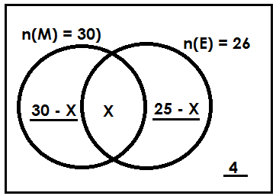

b) Find the value of X.

**solution**

30 – X + X + 25 – X + 4 = 40

30 + 25 + 4 – X = 40

59– X=40

59 – 59 – X = 40 - 59

-X = -19

-X= -19

-1 -1

**X= 19**

b) How many pupils like only one subject?

**Solution**

Only one = n(m) only + n (E) only.

= 30 – X + 25 – X

= 30 – 19 + 25 – 19

= 11 + 6

= 17 pupils

c) Find the probability of picking a pupil who does not like English from the class at random.

**Solution**

Prob = n(E) - pupils who do not like English

n(P) - universal

= 25 – X + 4

40

= (25 – 19) + 4

40

= 6 + 6

40

= 12

40

In a village of 60 farmers, 40 grow beans (B), 30 grow maize (M) and 2k farmers grow both crops while 12 do not grow any of the mentioned.

a) Complete the Venn diagram below.

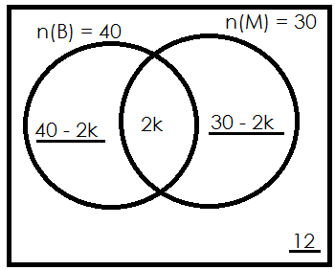

b) Find the value of K.

40 + 30 + 12 – 2k = 60

82 – 2k = 60

82 – 82 - 2k = 60 – 82

- 2k = -22

-2 -2

K = 11

c) How many farmers grow maize but not beans?

Maize only = 30 – 2k

= 30 – (2 x k)

= 30 – (2 x 11)

= 30 – 22

= 8 farmers

**Example 3**

In a class of 28 pupils, 12 take math (M) and 18 take English (E). given that (K + 2) pupils take both math and English and 3 pupils take neither subject.

a) complete the Venn diagram below.

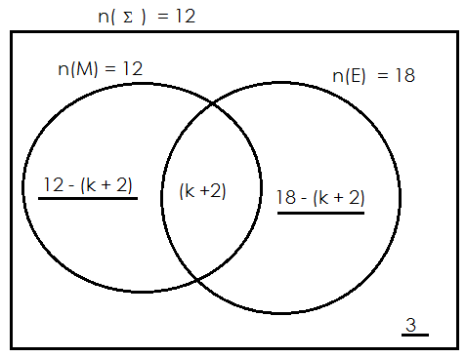

b) How many pupils like both subjects?

**Solution.**

12 – (k +2) + (k + 2) + 18 – (K + 2) + 3 = 28

12 + 3 + 18 – (k + 2) = 28

15 + 18 – k – 2 = 28

33 – 2 – k = 28

31 – k = 28

31 – 31 – k = 28 – 31

-k = -3

-1 -1

K = 3

Both= k + 2

= 3 + 2

**= 5 pupils**

c) How many pupils do not like English?

**Soln**.

n (E) = 12 – (k + 2) + 3

= 12 – (3 + 2) + 3

= 12 – 5 + 3

= 7 + 3

**= 10**

d. Find the probability of picking a person who likes math only.

Prob = n(E)

n (p)

= 12 – (k + 2)

28

= 12 – (3 + 2)

= 28

= 12 – 5

28

=  **7**

**28**

**Activity:**

1. In a class of 36 pupils, 18 like meat (M), 20 like fish (F) and y pupils like both meat and fish while 3 pupils don’t like any of the mentioned.

a) complete the Venn diagram below.

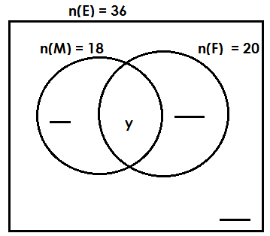

b) Find the value of y.

c) How many pupils like one type of food only?

d) Find the probability of picking a pupil who likes fish only?

2. At a birth day party attended by 30 guests, 18 took soda (S) and 15 took water (W). some guests took both and 12 guests did not take any drink.

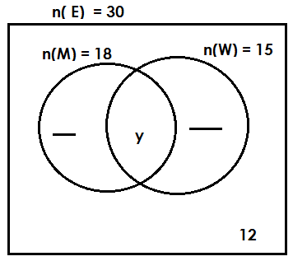a) Complete the Venn diagram below

b) How many guests took both types of drink?

c) How many guests did not take water?

3. In a village of 18 farmers, 10 grow tobacco (T) and 12 grow millet (M). given that 2p farmers grow both and 2 farmers grow neither of the two crops.

a) Complete the Venn diagram below.

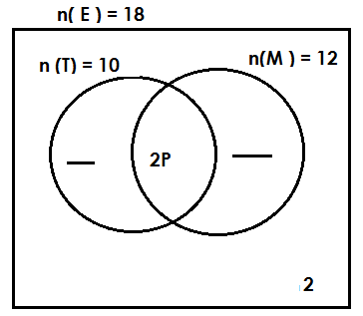

b) How many farmers grow both types of crops?

c) How many farmers grow one type of crops only?

4. During a trip to Jinja town, 30 students visited Nile breweries (N) and 24 students visited steel rolling mills (S), (X + 5) students visited both and 2 students did not visit any of the two factories.

1. 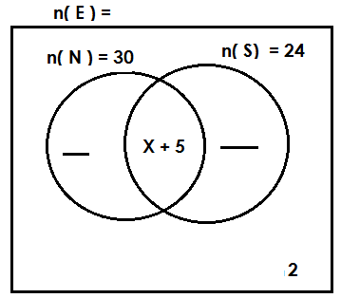Complete the Venn diagram below:

b) Given that 41 students altogether visited Jinja Town, find the value of X.

1. How many students visited Nile Breweries only?
2. If a student is picked at random, what is the chance that he / she visited one type of factory only

**B GIVEN ONE OF THE SETS AT THE UNKNOWN**

**Examples**

1. In a class of 50 pupils, 20 like mathematics (M) and K pupils like English (E). given that 10 pupils like both subjects and 6 pupils like neither of the two.

a) Complete the Venn diagram below.

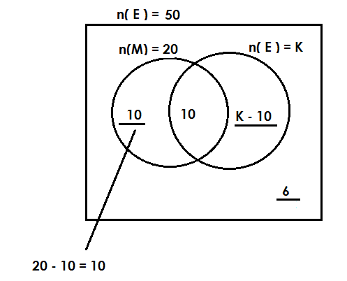

b) Find the value of K

**soln**.

K – 10 + 10 + 10 + 6 = 50

K + 10 + 6 = 50

K + 6 + 16 = 50 – 16

K = 34

c) How many pupils like one subject only.

**Soln.**

One subject only = 10 + (K – 10)

= 10 + (34 – 10)

= 10 + 24

= 34 pupils

1. Find the probability of picking a pupil who like English but not math.

Prob = n(E)

n(P)

= k- 10

50

= 34 – 10

50

**= 24**

**50**

**Example 2.**

2. In a class of 47 pupils, 12 like music (M) and 2y like swimming (S). 4 pupils like both and 3 do not like any of the two activities.

a) Complete the Venn diagram below.

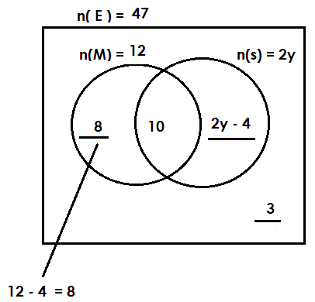

1. How many pupils like swimming only?

2y – 4 + 4 + 8 + 3 = 47

2y + 11 = 47

2y + 11 = 47 – 11

2y = 38

2 2

y = 18

swimming only = 2y – 4

= (2 x y) - 4

= (2 x 18) -4

= (36 – 4)

**= 32 pupils**

c) Find the probability of picking a pupil who like one subject only?

One subject only= 8 + (2y – 4)

= 8 + (2 x 18) – 4

= 8 + (36 – 4)

= 8 + 32

= 40

Prob = n(E)

n(P)

= 40

47

**Example 3.**

In a family of 41 people, 3K + 3 drink beers (B) and 22 drink sodas (S). 7 people drink both drink and 5 people neither drink beer nor soda.

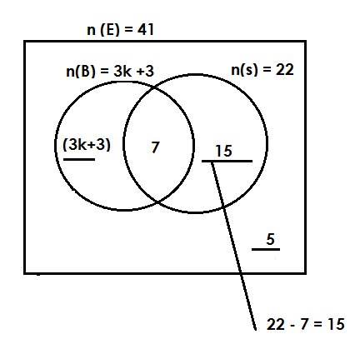a) Complete the Venn diagram below.

b) Find the value of K.

(3k + 3) – 7 + 7 + 15 = 41

3k + 3 + 15 + 5 = 41

3k + 23 = 41

3k + 23 – 23 = 41 – 23

3k = 18

3 = 3

K = 6

c) How many people drink only one type?

**Soln.**

Only one =

= (2k – 3) – 7 + 15

= (2 x 6) + 3 – 7 + 15

=18 + 3 – 7 + 15

=21 – 7 + 15

=21 + 15) – 7

=36 – 7

**=29 people**

**Activity**

1. In a class of 58 pupils, 30 like math (M) and K like science (S). given that 12 pupils like both and 4 do not like any of the two subjects.

1. **Complete the Venn diagram below.**

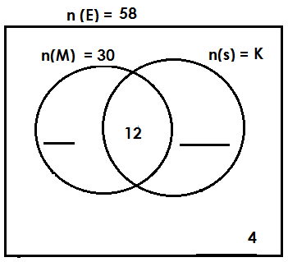

1. Find the value of K.
2. How many pupils like one type of subject only?
3. Find the probability of getting a pupil who like science only.

2. In a class of 35 pupils, 21 like math, 2pt 5 like both subjects while 4 pupils do not like any of the mentioned subject.

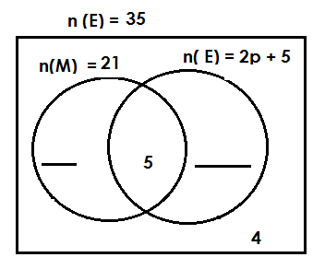a) Complete the Venn diagram below.

b) How many pupils like English?

c) Find the probability of picking a pupil who like English only.

3. In a village of 43 farmers, 21 grow maize, 3k – 5 grow beans, 8 grow both while 5 farmers do not grow any of the mentioned crops.

a) Complete the Venn diagram below.

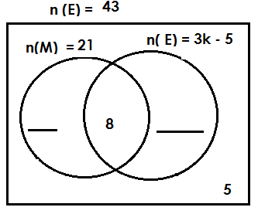

b) Find the value of K.

c) How many farmers who grow one type of crops only.

4. In a village of 53 people, k + 18 speak English, 22 speak Luganda and 6 people speak both languages while 4 people do not speak any of the two languages.

1. Complete the Venn diagram below.

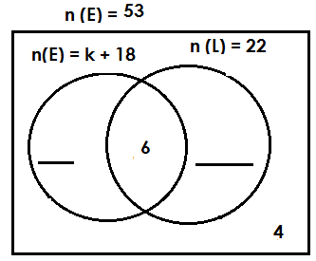

b) How many people speak English only?

c) How many people speak Luganda but not English.

d) Find the probability of picking a person who speak one type of language?

**C). GIVEN THE DIFFERENCE OF SETS AS UNKNOWN.**

**Examples**

1. In a class of 32 pupils, K pupils like math (M) only and 18 like English (E). given that 7 pupils like both while 4 pupils like neither.

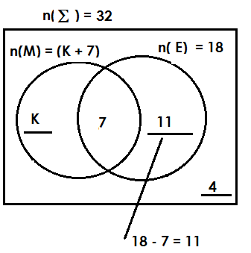a) Complete the Venn diagram below.

1. Find the value of K

**Soln.**

K + 7 + 11 + 4 = 32

K + 22 = 32

K + 22 – 22 = 32 – 22

K = 10

c) How many pupils like one subject only?

**Soln.**

One subject only = k + 11

= 10 + 11

= 21

d) Find the probability of picking a pupil who likes math.

n (M) = K + 7

= 10 + 7

= 17

Probability = n (E)

n (P)

= 17

32

In a class of 42 pupils, X + 16 play volley ball only, 18 play football and 7 play both games while 2 pupils do not only of the two games.

1. 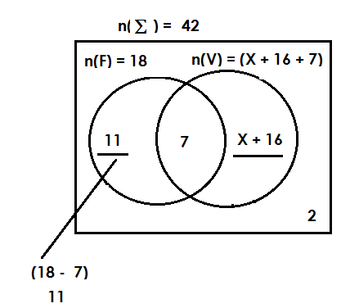Complete the Venn diagram below.
2. Find the value of X.

Soln.

X + 16 + 7 + 11 + 2 = 42

X + 36 = 42

X + 36 – 36 = 42 – 36

X = 6

1. Find the probability of picking a pupil who likes one subject only.

**Soln.**

One subject only = X + 16 + 11

= 6 + 16 + 11

= 33

**∴**Probability = n(E)

n(p)

**33**

**42**

**Activity**

1. In a village of 40 farmers 2y + 6 grow maize (M) only, 24 grow beans (B) and 10 farmers grow both crops. Given that 6 farmers grow neither.
2. 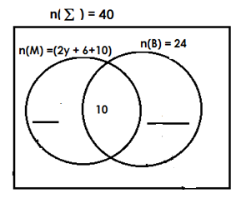Complete the Venn diagram below
3. How many farmers grow maize?
4. How many farmers grow one type of crop only?

2. In a group of 18 taxi drivers X driver take Entebbe (E) route only any 7 drivers take Kampala (K) route. Given that 3 drivers take both routes and 5 drivers take none.

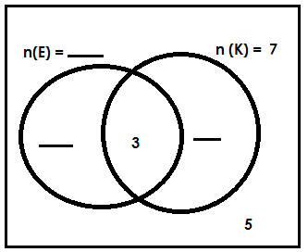a) Complete the Venn diagram below:

b) Find the value of X.

c) How many drivers take one route only?

d) Find the probability of picking a driver who takes Entebbe route only?

3. In a class of 30 pupils, (K + 2) like math only, 10 like SST (S) and 5 like both. Given that 4 like neither.

a) Complete the Venn diagram below.

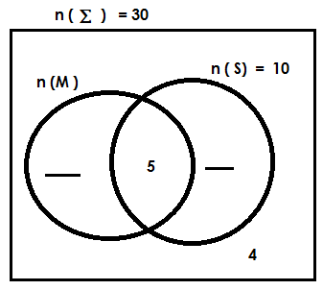

b) How many pupils like math?

c) How many pupils like one subject only?

4. At a party attended by 57 people, (2X + 2) took pepsi cola (P) only and 20 took Mirinda (M). 12 people took both and one person did not take any.

a) Complete the Venn diagram below:

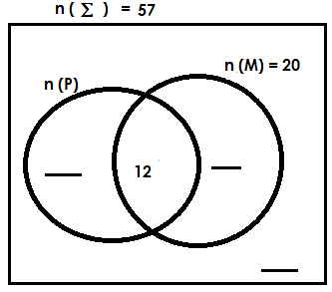

b) Find the value of X.

c) How many people took Pepsi only?

d) Find the probability of picking a person who took one type of drink only

5. In a group of 40 teachers, at St. Anthony Primary school, 10 eat meat (M) and (2y – 2) eat fish only. Given that 4 teachers eat neither, and 8 teachers eat both.

a) Complete the Venn diagram below: -

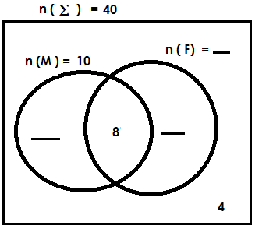

b) How many teachers eat fish.

c) Find the probability of picking a teacher who eats only one type.

**D). SOLVING PROBLEMS USING A VENN DIAGRAM GIVEN UNION COMPLEMENT AS THE UNKNOWN.**

**Examples**

In a class of 30 pupils, 15 eat fish (F) 10 eat meat (M) 5 eat both dishes and 2K do not eat any of the mentioned.

1. **Complete the Venn diagram**

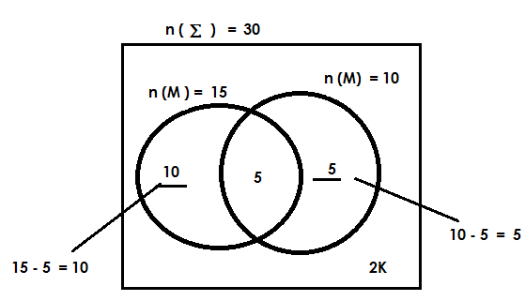

1. Find the value of K.

Solution.

2k + 10 + 5 + 5 = 30

2k + 20 = 30

2k + 20 – 20 = 30 – 20

2k = 10

2k = 10

2 2

**K = 5**

b) Find the probability of picking a pupil who does not eat meat.

**Solution:**

Prob = n (E)

n (P)

= n (M)’

n (**Σ** )

= 10 + 2k

30

= 10 + (2 x 5)

30

= 10 + 10

30

= 20

30

In a village of 40 farmers, 18 grow cassava (C), 14 grow beans (B), 10 grow both while 2y + 4 farmers grow none of the mentioned. Complete the Venn diagram.

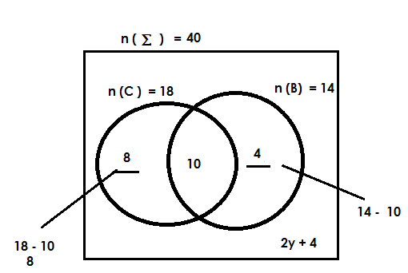

1. How many farmers do not grow any of the mentioned crop?

**Solution.**

2y + 4 + 4 + 10 + 8 = 40 Farmers who don’t grow any of the

2y + 26 = 40 = 2y + 4

2y + 26 – 26 = 40 – 26 = (2 x 7) + 4

2y = 14 = 14 +4

2y = 14 = 18

2 2

**Y = 7**

1. Find the probability of picking a farmer who grows only one crop.

**Solution**

Prob = n (E)

n (P)

= 8 + 4

40

= 12

40

**Activity:**

1. In a class of 40 pupils, 16 like English (E) 20 like math (M), 6 pupils like both subjects and K pupils do not like any of the mentioned subjects.

1. 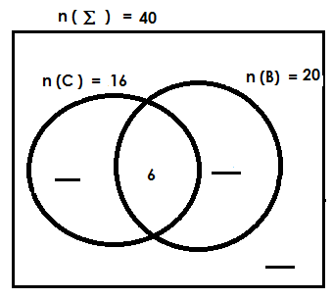Complete the Venn diagram.

b) Find the value of K.

c) Find the probability of picking a pupil who do not like English from the class at a random.

2. In a bus of 62 passengers, 20 bought water (W), 24 bought soda (S0 and 8 bought both drinks while 2P passengers did not buy any of the mentioned drinks.

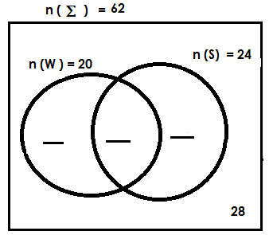a) Complete the Venn diagram.

b) Find the value of P.

c) How many passengers bought only one drink?

3. In a class of 40 pupils, 18 speak English (E), 20 speak Luganda (L) 8 pupils speak both any of the mentioned.

1. 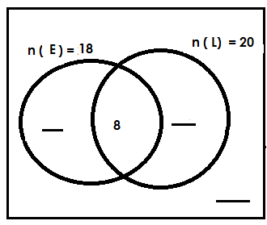Complete the Venn diagram.
2. Find the value of y.
3. Find the probability of picking a pupil who does not speak English from the class at a random.

4. At a party attended by 48 people, 20 ate meat (M0 16 ate chicken © 12 ate both dishes while 2k + 8 did not eat any of the mentioned.

a) Complete the Venn diagram.

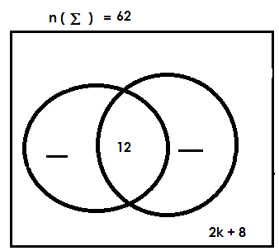

**n(c)=16**

**n(m)=20**

b) How many people did not eat chicken?

c) Find the probability of picking a person who ate only one dish at the part.

**SOLVING PROBLEMS USING VENN DIAGRAMS BY COMPARING SETS**

**Examples**

In a class, 30 pupils like math (M) K + 12 pupils like English only (E) and 8 pupils like both subjects while 3 pupils do not like any of the mentioned.

1. 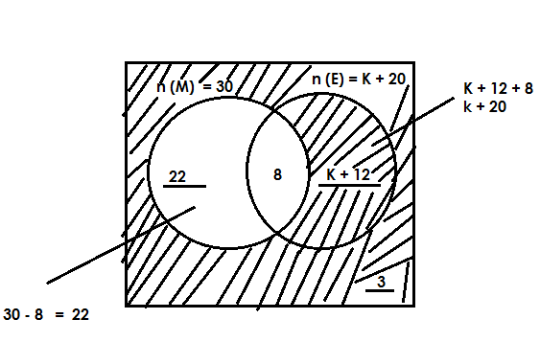Complete the Venn diagram

b) If 36 pupils do not like math. Find the value of K

**solution**

K +12 + 3 = 36

K + 15 = 36

K + 15 – 15 = 36 – 15

K = 21

1. How many pupils like English?

**Solution**

n(E) = K + 12 + 8

= 21 + 20

**= 41**

In a class 28 pupils like meat (M) 2y + 14 like. Fish and 8 pupils like both dishes while 4 pupils do not like any of the mentioned.

**a) Complete the venn diagram.**

**1**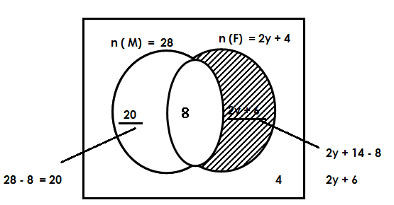

1. Given the 42 pupils like only one dish, how many pupils like fish.

Solution

2y + 6 + 20 = 42

2y + 26 = 42

2y + 26 – 26

2y = 16

2y = +68

2 2

**y = 8**

n (E) = 2y + 14

= (2 x 8) + 14

= 16 + 14

**= 30**

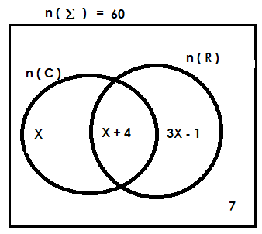The Venn diagram below shows the number of farmers who grow cassava (C) and Rice (R) use it to answer questions.

a) If 24 farmers grow cassava, find the value of X.

X + X + 4 = 24

2X + 4 = 24

2X + 4 – 4 = 24 – 4

2X = 20

2X = 20

2 2

X = 10

b) How many farmers grow only one type?

only one = n (c) only + n (R) only.

= X + 3X - 1

= 10 + (3 x 10) - 1

= 10 + 30 – 1

= 10 + 29

= 39

c) If a farmer is picked at random, to lead the farmers. Find the probability of picking a farmer who does not grow cassava.

**Soln.**

Prob = n (E)

n (P)

= 3X – 1 + 7

X + X + 4 + 3X – 1 + 7

= (3 x 10) – 1 + 7

10+10+4 +30 – 1 +7

= 30 – 1 + 7

6

= 36

60

In the Venn diagram below, 30 farmers grow maize (M), 15 grow both crops. Study it and answer the questions that follow.

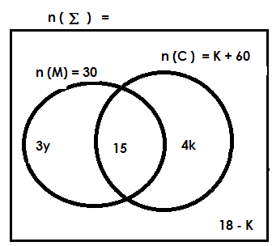

a) Find the value of y.

soln.

3y + 15 = 30

3y + 15 – 15 = 30 – 15

3y = 15

3y = 15

3 3

y = 5

b) Find the value of K.

**soln.**

4k + 15 = k + 60

4k + 15 = 15 = k + 60 – 15

4k = k + 45

4k - k = k – k + 45

3k = 45

3k = 45

3 3

K = 15

**Activity:**

1. In a class, 20 play football (F) P + 6 play volley ball (V) only and 5 pupils play both while 2 pupils play neither of the two.
2. 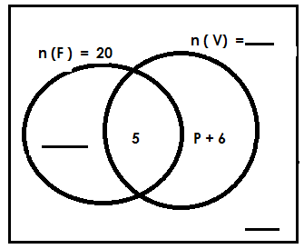Complete the Venn diagram.
3. If 28 pupils play volley ball, find the value of P.
4. How many pupils play only one game?

2. In a group, 30 people take soda (S), 2W – 4 people take water (W) and 4 people take both drinks while 3 people do not take any of the mentioned.

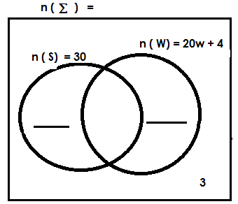a) Complete the Venn diagram.

b) Given that 40 people take only one drink. Find the number of people who take water in the group.

c) Find the probability of picking a person who take soda only from the group at a random.

3. In a village, 2x + 10 farmers grow beans only (B), 30 farmers grow maize (M) , 10 farmers grow both crops and X+16 farmers do not grow any.

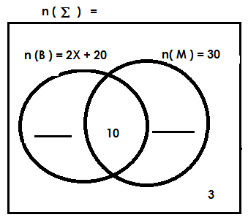a) Complete the Venn diagram.

b) Given that the number of farmers who grow beans only is the same as those who do not grow any of the mentioned crops. Find the value of X,

c) How many farmers grow only one crop?

d) Find the number of farmers in the whole village.

4. In the Venn diagram, the number of people who like posho only is equal

to the number of people who like rice only.

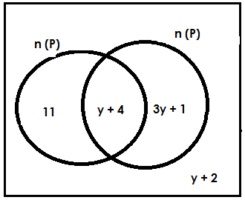

a) Find the value of y.

b) Find the probability of picking a pupil who does not like posho from the class at a random.

5. In a class, 13 pupils like English (E) only, **K** like both math (M) and English K + 15 like math but not English while 2 like neither of the two subjects.

a) Complete the Venn diagram

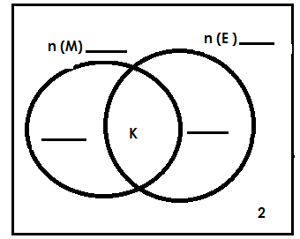

b) If 33 pupils like only one subject, find the value of K.

c) Find the probability of picking a pupil who like math from the class.

6. The Venn diagram below shows pupils who like math (M) and English (E). use it to answer questions if 16 more pupils like math than English.

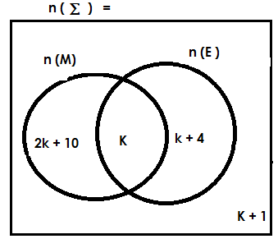

a) Find the value of K.

b) How many pupils who do not like English (E)?

**SOLVING PROBLEMS USING A VENN DIAGRAM GIVEN ONE OF THE SETS AS THE UNIVERSAL**

**Example I**

In a class of 48 pupils, all speak English 9E), 30 pupils speak Luganda (L) 20 pupils speak drinks (D) and X pupils speak all the three languages while 8 pupils speak English only.

**a) complete the Venn diagram.**

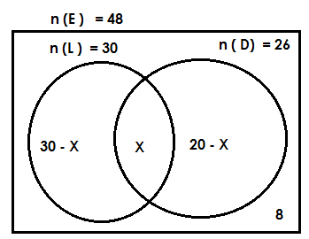

b) How many pupils speak all the three languages?

30 – X + X + 20 – X + 8 = 48

30 + 20 + 8 = X = 48

58 – X = 48

58 – 58 – X = 48 – 58

-x = -10

-x = -10

-1 -1

X = 10

c) How many pupils speak only two?

**Solution**

Only two = 30 – x + 20 – X

= 30 – 10 + 20 – 10

= 20 + 16

= 30 pupils

Find the probability of picking a pupil who speak only one language.

**Solution**

Prob = n(E)

n (P)

= 8

48

**Activity**

1. In a village of 50 farmers, all grow maize (M), 30 grow beans (B) 26 grow peas (P) and y farmers grow all the three crops while 8 farmers grow maize only.

a) Complete the diagram.

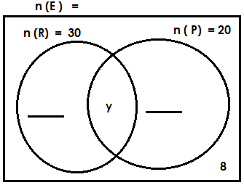

1. Find the value of X.
2. What is the probability of picking a farmer who do not grows only two crops?
3. In a bus of 38 passengers, all bought water (W), 20 bought chicken (c) 24 bought Ganga (G) and K passengers bought water only.
4. Complete the Venn diagram

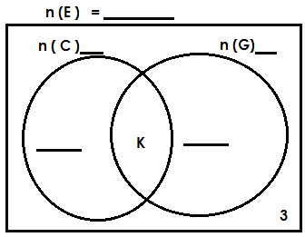

1. Find the value of K
2. Find the probability of picking a passenger who bought chicken and water only.
3. In a market of 50 traders, all sell dresses (D), 36 sell shirts (S), 28 sell bags (B) while M traders sell all the three items and six traders sell dresses only.
4. Complete the Venn diagram.

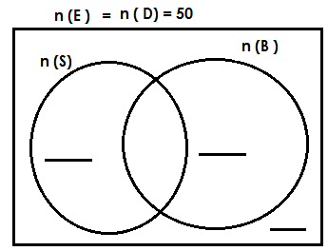

b) How many traders sell all the three items?

c) Find the number of traders who sell only two items.

**OPERATIONS ON WHOLE NUMBERS**

**Properties of operations**

1. Commutative property.

It states that the order in which numbers are arranged does not change the result.

Example

5 + 6 = 11 6 + 5 = 11

4 x 3 = 12 3 x 4 = 12

Commutative property in under addition and multiplication only.

2. **ASSOCIATIVE PROPERTY**

* It states that when carrying out addition or multiplication of more than two numbers the way in which numbers are grouped does not affect the sum or product.
* The alternation of brackets does not change answers in addition or multiplication of more than two numbers.

**Example 1.**

(6 + 4 ) + 5 = 6 + (4 + 5)

10 + 5 = 6 + 9

15 = 15

**Example II**

(6 x 4) x 5 = 6 x (4 x 5)

24 x 5 = 6 x 20

120 = 120

**DISTRIBUTIVE PROPERTY**

* The product of a factor and a sum or difference is equal to the sum of difference of the products respectively.

**Examples**

Work out: 4 x 3 + 6 x 4

Identify the common factors.

(4 x 3) + (6 x 4)

4 (6 + 3)

4 (9)

4 x 9

=36

Work out: (5 – 4 x 54) + (46 x 5.4)

**Soln.**

5.4 (54 + 46)

5.4 x 100

$\frac{54 }{10 }$ x 100

**540**

Work out: 3.4 x 127 - 27 x 3.4

**Soln.**

(3.4 x 127) – (3.4 x 27)

3.4 (127 – 27)

$\frac{34 }{10 }$ x 100

**349**

Work out: 146 **÷** 5 – 46 **÷**5

**Soln.**

(146**÷**5**) –** (46 **÷**5)

(146 – 46)**÷** 5

100 **÷**5

**= 20**

**Activity**

Work out the following using distributive property only.

1. 2 x 17 + 2 x 13

2. 75 x 29 + 25 x 19

3. 17 x 19 + 19 x 13

4. (178 x 10) + (10 x 22)

5. (75 x 25) – (75 x 19)

6. 4.6 x 18 – 8 x 4.6

7. 12.4 x 146 – 46 x 12.4

8. 0.6 x 119 – 19 x 0.6

9. (199 **÷** 8) – 7 **÷** 5

10. (179 **÷**13) – (10 **÷**13)

11. 79 **÷**8) – (7 **÷**8)

12. (625 **÷**20) + (75 **÷**20)

13. (606 **÷**12) + (18 **÷**12)

**STANDARD FORM / SCIENTIFIC NOTATION**

Standard form is a way of expressing numbers as multiples of powers of10, leaving one counting digit in the place value of ones.

**Note:**

* When a decimal point moves taking a left-hand movement / direction, we shall have a positive power.
* When a decimal point moves taking a right-hand movement, we shall have negative powers.

**Illustration**

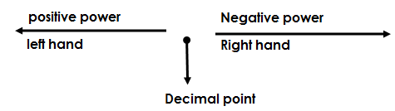

* The size of the power is determined by the number of steps moved by a decimal point.

**WRITING NUMBRS IN STANDARD FORM**

**Examples**

Express 4623 in a standard form.

Soln.

4623 = 4623 x 10?

**= 4.623 x 103**

Express 864000 in scientific notation

**Soln.**

8640000 = 864000 x 10?

= 8.64000 x 10

**= 8.64 x 105**

Note:

* For this case zeros are not significant

Write 732. 14 in a standard form.

**Soln.**

732.14 = 7.32.14 x 10?

**= 7.3214 x 102**

Write 8.9 in a standard form

**Soln**.

8.9 = 8.9 x 10?

= 8.9 x 10o

Express 0.00018 in a scientific notation.

**Soln.**

0.00018 = 0.00015 x 10?

= 1.8 x 10-4

**Activity:**

Write the following numbers in standard form.

1. 46

2. 694

3. 168000

4. 9

5. 469.2

6. 86.7

7. 4321.14

8. 1.9

9. 0.00049

10. 0.00364

11. 0.0008

12. 0.00000473

**FINDING NUMBERS THAT WHERE EXPRESSED IN SCIENTIFIC NOTATION**

**Example I**

Find the number that was written in scientific notation to give 3.72 x 105

Soln.

3.72 x 105 = x 10 x 10 x 10 x 10 x 10

**= 372000**

**Example II**

Find the number that was written in standard form to give 7.239 x 102.

Soln.

7.239 x 102 = $\frac{7239}{100}$ x 10 x 10

= $\frac{7239}{10}$

= 723.9

Which number was written in standard form to give 9.4 x 10-3?

**Soln.**

9.4 x 10-3 =  **x 3**

**= x**

**=**

= 0.0094

Find the original number that was written in a standard form to give 7.8 x 10-2.

**Soln.**

7.8 x 10-2 =  **x 2**

=  **x x 10**

=

**= 0.78**

**Activity:**

Finding the original numbers that were expressed in standard form to give the following.

1. 8.46 x 102

2. 7.641 x 103

3. 9.192 X 104

4. 8.763 x 102

5. 9.4 x 106

6. 6.4 x 10-2

7. 9.31 X 10-4

8. 3.12 x 10-2

9. 5.4 x 10-3

10. 6.42 x 10-

**LAWS OF INDICES**

**A. ABOUT MULTIPLICATION**

* 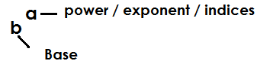If the bases are the same, maintain one base and add the powers.
* To simplify indices, leave the answers in power form.
* To work out indices is to evaluate i.e., to find the value of the expression.

**Examples**

Simplify: m4 x m6 x m2

**Soln.**

M4 x m6 x m2 = m4 +6 + 2

= M12

Simplify K4 x K -8

**Soln**.

K4 X K-8 = K4+ - 8

= K4 + ( -8)

= K4 – 8

**= K -4**

Simplify: 42 x 46

42 x 46 = 42 +6

**= 48**

Work out: 24 x 22

**Soln**.

24 x 22

= 24+2

= 26

= 2x2x2x2x2x2

= 74

Evaluate 34 x 3-6

34 x 3-6 = 34+(-6)

= 34 -6

= 3-2

= **2**

**=**

=

**Activity:**

A Simplify the following

1. K4 x k2 x k3

2. p4 x p2 x p5

3. m2 x m-4

4. 46 x 42 x 43

5. 8-2 x 84

6. 104 x 102 x 103

7. 94 X 93 X 9-10

8. W3 x w-9

**b. Work out the following**

1. 42 x 43

2. 24 x 21

3. 25 x 2-6

4. 9o x 93

5. 104 x 10 -6

6. 84 x 84

**LAWS OF INDICES IN DIVISION**

In division if the bases are the same, maintain one base and subtract the powers.

**Examples**

Simplify: p14**÷** p7

**Soln.**

P14 **÷**p7 = p14 – 7

**= p7**

Simplify: K4÷ K-8

**Soln.**

K4 ÷ K-8 = K-4-(-8 )

= K12

Work out: 25**÷**23

**Soln.**

25 **÷**23 = 25-3

= 22

= 2 x 2

**= 4**

Work out 32**÷**35

**Soln.**

32**÷** 35 = 32- 5

= 3-3

= **3**

=

=

**Activity:**

Simplify the following

1. m5**÷ m2**

2. K6 ÷ k2 ÷ k1

3. y6**÷**y10

4. 56**÷** 53

5. 54**÷**57

**6.** 27 ÷ 24

**7.** 3 -3 ÷ 3-8

**8.** 8-2 ÷ 89

**B Work out the following**

1. 26 ÷ 24
2. 34**÷**36
3. 52 ÷ 53
4. 93 ÷ 9-1
5. 8-4 ÷ 8-2
6. 104 ÷ 106

**MORE ABOUT INDICES**

**Example I**

Simplify: 96 X 92

95

**Soln.**

96 X 92 = 9 6 + 2

95 95

= 98

95

= 98÷ 95

= 9 8– 5

= 93

Simplify: 46 x 45

411

**Soln.**

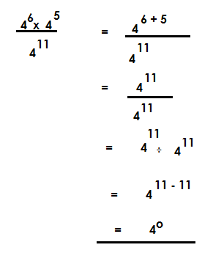

**ACTIVITY:**

Simplify the following: -

1. y2 x y4

y5

2. m2 x m-6

m-4

3. k6 x k2 x k3

k2 x k7

4. 8-2 x 8-3

8-4

5. 4p3 x 2p4

8p5

6. 3y4 x 6y3

9y7

7. 4m4 x 3m5

6m7

8. 6k3 x 4k6

12k8

**APPLICATION OF INDICES (A)**

**Examples.**

Solve: 3K = 81

**Soln.**

* 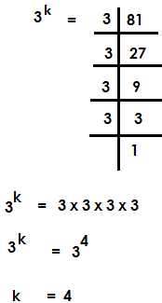Express 81 as power of 3.

Solve: 2a x 22 = 16

**Soln.**

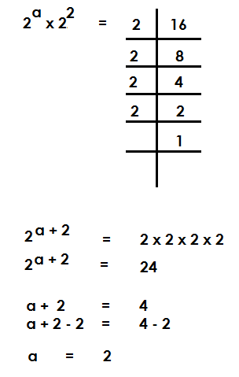

**Activity:**

Solve for the unknowns in the following: -

1. 2k = 32

2. 3n = 27

3. 4 a –1 = 64

4. 221 = 25

5. 2m x 22 = 32

6. 32a x 32 = 729

7. 5n x 5n = 25

8. 42 x 4y = 256

9. 6a x 62 = 216

**APPLICATION OF INDICES (B**)

**Examples**

Simplify:3m ÷32 = 9

**Soln.**

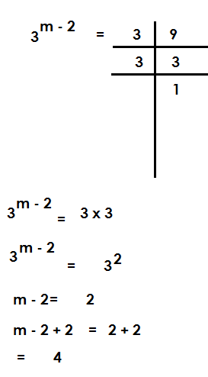

Solve: 2p ÷ 21 = 8

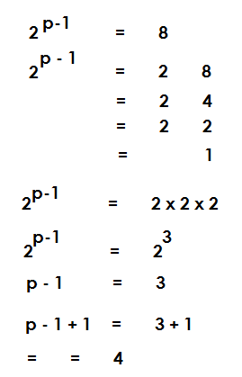**Soln.**

Solve 2p÷ 8 = 32

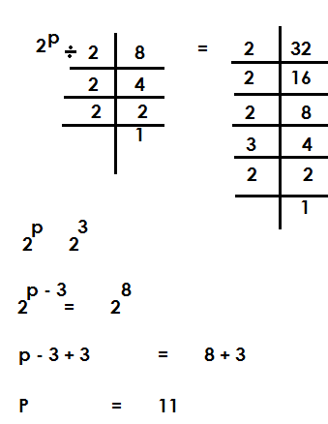**Soln.**

**Activity:**

Solve for the unknown in the following: -

1. 2x ÷ 22 = 4

2. 3p ÷ 31 = 9

3. 2b ÷ 22 = 8

4. 3n ÷ 32 = 27

5. 6k ÷ 61 = 36

6. 23y ÷ 2y  = 16

7. 32m ÷ 3m = 27

8. 53p ÷ 5p = 625

9. 3p÷ 3 = 9

10. 3m ÷ 9 = 31

11. 5y÷ 25 = 625

**APPLICATION OF INDICES (C)**

**Example I**

Solve: 2k x 32 = 36

**Soln**.

* 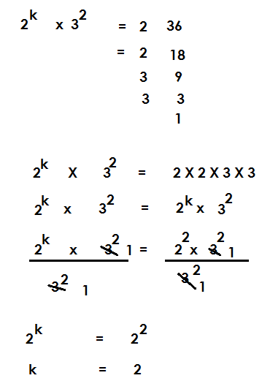Express 36 as power of 2 and 3 i.e., factorize 36 using 2 and 3.

**Activity:**

Solve for the unknown in the following

1. 2n ÷ 33 = 108

2. 3p ÷ 52 = 75

3. 32 x 7y = 441

4. 23 x 52k = 200

5. 2m x 52 = 100

6. 23 x 5k-1 = 200

**FINITE SYSTEM**

**Definition:**

This is a way of expressing numbers as remainders.

**ADDITION IN FINITE SYSTEM**

**Note:**

* Identify elements in a given modular system.
* In addition, using a dial we take a clockwise direction.

**Examples:**

1. Work out: 2 + 4 = (finite 5)

Soln.

Finite 5 = ( 0 , 1 , 2 , 3 , 4 )

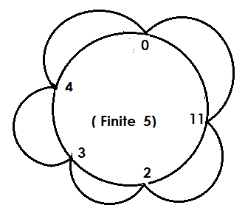

* 2 + 4 = 1 (finite 5)

2. Simplify 3 + 6 = _________ (mod 7)

Mod 7 = {0, 1, 2, 3, 4, 5, 6}

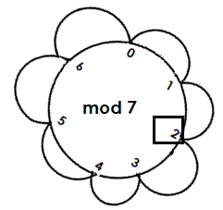

∴ 3 + 6 = 2 (mod 7)

3. work out: 3 + 4 + 3 = ______ (mod 7)

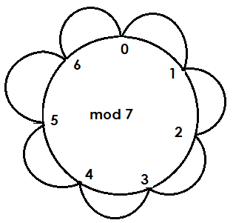

**∴**3 + 4 + 3 = 3 (mod 7)

**Activity:**

1. 2 + 3 = ___________ (finite 5)

2. 1 + 4 = _____________ (finite 5)

3. 3 + 5 = ____________ (finite 6)

4. 1 + 2 + 3 = ____________ (mod 7)

5. 2 + 6 + 3 = ____________ (mod 8)

6. 1 + 7 = _____________ (mod 8)

7. 2 + 3 + 4 = ____________ (mod 9)

8. 2 + 3 + 1 = ___________ (finite 7)

**Simplify without using a dial**

**Note:**

Addition in finite system without using a dial, consider remainders.

**Examples**

1. Add: 2 + 3 = __________ (finite5)

2 + 3 = ____________ (finite 5)

5 = ___________ (finite 5)

5 ÷ 5 = ____________ (finite 5)

1 rem 0

**∴** 2 + 3 =0 (finite 5)

2. Add: 3 + 4 + 3 = _____________ (finite 7)

**Soln.**

3 + 4 + 3 = _________ (finite 7)

10 = ________ (finite 7)

10 ÷ 7 = ________ (finite 7)

1 rem 5 = ________ (finite 7)

**∴** 3 + 4 + 3 = 3 (finite 7)

3. Workout: 23 + 42= _____ (finite 5)

2 x 2 x 2 + 4 x 4 = _____ (finite 5)

8 + 16 = _____ (finite 5)

24 = ______ (finite 5)

24 ÷ 5 = ______ (finite 5)

4 rem 4 = _______ (finite 5)

∴23 + 42 = 4 (finite 5)

**Activity**

**Work out:**

1. 3 + 4 = ______________ (finite 5)

2. 1 + 2 + 3 = _________ (finite 6)

3. 23 + 43 = __________ (finite 7)

4. 33 + 6 = ____________ (mod 7)

5. 2 + 3 + 4 = __________ (finite 5)

6. 6 + 20 = ___________ (mod 8)

7. 2 + 6 + 3 = _____________ (mod 7)

8. 0 + 3 + 2 + 4 = _________ (mod9)

**SUBTRACTION IN FINITE SYSTEM**

1. **USING A DAIL**

**Note:**

* 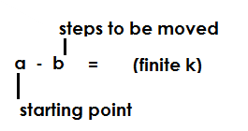In subtraction using a dial, take anti-clockwise direction.

**Examples:**

1. Work out: 2 – 6 = __________ (mod 5)

**Soln.**

Mod 5 = {0,1, 2, 3, 4}

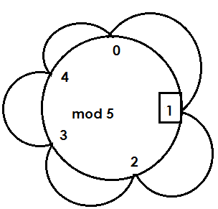

**∴2 – 6 = 1 (mod 5)**

2. 3 – 5 = __________ (finite 7)

**Soln**.

Finite 7 = ( 0 , 1 , 2 , 3 , 4 , 5 , 6 )

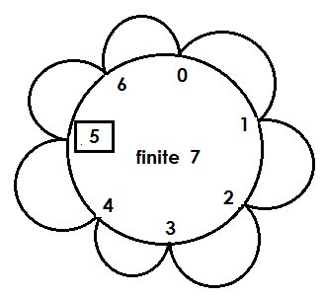

**∴** 3 – 5 =5 (finite 7)

3. Simplify: 2 – 3 = _____ (finite 5). Use a dial.

**Soln.**

Finite 5 = {0, 1, 2, 3, 4}

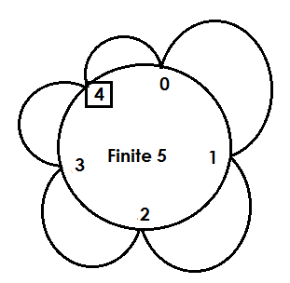

2 – 3 = 4 (finite 5)

4. work out; 1 – 2 – 3 = ________ (mod 5)

**Soln.**

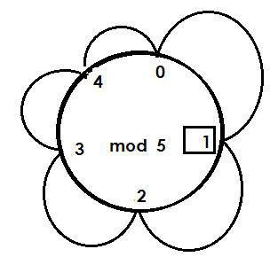Finite 5 = {0, 1, 2, 3, 4)

**∴1 – 2 - 3 = 1 (mod 5)**

**Activity:**

**Work out the following using a dial.**

1. 2 – 3 = ________ (finite 5)

2. 3 – 8 = _________ (mod 7)

3. 2 – 5 = _________ (finite 6)

4. 1 – 4 = _________ ( mod 5)

5. 3 – 7 = _________ (mod 6)

6. 1 – 3 - 4 = __________ (finite 7)

7. 2 – 3 – 4 = ___________ (finite 8)

8. 0 - 3 = ___________ (mod 5)

1. **SUBTRACTION IN FINITE SYSTEM WITHOUT USING A DIAL**

**Note:**

1. If the number you are subtracting is bigger than the original but when it is a member of a given finite system, increase the original by the given modular system.

1. If the number you are subtracting is not a member of the given finite system convert the number to the given finite system by dividing and consider the remainder.

**Examples:**

1. work out 4 – 6 = _____ (finite 5)

**Soln.**

4 – (6 – 5) = ______ (finite 5)

4 – (1 rem 1) = _______ (finite 5)

4 – 1 = 3 (finite 5)

**∴ 4 – 6 = 3 (finite 5)**

2. simplify: 1 – 24 = _______ (finite 5)

**Soln.**

1 – (24 ÷ 5) = _______ (finite 5)

1 – 4 rem 4 = _______ (finite 5)

1 – 4=_______ (finite 5)

(1 + 5) – 4 = _______ (finite 5)

6 – 4= 2 (finite 5)

**∴1 – 24 = 2 (finite 5)**

3. work out: 1 – 2 -3 = _____ (mod 6)

**Soln.**

1(- 2 – 3) = _______ (mode 6)

1 – 5 = ________ (mod 6)

(1 + 6) – 5 = ______ (mod 6)

7 – 5 = 2 (mod 6)

**∴ 1 – 2 – 3 = 2 (mod 6)**

**Activity:**

**Simplify:**

1. 2 – 5 = ______ (finite 7)

2. 1 – 3 = _______ (mod 5)

3. 1 – 8 = ________ (mod 5)

4. 4 – 5 = ________ (finite 7)

5. 2 – 16 = ________ (mod 5)

6. 4 – 20 = ________ (finite 6)

7. 3 – 19 = ________ (finite 5)

8. 1 – 3 – 4 = ________ (mod 7)

9. 3 – 4 – 5 = ________ (finite 9)

10. 0 - 2 = ________ (finite 5)

**MULTIPLICATION IN FINITE SYSTEM**

Using a dial

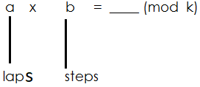**Note:**

* In multiplication we take a clockwise direction starting from zero.

**Examples**

1. Work out: 2 x 4 = ____ (finite 6)

(Finite 6) = {0, 1, 2, 3, 4, 5)

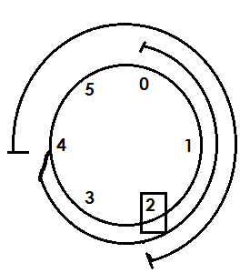

**∴2 x 4 = 2 (finite 6)**

2. Work out: 3 x 2 = _____ (finite5)

**Soln.**

Finite 5 = {0, 1, 2, 3, 4}

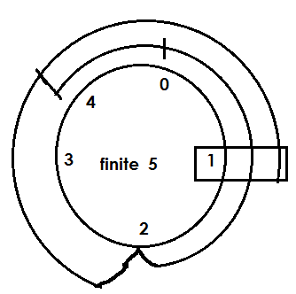

**∴**3 x 2 = 1 (finite 5)

3. 2 x 5 = __________ (mod 7)

**Soln.**

Mod 7 = {0, 1, 2, 3, 4, 5, 6}

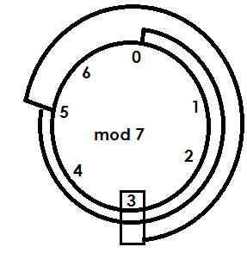

**∴**2 x 5 = 3 (mod 7)

**Activity:**

Work out the following using a dial

1. 2 x 3 = _____ (finite 5)

2. 3 x 4 = ________ (finite 6)

3. 3 x 5 = _______ (finite 8)

4. 4 x 3 = ________ (finite 5)

5. 6 x 2 = ___________ (mod 7)

6. 1 x 4 = _________ (mod 6)

7. 2 x 5 = ___________ (mod 8)

8. 2 x 4 = __________ (mod 7)

**MULTIPLYING IN FINITE SYSTEM (WITHOUT USING A DIAL)**

**Note:**

Just like addition, when multiplying numbers, consider remainders.

**Examples:**

1. Work out: 2 x 8 = ___________ (finite 7)

**Soln.**

2 x 8 = _______ (finite 7)

16 = _________ (finite 7)

16 ÷ 7= _______ (finite 7)

2 rem. (2) = _______ (finite 7)

∴2 x 8 = 2 (finite 7)

2. Workout: 3 x 2 = ______ (finite 5)

**Soln.**

3 x 2 = ________ (finite 5)

6 = ________ (finite 5)

6 ÷ 5 = ______ (finite 5)

1 rem (1) = ______ (finite 5)

∴ 3 x 2 = 1 (finite 5)

1. Work out: 3 x 2 x 4 = _____ (finite 7)

3 x 2 x 4 = ______ (finite 7)

24 = _______ (finite 7)

24 ÷ 7 = _______ (finite 7)

3 rem. (3) = ________ (finite 7)

∴ 3 x 2 x 4 = 3 (finite 7)

**Activity:**

**Work out the following without using and dial**

1. 2 x 5 = _______ (mod 6)

2. 4 x 5 = _______ (mod 7)

3. 4 X 3 = ________ (mod 7)

4. 3 x 5 = _______ (mod 8)

5. 1 x 2 x 3 = ________ (mod 5)

6. 2 x 1 x 4 = _______ (mod 5)

7. 22 X 32 = _____________ (finite 8)

8. 42 = __________ (mod 7)

9. 4 X 2 = _________ (finite 6)

10. 3 x 2 x 4 = __________ (mod 8)

**DIVISION IN FINITE SYSTEM**

* In division of finite system, do not consider remainder.
* Take the quoted to be the final answer.
* If the dividend is not a multiple of the divisor, increase it by a given modular system until a multiple of the dividend is got.

**Examples**

1. Work out: 2 ÷ 3 = 4 (finite 5)

**Soln.**

(2 + 5) ÷ 3 = __________ (finite 5)

1. = ÷ 3 = ______ (finite 5)

(7 + 5) ÷ 3 = _______ (finite 5)

12 ÷ 3= 4 (finite 5)

2. Work out: 4 ÷ 3 = 6 (mod 7)

**Soln.**

(4 + 7) ÷ 3 = _______ (mod 7)

11 ÷ 3 = ______ (mod 7)

(11 + 7) ÷ 3 = _____ (mod 7)

18 ÷ 3 = 6 (mod 7)

∴4 ÷3 = 6 (mod 7)

3. Workout: 5 ÷7 = _____ (finite 12)

**Soln**.

(5 + 12) ÷7 = _____ (finite 12)

17 ÷7 = ____ (finite 12)

(17 + 12) ÷ 7 = ______ (finite 12)

29 + 7 = ______ (finite 12)

(29 + 12) ÷ 7 = ______ (finite 12)

41 ÷ 7 = _______ (finite 12)

(41 + 12) ÷ 7 = ______ (finite 12)

63 ÷7 = ______ (finite 12)

63 ÷7 = 9 (finite 19)

5 ÷ 7 = 9 (finite 12)

**Activity:**

**Work out:**

1. 3 ÷4 = _____ (mod 7)

2. 3 ÷ 5 = ______ (mod 7)

3. 3 ÷ 2 = ______ (finite 5)

4. 1 ÷ 3 = 3 = _____ (mod 5)

5. 4 ÷ 5 = _____ (mod 6)

6. 1 ÷ 4 = _______ (finite 7)

7. 1 ÷ 6 = _______ (mod 7)

8. 6 ÷9 = ________ (mod 12)

9. 5 ÷3 = ______ (finite 7)

10. 5 ÷ 6 = ________ (finite 7)

**FINDING UNKNOWNS IN FINITES SYSTEM**

**Examples**

1. Solve: m + 6 = 2 (finite 7)

**Soln.**

M + 6 – 6 = 2 – 6 (finite 7)

M = (2 + 7) – 6 (finite 7)

M = (9 – 6 (finite 7)

M = 3 (finite 7)

2. Solve: K – 6 = 2 (mod 4)

**Soln.**

K – 6 + 6 = 2 + 6 (mod 4)

K = 8 (mod 4)

K =8 ÷ 4 (mod 4)

K = 2 rem (0) (mod 4)

K = 0 (mod 4)

3**.** Solve: 2p = 5 (mod 7)

**soln.**

2p = 5 + 5 (mod 7)

2p = 12 (mod 7)

$\frac{2p}{2}$ = $\frac{12}{2}$ (mod 7)

**P = 6 (mod 7)**

4. Solve: 3y + 1 = 6 (finite 7)

**Soln.**

3y + 1 – 1 = 6 – 1 (finite 7)

3y = 5 (finite 7)

3y = 12 (finite 7)

$\frac{3y}{3}$ = $\frac{12}{3}$ (finite 7)

y = 4 (finite 7)

5. solve: 6 (m – 3) = 4 (mod 8)

6m – 18 = 4(mod 8)

6m – 18 + 18 = 4 + 18 (mod 8)

6m = 22 (mod 8)

6m = 22 + 8 (mod 8)

$\frac{6m}{6}$ = $\frac{30}{6}$ (mod 8)

$\frac{6m}{6}$ = $\frac{30}{6}$ (mod 8)

M = 5 (mod 8)

6. Solve: = 5 (finite 12)

**Soln.**

$\frac{2p-4}{2}$ x 2 = 5 x 2 (finite 12)

2p – 4 = 10 (finite 12)

2p – 4 + 4 = 10 + 4 (finite 12)

$\frac{2p}{2}$ = $\frac{14}{2}$ (finite 12)

P = 7 (finite 12)

**Activity:**

Solve:

1. k + 8 = 3 (mod 6)

2. y + 4 = 1 (finite 5)

3. m + 6 = 1 (mod 7)

4. 3 + y = 2 (mod 7)

5. p – 8 = 4 (mod 8)

6. n – 3 = 7 (mod 8)

7. 3k = 4 (mod 7)

8. 5m = 3 (finite 6)

9. 3y – 4 = 5 (mod 6)

10. 4(y – 2) = 3 (finite 5)

11. = 3 (finite 8)

12. = 1 (finite 7)

**APPLICATION OF FINITE SYSTEM**

**Note:**

* Days of the week are in finite 7. Therefore;

|  |  |  |  |  |  |  |
| --- | --- | --- | --- | --- | --- | --- |
| Mon | Tue | Wed | Thurs. | Fri | Sat | Sun |
| 1 | 2 | 3 | 4 | 5 | 6 | 0 |

Months of the year are in mod 12.

|  |  |  |  |  |  |  |  |  |  |  |  |
| --- | --- | --- | --- | --- | --- | --- | --- | --- | --- | --- | --- |
| J | F | M | A | M | J | J | A | S | O | N | D |
| 1 | 2 | 3 | 4 | 5 | 6 | 7 | 8 | 9 | 10 | 11 | 12 |

* Time of the day is in finite 12.
* Questions stated in respect to future, we add.
* Questions stated in respect to past we shall subtract.

**Example I**

If today is Wednesday, what day of the week will it be after 64 days?

**Soln.**

Day + 64 = ____ (mod 7)

Wed + 64 = ______ (mod 7)

3 + 64 = _______ (mod 7)

67 = ______ (mod 7)

67 ÷ 7 = ________ (mod 7)

9 rem (4) mod 7.

**3 + 6 = 4 (mod 7)**

**∴ It will be Thursday.**

Example II

If today is Monday, what day of the week was it 20 days ago.

**Soln.**

Day -20 = ______ (mod 7)

Mon – 20 = _______ mod 7)

1 – 20 ÷ 7 = ____ (mod 7)

1 – (2 rem 6) = _______ (mod 7)

1 – 6 = ________ (mod 7)

(1 + 7) -6 = ______ (mod 7)

8 - 6 = 2 (mod 7)

**∴ It was Tuesday**

**Example III**

If this is march, what month of the year will it be after 40 months.

**Soln.**

Month + 40 = ______ (mod 12)

March + 40 = _____ (mod 12)

3 + 40 = ______ (mod 12)

43 = ______ (mod 12)

43 ÷ 12 = ______ (mod 12

3 rem (9) mod 12)

3 + 40 = 9 (mod 12)

**∴It will be September.**

**Example IV**

If this is may, which month of the year was it 46 months ago?

**Soln.**

Month – 46 = ______ (finite 12)

May – 46 = ______ (finite 12)

5 – 46 = _______ (finite 12)

5 – 46 ÷ 12 = _____ (finite 12)

5 – (3 rem 10) finite 12

5 – 46 = 10 (finite 12)

**∴ It was October.**

**Activity:**

1. If today is Saturday, what day of the week will it be after 72 days?

2. Otieno will celebrate his birthday 56 days to come if today is Wednesday, what day of the week will he celebrate?

3. If today is Thursday, what day of the week will it be after 96 days?

4. If today is Monday, what day of the week will be after 20 days?

5. If today is Thursday, which day of the week was it 36 days ago?

6. Matama was born 142 days ago, if today is Thursday, which day of the week was it?

7. If today is Saturday, which day of the week was it 76 days ago?

8. This is April, which month of the year was it 18 months ago?

9. Wandera celebrated his birth day 10 months ago. If this is October, which month of the year was?

10. Okello went to London 46 months ago, if this is January, which month of the year did he go?

11. If this is May, which month of the year will it be after 19 months?

12. This is September, which month of the year will it be after 96 months?

13. Isaac is to go to London in 86 months of this is June, which month of the year will he go?

14. Okello will celebrate his birth day 52 months to come, if we are in November, which month of the year will be celebrated

**APPLICATION OF FINITE SYSTEM GIVEN DAYS AND DATES OF THE MONTH**

**Note:**

* Months with 30 days are September, April, June and November all the rest have 31 except February, which has 28 and 29 days in each leap year.
* A leap year is the year having 366 days.

**Examples**

If today is Thursday, 28th March, what day of the week will it be on 16th July of the same year?

**Soln.**

March 31 – 28 ____ 03

April __________ 30

May ___________ 31

June ___________ 30

July ____________ + 16

**Total = 110 days**

Day + 110 = _________ (mod 7)

Thurs + 110 = ________ (mod 7)

4 + 110 = ____________ (mod 7)

114 = _______ (mod 7)

114 ÷ 7 = _______ (mod 7)

16 rem (2)(mod 7)

**∴ it will be Tuesday.**

If today is Tuesday 17th April, what day of the week was it 13th January of the same year?

**Soln.**

April ______________ 17

March _______________ 31

February ____________ 28

January 31 – 13 + 18

**Total = 94 days**

Day – 94 = ______ (mod 7)

Tue – 94 = ______ (mod 7)

2 – 94 = ________ (mod 7)

2 – (94 ÷ 7) = ______ (mod 7)

2 – 13 rem (3) (mod 7)

2 – 3 =___________ (mod 7)

(2 + 7) – 3 = __________ (mod 7)

9 – 3 = 6 (mod 7)

2 – 94 = 6 (mod 7)

∴ It was Saturday.

**Activity:**

1. If today is 20th May, Friday, what day of the week will it be 10th November of the same year?

2. If today is Monday 10th March, what day of the week will it be on 21st May of the same year?

3. If today is Thursday 2nd May, what day of the week will it be on 18th August of the same year?

4. If today is Sunday 31st March, what day of the week will it be 20th July of the same year?

5. If today is Tuesday 9th September, which day of the week was it on 11th June, 11th the same year?

6. If today is Tuesday 18th September, what day of the week was it 10th June of the same year?

7. If today is Monday 6th July, what day of the week was it 9th march of the same year?

8. If today is 8th Thursday July which day of the week was it 10th April of the same year?

**APPLICATION OF FINITE SYSTEM (ABOUT TIME)**

* In order to consider part of the day, i.e., pm or am, we have to base on the quotient.
* If the quotient is even, it leaves am as am and pm as pm.
* If the quotient is odd it changes am to pm and pm to am.
* Application of finite system in time we use finite 12.

**Examples**

* If it’s 9:00a.m, what time of the day will it be after 32 hours?

Soln.

9 + 32 = __________ (mod 12)

41 = _____________ (mod 12)

41 ÷ 12 = __________ (mod 12)

Odd (3) rem 5 (mod 12)

**∴ it will be 5:00pm.**

It is 9:40pm, what time of the day will it be after 41 hours?

**Soln.**

9 + 41 = _________ (finite 12)

50 = __________ (finite 12)

50 ÷ 12= _______ (finite 12)

Even (4) rem 4 (finite 12)

**∴It will be 2:40pm.**

**Activity:**

1. It is now 7:00pm, what time of the day will it be after 32 hours?

2. It is 5:30am, what time of the day will it be after 38 hours?

3. I have a flight in 52 hours, if it’s now 3:20pm, what time of the day will it be?

4. It is 11:00am and we are to start the function in 70 hours, at what time of the day shall we start?

5. It is now 1:40pm what time of the day will it be after 23 hours?

6. If it’s 4:35am, what time of the day will it be after 63 hours?

**APPLICATION OF FINITE SYSTEM INVOLVING MORE GROUPS**

**Examples**

1. Find the smallest number of pens that when shared by 5 pupils 2 pens remain and when shared by 8 pupils 5 pens remain?

Soln.

2 (mod 5) 7, 12, 17, 22, 27,32

3 mode 11, 19, 27, 35.

**∴ The number is 27**

Find the smallest number that when divided by 5, 3 remains, when divided by 6, 4 remain and when divided by 4, 0 remains.

Soln.

3 (mod 5) 8,13 , 18 , 23 , 28 , 33

4 (mod 6) ,10,16 , 22 , 28 , 34.

**∴ The number is 28.**

**Activity:**

1. Find the least number of mangoes that when shared by 6, 7 remain and when shared by 5, 2 remain.

2. A man had some oranges, when he shared them among 3 groups, 2 remained, when he shared in 4 groups 3 remained and when he shared them in 5 groups 3 remained. Find the smallest number of oranges that he had.

3. Find the smallest number that when divided by 8, 2 remain and when shared by 9, 8 remain.

4. Find the smallest number that when shared by 7, 3 remain, when shared by 4, 2 remain and when shared by 8, 6 remain.

5. Find the least number of sweets such that when divided by 3, 2 remain, when divided by 4, 3 remain and when divided by 5, 3 remain.

6. A teacher bought some pens and put them in groups of 95 and 7 pens were left, when he put them in groups of 8s only 4 pens were left but when he put them in group of 3, only, 1 pen was left. Find the smallest number of pens that the teacher bought.

**FRACTIONS**

A fraction is a part of a whole

**MIXED OPERATIONS ON COMMON FRACTIONS**

**1. Given addition and subtraction**

**Note:**

Given addition and subtraction, we re-arrange starting with addition

**Example I**

Simplify: $\frac{1}{5}$– 1 $\frac{1}{2}$ + 2 LCM = 10

Soln.

= +  - 1 $\frac{1}{2}$

= $\frac{1}{5}$ + $\frac{2}{1}$- $\frac{8}{2}$

= ( $\frac{1}{5}$ x 10) + ( $\frac{2}{1}$ x 10) – ( $\frac{3}{2}$ x 10)

10

= (2 + 20) – 15

10

= $\frac{7}{10}$

**Example II**

Simplify: $\frac{1}{4}$ **- $\frac{2}{3}$ + $\frac{1}{2}$**

Soln. LCM = 12

$= \frac{1}{4}$**+ $\frac{2 }{3 }$- $\frac{2}{3}$**

**= $\frac{1}{4}$ + - $\frac{1}{2}$- $\frac{2}{3}$**

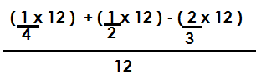

=

= $\frac{\left(3+6 \right)- 8}{12}$

**= $\frac{9-8}{12}$**

**= $\frac{1}{12}$**

**Activity:**

**Simplify the following: -**

1. - + 1

2. 2/3 – 2 ½ + 3 ¼

3. 1/5 – ½ + ¾

4. 1/6 – 2/3 + 4/5

5. - +

6. - 2 + 2

7. ¼ - 1½ + 2

8. 1/3 – ½ + 2¼

**2. GIVEN OTHER OPERATIONS**

**Note:**

Given other operations, BODMAS is applied.

**Examples**

Simplify: 1 ½ x 1/3 ÷ 4/9

**Soln.**

BODMAS

1 ½ x 1/3 ÷ 4/9

x ( ÷ )

x x

=

= 1 rem 1

= 1

Simplify: $\frac{1}{9}$ ÷ $\frac{2}{3}$ x ¼ ÷ $\frac{5}{6}$

**Soln.**

BODMAS

( ÷ ) x ( ÷ )

( x ) x ( ÷ )

1/9 x 3 / 8 x ¼ x 6/5

**=**

**Activity:**

1. simplify: - x ÷ +

2.

3. - of +

4. of ÷ +

5. x ÷ x

6. – ÷ + 1

7. x + ÷

8. ÷ ( + )

9. 2 ½ X ( ½ X )

10. + ÷

**CHANGING COMMON FRACTIONS TO DECIMALS**

**EXAMPLE I**

Change $\frac{2}{3}$ to a decimal fraction

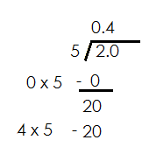Soln.

**Example II**

Change $\frac{5}{6}$ to a decimal fraction.

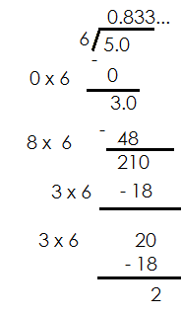Soln.

$\frac{5}{6}$ =

**ACTIVITY**

Change the following common fractions to decimal fractions.

**1. ½**

**2. $\frac{4}{5}$**

**3. $\frac{3}{4}$**

**4. $\frac{3}{7}$**

**5. $\frac{5}{9}$**

**6. $\frac{14}{15}$**

**7. $\frac{2}{3}$**

**8. $\frac{3}{11}$**

**9. $\frac{8}{15}$**

**10. $\frac{5}{11}$**

**RECURRING DECIMALS TO COMMON FRACTIONS**

* Recurring decimals are also called non terminating fractions / decimals.
* Vulgar fractions are common fractions i.e., fractions with numerators and denominators.

**Examples**

1. Change 0.666 … to common fractions.

**Soln.**

Let the common fractions be n.

n = 0.66 …

n x 10 = 0.666… x 10

10n – n = 6.666…

10n – n = 6.666…

-0.666…

9n = 6

9n = 6

9 9

n =

2. Change 0.2424… to a common fraction.

**Soln.**

Let the common fraction be m.

M = 0.2424…

M x 100 = 0.2424… x 100

100m = 24.2424…

100m – m = 24.2424…

= 0.2424

99m = 24

99m = 24 8

99 99 33

m = 8

33

3. change 0.5333… to a common fraction.

Soln.

Let the common fraction be K.

K = 0.5333…

K X 10 = 0.5333… X 10

10K = 5.333…

10K X 10 = 5.333… X 10

100K = 53.333…

= 5.333…

90K = 48

90K = 48 8

90 90 15

K =8

15

**ACTIVITY:**

Change the following recurring decimals to common fractions.

a) 0.3636…

b) 0.6363…

c) 0.4545…

d) 0.2121…

e) 0.5656…

f) 0. 233…

g) 0.333…

h) 0.8333…

i) 0.799…

j) 0.2525…

**MIXED OPERATIONS IN DECIMALS**

1. Given addition and subtraction

**Example**

1. work out: 0.6 – 3.6 + 4.4

Soln.

(0.6 + 4.4)-3.6 0.6

45.0 + 4.4

-3.6  **5.0**

**1.4**

2. Work out: 4.6 – 12.1 + 9.44

**Soln.**

4.60

+ 9.44

**14.04**  - 12.1

14.04

- 12.10

**1.94**

**ACTIVITY:**

**WORK OUT:**

1. 8.2 – 12.6 + 5.4

2. 0.4 – 1.12 + 6.14

3. 6.8 – 8.4 + 7.43

4. 3.4 – 2.6 + 3.2

5. 4.2 – 4.6 + 3.8

6. 1.22 – 2.8 + 3.8

7. 7.2 – 11.4 + 5.4

8. 3.28 – 1.48 + 1.82

9. 14.8 – 2.2 + 1.2

10. 0.58 – 2.8 + 4.42

**GIVEN OTHER OPERATIONS**

**Examples**

1. Work out: 1.6 x 0.3 – 0.2 x 0.7

Soln.

BODMAS

(1.6 x 0.3) – (0.2 x 0.7)

( $\frac{16}{10}$ x $\frac{3}{10}$) – ( $\frac{2}{10}$ x $\frac{7}{10}$)

( $\frac{16}{10}$ x $\frac{3}{10}$) – ( $\frac{2}{10}$ x )

- 0.14

0.48

- 0.14

**0.34**

2. Work out: 0.28 – 0.14 ÷ 0.2

Soln.

= 0.28 – (0.14 ÷ 0.2)

= 0.28 – ( $\frac{14}{100}$ ÷ $\frac{2}{10})$

= 0.28 – ( $\frac{14}{100} x \frac{10}{2}$)

$= \frac{28}{100}$- $\frac{7}{10}$

= ( $\frac{28}{100}$ x 100) - ( $\frac{7}{10}$ x 100)

100

$$= \frac{28-70}{100}$$

= $\frac{- 42}{100}$

=**-** 0.42

**Activity:**

**Work out the following:**

1. 0.12 x 0.34 + 0.36 ÷ 0.4

2. 0.12 x 0.3 + (0.36 ÷ 0.4)

1. 0.28 ÷ 0.14 ÷ 0.2 ÷ 0.4 + 0.5
2. 0.15 ÷ 0.3 x 0.12
3. 1.8 + (1.2 ÷ 0.3) + 8
4. 3.2 x 0.24 + (3.2 ÷ 0.8)
5. 1.4 x 0.2 – 0.2 x 0.3

**DECIMALISATION**

**Examples**

1. Work out: $\frac{0.49 x 0.28}{0.9 x 0.7}$

**Soln**.

= (0.49 x 0.28) ÷ (0.9 x 0.7)

= ( x $\frac{28}{100}$) ÷ ( $\frac{9}{10}$ x $\frac{7}{10}$)

= $\frac{49}{100}$ x x x

=

**=**

**=0.28**

2. Work out: $\frac{7.4-3.2}{0.2 x 0.3}$

**Soln**.

(7.4 – 3.2) ÷ (0.2 x 0.3)

7.4 ÷ (0.2 x 0.3)

-3.2 ÷ (0.2 x 0.3)

4.2

$\frac{42}{10}$**÷ ( $\frac{2}{10}$ x $\frac{3}{10}$)**

$\frac{42}{10}$**x $\frac{100}{6}$**

70

1. Simplify: $\frac{8.4 x 0.2}{0.14-0.02}$

Soln.

= (8.4 x 0.2) ÷ (0.14 – 0.02)

= (8.4 x 0.2) ÷ 0.14

- 0.02

**0.12**

= ( $\frac{84}{100}$ x $\frac{2}{10}$) ÷ $\frac{12}{100}$

= $\frac{84 x 2}{10 x 10}$ x $\frac{100}{12}$

=14

**Activity:**

Work out the following:

**1. $\frac{0.14 x 0.8}{0.4}$**

**2. $\frac{0.63 x 0.49}{0.9 x 0.7}$**

**3. $\frac{0.42 x 0.36}{0.7 x 0.12}$**

**4. $\frac{0.49-0.04}{0.3 + 0.6}$**

**5. $\frac{0.48 -0.12}{0.4 +0.2}$**

**6. $\frac{8.4 X 0.02}{0.14-0.02}$**

**7. $\frac{0.36 X 0.2}{0.9 -0.6}$**

**8. $\frac{4.5 + 3}{0.5 X 2.5}$**

**9.**

$\frac{4.8 x 0.2}{0.14-0.02}$

**APPLICATION OF FRACTIONS**

**Examples**

1. In a class of 40 pupils, ¼ are boys and the rest are girls. Find the fraction of girls.

Soln.

Fraction of boys = ¼

Fraction of girls = 1 – ¼

= $\frac{4}{4}$- $\frac{1}{4}$

= $\frac{4}{4}$- $\frac{1}{4}$

= $\frac{4-1}{4}$

= $\frac{3}{4}$

b) How many more girls than boys are in the class?

**Soln.**

|  |  |  |
| --- | --- | --- |
| No. of girls | No. of boys | More |
| $\frac{3}{4}$ x 40  3 x 10  30 | $\frac{1}{4}$ x 40  1 x 10  10 | 30  - 10  20 |

2. After covering 40km, Othieno’s vehicle got a puncture this was

$\frac{2}{5}$ of the whole journey. How long was the whole journey?

**Soln.**

Let the journey be K.

$\frac{2}{5}$ x k = 40km

5 x $\frac{2}{5}$ k = 40km x 5

$\frac{2k}{2}$ = $\frac{200 km}{2}$

**= 100km**

b) Find the remaining distance.

**Soln.**

Remaining fraction

1 - $\frac{2}{5}$

$\frac{5}{5}$- $\frac{2}{5}$

= 3

5

Remaining distance

= $\frac{3}{5}$ x 100 km

=3 x 20 km

=60 km

3. of my salary is equal to $\frac{3}{4}$ of my uncle’s salary. If my uncle’s salary is sh. 100,000. How much is my salary?

**Soln.**

Let my salary be n.

$\frac{2}{3}$ of n = $\frac{3}{4}$ of sh. 100,000.

$\frac{2n}{3}$ = sh. 75000 x 3

$\frac{2n}{2}$ = sh. $\frac{75000 x 3 }{2}$

n = sh. 112500

**Activity:**

1. In a class, $\frac{2}{3}$ are girls and the rest are boys. There are 6 girls in the class. How many pupils are in the class?

2. In a class, $\frac{3}{8}$ are boys and the rest are girls. If there are 15 girls, how many boys are in the class?

3. Othieno spent $\frac{3}{5}$ of his income on food and he saved sh. 20,000. How much did he spend?

4. Scala covered $\frac{3}{7}$ of the journey by bus and he walked 8km. find the distance covered by bus?

5. of Okello’s salary is equal to $\frac{2}{5}$ of John’s salary. If John’s salary is sh. 50,000, How much is Okello’s salary?

6. After covering $\frac{3}{4}$ of the journey, Peter still had 40km to cover. How long was the whole journey?

7. A woman sold $\frac{7}{10}$ of her apples and she remained with 30 apples, how many apples did she have at first?

8. of the school team like red shorts and the rest like blue shorts. If 14 players like blue shorts, how many players are in a school?

1. In a school, $\frac{5}{12}$ of the workers can speak Kiswahili and the rest speak English. If 28 workers speak English, how many workers are there in the school altogether?

**FININD REMAINING FRACTIONS GIVEN TWO OR MORE FRACTIONS**

**Examples**

1. A man spent ¼ of his income on food, $\frac{1}{3}$ on fees and he saved the rest.

a) Find the fraction saved.

Soln.

Fraction saved = 1 – ( $\frac{1}{4}$ + $\frac{1}{3}$)

= 1 – ( $\frac{3+4}{12}$)

= 1 - $\frac{7}{12}$

= $\frac{12}{12}$- $\frac{7}{12}$

= $\frac{5}{12}$

b) Show the above information on a pie chart using a radius of 3cm.

|  |  |  |
| --- | --- | --- |
| **Food** | **Fees** | **Savings** |
| x 360o  90o | x 360o  120o | x 360o  150o |

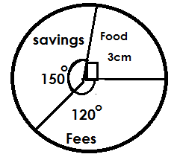

2. Mapala spent $\frac{1}{5}$ of his income on rate, $\frac{1}{3}$ on fees and saved the rest.

a) Find the fraction saved.

**Soln.**

1 - ( $\frac{1}{5}$ + $\frac{1}{3}$)

1 – ( $\frac{3+5}{15}$)

1 - $\frac{8}{15}$

$\frac{15}{15}$- $\frac{8}{15}$

$$\frac{7}{15}$$

b) If he saved sh. 28,000, how much did he spend on rent?

**Soln.**

Let the income be m.

$\frac{7}{15}$ x m = sh. 28,000

5 x $\frac{7}{5}$ =sh. 28,000 x 15

$\frac{7}{7}$ m = sh. $\frac{28,000 x 15}{7}$

m = $\frac{1}{5}$ x sh. 60,000

**=sh. 12,000**

3. of the farmers grow maize, $\frac{1}{6}$ grow rice and the rest grow beans. Find the number of farmers on the village if 48 farmers grow beans.

Soln.

Fraction of beans = 1 – ( $\frac{2}{3}$ + $\frac{1}{6}$)

= 1 - ( $\frac{4+1 }{6}$)

= 1 - $\frac{5}{6}$

= $\frac{6}{6}$- $\frac{5}{6}$

**= $\frac{1}{6}$**

Let the no. of farmers be m

$\frac{1}{6}$**x** m= 48

m = 48

6

6 x $\frac{m}{6}$**= 48 x 6**

**m = 2888 farmers**

4. Konde spent 25% of his income on food $\frac{1}{5}$ on rent and the rest on transport. If he spent shs. 44,000 on transport, how much did he spend on food?

**Soln.**

Fraction on transport =1 – (25% + $\frac{1}{5}$)

=1 – ( $\frac{25}{100}$ + $\frac{1}{5}$)

=1 – ( $\frac{1}{4}$ + $\frac{1}{5}$)

=1 – ( $\frac{1+4}{25}$)

=1 - $\frac{9}{20}$

= $\frac{20}{20}$- $\frac{9}{20}$

= $\frac{11}{20}$

Let the income be K.

$\frac{11 }{20}$ × k = sh. 44000

$\frac{11k}{20}$ = sh. 44000

20 x $\frac{11k }{20}$ = 44,000 x 20

$\frac{11k}{20}$ = sh. $\frac{44000 x 20}{11}$

K = sh. 80,000

Food = 25% of sh. 80,000

= $\frac{25}{100}$ x sh. 80,000

= 25 x sh. 800

= sh. 20,000

**Activity:**

1. Mandevo covered $\frac{1}{6}$ of the journey by his bus, $\frac{1}{4}$ by taxi and he walked 35km. how long was the whole journey?

b) Find the distance covered by bus.

c) Show the above information on a pie chart of radius 3cm.

2. Kato spent ¼ of his salary on medical $\frac{1}{3}$ on rent, $\frac{1}{6}$ on fees and the rest on food. If he spent sh. 36,000, how much did he spend on medical?

b) Show the above information on a pie chart of radius 4cm.

3. SSekato spent $\frac{1}{5}$ of his salary on food $\frac{2}{3}$ on rent and saved the rest. If he saved 40,000, calculate his income.

4. Peter read $\frac{2}{5}$ of a book on Monday, $\frac{1}{4}$ on Tuesday and the rest on Wednesday. If he read 21 papers on Wednesday, how many papers make up a book?

5. of the farmers grow maize, grow rice and the rest grow beans. Find the number of farmers on the village if 48 farmers grow beans.

6. Okello spent 40% of his income on food, ¼ on fees and the rest on medical. If he spent sh.21,000 on medical. How much was his income?

7. Kapsico spent 20% of his income on food, ¼ on fees, $\frac{1}{10}$ on rent and he saved sh. 28,000. How much was his income?

**APPLICATION ON FRACTIONS INVOLVING A REMAINDER**

**Examples**

1. Wandera spent $\frac{1}{6}$ of his income on food, $\frac{2}{5}$ of the remainder on fees and saved the rest. Find the fraction he saved.

Soln.

|  |  |  |  |
| --- | --- | --- | --- |
| **Food** | **Remainder** | **Fees** | **saved** |
| $$\frac{1}{6}$$ | 1 – $\frac{1}{6}$ $\frac{6}{6}$- $\frac{1}{6}$ $$\frac{5}{6}$$ | $\frac{2}{5}$ of $\frac{5}{6}$ $\frac{2}{8}$ x $\frac{5}{6}$ $$\frac{1}{3}$$ | $\frac{5}{6}$- $\frac{1}{3}$ $$\frac{5-2 }{6}$$ $$\frac{ 3}{ 6}$$ $$\frac{1}{2}$$ |

b) If he saved sh. 60,000, how much did he spend on food.

**Soln.**

Let his income be K.

$\frac{1}{2}$ x k = Sh. 60,000

2 x $\frac{k}{2}$ = sh. 60,000 x 2

K = sh. 120,000

**Food**

= $\frac{1}{6}$ x sh. 120,000

=sh. 20,000

1. A man spent ¼ of his income on food, $\frac{1}{3}$ of the remainder on fees and he saves the rest. If he saved sh. 80,000 more than what he spent on food, find his income.

Soln.

|  |  |  |  |
| --- | --- | --- | --- |
| Food | Rem | Fees | Saved |
| $$\frac{1}{4}$$ | 1 - $\frac{1}{4}$ $\frac{4}{4}$- $\frac{1}{4}$ $$\frac{3}{4}$$ | $\frac{1}{3}$ of rem $\frac{1}{3}$ x $\frac{1}{4}$ $$\frac{1}{4}$$ | $\frac{3}{4}$- $\frac{1}{4}$ $$\frac{3-1}{4}$$ $$\frac{2}{4}$$ $$\frac{1}{2}$$ |

Difference in fractions

= $\frac{1}{2}$- $\frac{1}{4}$

= $\frac{2-1}{4}$

= $\frac{1}{4}$

Let his income be K.

$\frac{1}{4}$ x K = sh. 80,000

$\frac{k}{4}$ = sh. 80,000

$\frac{k}{4}$ x 4 = sh. 80,000 x 4

K = sh. 320,000

b) How much did he save?

**Soln.**

Savings = ½ x sh. 320,000

**=sh. 160,000**

Matama spent $\frac{1}{5}$ of her income on Rent, 25% of the remainder on medical and she saved the rest.

1. Find the fraction saved.

|  |  |  |  |
| --- | --- | --- | --- |
| Rent | Rem | Medical | Saved |
| $$\frac{1}{5}$$ | 1 - $\frac{1}{5}$ $\frac{5}{5}$- $\frac{1}{5}$ $$\frac{4}{5}$$ | 25% of rem  25% × $\frac{4}{5}$ $\frac{25}{100}$ x $\frac{4}{5}$ $$\frac{1}{5}$$ | $\frac{4}{5}$- $\frac{1}{5}$ $$\frac{3}{5}$$ |

If she spent sh. 20,000 on medical, how much did she save?

**Soln.**

Let her income be K.

$\frac{1}{5}$ x k = sh. 20,000

$\frac{k}{5}$ = sh. 20,000

$\frac{k}{5}$ = sh. 20,000 x 5

K = sh. 100,000

Medical

= $\frac{3}{5}$ x sh. 100,000

**= sh. 60,000**

**Example IV**

Owino spent $\frac{1}{3}$ of his income on food, ¼ on fees. ¾ of the remainder on transport and he saved the rest. Find the faction saved.

Soln

|  |  |  |  |  |
| --- | --- | --- | --- | --- |
| Feed | Fees | Rem | Transport | Saved |
| $$\frac{1}{3}$$ | $$\frac{1}{4}$$ | 1 – ( $\frac{1}{3}$ + $\frac{1}{4}$)  1 – ( $\frac{4+3}{12}$)  1 - $\frac{7}{12}$ $\frac{12}{12}$- $\frac{7}{12}$ $$\frac{5}{12}$$ | $\frac{3}{4}$ of Rem $\frac{1}{4}$ x $\frac{5}{12}$ $$\frac{5}{16}$$ | $\frac{5}{12}$- $\frac{5}{16}$ $$\frac{20-15}{48}$$ $$\frac{5}{48}$$ |

1. If he saved sh. 20,000, find his income.

Soln.

Let his income be p.

$\frac{5}{48}$ x p = sh. 20,000

$\frac{5p}{48}$ = sh. 20,000

$\frac{5p}{48}$ = sh. 20,000 x 48

5p = sh. 20,000 x 48

$\frac{5p}{5}$ = $\frac{sh.20,000 ×48}{5}$

P = Sh. 192,000

**Activity:**

1. Akello covered $\frac{1}{8}$ of the journey by bus, $\frac{5}{7}$ of the remainder by a taxi and the rest by train. Find the fraction covered by train.

b) If the covered 20km by train, how long was the whole journey?

2. Opio spent $\frac{1}{3}$ of his salary on medical, $\frac{1}{4}$ of the remainder on rent and the rest on food. Find the fraction spent on fees.

b) If he spent sh. 40,000 on fees than on medical, how much is his salary?

1. Martha spent 20% of her income on food, $\frac{1}{3}$ of the remainder on fees and she saved sh. 20,000. Find her income.
2. Ssemutala spent 40% of his income on transport, $\frac{1}{4}$ of the remainder on medical and the rest on clothes. If he spent sh. 180,000 on clothes, how much did he spend on transport?

5. Pison spent $\frac{1}{3}$ of his income on food, $\frac{1}{5}$ on rent, $\frac{2}{3}$ of the remainder on fees and the rest on medical, find the fraction spent on medical.

b) If he spent sh. 35,000 on medical, how much did he spend on rent?

6. In a school, $\frac{1}{2}$ of the pupils eat meat, $\frac{1}{3}$ eat fish and $\frac{1}{4}$ of the remainder eat beans while the rest eat greens, if 30 pupils eat greens. How many pupils are in the class?

**MORE ABOUT APPLICATION OF FRACTIONS**

**EXAMPLE I**

A tank of water was ½ full, when 60 litres were added it became ¾ full. How many litres of water can the tank hold when completely full?

Soln.

Fraction added

= New - old

= $\frac{3}{4}$- $\frac{1}{2}$

= $\frac{3-2}{4}$

= $\frac{1}{4}$

Let the capacity of the tank be m

$\frac{1}{4}$ x m = 60 L

$\frac{m}{4}$ = 60 L

$\frac{m}{4}$ ×4 = 60L ×4

**M = 240 L**

b) How many litres of water were in the tank?

**Soln.**

$= \frac{1}{2}$ x 240L

**=120 L**

**Example II**

A tank was 2/3 full of water, when 200L of water were used, it became 5/12 full. Find its capacity.

**Soln.**

Fraction used

= old – New

= $\frac{2}{3}$- $\frac{2}{12}$

= $\frac{8-5}{12}$

= $\frac{3}{12}$

= ¼

Let its capacity be P.

¼ x p = 200L

$\frac{p}{4}$ = 200L

$\frac{p}{4}$ x 4 = 200L x 4

P = 800L

**Example III**

A tank was $\frac{2}{3}$ full of water, when ¼ of water in the tank was used, 2500L remained. Find the capacity of the tank.

**Soln.**

Fraction used

= $\frac{1}{4}$ x $\frac{2}{3}$

= $\frac{1}{6}$

**Remaining fraction.**

**= $\frac{2}{3}$- $\frac{1}{6}$**

**= $\frac{4-1}{6}$**

**= $\frac{3}{6}$**

**= $\frac{1}{2}$**

Let the capacity be m.

½ x m = 2500L

= $\frac{m}{2}$ =2500L

$\frac{m}{2}$ x 2 = 2500L x 2

**m = 5000 L**

**Activity:**

1. A tank was $\frac{1}{5}$ full of water, when 8L of water were added it became $\frac{1}{3}$ full.

a) How many litres of water can the tank hold when completely full of water?

b) How many litres of water were in the tank?

2. A jerry can was ¼ full of water, when 15L were added, it became 2/3 full. Find its capacity.

b) How many litres of water are in the tank?

3. A tank was $\frac{1}{3}$ full of water, when 60L were drawn, the tank became $\frac{2}{15}$ full, find its capacity.

4. A Jerry can was ½ full of water, when 10 L were used for cooking, the jerry can become $\frac{5}{14}$ full, find its capacity.

5. A petrol tank was $\frac{2}{3}$ full, when ¼ of it was used to cover a certain distance, 120 L remained. Find the capacity of the tank.

b) If a car consumes 5 litres of petrol to cover a distance of 19km, find the distance covered.

6. At a wedding party, a water tank was $\frac{3}{8}$ full, when $\frac{2}{3}$ of it was used for cooking, 40L remained, if 10L were used to prepare 15kg of rice, how many kgs of rice were cooked?

**APPLICATION OF FRACTIONS INVOLVING OTHER PARTS OF FRACTIONS**

In a class of 120 pupils, ¼ are girls and the rest are boys.

1. Find number of boys in the class.

**Soln.**

Fraction of boys= 1 – $\frac{1}{4}$

= $\frac{4}{4}$- $\frac{1}{4}$

= $\frac{3}{4}$

No of boys = $\frac{3}{4}$ x 120

**= 90 boys**

1. 2/3 of the boys and 1/5 of the girls are in yellow color. How many pupils are in yellow color

|  |  |  |  |  |
| --- | --- | --- | --- | --- |
| No. of boys | Boys in yellow | No. of girls | Girls in yellow | Total |
| ¾ x 120  90 | 2/3 x 90  60 | ¼ x 120  30 | 1/5 x 30  6 | 60  + 6  66 |

**Activity:**

1. In a school of 2000 pupils, $\frac{2}{5}$ are girls and the rest are boys, ½ of the girls and $\frac{1}{3}$ of the boys are in upper. Find the number of pupils in lower.

2. In a village of 2400 people, the ratio of female to male is 7:3, find the number of females in the village.

b) 40% of the females and 30% of the males are children, how many adults are in the village?

c) In each adult pays tax of sh. 20,000/=, how much will be collected by local council?

3. A certain country in Uganda has a population of 300,000 people, of whom. ½ are females, $\frac{3 }{5}$ of the females are girls and $\frac{2}{3}$ of the males are boys. Find the number of children in the country.

4. Out of 120 students who sat for the test, 1/3 were girls and the rest were boys.

a) How many girls took the test?

b) If 40% of the boys failed and 55% of the girls passed, how many students passed the test?

**APPLICATION OF FRACTIONS INVOLVING TAPS THAT REQUIRE TO ADD.**

**Examples**

1. Tap A takes 5min to fill a tank and tap B takes 15 min to fill the same tank. How long will it take both tapes to fill the tank it opened at the same time?

|  |  |  |
| --- | --- | --- |
| Tap A | Tap B | Both |
| 5min = 1tank  1min = $\frac{1}{5}$ tank | 15min = 1tank  1min = $\frac{1}{15}$ tank | +  tank |

tank = 1min

1 tank = (1 ÷ $\frac{4}{15}$)min

= 1 x $\frac{15}{4}$

= $\frac{15}{4}$ 3 rem 3

**= 3 $\frac{3}{4}$ minutes**

Tap X takes 9 min to fill the tank, tap Y take 12 min to fill and tap Z takes 18 min to fill the same tank. If all tapes are opened at the same time, how long will it take the tank to get filled?

|  |  |  |  |
| --- | --- | --- | --- |
| Tap X | Tap Y | Tap Z | All taps |
| 9 min = 1tank  1 min = $\frac{1 }{9}$ tank | 12 min = 1tank  1min = $\frac{1}{12}$ tank | 18 min = 1tank  1min = $\frac{1}{18}$ tank | $\frac{1}{9}$ + $\frac{1}{12}$ + $\frac{1}{18}$ $$\frac{4+3+2}{36}$$ = $\frac{9}{36}$ = $\frac{1}{4}$ tank |

¼ tank = 1 min

1 tank = (1 ÷ ¼) min

= (1 x $\frac{4}{1}$) min

= 4 min

b) 15 litres of water are filled in the tank in every 20 seconds, how many litres of water can the tank hold when completely full?

1 min = 60 sec

4 min = (4 x 60) sec

= 240 sec

20 sec = 15L

1 sec = $\frac{15}{20}$ L

240 sec = $\frac{15}{20}$ x 240L

=180 litres

1. If the tank was ¾ full of water, how long did the taps take to fill the tank.

Fraction to be filled. =1 - $\frac{3}{4}$

= $\frac{4}{4}$- $\frac{3}{4}$

= $\frac{1}{4}$

No. of min

= ( $\frac{1}{4}$ x 4) minutes

= 1 minute

**Activity:**

1. tap A takes 24 minutes to fill the tank and tap B takes 8 min to fill the same tank. How long will it take the same tank to get filled if both taps are left open at the same time?

b) One day the tank was $\frac{1}{3}$ full, how long did the tank takes to be filled?

2. Martha takes 10 min to sweep the class, while Peter takes 15 min to sweep the same class. How long will both of them take to sweep the classroom if they started at the same time?

3. Tap A takes 8 min to fill the tank, tap B takes 6 minutes and tap C takes 24 minutes to fill the same tank. How long will it take the tank to get filled if they are opened at the same time?

b) If 16 litres of water are poured in the tank in 5 seconds, find the capacity of the tank.

4. Jane takes 12 minutes to clean the compound, Musa takes 8 minutes and Wasswa takes 24 minutes to clean the same compound, how long will they take to clean the class if they started cleaning at the same time?

**APPLICATION OF FRACTIONS ON TAPS INVOLVING SUBTRACTION.**

**Example I**

Tap F and tap A are connected on a water tank, tap F call fill the tank in 2 hours while tap A can empty the tank in 3 hours. One day the tank was $\frac{1}{5}$ full of water. How long did it take the tank to get fill if both taps were opened at the same time?

|  |  |  |
| --- | --- | --- |
| TAP F | TAP A | ALL TAPS |
| 2 hours = 1tank  1 hr = ½ tank | 3 hours = 1tank  1 hr = $\frac{1}{3}$ tank | $\frac{1}{2}$- $\frac{1}{3}$ $$\frac{3-2}{6}$$ $$\frac{1}{6}$$ |

$\frac{1}{6}$ tank = 1 hr

1 tank = (1 ÷ $\frac{1}{6}$) hours

= (1 x $\frac{6}{1}$)hr

**=6 hours**

Fraction to be filled = 1 - $\frac{1}{5}$

= $\frac{1}{6}$- $\frac{1}{5}$

= $\frac{4}{5}$

Time take = ( $\frac{4}{5}$ x 6) minutes

= $\frac{24}{5}$ 4 rem 4

= 4 $\frac{4}{5}$ hours.

**Example II**

Tap A takes 12 min to fill a tank and tap B takes 9 minutes to fill the same tank while tap C takes 18 minutes to empty the tank. How long will it take the taps to fill the tank if all were left open at the same time?

**Soln.**

|  |  |  |  |
| --- | --- | --- | --- |
| Tap A | Tap B | Tap C | ALL TAPS |
| 12 min = 1  1 min = $\frac{1}{12}$ | 9 min = 1  1 min = $\frac{1}{9}$ | 18 min = 1  1 min = $\frac{1}{18}$ | ( $\frac{1}{12}+ \frac{1}{9}$) – $\frac{1}{18}$ ( $\frac{3+3}{36}$) - 2 $$\frac{7-2}{36}$$ $$\frac{5}{36}$$ |

$\frac{5}{36}$ tank = 1 min

1 tank = (1 $\frac{5}{36}$) min.

= $\frac{1 x 36}{5}$ min

= $\frac{36}{5}$ min

= 7 $\frac{1}{5}$ minutes

**Activity**

1. Tap A takes 9 min to fill the tank and tap B takes 12 min to empty the tank one day the tank was $\frac{1}{12}$ full, how long did it take the tank to get filled with water?

2. Tap M takes 8 minutes to fill the tank and tap B draws water from the same tank in 12 minutes. How long will it take the tank to get filled with water if both taps are left open at the same time?

3. A water source has two taps. Tap B fills a jerrycan in 7 minutes and tap K empties the same jerrycan in 14 minutes. How long will it take the jerrycan to get filled which was $\frac{1}{7}$ full of water?

b) 20 litres of water were poured in the tank in 5 seconds. Find the capacity of the tank?

4. Tap A takes 12 mins to fill the tank and tap B takes 8 minutes to fill the same tank while tap C takes 24 min to draw water from the tank. How long will it take the tank to be filled if all taps left opened?

5. Tap K takes 6 min to fill the tank, and tap C takes 8 minutes to fill the same tank while tap F takes 4 minutes to empty the same tank. How long will it take to fill the tank if all taps are left open?

**APPLICATION OF FRACTIONS ON TAPS THAT INVOLVES UNKNOWNS**

Tap A takes K minutes to fill the tank and tap B takes 12 minutes to fill the same tank if both taps are left open, they take 4 minutes to fill the tank. Find the value of K.

**Soln.**

|  |  |  |
| --- | --- | --- |
| Tap A | Tap B | Both taps |
| K min = 1tank  1 min = $\frac{1}{k}$ tank | 12 min = 1tank  1 min = ½ tank | 4 min = 1tank  1 min = ¼ tank |

+ =

+ – = -

=

=

=

**1 x k = 1 x 6**

**k = 6 min**

**Example II**

Tap F takes y minutes to fill the tank and tap E takes 3 minutes to empty the same tank. If both taps are left open, they take 6 minutes to fill the tank. Find the value of F.

**Soln.**

|  |  |  |
| --- | --- | --- |
| Tap F | Tap K | Both |
| Y min = 1tank  1 min = $\frac{1}{y}$ tank | 3 min = 1tank  1min = $\frac{1}{3}$ tank | 6 min = 1tank  1 min = $\frac{1}{6}$ tank |

- =

– + = +

=

=

=

**1 x y = 1 x 2**

**Y = 2 minutes**

**Activity:**

1. Tap A takes 10 minutes to fill a tank and tap B takes **Y** min to fill the same tank. If both taps are left open, it takes 6 minutes for the tank to get filled. Find the value of y.

1. Tap A takes **X** minutes to fill a tank and tap B takes 6 minutes to fill the same tank. If both taps are left open at the same time, it takes 2 minutes for the tank to get filled. Find the value of x.
2. Tap Q fill a tank in 8 minutes and tap W takes **k** minutes to empty Tank. If both taps are left open, they take 24 minutes to fill the tank. Find the value of K.
3. It takes **y** minutes for the tank to be filled by tap A and tap B takes 8 minutes to empty the same tank. If both taps take 24 minutes to fill the tank find the value of **y**.

**PROPORTIONS**

**Note:**

1. Proportion is the way of comparing two different things in terms of quantity.

2. Proportions is divided into three; -

* Direct proportion
* Indirect proportion
* Constant proportion

**DIRECT PROPORTIONS**

**Note:**

* In direct proportions, formation of a scale is important.
* What we are looking for must be on right and what we have on left.
* The equivalence of one (1) is got by dividing what is on right by what is on left (1 - $\frac{R}{L}$)

**Examples:**

1. Three books costs sh. 1200. Find the cost of 5 such similar books.

**Soln.**

3 books = sh. 1200

1 book = ( $\frac{sh.1200}{3}$)

5 books = sh ($\frac{1200 x 5}{3}$)

**= Sh. 2,000.**

1. At a shop, 3 tomatoes cost sh. 600. How many tomatoes will one get from shs. 3000?

**Soln**.

Sh. 600 = 3 tomatoes.

Sh. 1 = ( $\frac{3}{600}$) tomatoes.

Sh. 3000 = ( $\frac{3}{600}$ x 3000) tomatoes

**= 15 tomatoes.**

1. A vehicle consumes 7 litres to cover a distance of 15 km. how many litres of petrol will it consume to cover a distance of 135km.

**Soln**.

15km = 7 litres

1 km = ( $\frac{7}{15}$) litres

135 km = ( $\frac{7}{15}$ x 135) litres.

= (7 x 9) litres.

**= 63 litres**

**Activity:**

1. Five books cost sh. 5000. Find the cost of 12 such similar books.
2. Mandela’s car consumes 4 litres of petrol every 7km. how many litres of petrol will it consume to cover a distance of 35km?
3. 6 dresses cost sh. 18,000. If Ouma had sh. 12,000, how many dresses did he get?
4. A taxi carries 14 passenger per trip. How many trips will it make to carry 392 passengers?
5. Seven shirts cost 49000. Find the cost of 3 such similar shirts.
6. 3 pencils cost sh. 2,100, how many pencils will I get if I have sh. 84,000?
7. 4 shirts cost sh. 24,000. Find the cost of 9 similar shirts.
8. James’s car consumes 6 litres of petrol to cover a distance of 20km. how many litres of petrol will be needed to cover a distance of 240 km?
9. Opio bought 4 shirts at sh. 60,000, how many shirts will James get if he moved with sh. 180,000?
10. Two pens cost sh. 2,000. Find the cost of 8 similar pens.

**EXCHANGE RATES**

An exchange rate is the value a country’s currency in another country**.**

**Example I**

1. Given exchange rates at the forex bureau.

1 dollar ($) = Ug. Sh. 3000.

1 pound ( £) = Ug. Sh. 4,000.

K sh. 1 = Ug. Sh. 25

a) A trader had 120 pounds, how much in Uganda shillings did he get at the bureau?

**Soln.**

1 pound = Ug. Sh. 4,000.

120 pounds = Ug. Sh. 4,000 x 120

= Ug. Sh. 480,000

1. Pande had Ug. Sh. 4,800,000, how many dollars did he get at the forex bureau?

**Soln.**

Ug. Sh. 3,000 = 1 dollar

Ug. Sh.1 = ( $\frac{1}{3,000}$) dollar

Ug. Sh. 4,800,000 = ( $\frac{1}{3,000}$ x 4,800,000) dollars.

= 1,600 dollars

1. Pomitar had 120 pounds. How many dollars did he get at the forex Bureau?

**Soln.**

1 pound = Ug. Sh. 4,000

120 pounds = Ug. Sh. 4,000 x 120

= Ug. Sh. 480,000

Ug. Sh. 3,000 = 1 dollar

Ug. Sh. 1 = ( $\frac{1}{3,000}$) dollars

Ug. Sh. 480,000 = $\frac{1}{3,000}$ x 480,000

**= 160 dollars**

**Example 2**

The table below shows, the buying and selling rates at quality forex bureau.

**Note:**

Given the foreign currency, use buying rate and local currency use selling rates.

|  |  |  |
| --- | --- | --- |
| **Currency** | **Buying** | **Selling** |
| K Sh. 1 | Ug. Sh. 20 | Ug. Sh. 30 |
| 1 pound | Ug. Sh. 3000 | Ug. Sh. 4,000 |
| 1 dollar | Ug. Sh. 2,000 | Ug. Sh. 2500 |

a) A trader has Ug. Sh. 120,000. How much in Kenya shillings did he get at the Bureau?

**Soln.**

Ug. Sh. 30 = K sh. 1

Ug. Sh. 1 = ( $\frac{1}{30}$)

Ug. Sh.120,000 = ( $\frac{1}{30}$ x120,000) K.sh.

**=K. sh. 4,000**

b) A trader had 600 pounds. How much in Uganda shillings did he get?

**Soln.**

1 pound = Ug. Sh. 3,000

600 pounds = Ug. Sh. (3,000 x 600)

**= Ug. Sh. 1,800,000**

c) Wandulu had 180 dollars. How much in Kenya shillings did he get at the forex bureau?

**Soln.**

1 dollar = Ug. Sh. 2,000

180 dollars = Ug. Sh. 2000 x 180

= Ug. Sh. 360,000

Ug. Sh. 30 = K sh. 1.

Ug. Sh. 1 = K sh. ( $\frac{1}{30}$)

Ug. Sh. 360,000 = $\frac{1}{30}$ x 360,000

= K sh. 12,000

**Activity:**

1. Below is a table showing exchange rate of different currencies at the forex Bureau.

1K sh. = Ug. Sh. 30

1 pound = Ug. Sh. 4500

1 dollar = Ug. Sh. 2500

1. A trader entered Uganda with 480 dollars. How much in K sh. Did he get?
2. A tourist had 46 pounds. How much in Uganda shillings did he get at the forex Bureau.

c) Kiberu had Ug. Sh. 1,350,000. How many pounds did he get at the Bureau?

2. Given the exchange rates below:

1 dollar ($) = Ug. Sh. 3000

K sh. 1 = Ug. Sh. 25

a) Pokopoko entered Uganda with 600 dollars. How much in Kenya shillings did he have?

3. At Kamukamu forex Bureau, the exchange rates are as follow: -

K sh. 1 = Ug. Sh. 25

1 dollar = Ug. Sh. 3,000

1 pound = Ug. Sh. 4,000

1. Musa entered Uganda with k sh. 2500. How much money did he get at the Forex Bureau?

b) Kasambo had Ug. Sh. 1200,000. How many dollars did he get at the forex Bureau?

c) Kintu entered Uganda with 360 pounds. How much in Kenya shillings did he get at the forex Bureau?

4. Given the exchange rates at the Forex Bureau.

1 US dollar = U. sh. 2500

1K sh. = Ug sh. 24

1. How much money in Uganda shillings will I get from the Bureau if I have 120 dollars?
2. Okello had 72,000 U.sh. how much in k sh. did he have?
3. If a trader had K sh. 12,000, how many dollars did he get from the Forex Bureau?
4. The table below shows the buying and selling rates of different currencies at kamu forex Bureau.

|  |  |  |
| --- | --- | --- |
| Currency | Buying | Selling |
| K sh. | Ug. Sh. 20 | U sh. 30 |
| US dollar ($) | Ug. Sh. 2000 | Ug. Sh. 2500 |
| R. Franc | Ug. Sh. 10 | Ug. Sh. 15 |
| Pound (£) | U sh. 400 | Ug. Sh. 4200 |
| T. Z sh. | U sh. 40 | Ug. Sh. 42 |

1. Wandela had 120 dollars. How much in Ug. Shillings did he have?

b) A trader entered Uganda with 25 pounds. How much in Uganda shillings did he get?

c) Mr. Titto had Ug. Sh. 200,000, how much in dollars did he have?

1. Soweto had Tz.sh. 180,000. How much in Kenya shillings did he get?

**INDIRECT PROPORTION (INVERSE PROPORTION)**

**Note:**

In indirect proportion, we get the equivalence of one (1) by multiplying.

**Examples**

1. 3 men can do a piece of work in 24 minutes. How long will 6 men take to do the same piece of work?

Soln.

3 men = 24 min.

1 man = (24 x 3) min

6 men = ( $\frac{24 x 3}{6}$) min

= 4 x 3 min

**= 12 minutes**

2. Six boys can slash a compound in 5 hours. How many more boys are needed to do the same piece of work in 2 hours?

**Soln.**

Min girls

5 hrs = 6 boys

1 hr = (5 x 6) boys

2 hrs = ( $\frac{5 x 6}{2}$)boys

= 15 boys

More boys = (15 – 6) boys

= 9 boys

3. 12 boys take 6 hrs to slash the compound. How many more boys are needed to slash the same compound in 2 hours?

**Soln.**

6 hours = 12 boys

1 hours = (12 x 6) boys

2 hours = ( $\frac{12 x 6}{2}$) boys

= 36 boys

More boys = (36 – 12) boys

= 24 boys

**Activity:**

1. 6 girls take 8 minis to mop the classroom. How long will 12 girls take to do the same task?

2. Two children can dig the school garden in 8 days. How many children can dig the same garden in 4 days?

3. 4 boys take 9 minutes to off load a lorry. How many more boys are needed to do the same Job in 6 minutes?

4. 7 girls take 28 minutes to wash a basket of clothes. How many more girls are needed to wash the same basket in 4 minutes?

5. 25 boys constructed a house in 8 days. How many boys are needed to do the same work in 10 days?

6. In a home, 6 potters can clean and mop the house in 4 minutes. How many more potters will be needed to finish the same work in only 2 minutes?

7. 9 men can build a wall in 14 days. How long will 7 men take to build the same wall?

8. 5 men take 6 hours to dig a trench. How many more hours would it require 3 men to complete the same piece of work?

9. There is enough food for 20 pupils which can last for 5 days. If 10 more pupils join how long will the food last?

10. Nine men can construct a house in 18 days. How many less days will 27 men take?

**PERCENTAGES**

**Note:**

* A percentage is a number after every a hundred.
* A percentage is a fraction with a denominator as 100.
* Percentage means out of hundred.
* A symbol for percent is %

**CHANGING PERCENTAGE TO COMMON FRACTION**

**Examples**

1. Change 20% to a common fraction.

**Soln.**

20% =

**=**

2. Change 12 ½% to a common fraction.

**Soln**.

12 ½% = 12 ½ ÷ 100

= $\frac{25}{2}$ ÷ $\frac{100}{1}$

= $\frac{25}{2}$ X $\frac{100}{1}$

**= $\frac{1}{8}$**

**Activity:**

1. change the following percentages to fractions.

a) 40%

b) 25%

c) 60%

d) 75%

e) 62 ½%

f) 2 ½%

g) 16 $\frac{2}{3}$%

h) 83 $\frac{1}{3}$%

i) 33 $\frac{1}{3}$%

j) 50%

**CHANGING PERCENTAGES TO DECIMALS**

**Examples**

1. Change 66% to a decimal.

Soln.

66% =

**= 0.66**

2. change 12 ½ % to a decimal.

**Soln.**

12 ½ % = 12 ½ ÷ 100

= ÷

= x

**=**

3. Change 0.6% to decimal.

**Soln.**

0.6% = ( $\frac{6}{10}$)%

= $\frac{6}{10}$ ÷ $\frac{100}{1}$

= $\frac{6}{10}$ x $\frac{1}{100}$

= $\frac{6}{100}$

= 0.006

**Activity:**

1. Change the following percentages to decimals.

a) 45%

b) 22%

c) 46%

d) 1.2%

e) 20%

f) 2 ½%

g) 1.6%

h) 15 ¼ %

**CHANGING DECIMALS TO PERCENTAGES**

**Examples**

1. Change 0.5 to percentage form.

**Soln.**

0.5 = $\frac{5}{10}$

= $\frac{5}{10}$ x 100%

= 5 x 10%

= 50%

2. Write 0.036 as a percentage.

**Soln.**

0.036 = 0.036 x 100%

= $\frac{36}{1000}$ x 100%

= $\frac{36}{10}$%

= 3.6%

**Activity:**

1. Change the following decimals to percentages.

a) 0.18

b) 0.49

c) 0.0063

d) 2.63

e) 0.036

f) 0.012

g) 0.4

h) 0.002

i) 6.2

**CHANGING FRACTIONS TO PERCENTAGES**

**Examples**

1. Change $\frac{3}{5}$ to a percentage.

**Soln.**

%age = $\frac{3}{5}$ x 100%

= 3 x 20%

**= 60%**

2. Change $\frac{1}{3}$ to percentage.

**Soln.**

%age = $\frac{1}{3}$ x 100%

=

**= 33 %**

3. Change $\frac{2 }{3}$ to a percentage.

Soln.

% = $\frac{2}{3}$ x 100%

= $\frac{200}{3}$%

= 66 $\frac{2}{3}$%

**Activity:**

**Change the following fractions to percentage.**

1. $\frac{2}{5}$

2. $\frac{3}{10}$

3. $\frac{3}{7}$

4. $\frac{4}{9}$

5. $\frac{1}{8}$

6. $\frac{4}{5}$

7. $\frac{3}{4}$

8. $\frac{1}{2}$

9. $\frac{1}{4}$

10. $\frac{9}{10}$

**EXPRESSING RATIOS AS PERCENTAGES**

**Examples**

1. Express 4:5 as a percentage.

**Soln.**

Fraction = $\frac{4}{5}$

%age = $\frac{4}{5}$ x 100%

= 4 x 20%

= 80%

2. Express $\frac{1}{10}$: $\frac{1}{7}$

**Soln.**

Fraction = $\frac{1}{10}$ ÷ $\frac{1}{7}$

= $\frac{1}{10}$ x $\frac{7}{1}$

= $\frac{7}{10}$

Percentage = $\frac{7}{10}$ x 100%

= 7 x 10%

**= 70%**

**Activity:**

Express the following ratios to percentage.

1. 2 : 5

2. 1 : 4

3. 7 : 20

4. 9 : 10

5. :

6. :

7. :

8. 5 : 7

9. 3 : 4

1. :
2. :
3. :
4. :

**FINDING PARTS OF PERCENTAGES**

**Example I**

In a village 40% of the farmers grow beans and the rest grow maize. Find the percentage of farmers who grow maize.

**Soln.**

Let the %age of farmers who grow maize be K

K + 40% = 100%

K + 40% - 40% = 100% - 40%

**K= 60%**

**Example II**

In a class, there 20% more girls than boys. Find the percentage of boys.

Let % of boys be P.

|  |  |  |
| --- | --- | --- |
| Boys | Girls | Total |
| P | P + 20% | 100% |

P + P + 20% = 100%

2p + 20% = 100%

2p + 20% - 20% = 100% - 20%

2p = 80%

$\frac{2p}{2p}$ = $\frac{80}{2}$%

P = 40%

**Activity:**

1. In a basket, there are 3% more oranges than mangoes. Find the percentage of mangoes in the basket.

b) Find the percentage of oranges in the basket.

2. There are 10% more men than women in a meeting.

i) What is the percentage of women?

ii) Find the percentage of men in the meeting.

3. A family spent 40% more on school fees than on clothing. Find the percentage spent on clothing.

4. There are 10% more boys than girls in the class, find the percentage of boys in the class.

5. A child read 25% of a book on Monday, 38% on Tuesday and 16% on Wednesday. What percentage is left to be read.

6. 30% of the vehicles in town are white, 35% are red cars and the rest are black. What percentage of the cars are black?

7. The pie chart below shows how a man divided his land among his 4 children.

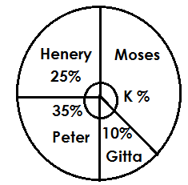

a) What percentage of the land was given to Moses.

b) Find the fraction of the land that was given to Henry.

**EXPRESSING QUANTITIES AS PERCENTAGES**

**Example I**

In a class of 40% pupils, 30 are girls and the rest are boys.

a) Find the percentage of boys in the class.

**Soln.**

No. of boys = 40 – 30

= 10 boys

%age of boys = $\frac{10}{40}$ x 100%

= 25%

b) Find the percentage of girls.

**Soln.**

%age of girls = $\frac{30}{40}$ x 100%

= 3 x 25%

**= 75%**

**Example II**

In a class, there are 7 desks, 8 pens and 10 books. Find the percentage of each item in the class.

Soln.

Total = 10 + 8 + 7 = 25

Desks = $\frac{7}{25}$ x 100%

**= 28%**

Pens = $\frac{8}{25}$ x 100%

**= 32%**

Books = $\frac{10}{25}$ x 100

**= 40%**

**Activity:**

1. A man gave out sh. 5,000 to the three families A, B and C as follows: -

A = sh. 1500

B = sh. 2000 and the rest to C

a) Find the percentage of money that was given to C.

b) What percentage was given to B.

2. A bag contains 15 pens which are blue, 10 red pens and 25 black pens. Find the percentage of each type of pens in the bag.

3. In a class of 25 pupils, 20 are girls. Find the percentage of boys.

b) Find the percentage of girls.

4. In a class of 80 pupils, 60 passed the exams. What percentage of the class failed exams?

b) Find the percentage of pupils who passed exams.

5. Juma scored the following marks in 4 tests, $\frac{9}{10}$ in the first test, $\frac{25}{50}$ in the second test, $\frac{64}{80}$ in the third test and $\frac{18}{25}$ in the fourth test. What percentage did he get in each test?

**Expressing quantities as percentages of other quantities.**

**Note:**

The quantity that comes after the word “of” is the denominator.

**Example I**

Express 20 as a percentage of 80.

**Soln**.

As a %age = $\frac{20}{80}$ x 100%

**= 25%**

**Example II**

What percentage of 400cm is 200cm?

**Soln.**

%age = $\frac{200}{400}$ cm x 100%

**= 50%**

**Example III**

Express 30cm as a percentage of 2m.

**Soln**.

1 m = 100cm

2m = (2 x 100) cm

= 200 cm

As a %age = $\frac{30cm }{200cm}$ x 100%

**= 15%**

**Activity:**

1. Express 3 as a percentage of 4.

2. What percentage of 20 is 4?

3. Express 36 books as a percentage of a gross.

4. What percentage of 2m is 40 cm?

5. Express 200g as a percentage of 2kg.

6. Express 250g as a percentage of 1kg.

7. Express 30 cm as a percentage of 2m.

8. What percentage of a score is 5.

9. What percentage of 10 weeks is 14 days?

10. Express 10 dm as a percentage of 25dm

**SHARING QUANTITIES USING PERCENTAGES**

**Example I**

Find 40% of 150.

**Soln.**

= 40% x 150

= $\frac{40}{100}$ x 150

**= 60**

**Example II**

What is 50% of 3 dozen of books?

**Soln.**

1 dozen = 12 books

3 dozen = (12 x 3) books

= 36 books

As %age = 50% x 36

= $\frac{50}{100}$ x 36 books

**= 18 books**

**Example III**

In a village of 800 people 40% are females and the rest are males.

a) Find the number of males in the village.

**Soln.**

Let the %age of males be K

K + 40% = 100%

K + 40% - 40% = 100 – 40%

**K = 60%**

No of males = 60% x 800

= $\frac{60}{100}$ x 800

**= 480**

1. How many more males than females are in the village?

**Soln.**

|  |  |  |
| --- | --- | --- |
| Male | Female | More |
| 60% | 40% | 60% - 40%  20% |

More males = 20% x 800

= $\frac{20}{100}$ X 800

**= 160 males**

**Example IV**

In a class there are 10% more girls than boys. If there are 600 pupils, find the number of girls in a class.

**Soln**.

Let %age of boys be M.

|  |  |  |
| --- | --- | --- |
| Boys | Girls | Total |
| M | M + 10% | 100% |

M + m + 10% = 100%

2m + 10% = 100%

2m + 10% - 10% = 100% - 10%

2m = 90%

$\frac{2m}{2}$ = $\frac{90\%}{2}$

M = 45%

%age of girls = m + 10%

= 45% + 10%

**= 55%**

No. of girls = 55% x 600

= $\frac{55}{100}$ x 600

**= 330 girls**

**Activity:**

1. What is 25% of 200 books?

2. In a class of 80 pupils, 20% are girls and the rest are boys. Find the number of girls in a class.

b) Find the number of boys in a class.

3. The pie – chart below shows how villages shared sh. 2,000,000 donated by president.

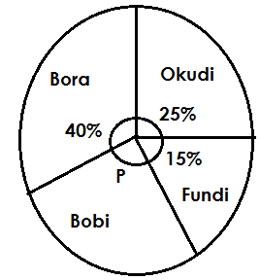

a) How much money was given to bobi?

b) How much more money was given to Bora than Okudi?

c) Express the amount of money given to fundi as a fraction.

4. In a class of 120 pupils, there are 30% more girls than boys.

a) How many boys are in the class.

b) Find the number of girls in the class.

5. In a club of 600 customers, there are 20% more men than women, how many women are in the club?

b) Find the number of men in the club.

1. Find 15% of 4dm.
2. What is 80% of 3 dozen of books?
3. Find 25% of 2 hours.

9. What is 50% of 1kg.

**FINDING QUANTITIES SHARED USING PERCENTAGES**

**Example I**

30% of a number is 12. Find the number.

**Soln.**

Let the number be K.

30% x K = 12

$\frac{30}{100}$ x K = 12

$\frac{30}{100}$ K = 12

$\frac{30}{100}$ x 100 = 12 x 100

$\frac{30}{30}$ K = $\frac{12 x 100}{30}$

**K= 40**

**Example II**

In a class, 40% are girls and the rest are boys. If there are 12 boys, find the number of pupils in the class.

**Soln.**

Let the %age of boys be K.

K + 40% = 100%

K + 40% - 40% = 100% - 40%

K = 60%

Let the number of pupils be m.

60% x m = 12

$\frac{60}{100}$ x m = 12

$\frac{60 m}{100}$ = 12

$\frac{60 m}{100}$ x 100 = 12 x 100

60m = $\frac{12 x 100}{60}$

**M = 20 pupils**

**Example III**

In a bag of 10% of the pens are blue and the rest are green. If there are 8 more green pens than blue pens. How many pens are in the bag?

**Soln.**

Let the %age of green pens be y.

Y + 10% = 100%

Y + 10% - 10% = 100% - 10%

**Y = 90%**

|  |  |  |
| --- | --- | --- |
| Green | Blue | More |
| 90% | 10% | 90% - 10% = 80% |

Let no of pens in the bag be m.

80% x m = 8

$\frac{80}{100}$ x m = 8

$\frac{80 m}{100}$ = 8

$\frac{80 m}{100}$ x 100 = 8 x 100

80m = 8 x 100

$\frac{80 m}{80}$**= $\frac{8 x 100}{80}$**

**M = 10 pens.**

**Activity:**

1. 30% of a number is 12, find the number.

2. In a village, 20% of the farmers grow maize and the rest grow beans. If 16 farmers grow bean, how many farmers are in the village?

b) How many farmers grow maize?

1. In a bus 40% are children and the rest are adults. If there are 24 adults, how many children are in the bus?

4. In a class, 30% are boys and the rest are girls. If there are 20 more girls than boys, how many boys are in the class?

b) Find the number of girls in the class.

1. In a class, there are 20% more boys than girls. If there are 24 boys, how many girls are in the class?

6. In a bus there are 40% more adults than children. If there are 12 children, how many adults are in the bus?

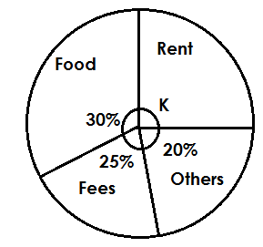7. The pie chart below shows Mukasa’s monthly expenditure.

If he spends shs. 20,000 on food more than rent. How much does he spend on others?

8. The pie chart below shows Mr. Kalungi’s monthly expenditure.

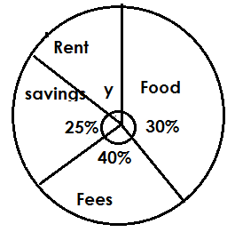

a) If he spends shs. 180,000 on fees and rent, how much does he spend on food?

1. After spending 30% on food, Wamboka saved sh. 28,000. How much did he spend on food?

10. After covering 40% of the journey, a vehicle got a puncture and he remained with 30km. What distance had he covered?

**INCREASING AND DECREASING QUANTITIES USING PERCENTAGES**

**Example I**

Increase 60 oranges by 20%

**Soln.**

(100% + 20%) x 60 oranges

120% x 60

$\frac{120}{100}$ x 60

**72 oranges**

**Example II**

Increase 40 by 12 ½%

**Soln.**

(100% + 12½) x 40

$\frac{200 +25\%}{2}$ x 40

( $\frac{100}{1}$ + $\frac{25}{2}$)% x 40

$\frac{225\%}{2}$ x 40

( $\frac{225}{2}$ ÷ $\frac{100}{1}$) x 40

= $\frac{225}{2}$ x $\frac{1}{100}$ x 40

**= 45**

**Example III**

Decrease 84 by 10%

**Soln.**

= (100% - 10%) x 84

= 90% x 84

$=\frac{90}{100}$ x 84

= $\frac{75}{10}$%

**= 75.6**

**Example II**

Decrease 300 by 33 $\frac{1}{3}$%

**Soln.**

(100% - 33 $\frac{1}{3}$%) x 300

( $\frac{100}{1}$- $\frac{100}{3}$) % x 300

$\frac{300-100 \%}{3}$ x 300

( $\frac{200}{3}\frac{100}{1}$) x 300

$\frac{200}{3}$ x $\frac{1}{100}$ x 300

**= 200**

**Activity:**

1. Increase 96 by 10%

2. Increase sh. 4000 by 60%

3. A school had 1200 pupils last year. Due to the good performance, the number increase by 15% find the new number of pupils in the school.

4. Increase 1200 by 22 ½%

5. Decrease 240 by 20%

6. A father gave his son sh. 4000 as pocket money. After one month at school, the pocket money had reduced by 12 ½. How much money did the boy remain with after that period?

7. Decrease sh. 14,000 by 5 ½%

8. The number of animals on a farm increased from 700 by 30%. Find the new number of animals on the farm.

9. Decrease sh. 24,000 by 66 %

10. Otieno bought a plot of land at sh. 1,500,000. After one year he increased the cost price by 2 $\frac{2}{3}$% when he was selling it to Ojame. At how much did Ojame pay for the plot of land?

**MULTIPLE INCREASE AND DECREASE OF QUANTITIES USING PERCENTAGES**

**Examples**

1. increase 600 by 10% and then by 20%

**Soln**.

First %ageincrease = 100% + 10%

= 110%

Second %age increase = (100% + 20%)

= 120%

Final no. = 110% x 120% x 600

= $\frac{110}{100}$ x $\frac{126}{100}$ x 600

= 11 x 12 x 6

= 792

2. Decrease sh. 1200 by 10% then by 30%

**Soln.**

First % decrease = (100% - 10%)

**= 90%**

Second % decrease = 100% - 30%

= 70%

Final no. = sh. 1200 x $\frac{90}{100}$ x $\frac{70}{100}$

= sh. 12 x 9 x7

**= sh. 756**

3. Increase 600 by 40% and then decrease it by 10%

**Soln.**

Increase = (100% + 40%) x 800

= 140% x 800

= $\frac{140}{100}$ x 800

= 1120

Decrease = (100% - 10%) x 1120

= 90% x 1120

= $\frac{90}{100}$ x 1120

= 9 x 112

**= 1008**

1. The number of pupils in a school decreased by 20% from 1200, this year they had a good performance and the number increased by 10%. What is the new number of pupils?

**Soln.**

Decrease = (100% - 20%) x 1200

= 80% x 1200

= $\frac{80}{100}$ x 1200

= 80 x 12

= 960

Increase = (100% + 10%) x 960

= 110% x 960

= $\frac{110}{100}$ x 960

= 11 x 96

**= 1056 pupils**

**Activity:**

1.Increase 12000 by 20% then by 30%.

2.Increase 480 girls by 20% and then by 25%.

3.Decrease sh. 9000 by 40% and then by 10%

4.The number of pupils decreased by 20% for the first year and then by 15% forthe second year. How many pupils are in the school if they were 1600?

5.Decrease sh. 70,000 by 70% and then by 30%

6.Decrease 8400 by 10% then by 10%

7.Peter’s salary of sh. 400,000 was increased by 20% and later decreased by 10%. Find his new salary.

8.Askari’s salary was increased from sh. 120,000 by 20% due to the poor performance during the duty, his salary was later reduced by 30%. Find his new salary.

9.Increase sh. 20,000 by 20% then decrease it by 80%

10.Jane’s salary was increased by 40% from sh. 40,000 and later decreased by 60%. Find her new salary.

**FINDING THE ORIGINAL NUMBER THAT WAS INCREASED OR DECREASED USING PERCENTAGES.**

**Examples**

1.Which number was increased by 20% to become 36

**Soln.**

Let the number be K.

(100% + 20%) x k = 36

120% x K = 36

$\frac{120}{100}$ x k = 36

$\frac{120 }{100}$ k = 36

100 x $\frac{120}{100}$ k = 36 x 100

k =

K = 30

2. After increasing a number by 5 ½% it became 422. Find the number.

**Soln**.

Let the number be n

100% + 5½ % x n = 422

(100% + $\frac{11}{2}$)% x n = 422

( $\frac{200+11}{2}$)% x n = 422

( $\frac{211}{2}$ ÷ $\frac{100}{1}$) x n = 422

$\frac{211 n}{200}$ = 422

$\frac{211 n}{200}$ x 200 = 422 x 200

n =

**n = 400**

3. Find the number which was decreased by 20% to become 48.

**Soln.**

Let the no be k.

(100% - 20%) of n = 48

80% x n = 48

100 x $\frac{80}{100}$ n = 48 x 100

=

**n = 60**

4. After decreasing Othieno’s salary by 20% he now earns sh. 240,000. How much was his original salary?

**Soln.**

Let his original salary be m.

(100% - 20%) x m = sh. 240,000

80% x m = sh. 240,000

100 x $\frac{80}{100}$ m = sh. 240,000 x 100

$\frac{80}{80}$ m = sh. $\frac{240,000 x 100}{80}$

m = 300,000

b) How much would be his salary if it was increased by 30%

**soln**.

=(100% + 30%) x sh. 300,000

=130% x sh. 300,000

= $\frac{130}{100}$ x sh. 300,000

**= sh. 390,000**

**Activity:**

1. Which number was increased by 40% to become 42?

2. Find the number that was increased by 12 ½% to become 45.

3. Find the number that was increased by 20% and then by 10% to become 528.

4. Which number was decreased by 30% to become 63.

5. After decreasing a number by 12 ½%, it became 35. Find the number.

6. After increasing a number by 12 ½% it becomes sh. 81,000. Find the number.

7. What number when increased by 66 $\frac{2}{3}$% becomes 400?

8. If a man’s salary is decreased by 35% it becomes sh. 15,000. What could be his salary if it increased by 40%.

9. Matama bought a radio at a certain amount of money and later sold it to Ogwal after increasing the cost price by 20%. After one year, Ogwal decreased the price by 30% after selling it to Owino who paid sh. 67200. At how much did Matama buy the radio.

**FINDING PERCENTAGE INCREASE AND DECREASE**

**Note:**

Percentage increase = $\frac{increase x 100\%}{original}$

Increase = new – old

Decrease = old – new

Percentage decrease = $\frac{decrease x 100\%}{oroginal}$

**Examples**

1. The number of animals on a farm increased from 50 to 80. By what percentage was the increase.

**Soln.**

% increase = $\frac{increase x 100\%}{original}$

Increase = New – old

= 80 – 50

= 30

%age increase = $\frac{30}{50}$ x 100%

= 3 x 20%

= 60%

1. The number of pupils in class decreased from 800 to 600. Find the percentage decrease.

**Soln.**

Decrease = original – New

= 800 – 600

= 200

Percentage decrease = $\frac{decrease}{original }$ x 100%

= $\frac{200}{860}$ x 100%

= 25%

1. The number of animals on a farm decreased from 200 by 60. Find the percentage decrease.

**Soln.**

Percentage decrease = $\frac{decrease}{original}$ x 100

= $\frac{60}{200}$ x 100%

**= 30%**

**Activity:**

1. Kambe’s salary was increased from sh. 100,000 by sh. 20,000. Calculate the percentage increase in his salary.
2. The number of books in the library increased to 500 books by 100 books. Find the percentage increase in the number of books.
3. A father raised a boy’s pocket money from sh. 8000 to sh. 10,000. At what percentage was the boy’s pocket money raised.
4. When 200 birds are decreased, they become 150 birds. Calculate the percentage decrease.
5. The number of Malaria patients decreased from 50 by 10. Find the percentage in the patients.
6. When 200 birds are decreased, they become 150 birds. Calculate the percentage decrease.
7. Mandela’s salary was increased from sh. 20,000 to sh. 29,000. What was his percentage increase?
8. A school collected 7.5 million last year. This year the collection dropped by 2.5 million. Find the percentage decrease.
9. On a farm of 400 animals, there was an outbreak and the number decreased to 350. By what percentage did the number decrease?

**PROFITS AND PERCENTAGE PROFIT**

**Definitions**

1. Profit is the extra amount of money added to the cost price of an item by a trader.

2. Profit is the extra money got after selling an item as compared to the buying price.

3. Profit is the same as increase, gain and raise.

4. Market price is the original /usual price of an item.

**Note:**

Profit = selling price – buying price (cost price)

Profit = SP – BP

**WHERE;**

SP = selling price

BP = buying price / cost price.

Percentage profit = $\frac{profit}{buying price}$ x 100%

**Examples**

1. A trader bought a radio at sh. 80,000 and later sold it at sh. 100,000. Calculate his percentage profit.

**Soln.**

Buying price (BP) = sh. 80,000

Selling price (SP) = sh. 100,000

Profit = SP – BP

= sh. 100,000

= sh.80,000

**= sh. 20,000**

Percentage profit = $\frac{profit }{buying price}$ x 100%

= sh. $\frac{20,000}{80,000}$ x 100%

**= 25%**

1. After selling a shirt at sh. 12,000, a trader realized a profit of sh. 2,000. Calculate his percentage profit.

**Soln**.

Profit = sh. 2000

Buying = selling price – profit

= sh. 12000 – sh. 2,000

= sh. 10,000

Percentage profit = $\frac{profit }{buying price}$ x 100%

= $\frac{sh.2000}{sh.10,000}$ x 100%

**= 20%**

1. A man bought a watch at sh. 20,000 and later sold it at a profit of sh. 5,000. Calculate his percentage profit.

**Soln**.

Profit = sh. 5,000

Buying price = sh. 20,000

% profit = $\frac{profit}{Buying price}$ x 100%

= $\frac{sh.5,000 x 100\%}{sh.20,000}$

**= 25%**

**Activity:**

1. a trader bought a dress at sh. 4,000 and later sold it at a profit of sh. 1,000. Calculate his percentage profit.
2. Wambi bought a plot of land at sh. 8,000,000 and later sold it as sh. 11,000,000. Find his percentage profit.
3. A boy bought a shirt at sh. 40,000 and sold it at sh. 50,000. Find his profit percent.
4. Okello bought a radio at sh. 100,000 and later sold it to Opio at sh. 120,000. Find his percentage profit.
5. A trader bought an item of sh. 7,500 and sold it at sh. 15,000. Find his percentage profit.
6. A woman bought 2 trays of eggs at sh. 15,000. She sold each egg at sh. 300. Calculate her percentage profit.
7. A trader bought a dress of sh. 1,600 and sold it at sh. 2,000. Find her profit percent.
8. The cost of a book is sh. 200. If a shopkeeper sold it at sh. 250, what was the percentage gain?
9. Matia sold his cow for sh. 47,700. If the cost of the cow was sh. 45,000. Find his percentage profit.

10. A trader bought a gross of books for sh. 36,000. He sold each book for sh. 500. Find the percentage profit made.

**LOSS AND PERCENTAGE LOSS**

* Loss is the less amount of money got compared to the cost price of an item.
* It is the same as decrease, deduction and sometimes discount in terms of calculation.

**Note:**

Loss = buying price – selling price

**Where**

BP = buying price

SP= selling price

Percentage loss = $\frac{loss }{buying price }$ x 100%

**Examples**

1. After selling a dress at sh. 80,000. Wandera realized a loss of sh. 20,000. What was the percentage loss?

**Soln**.

SP = sh. 80,000 BP=SP + Loss

Loss = sh. 20,000 =sh. 80,000 + sh. 20,000

Loss% = $\frac{loss}{B.P}$ X 100% =sh. 100,000

= $\frac{sh.20,000}{sh.100,000}$ x 100%

**= 20%**

2. A trader bought a watch at sh. 25,000 and later sold it at sh. 20,000. Calculate his percentage loss.

soln.

loss = B.P – S.P

= sh. 25,000

- sh. 20,000

**= Sh. 5,000**

%ageloss = $\frac{loss}{B.P}$ x 100%

= $\frac{sh.5000}{sh. 25,000}$ x 100%

**= 20%**

3. Kayima bought a pair of shoes at sh. 20,000 and sold it at a loss of sh. 5,000. Find his loss percent.

Soln.

Loss = sh. 5,000

Buying price = sh. 20,000

Loss % = $\frac{loss}{B.P}$ x 100%

= $\frac{sh.5,000}{sh.20,000}$ x 100%

**= 25%**

**Activity:**

1. A school girl bought a pen at sh. 1000 and sold it at a loss of sh. 500. Find her percentage loss.
2. Kampyo bought a radio at sh. 15,000 and later sold it at sh. 12,000. Calculate his percentage loss.
3. Nagitta bought a pair of shoes at sh. 20,000 and sold it at a loss of sh. 4,000. Calculate her percentage loss.
4. After selling a watch at sh. 4,000, a trader realized a loss of sh. 1,000. Find his percentage loss.
5. A man bought 6 pots at sh. 9,000. Some 2 pots got broken and sold the remaining pots at sh. 2,000 each pot. Find his percentage loss.
6. The cost of 1 litre of milk is sh. 500. Aisha sold it at sh. 450. Calculate the percentage loss.
7. Kapere bought a motorcycle at sh. 600,000. After one year he sold it at sh. 480,000. Find his percentage loss.
8. After selling a set of chairs for sh. 150,000, a trader made a loss of sh. 30,000. Calculate the percentage loss.
9. A loss on a shirt which was sold at sh. 50,000 was sh. 6,000. Calculate the percentage loss.

**FINDING SELLING PRICE GIVEN PERCENTAGE PROFIT OR PERCENTAGE LOSS**

**Example I**

Opio bought a radio at sh. 20,000 and later sold it at a profit of 30%. How much was his selling price?

(100% + 30%) X Sh. 20,000

130% X sh. 20,000

$\frac{130\%}{100}$ x sh. 20,000

**Sh. 26,000**

**Example II**

A trader bought a shirt at sh. 40,000 after selling it, he realized a percentage loss of 10%. How much money did he sell it?

Soln.

(100% - 10%) x sh. 40,000

90% x sh. 40,000

$\frac{90}{100}$ x sh. 40,000

**Sh. 36,000**

**Example III**

Tom bought a TV at sh. 100,000, he later sold it to Patunda at a profit of 15%. After one year, Patunda sold it to Okum at a loss of 10%.

1. At how much did Patunda pay for the TV?

**Soln**.

(100% + 15%) x sh. 100,000

115% x sh. 100,000

$\frac{115}{100}$ x sh. 100,000

**= sh. 115000**

b) Find amount at which Okum bought the TV.

**Soln.**

(100% - 10%) x sh. 115,000

90% x sh. 115000

$\frac{90}{100}$ x sh. 115000

**=Sh. 103,500**

**Activity:**

1. A man bought a shirt at sh. 12,000, he later sold it at a profit of 20%. Find his selling price.

2. Wandera bought a plot of land at sh. 4,000,000. After he sold it to Wako at a profit of 10%. At how much did Wako pay for the plot of land?

3. A trader bought a car at sh. 800,000. He later sold it at a loss of 30%. At how much did he sell the car?

4. Martha bought a dress at sh. 20,000. She sold it to Jane at a profit of 10% after 1-month Jane also sold it to Fatuma at a loss of 20%.

a) At how much did Jane pay for the dress?

b) Find the amount at which Jane sold the dress.

5. A tomato seller bought 60 tomatoes at sh. 12,000. At what price must she sell each tomato in order to get a profit of 30%.

6. Junju bought a plot of land at sh. 500,000 and be sold it to Mugabe at a profit of 20%. If Mugabe later sold it to Agaba at a loss of 20%. Calculate Agaba’s buying price.

**FINDING COST PRICE GIVEN PERCENTAGE LOSS OR PERCENTAGE PROFIT**

**Example I**

After selling a shirt at sh. 26,000, a trader realized a profit of 30%. At how much did he buy the shirt.

**Soln.**

(100% + 30%) x CP = sh. 26,000

130% x CP = sh. 26,000

$\frac{130}{100}$ x CP = sh. 26,000

$\frac{130CP}{100}$ = sh. 26,000

$\frac{130}{100}$ CP = sh. 26,000 x 100

$\frac{130 CP}{100}$ X100 = sh. $\frac{26,000}{130}$ x 100

**CP = sh. 20,000**

**Example II**

James sold a cow at sh. 630,000 making a loss of 30%. How much would he have sold it in order to gain a profit of 10%

**Soln.**

Let cost price be cp

(100% - 30%) X CP = sh. 630,000

70% x CP = sh. 630,000

$\frac{70}{100}$ x CP = sh. 630,000

$\frac{70}{100}$ CP = sh. 630,000

$\frac{70PC}{100}$ x 100 = sh. 630,000 x 100

70CP = sh. 630,000 x 100

$\frac{70CP}{70}$ = sh. $\frac{630, 000}{70}$ x 100

**CP = sh. 900,000**

= (100% + 10% ) x sh. 900,000

= 110% x sh. 900,000

= $\frac{110}{100}$ x sh. 900,000

**SP = 990,000**

**Activity**

1. After selling a dress at sh. 48,000, Matama realized a profit of 20%. At how much did she buy the dress?
2. Mega sold his radio to Aguti at sh. 54,000 making a loss of 10%. Aguti later sold it to Othieno at a profit of 15%.

a) Calculate the amount of money Mega paid for the radio.

b) At how much did Aguti sell the radio?

1. After selling a chair at sh. 89,000, a carpenter realized a profit of 30%. What was his cost price?
2. Kadaga sold a bag at sh. 64,000 to Jane making a profit of 60%. Jane later sold it to Kawuma at a loss of 20%

a) At how much did Kadaga buy the bag?

b) Find the amount at which Kawuma paid for the bag?

1. Othieno sold a shirt at sh. 36,000 realizing a loss of 10%. At how much did he buy it.

6. A man sold his car at sh. 3,000,000, realizing a loss of 40%. At how much would he have sold it in order to realize a profit of 20%.

**Discount and percentage discount**

* Discount is theamount of money reduced from the usual price of an item.
* Discount is the amount of money that is taken off from the cost price of an item.

Discount=cost price – cash paid

= Market price – cash paid

Percentage discount = $\frac{Discount}{Cost price}$ x 100%

**Example 1**

A man bought a shirt that was marked sh. 40,000 at a discount of 20%. How much was the discount?

Soln.

Discount = 20% x sh. 40,000

= $\frac{20}{100}$ x sh. 40,000

= sh. 8,000

1. How much did he pay?

**Soln**.

Amount paid = (100% - 20%) x sh. 40,000

= 80% x sh. 40,000

= $\frac{80 }{100}$ x sh. 40,000

= sh. 32,000

Martine bought a radio that was marked sh. 50,000 at a discount of sh. 6,000. Calculate his percentage discount.

**Soln.**

%age discount = $\frac{discount}{cash price}$ x 100%

= sh. $\frac{6,000}{50,000}$ x 100%

**= 12%**

b) How much did he pay?

**Soln.**

Amount paid = sh. 80,000

= sh. 6,000

**= sh. 44,000**

**Example III**

Nakita went to the market and bought the following items.

* 2kg of sugar at sh. 2,500 per kg.
* 1 ½ kg of rice at sh. 2000 a kg.
* 3 bars of soap at sh. 6,000
* 500g of meat at 10,000 a kg.

1. If she was given a discount of 10%, how much did she pay?

**Soln.**

|  |  |  |  |
| --- | --- | --- | --- |
| Sugar | Rice | Soap | Meat |
| Sh. 2500  X 2  **Sh. 5,000** | Sh. 2000 x 1 ½  Sh. 2,000 x $\frac{2}{3}$ Sh. 3,000 | Sh. 6000 | $\frac{500}{1000}$ x 10000  Sh. 5,000 |

**Total**

Sh. 5,000

Sh. 3,000

Sh. 6,000

Sh. 5,000

**Sh. 19,000**

Amount paid

(100% - 10%) x sh. 19,000

90% x sh. 19,000

$\frac{90}{100}$ x sh. 19000

90 x sh. 190

**Sh.17100**

**Activity:**

1. Okot went to the market and bought a radio marked sh. 40,000. If he was offered a discount of 5%. How much did he pay?
2. Kanda went to the market and bought 2kg of sugar at sh. 4000 each kg. how much was the discount if it was 10%?
3. The marked price of a dress is sh. 25,000 after a discount a customer paid sh. 20,000. How much was the discount?

4. A man bought shoes which were marked sh. 80,000 at a discount of 40%.

a) How much was the discount?

b) How much did he pay?

1. Kalinago paid sh. 36,000 for a shirt. If he was given a discount of 20%, how much was the cost price?

6. Wasswa went to the market and bought the following items.

* 3kg of beans at sh. 2,000 per kg.
* 2 ½ kg of posho at sh. 1,800 a kg.
* 2 litres of cooking oil at sh. 4,000
* 250gm of salt at sh. 2,000 a kg.

1. If he went with sh. 20,000 and he was offered a discount of 20%, how much was his change?

7. Keith went to the market and bought the following items: -

* 2kg of rice at sh. 4,000 a kg.
* 1 ½ kg of beans at sh. 2,000 a kg.
* 500 ml of cooking oil at sh. 4,000 a litre.
* 12 tomatoes at sh. 500 per heap of 3 tomatoes.

If he was given a discount of 10%, how much did he pay?

**SIMPLE INTEREST**

**Definitions**

**Principles (P)**

This is the amount of money borrowed or lent or deposited in a bank.

**Rate (R)**

Rate is the percentage used to calculate interest.

**Time (T)**

Time is the period in years, months or week in which the money is kept, invested or used.

**Simple interest (I)**

Simple interest is the extra /additional amount of money offered or paid back.

**Amount (A)**

Amount = principle + interest.

**CALCULATING SIMPLE INTEREST AND AMOUNT**

**Note:**

Simple interest = principle x rate x time

SI = P x T x R

**Examples**

1. Othieno deposited sh. 20,000 in a bank at 20% per year for 2 years. Find the simple interest.

**Soln.**

P = sh. 20,000

T = 2yrs

R = 20%

I = P x T x R

= sh. 20,000 x 2 x $\frac{20}{100}$

= sh. 2,000 x 2 x 2

**= sh. 8,000**

2. Calculate the simple interest on sh. 24,000 at a rate of 15% per year for 8 months.

**Soln.**

P = sh. 24,000

R = 15% per year

T = 8 months

I = P x T x R

= sh. 24,000 x $\frac{8}{2}$ x $\frac{15}{100}$

= sh. 120 x 8 x 15

**= sh. 14,400**

**Note:**

* When rate is given as per year and time is in months, express the months as a fraction of the year i.e. Months divided by 12.
* When rate is given as per month and time is also in months don’t divide the month by 12.
* If rate givenis in months and period is in years, changeperiod to months by multiplying by 12

3. Matama borrowed sh. 400,000 from a bank at a rate of 12% per month for 4 months. Find the amount sh. Paid back after that period of 4 months.

Soln.

P = sh. 400,000

R = 12% per month

I = 4 months

I = P x T x R

= sh. 400,000 x 4 x $\frac{12}{100}$

= sh. 4,000 x 4 x 12

= sh. 192,000

Amount (A) = principal (P) + Simple interest I.

= sh. 400,000 + sh. 192,000

= sh. 400,000

= + sh. 192,000

= **sh. 592,000**

**Activity:**

1. Find the simple interest on sh. 100,000 deposited in a bank for 5 years at 5% per annum.

2. A man borrowed sh. 30,000 at a simple interest rate of 20% per month for 2 years. What will be his simple interest?

3. Kagame deposited sh. 60,000 in a bank that offers a simple interest rate of 5 $\frac{2}{3}$% per year for 2 years. Calculate his simple interest.

4. Kaire borrowed sh. 360,000 from a bank at a simple interest rate of 33 $\frac{1}{3}$% per year for 4 months. Calculate his amount of money paid back.

5. Calculate the simple interest on sh. 200,000 kept in a bank for 2 months at 5% per month.

6. Calculate the simple interest on sh. 40,000 at 10% per month for 1½ years.

7. A woman finance company gives 15% interest on every money borrowed. Calculate the amount of money one would pay back after borrowing sh. 2,500,000 for 3 years.

8. calculate the simple interest on sh. 60,000 deposited in a bank for 2 ½ years at 5 ½% per year.

**FINDING PRINCIPAL**

**Examples:**

1. Oguti deposited a certain amount of money in a bank at a rate of 20% per year for 3 years. If he earned a simple interest of sh 12,000, how much money did he deposit?

**Soln.**

P x R x T = ST.

P x $\frac{20 }{100}$ x 3 = sh. 12,000

10 x $\frac{6P}{10}$ = sh. 12,000 x 10

$\frac{6P}{6}$ = sh. $\frac{12000 x 10}{6}$

**P = sh. 20,000**

2. After depositing a sum of money in the bank that offers a simple interest rate of 4% per year. Omara earned a simple interest of sh. 12,000 in 9 months. How much was deposited in the bank?

**Soln.**

P x R x T = ST

P x 4% x $\frac{9}{12}$ = sh. 12,000

P x $\frac{4}{100}$ x $\frac{9}{12}$ = sh. 12,000

$\frac{36P}{1200}$ = sh.12,000

1200 x $\frac{36P}{1200}$ = sh.12,000 x1200

$\frac{36P}{36}$ = sh. $\frac{12,000 X 1200}{36}$

**P = sh. 400,000**

**Activity:**

1. Find the amount of money that can yield sh. 8,000 at a simple interest rate of 10% per year in one year.
2. What sum of money will yield a simple interest of sh. 18,000 after 3 months at a rate of 20% per year?
3. A man deposited a certain amount of money for 3 years at a simple interest rate of 12 ½ per year. If he got an interest of sh. 25,000, how much did he withdraw?
4. Oluk borrowed a certain amount of money at a simple interest rate of 33 $\frac{1}{3}$ per year for 6 months. If he paid an interest of sh. 3,000, how much did he borrow?
5. Find the amount of money that can yield sh. 144,000 at a simple interest rate of 20% per year for 2 years.
6. Kamya deposited a certain amount of money in a bank at a rate of 10% per year for 1½ years. If he earned a simple interest of sh. 72,000, how much money did he deposit?
7. What amount of money will yield sh. 144,000 in 2 years at 20% per annum?
8. Anent deposited a certain amount of money for 2 years at a simple interest rate of 5% per year. If he got an interest of sh. 20,000, how much did he withdraw?

**FINDING RATE**

Examples

1. Calculate the rate if sh. 60,000 can yield sh. 6,800 in 2 years.

**Soln.**

P x R x T = ST

Sh. 60,000 x R% x 2 = sh. 6,800

Sh. 60,000 x $\frac{R}{100}$ x 2 = sh. 6,800

Sh. 60 x R x 2 = sh. 6,800

$\frac{120 R}{120}$ = sh. $\frac{6,800}{120}$

R = 5 $\frac{2}{3}$%

**OR**

R = $\frac{1 X 100}{P x T}$

= sh. $\frac{6800 x 100}{60,000 x 2}$

= $\frac{34}{6}$

**= 5 $\frac{2}{3}$%**

**2. Example 2**

Calculate the rate of interest if sh. 30,000 can yield sh. 3000 in 2 ½ years.

**Soln.**

P x R x T = SI

Sh. 30,000 x R% x 2½ = sh. 3,000

Sh. 30,000 x $\frac{R}{100}$ x $\frac{5}{2}$ = sh. 3,000

Sh. 150 x R x 5 = sh. 3,000

Sh. $\frac{750 R}{750}$ = sh. $\frac{3000}{750}$

R = 4%

**ACTIVITY:**

1. Sarah deposited sh. 50,000 on her saving account for 3 years and earned sh.15,000. Calculate the rate of interest.

1. Calculate the rate of interest if sh. 20,000 is deposited in a bank for 3 years can yield a simple interest of sh. 12,000.
2. A man deposited sh. 40,000 in a bank for 5 years. If he earned an interest of sh. 25,000, calculate the rate of interest.
3. Calculate the annual rate of interest if sh. 30,000 can yield sh. 1125 in 9 months.

5. Wamala deposited sh. 40,000 at a certain annual interest rate in a bank. If he earned sh. 19,200 interest after 4 months, what was the rate of interest?

6. The simple interest earned by Simon after depositing sh. 30,000 in the bank for 4 years was sh. 1,800. Calculate the rate of interest offered by the bank.

1. Calculate the rate of interest if sh. 30,00 can yield a simple interest of sh. 1125 in 9 months.
2. Tony deposited sh. 50,000 on his savings account. At the end of 3 years the simple interest earned was sh. 15,000. Calculate the rate of interest.
3. If the interest on a loan of sh. 140,000 for 6 months is sh. 5,600. Find the interest rate.
4. Kato deposited sh. 1,500,000 for 2 ½ years and earned an interest of sh. 375,000. Calculate his percentage rate.

**FINDING TIME**

**Examples**

1. Wandela deposited sh. 50,000 in a bank at a rate of 10% per year. If he earned a simple interest of sh. 15,000 for how long was the money in the bank?

**Soln**.

P x R x T = S.I

Sh. 50,000 x 10% x T = sh. 15,000

Sh. 50,000 x $\frac{10}{100}$ x T = sh. 15,000

Sh. $\frac{5000 T}{5000}$ = sh. $\frac{15000}{5000}$

T = 3 years.

**OR**

T = $\frac{T x 100}{P x R}$

= sh. $\frac{15000 x 100}{50,000 x 10}$

**= 3 years**

2. In how many months can sh. 50,000 yield a simple interest of sh. 15,000 at 3% per year?

**Soln**.

P x T x R = S.I

Sh. $\frac{50,000 x T x 3}{100}$ = sh. 15,000

Sh. $\frac{5000T}{500}$ =sh. $\frac{15000 x 4}{500}$

T = 120 months

**Activity:**

1. After depositing sh. 120,000 in a bank at a simple interest rate of 10% per year. Magufu earned a simple interest of sh. 7200. For how long was the money in the bank.
2. Owino got a simple interest of sh. 5000 after lending shs.20,000 to Mark at a simple interest rate of 10%. For how long did Mark use the money.
3. In what time will sh. 12,000 yield an interest of sh. 1800 at 5% per year?
4. A girl borrowed sh. 50,000 at a rate of 3% and paid sh. 15,000 as interest. How long did he use the money?
5. After what time will sh. 12,000 yield an interest of sh. 1800 at 5%?
6. A lady borrowed sh. 50,000 at a rate of 3% and paid sh. 15,000 as interest. How long did she use the money?
7. In what time will sh. 60,000 yield an interest of sh. 3,000 at 5% per year?
8. A man borrowed sh. 120,000 at a rate of 20% per annum. How long will he take to pay an interest of sh. 90,000 on the loan?

**FINDING PRINCIPAL GIVEN AMOUNT**

**Examples**

1. A man deposited a sum of money in a bank that offer a simple interest rate of 20% p.a. after 3 years he withdrew sh. 960,000. How much did he deposit?

**Soln.**

P + S. I = amount

P + (P x R x T) = sh. 960,000

P + (P x 20% x 3) = sh.960,000

P + (P x $\frac{20}{100}$ x 3) = sh. 960,000

+ = sh. 960,000

10 x $\frac{P}{1}$*+ $\frac{6P}{10}$*  = sh. 960,000 x 10

10P + 6P = sh. 960,000 x 10

16P = sh.960,000 x 10

$\frac{16P}{16}$ = sh. $\frac{960, 000 x 10}{16}$

**P = sh. 600,000**

1. **Example 2.**

Find the amount of money that can amount to sh. 26,400 in 8 months at a rate of 15% per year.

**Soln.**

P + S. I = amount

P + (P x R x T) = sh. 26,400

P + P x 15% x $\frac{8}{12}$ = sh. 26,400

P + P x $\frac{15}{12}$ x 8 = sh. 26,400

P + P x $\frac{30}{300}$ = sh. 28,400

P x 300 + $\frac{30P}{300}$ x 300 = sh. 26400 x 3,000

300P + 30P = sh. 26,400 x 300

330P = sh.26,400 x 300

$\frac{330P}{330}$ = $\frac{26400 x 300}{330}$

**P = sh. 24,000**

**ACTIVITY:**

1. Find the amount of money that when deposited in a bank for three months at a simple interest rate of 20% per year can amount to sh. 378,000.

2. Kalevu borrowed a certain amount of money at a rate of 10% per year. If he paid sh. 9,000 after two years altogether. How much did he borrow?

3. Kyaligonza deposited a sum of money in a bank that offers a simple interest rate of 20% per year. After 4 years she withdrew sh. 216,000. How much did he deposit in the bank?

4. Kyamute borrowed some money from the bank at an interest rate of 33 $\frac{1}{3}$% per annum. If he paid sh. 21,000 in six months, how much did he borrow?

5. Kayondo deposited a certain amount of money in the bank which offer a simple interest rate of 2½ per annum. After 9 months on his account there was an amount of sh. 163,000. How much money did he deposit in the bank?

6. Find the sum of money such that when kept in a bank for 2 months at 10% p.a can amount to sh. 200,000.

7. Kemigisha borrowed a certain amount of money at a rate of 20% per year. If she paid sh. 10,000 after 5 years. How much did he borrow?

**MEASURES**

**CIRCLES**

A circle is a shape made up of a complete curve / arc.

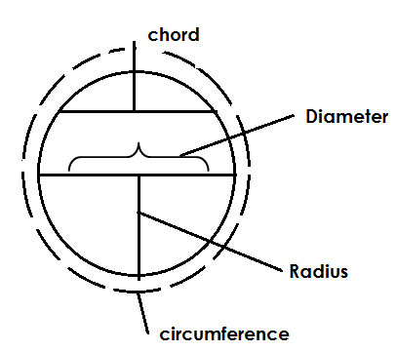**Parts of a circle**

**CHORD**

* A chord is a line running from one end to another end of a circle.

**DIAMETER**

* This is a line of a circle running from one end to another end through the Centre.
* Diameter is the longest chord of the circle.
* Diameter is twice the radius i.e.
* D = r + r

**RADIUS**

* Radius is a line of a circle running from the centre to the circumference.
* Radius is a half diameter i.e.

R = $\frac{D}{2}$ or D ÷ 2 if given fractions.

**CIRCUMFERENCE**

* Circumference is the total distance round a circle or a circular object.

Circumference = $π$ D

**Where;**

$π$ = Pi

D = Diameter

**Pi ( $π$)**

* Pi is the quotient of circumference and diameter of a circle.
* Pi is taken as $\frac{22}{7}$ or 3 $\frac{1}{7}$ or 3.14
* We use pi as $\frac{22}{7}$ or 3 $\frac{1}{7}$ if diameter, radius or height of a circular object is a multiple of 7.
* We use pi as 3.14 if diameter or radius given is not a multiple of 7.

**FORMULAS TO BE USED**

|  |  |  |  |
| --- | --- | --- | --- |
| **SHAPE** | **CIRCUMFERENCE** | **PERIMETER** | **AREA** |
| **CIRCLE** | **D** | _____________ | r2 |
| **SEMI CIRCLE** | **½D** | ½ **D +D** | **½r**2 |
| **QUADRANT** | **¼ D** | **¼ + D** | ¼ **r**2 |
| **OTHER SECTORS** | $\frac{A}{360}π$**D** | $\frac{A}{360}π$**D +D** | $$\frac{A}{360} πr^{2}$$ |

**FINDING CIRCUMFERENCE AND AREA OF A CIRCLE**

**Example I**

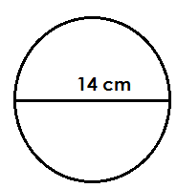Below is a circle.

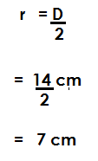

a) Find its circumference

**soln.**

cir = $π$**D**

**= $\frac{22}{7}$** X 14cm

= 22 x 2 cm

**= 44 cm**

1. calculate its area.

**Solution**.

Area = r2

Area= x 7cm x 7 cm

=154 cm2

**Example II**

1. Find circumference of a circle whose diameter is 40 m.

**Soln.**

Cir = $π$**D**

**=** 3.14 X 40m

= $\frac{314}{100}$ X 40m

= $\frac{1256m}{10}$

**= 125.6m**

b) Calculate its area.

**Soln.**

r = $\frac{D}{2}$

= $\frac{40 m}{2}$

**= 20m**

$$Area=πr^{2}$$

= 3.14 x 20m x 20m

= $\frac{314}{100}$ x 20m x 20m

= 1256m2

**Example III**

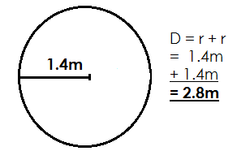Below is a circle, use it to answer questions.

a) Calculate its circumference.

**Soln.**

Cir = $πD$

= $\frac{22}{7}$ x 2.8m

= $\frac{22}{7}$ x $\frac{28m}{10}$

= $\frac{88m}{10}$

**= 8.8m**

b) Find its area.

$$A=πr^{2}$$

= $\frac{22}{7}$ x 1.4m x 1.4m

= x x

= 2

= 6.16m2

**Activity:**

1. Find circumference and area of the following.

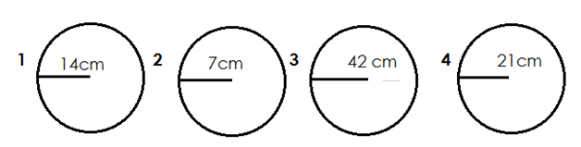

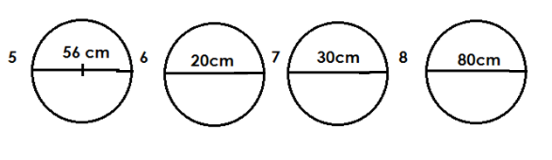

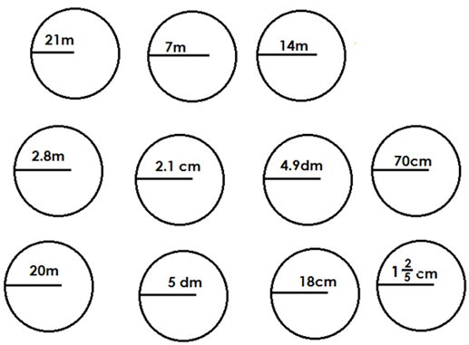2 Calculate circumference and area of the following circles.

1. A goat was tied on a peg using a rope of length 10m.
2. Find the distance around its grazing area.
3. Find area of the grazing ground.

**FINDING DIAMETER OR RADIUS GIVEN CIRCUMFERENCE OR AREA.**

1. Circumference of a circle is 176m. Find its radius.

**Soln**.

$πD$ = circumference

$\frac{22D}{7}$ = 176m

$\frac{22D}{7}$ x 7 = 176 m x 7

$\frac{22D}{22}$ = $\frac{116m x 7}{22}$

**D = 56M.**

R = $\frac{D}{2}$

= $\frac{56m}{2}$

= **28m.**

1. Calculate its area.

**Soln**. $$A=πr^{2}$$

= $\frac{22}{7}$ x 28m x 28m

**=2464m2**

**Example II**

Circumference of a circle is 8.8cm, calculate its area

**Soln.**

$πD$ = circumference

$\frac{22D}{7}$ = 8.8cm

$\frac{22D}{7}$ x 7 = 8.8cm x 7

22D = 8.8cm x 7

22D = 61.6CM

22D x 10 = $\frac{616m}{10}$ x 10

22D x 10 = 616m

$\frac{22D x 10}{22 x 10}$ = $\frac{616m}{22 x 10}$

D = $\frac{28m}{10}$

**= 2.8m**

R = D ÷ 2

= 2.8 ÷ 2

= $\frac{28}{10}$ **÷ $\frac{2}{1}$**

**= $\frac{28}{10}$ X $\frac{1}{2}$**

**= $\frac{14}{10}$**

= 1.4m

$$A=πr^{2}$$

= $\frac{22}{7}$ x 1.4m x 1.4m

= x m x m

= 2

= 6.16m2

Find the circumference of a circle whose area is 154cm2.

= Area

= 154cm2

= 154cm2 x 7

22r2 = 154cm2 x 7

= cm2 x 7

= 49cm2

= cm2

**r = 7cm**

D = r + r

= 7cm + 7cm

= 14cm

Circumference = $πD$

= $\frac{22}{7}$ x 14cm

**= 44cm**

Area of a circle is 38½ m2. Find its diameter.

= Area

= 38 ½ m2

x 7 = 38 ½ m2 x 7

22 = x 7

22 = m2 x 2

22r2 x 2 = 539m2

= m

r2 =

r2 =

=

r =

r =

r = 3 ½ m

D = 2r

= 2 x m

**= 7m**

**Activity:**

1. Circumference of a circle is 8.8cm. calculate its area.

2. Find diameter of a circle whose circumference is 2.2cm.

3. Find area of a circle whose circumference is 880cm.

4. Circumference of a circle is 66m. find its area.

5. Find the area of a circle whose circumference is 132cm.

6. A goat was tied on a stump such that the furthest distance round its grazing place is 44m.

a) Find length of the rope.

b) Calculate the area of the grazing ground.

7. Find the area of the garden whose distance round is 2.2m.

8. Find circumference of a circle whose area is 154cm2.

9. The area of a circular field is 616m2. Calculate its circumference.

10. Find radius of a circle whose area is 2464cm2.

11. Area of a circle is 9 cm2. Find its diameter.

12. Area of a circle is 17,850m2, find its radius take it as 3.14.

**SEMI CIRCLE**

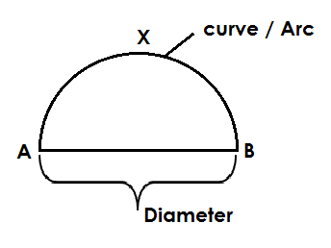A semi-circle is a half of a circle.

Area of a semicircle= ½ $πr^{2}$

Circumference / length of the curve = $\frac{1}{2}π$ D

Perimeter = $\frac{1}{2}π$ D + D

**FINDING AREA PERIMETER AND CIRCUMFERENCE OF A SEMI CIRCLE**

Examples

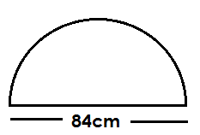Below is a semi circle use it to answer questions.

r = $\frac{D}{2}$

= $\frac{84}{2}$

**= 42cm**

Find its area

**Soln.**

$$A=\frac{1}{2} πr^{2}$$

= $\frac{1}{2}$ x $\frac{22}{7}$ x 42cm x 42cm

**= 2772cm2**

b) Find length of the curved line.

**Soln.**

Length = ½ $πD$

= $\frac{1}{2}$ X $\frac{22}{7}$ X 84cm

**= 132 cm**

c)Calculate its perimeter

**soln**

perimeter = ½ $πD+D$

= ( $\frac{1}{2}$ x $\frac{22}{7}$ x 84cm) + 84cm

= 131cm + 84cm

**= 216cm**

**Example II**

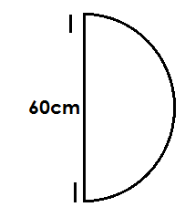Use the figure below to answer questions.

R = ½

= $\frac{60cm}{2}$

**= 30cm**

Find its area.

$$A=\frac{1}{2}πr^{2}$$

= $\frac{1}{2}$ x 3.14 x 30cm x 30cm

= $\frac{1}{2}$ x $\frac{314}{100}$ x 30cm x 30cm

**=1413 cm2**

b) Find length of the curved line.

Soln

Length= $πD$

= $\frac{1}{2}πD$

= ½ x 3.14 x 60cm

= ½ x $\frac{314}{100}$ x 60cm

= $\frac{942}{10}$ cm

**= 94.2cm**

c) calculate its perimeter

**soln.**

perimeter = ½ $πD$ + D

= (½ x 3.14 x 60cm) + 60cm

= (½ x $\frac{314}{100}$ x 60cm) + 60 cm

= $\frac{942}{10}$ + 60 cm 94.2

= 94.2 cm + 60 cm + 60.0

**= 154.2 cm 154.2**

**Activity:**

Find area, length of the curved line and perimeter of the following semi circles.

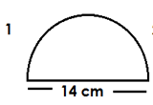

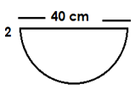

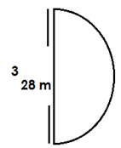

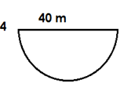

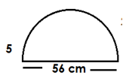

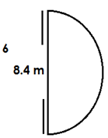

**FINDING DIAMETER OR RADIUS OF A SEMI CIRCLE GIVEN PERIMETER OR AREA**

**Example I**

Perimeter of a semi-circle is 108m. Find its area.

**Soln.**

½ $πD+D$ =perimeter

½ x $\frac{22}{7}$ D + D = 108 m

$\frac{11}{7}$ D + D = 108 m

$\frac{11D}{7}$ x 7 + D x 7 = 108 m x 7

11D + 7D = 108m x 7

18D = 108m x 7

$\frac{18D}{18}$ = $\frac{108m}{18 }$ x 7

D = 42m

r = $\frac{D}{2}$

= $\frac{42m}{2}$

= 21m

$$A=πr^{2}$$

= $\frac{1}{2}$ x $\frac{22}{7}$ x 21m x 21m

**= 693m2**

**Example II**

Area of a semi-circle is 628cm2. Find its radius. Take $π$ as 3.14.

**Soln**.

$\frac{1}{2}πr^{2}$ = Area

$\frac{1}{2}$ x 3.14 x r2  = 62.8cm2

x r2  = 628cm2

= 628 cm2

x 100 = 628cm2 x 100

157 = 628cm2 x100

= cm2 x 100

r2 = 400cm2

=

**r = 20cm**

**Activity:**

1. Perimeter of a semi-circle is 72cm, find its diameter.

b) Calculate its area.

2. Calculate the area of a semi-circle whose perimeter is 36cm.

3. Find area of a semi-circle whose perimeter is 252m.

4. Area of a semi-circle is 693cm2. Find its radius.

5. Find perimeter of a semi-circle whose area is 1232 cm2.

6. Area of a semi-circle is 2772m2. Calculate its perimeter.

7. Find area of a semi-circle whose perimeter is 108m.

8. Given that perimeter of a semi-circle is 27.72. find its diameter.

**A QUADRANT (AQUARTER)**

* A quadrant is a quart part of a circle.
* A quadrant is made up of two radii and an arc.

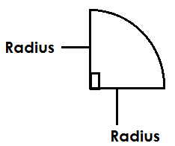

Area = ¼ $πr^{2}$

Length of the curve = ¼ $π$ D

Perimeter = ¼ $π$ D + D

**Example I**

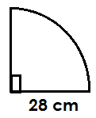Below is quadrant use it to answer questions.

a) Find its area.

**Soln.**

$$A=\frac{1}{4} πr^{2}$$

= $\frac{1}{4}$ X $\frac{22}{7}$ X 28 cm x 28cm

**= 616cm2**

1. Find length of the curved line.

**Soln.**

D = r +r

= 28cm + 28cm

= 56 cm

Length = $\frac{1}{4} πD$

= $\frac{1}{4}$ x $\frac{22}{7}$ x 56cm

**= 44 cm**

c) Calculate its perimeter.

**Soln.**

P = $\frac{1}{4} πD$ + D

= ( $\frac{1}{4}$ x $\frac{22}{7}$ x 56cm) + 56 cm

= 44cm + 56 cm

= 100cm

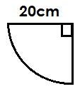Below is a quadrant, use it to answer questions.

D = r + r

= 20cm + 20cm

= 40c

1. Find its area.

**Soln.**

$$A=\frac{1}{4} πr^{2}$$

= $\frac{1}{4}$ x 3.14 x 20cm x 20cm

= $\frac{1}{4}$ x $\frac{314}{100}$ x 20cm x 20cm

**= 314 cm2**

1. Find length of its curved line.

Length = $\frac{1}{4} πD$

= $\frac{1}{4}$ X 3.14 X 40CM

= $\frac{1}{4}$ x $\frac{314}{100}$ x 40cm

**= 31.4 cm**

Calculate its perimeter

Perimeter = $\frac{1}{4} πD$ + D

= ( $\frac{1}{4}$ x 3.14 x 40cm) + 40cm

= ( $\frac{1}{4}$ x $\frac{314}{100}$ x 40cm) + 40cm

= 31.4 cm + 40cm

**= 71.4 cm**

**Activity:**

Find areas, length of the curved line and perimeter of the following quadrants.

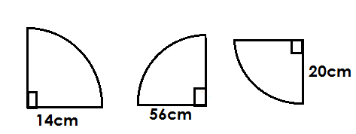

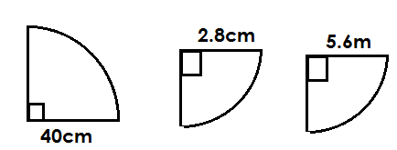

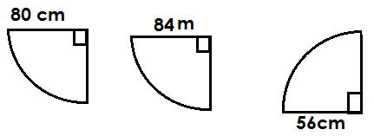

**FINDING RADIUS GIVEN PERIMETER OR AREA OF A QUADRANT**

Perimeter of a quadrant is 300cm. find its radius.

**Soln.**

$\frac{1}{4 }π$ D + D = perimeter

( $\frac{1}{4 }$ x $\frac{22}{7}$ x D) + D = 300 cm

+ D= 300 cm

$\frac{1}{4 }$ x $\frac{11D}{14 }$ + D x 14 = 300 cm x 14

11D + 14D = 300 cm x 14

250 = 300 cm x 14

$\frac{25D}{25}$ = $\frac{300 cm x 14}{25}$

D = 168 cm

Radius = $\frac{D}{2}$

= $\frac{168 cm}{2}$

**= 84 cm**

b) Calculate its area.

Soln.

Area = $\frac{1}{4 }πr^{2}$

= $\frac{1}{4 }$ x $\frac{22}{7}$ x 84 cm x 84 cm

**= 5544 cm2**

**Example II**

Area of a quadrant is 7850 cm2, find its radius (Take $π$ = 3.14)

$\frac{1}{4}πr^{2}$ = Area. d = r + r

= 100 cm + 100cm

$\frac{1}{4}$ x 3.14 x $r^{2}$ =7850 cm2 = 200 cm

x = 7850 cm2

= 7850 cm2

x =7850 cm2 x 200

157 = 7850 cm2 x 200

=

= 10,00cm2

= 2

**r = 100 cm**

Find its perimeter

***Soln.***

P = $\frac{1}{4}π$ D + D

= ( $\frac{1}{4}$ x 3.14 x 200 cm) + 200 cm

= ( $\frac{1}{4}$ x $\frac{314}{100}$ x 200 cm) + 200 cm

= 157 cm + 200 cm

**= 357 cm**

**Activity:**

1. Perimeter of a quadrant is 44cm. find its radius.

b) Calculate its area.

2. Find area of a quadrant whose perimeter is 22m.

3. Perimeter of a quadrant is 50 cm, calculate its area.

4. Find radius of quadrant whose area is 2464 cm2.

5. Area of a quadrant is 1256 cm2. Find its perimeter. (Take $π$ as 3.14).

**OTHER SECTORS**

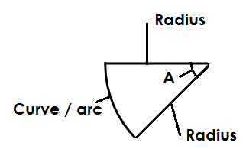

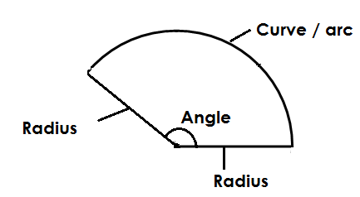

Area = $\frac{A}{360}πr^{2}$

Length of the curve = $\frac{A}{360} π$ D

Perimeter = $\frac{A}{360}πD+D$

Where A is the given angle in a sector.

**FINDING AREA PERIMETER AND CIRCUMFERENCE OF OTHER SECTOR**

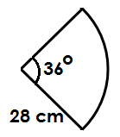1. Below is a sector.

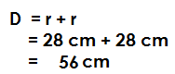

1. Find its area.

**Soln.**

Area = $\frac{A}{360 }πr^{2}$

= $\frac{360}{360 }$ x $\frac{22}{7}$ x 28 cm x 28 cm

= $\frac{2464}{10}$

**= 246.4 cm2**

b) Calculate its perimeter.

Soln.

P = $\frac{A}{360 }π$ D + D

= ( $\frac{36}{360}$ x $\frac{22}{7}$ x 56 cm ) + 56cm

= $\frac{176 cm}{10}$ + 56 cm

= 17.6 cm + 56 cm

**= 73.6 cm**

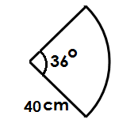2. Below is a sector.

a) Find the area of the above sector. Use $π$ = 3.14

soln.

A = $\frac{A}{360} πr^{2}$

= $\frac{36}{360}$ x 3.14 x 40cm x 40cm

= $\frac{5024}{10}$ cm

**= 502.4 cm2**

b) Find the perimeter of the above sector.

P = $\frac{A}{360}πD x D$

= ( $\frac{36}{360}$ x 3.14 x 80cm) + 80cm

= $\frac{2512}{100}$ + 80 cm

= 25.12 + 80cm

**= 105.12 cm**

**Activity:**

1. 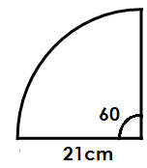Below is a sector. Use it to answer questions that follow. (Use $π$ as $\frac{22}{7}$)

a)Calculate its area.

b) Find the length of its curved line.

c) Calculate its perimeter.

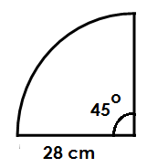2. Find the area, length of the curved line and perimeter.

a) Find the area.

b) Find the length of the curved line (circumference)

c) Find the perimeter.

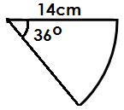3. Given the sector below.

a) Find the area of the above sector.

b) What is the circumference of the sector above?

c) Find the perimeter of the figure above.

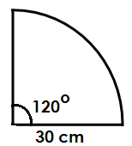4. Study the figure below and answer questions that follow.

a) What is the area of the figure above?

b) Find the circumference of the figure above.

c) Find its perimeter

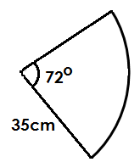5. Study the sector and answer the questions that follow.

a) Find its area.

b) Find the circumference of the figure.

c) What is the perimeter of the above figure?

6. The figure below is a sector. Study it to answer the questions below,

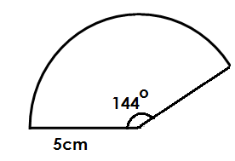

a) Find the area of the figure above.

b) Find the circumference.

c) What is the perimeter of the figure above?

**FINDING AREA AND PERIMETER OF COMBINED FIGURES**

**Note:**

While finding perimeter of combined dotted line are not considered since they are taken to be imaginary lines.

**Examples**

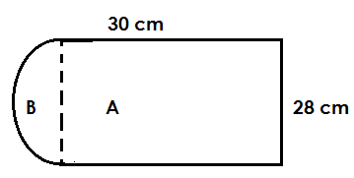1. Below is a figure. Use it to answer questions below.

1. Find its area.

**Soln.**

|  |  |  |
| --- | --- | --- |
| Area of A | Area of B | Total |
| L X W  30cm x 28cm  **840cm2** | x x x  **308 cm2** | 840cm2  + 308cm2  **1148cm2** |

1. Find its perimeter

|  |  |  |
| --- | --- | --- |
| Lines | Curve | Perimeter |
| 28cm + 30cm + 30cm  **88cm** | $$\frac{1}{2}πd$$ $\frac{1}{2}$ x $\frac{22}{7}$ x 28cm  **44 cm** | 88cm  + 44cm  **132cm** |

1. Study the figure below and answer questions that follow.

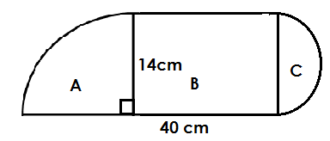

a) Find the area of the figure above.

**Soln.**

|  |  |  |  |
| --- | --- | --- | --- |
| Area of A | Area of B | Area of C | Total |
| A = $\frac{1}{4}πr^{2}$ = $\frac{1}{4}$ x $\frac{22}{7}$ x 14cm x 14cm | L x W  40cm x 14cm  560 cm2 | A =  = x x 7cm x7cm  77cm2 | 154cm2  + 569cm2  77cm2  **791cm2** |

**Activity:**

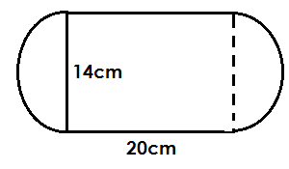1. Find the area and perimeter of the figure below.

a) Find the area of the figure above.

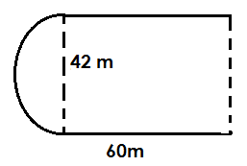b) Find the perimeter of the figure above.

2.

a) Find the area of the above figure.

b) Find the perimeter of the figure.

1. 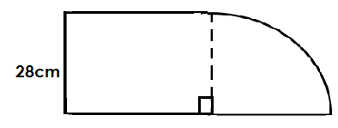Use the figure below to answer questions below it.

**30cm**

a) Find the area of the figure.

b) Find the perimeter of the figure.

1. 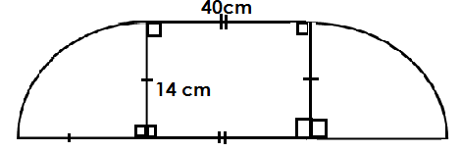Study the figure below and answer questions that follow.

a) Find the area of the figure above.

b) Find its perimeter.

1. 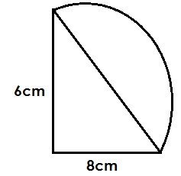Below is a figure. Use it to answer questions below.
2. Find the area of the figure.

b) Find the perimeter of the figure.

1. 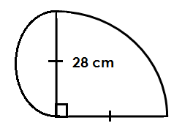Study the figure below and answer questions that follow.
2. Study the figure below and answer questions that follow.

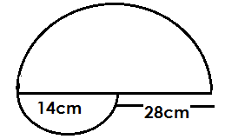

a) Find the area of the figure

b) Find the perimeter of the figure.

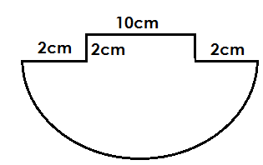8) Below is a figure. Study it and answer questions below.

a) Find the area of the above figure.

b) Work out its perimeter.

**FINDING AREA AND PERIMETER OF SHADED PARTS**

Note:

While finding perimeter of shaded parts, dotted lines are not considered.

**Examples**

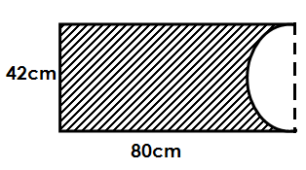1. Use the diagram below to answer questions that follow.

a) Find the area of the shaded part.

**Soln.**

|  |  |  |
| --- | --- | --- |
| Area of outer | Area of inner | Shaded area |
| A = L x W  = 80cm x 42cm  **=336 cm2** | A =  = x x x  **=693cm2** | 360cm2  - 693cm2  **2667cm2** |

b) Find its perimeter. (perimeter of the shaded part)

**soln.**

|  |  |  |
| --- | --- | --- |
| Lines | Curve | Total |
| 80cm + 42cm + 80cm  **202cm** | $$\frac{1}{2}πr^{2}$$ $\frac{1}{2}$ x $\frac{22}{7}$ x 42cm  **66cm** | 202cm  + 66cm  **268cm** |

2. Study the figure below and answer questions that follow.

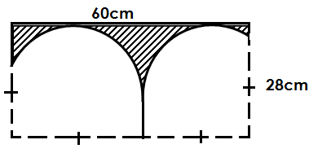

a) Find the area of the figure.

**Soln**.

|  |  |  |
| --- | --- | --- |
| Area of outer | Area of inner | Shaded area |
| L x W  60cm x 28cm  **168cm2** | x 2  x x 28 x 28 x 2  **1232cm2** | 1680cm2  - 1232cm2  **448cm2** |

b) Find the perimeter of the shaded part.

**Soln.**

|  |  |  |
| --- | --- | --- |
| Lines | Curves | Perimeter |
| 60cm | $\frac{1}{4}π$ d x 2 $\frac{1}{4}$ X $\frac{22}{7}$ X 56cm x 2  **88cm** | 60cm  + 88cm  **148cm** |

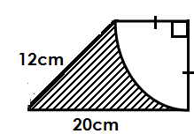3. Study the figure and answer questions below.

1. Find the area of the figure above.

**Soln.**

|  |  |  |
| --- | --- | --- |
| Area of outer | Area of inner | Shaded area |
| A = $\frac{1}{2}$ h (a + b)  = $\frac{1}{2}$ x 14cm x (14cm + 20cm)  **= 238cm2** | x x 14cm x 14cm  154cm2 | 238cm2  - 154cm2  **84cm2** |

1. Find the perimeter of the shaded part.

**Soln.**

|  |  |  |
| --- | --- | --- |
| Lines | Curve | Perimeter |
| 12cm + 20cm  **32cm** | $$\frac{1}{4}πd$$ $\frac{1}{4}$ x $\frac{22}{7}$ x 28cm  **22cm** | 32cm  + 22cm  **54cm** |

**Activity:**

1. Find the area of the shaded parts of the figures below and perimeter of the shaded part ( $π$ = $\frac{22}{7}$)

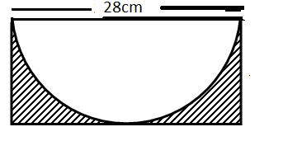

a) Find the area of the shaded part.

b) Find the perimeter of the shaded part.

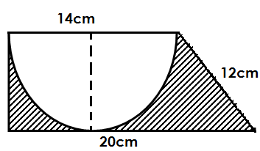2. Below is a figure, use it to answer questions below. (Use $π$ = $\frac{22}{7}$)

a) Find the area of the shaded part.

b) Find the perimeter of the shaded parts of the figure.

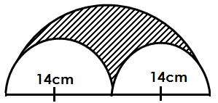3. Study the figure below and answer questions that follow. (Use $π$ = $\frac{22}{7}$)

a) Find the area of the shaded part.

b) Find the perimeter of the shaded parts of the figure above.

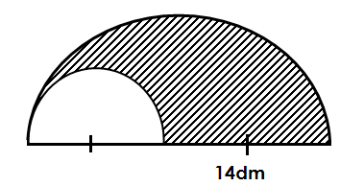5. Below is a circle enclosed in a semi-circle (Use $π$ = $\frac{22}{7}$)

a) Find the area of the shaded part.

b) Find the total distance around the shaded parts.

6. Use the diagram below to answer questions that follow.

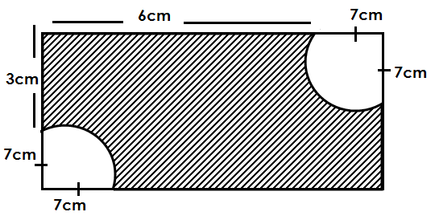

a) Find the area of the shaded part of the figure.

b) Find the total distance round the shaded parts of the figure.

1. Given the figure below.

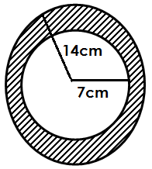

a) Find the area of the shaded part. (Use $π$ = $\frac{22}{7}$)

b) Find the perimeter of the shaded part of the figure above.

1. 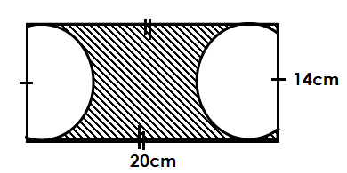Use the diagram below to answer questions below.

a) Find the area of the shaded part. (Use $π$ = $\frac{22}{7}$)

b) Find the perimeter of the shaded parts. (Use $π$ = $\frac{22}{7}$)

**MORE ABOUT SHADED PARTS**

**Examples**

1. Area of the shaded part in the figure below is 126cm2. Find the length of the rectangle.

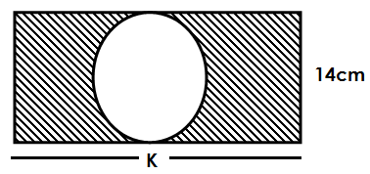

**Soln.**

Outer - inner = shaded area.

L x W - = 126cm2

K x 14cm - x 7cm x7cm = 126cm2

K x 14cm - 154cm2 = 126cm2

K x 14cm - 154cm + 154cm2 = 126cm2 + 154cm2

K x 14cm = 280cm2

=

K = 20cm

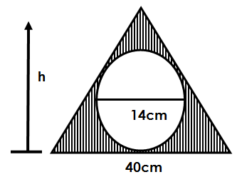2. Given the diagram below.

If the area of the shaded part in the above figure is 206cm2. Find the height (h) of the triangle.

Soln.

Area of inner

= $πr^{2}$

$=\frac{22}{7}$ x 7cm x 7cm

=154 cm2

Area of triangle = Area of shaded + Area of inner.

= 206cm2

+ 154cm2

360cm2

x b x h = Area

x 40cm x h = 360cm2

=  x cm

h = 18cm

**Activity:**

1. Study the figure below and answer questions that follow.

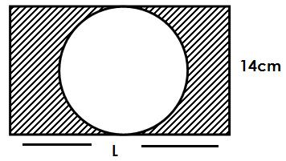

Given that the shaded area is 306cm2. Find the value of L.

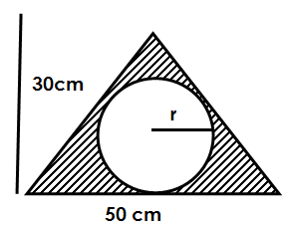2. In the figure below, the shaded area is 134cm2.

Find the value of r.

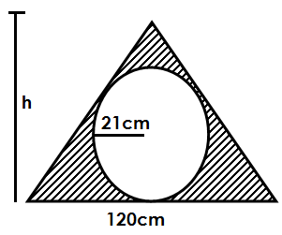3. Find the value of h in the figure below given that the shaded area is 1014cm2

4. In the figure below the shaded area is 846cm2. Find the value of r.

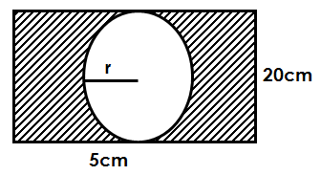

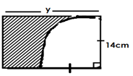5. In the figure below, the area of the shaded part 126cm2.

1. Find the value of Y.
2. Calculate the perimeter of the shaded part.

**REVOLUTIONS / TURNS**

* A revolution is a complete turn.
* A revolution is the turning made from a given point and back to that very point.
* A complete revolution is equal to 360o.

**FINDING NUMBER OF REVOLUTIONS**

Number of revolutions = $\frac{distance}{circumference }$

**Note:**

Distance must be in the same units with diameter or radius of the given circular surface.

**Example I**

A bicycle wheel of diameter 14cm was used to cover a distance of 8.8km, in how many revolutions was the distance covered?

Soln.

No. of revolutions = $\frac{distance}{circumference}$

Cir = $πD$

= $\frac{22}{7}$ x 14cm

= 44cm

1km = 100,000cm

8.8km= (8.8 X 100,000) cm.

= ( $\frac{88}{10}$ x 100,000) cm

= 880,000cm

No. of revolutions = $\frac{880,000 cm}{44cm}$

= 20,000 revolutions

**Example II**

Find number of revolutions that a wheel barrow wheel of diameter 350cm can cover in a distance of 440m.

**Soln.**

No. of revolutions = $\frac{distance}{circumference}$

**Soln**.

Cir = $πD$

= $\frac{22}{7}$ x 35cm

= 22 x 5cm

= 110cm

1m = 100cm

440cm= 44,000cm

No. of revolutions = $\frac{440,000cm}{110cm}$

**= 400 Revolutions**

**Activity:**

1. Bernard rolled a car wheel of diameter 70cm from home to town through a distance of 6.6km. find the number of revolutions that he made.

2. A drum of diameter 42cm was rolled through a distance of 66cm. in how many revolutions was the drum rolled?

3. A car wheel of diameter 35cm covered a distance of 4.4km. in how many revolutions was the distance covered?

4. How many revolutions can a car wheel of radius 70cm make to cover a distance of 88km.

5. Odongo rolled a drum of radius 14cm through a distance of 13.2km. find the number of revolutions made.

6. A motorbike wheel of diameter 70cm covered a distance at a speed of 60km/hr. in 3 $\frac{2}{3}$. Find the number of revolutions made.

7. How many revolutions can a car wheel of diameter 210cm make to cover a certain distance at a speed of 48km/hr. in 5 hours.

8. Opoka rides a bicycle of diameter 63cm through a distance of 2.97km. find the number of revolutions that the distance was made.

**FINDING RADIUS OR DIAMETER GIVEN NUMBER OF REVOLUTIONS**

**Note:**

* Circumference = 1 revolution
* Circumference = $\frac{Distance}{No.of revolutions}$

It is better to change the given distance to centimeters (cm).

**Example I**

A distance of 4.4km was covered by a bicycle wheel in 4000 revolutions. What was the diameter of the bicycle wheel?

**Soln.**

1km = 100,000km

4.4km = (4.4 x 100,000) cm

= ( $\frac{44}{10}$ x 100,000) cm

= 440,000cm.

Circumference = $\frac{Distance}{No.of revolutions}$

= $\frac{440,000 cm}{4,000}$

=110cm

From:

$πD$ = circumference

$\frac{22D}{7}$ = 110cm

$\frac{22D}{7}$ x 7 = 110cm x 7

22D = 110cm x 7

$\frac{22D}{22}$ = 110cm x 7

D = 35cm

**Example II**

A thread of length 4400cm was wound round a cylindrical pipe shown below.

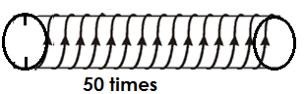

a) Find diameter of the wheel.

Circumference = $\frac{Distance}{No.of revolutions}$

= $\frac{4400cm}{50}$ 4400cm

= 88cm

$πD$ = circumference

$\frac{22D}{7}$ = 88cm

$\frac{22D}{7}$ x 7 = 88cm x 7

22D = 88cm x 7

$\frac{22D}{22}$ = $\frac{88xm x 7}{22}$

D = 4cm x 7

D = 28cm

b) Work out the area of its circular end.

r = $\frac{D}{2}$

= $\frac{28cm}{2}$

**Soln.** = 14cm

Area = $πr^{2}$

= $\frac{22}{7}$ x 14cm x 14cm

**= 616cm2**

**Activity:**

1. A lorry covered a distance of 8.8km in 20,000 revolutions. Find radius of the wheel
2. Opio’s car covered a distance of 4.4km in 4000 revolutions, what was the diameter of the wheel.
3. A wheel barrow was pushed through a distance of 17.6m in 40 revolutions. Find the diameter of its wheel.
4. Odongo rolled a drum through a distance of 13.2km in 15000 revolutions. Find radius of the drum.

5. A thread of length 88m was wound round the cylindrical log shown below.

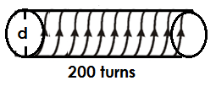

Find the diameter of the cylindrical log.

1. A drum was rolled from the kitchen to the office through a distance of 176m in 400 revolutions. Find the diameter of the drum.
2. Find the diameter of a bicycle wheel that was rolled through a distance of 440m in 2000 revolutions.

**FINDING DISTANCE GIVEN NUMBER OF REVOLUTIONS AND DIAMETER OR RADIUS**

**Note:**

* Distance = circumference x No. of revolutions.
* Length = circumference x No. of turns.

**Example I**

A bicycle wheel of diameter 70cm covered a distance from Town A to town B in 1000 revolutions. Find the distance covered in km.

**Soln.**

Distance = circumference x No. of revolution

Cir = $πD$

= $\frac{22}{7}$ x 70cm

= 220cm

Distance = 220cm x 1000

= 220,000cm

100,000cm = 1km

1cm = $\frac{1}{100,000}$ km

220,000 = ( $\frac{1}{100,000}$ x 220,000) Km

= $\frac{22}{10}$ km

= 2.2km

**Example II**

The diagram below shows a wire that was wound round a cylindrical log.

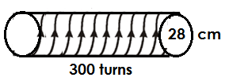

a) Find the length of the wire.

**Soln.**

Length = circumference x No. of turns

Cir = $πD$

= $\frac{22}{7}$ x 28cm

= 88cm

Length = 88cm x 800

**= 26400cm**

**Activity:**

1. Find the distance covered by a motorcycle whose diameter is 35cm in 200 revolutions. Give your answer in metres.

2. A drum of diameter 42cm was rolled 1000 times. Find the distance covered.

3. A car wheel of radius 35cm covered a certain distance in 400 revolutions. Find the distance covered.

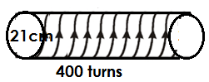4. A thread was wound round a cylindrical log below.

Find the length of the thread.

1. A bicycle wheel has a diameter of 14cm. what distance can it cover in 500 revolutions.
2. A thread has been wound on a cylindrical tin 2000 times. Find the length of the thread if diameter of the tin was 40cm take $π$ as 3.14.
3. A bicycle wheel of diameter 49cm covered a certain distance in 4000 revolutions. Find the distance covered in km.

**APPLICATION OF LENGTH**

1. Given standing on a line.

No. of pupils = (Position x No. of ends) – excess

1. Given two positions .

No. of pupils = (sum of position) – 1

**Examples**

1. Peter is the 3rd pupil from either side of a line. How many pupils are in the line?

**Soln.**

No. of pupils = (Position x No. of ends) – Excess

= (3 X 2) – 1

= 6 – 1

**= 5**

2. Alex is the 4th pupil from one side and is the 6 from the other side of the line. How many pupils are on the line?

**Soln.**

No. of pupil = (sum of position) – 1

= (4 + 6) – 1

= 10 – 1

**= 9**

3. Pupils were told to stand in a line at interval of 4 metres apart. John was the 6th from either side of the line.

1. How many pupils were in a line?

**Soln.**

No. of pupils = (Position x No. of ends) – Excess

= (6 x 2) – 1

= 12 – 1

**= 11**

b) Calculate the length of the line

**soln.**

No. of space = No. of pupils – 1

= 11 – 1

= 10 spaces

Each space = 4m

10 spaces = 10 x 4m

**= 40 metres**

**Activity**

1. Kato is the 5th pupil from either side of the line. How many pupils are on the line?

2. John is the fourth pupil from either side on a line. How many pupils are there on the line?

3. Children were told to stand on a line and Isa was the 6th from one side and was the 8th from the other side. How many children were on the line?

4. Pupils were told to stand on a line at an interval of 2 metres apart. James was the 3rd from either side.

a) How many pupils were on the line?

b) Calculate the length of the line.

5. During elections of village chairperson, voters were told to stand on a line. The former chairperson was the 6th from one side and 9th from the other side.

a) How many voters were there altogether?

b) If the voters stood at an interval of 3 metres apart, find the length of the line in centimeters.

6. Kamoga is the 6th boy from either side on a line. How many boys are there on the line?

7. Soldiers stood on a line at intervals of 4 metres apart where by their commander was the 7th from one side and 5th from the other side of the line.

a) How many soldiers were on the line?

b) Calculate the length of the line.

**PLANTING POLES / POSTS IN A STRAIGHT LINE**

Note:

1. No of poles = ( $\frac{Distance}{interval}$) + 1

(2) No. of spaces = No. of posts -- 1.

**Example**

1. 14 posts were planted along a straight road at an interval of 5 metres apart. What distance was covered?

**Soln.**

No. of spaces = No. of posts – 1

= 14 – 1

= 13

Each space = 5 metres

13 spaces = 13 x 5 metres

= 65 metres

1. Posts are planted at an interval of 5m apart along a straight road of length 65m. how many posts were used?

Soln.

No. of posts = ( $\frac{Distance}{interval}$) + 1

= ( $\frac{65 m}{5m }$) + 1

= 13 posts + 1 post

= 14 posts

1. 14 posts are planted along a straight road of distance 65m. find the *interval at which they are planted***.**

**Soln.**

No. of spaces = No. of posts – 1

= 14 posts – 1

= 13

Interval = $\frac{Distance}{No.of spaces}$

= $\frac{65m}{13}$

= 5m

**Activity:**

1. 23 posts were planted along a straight road at an interval of 5 metres apart. Calculate the distance covered.

2. Electric poles were planted in a straight line at an interval of 20 metres apart to cover a distance of 5km.

a) Calculate the number of poles which were used.

b) If each pole was bought at sh. 5,000, how much money was used to purchase all the poles?

3. 16 posts are planted a long a straight road of distance 7.5km. find the interval at which the poles were planted in metres.

4. 88 electric poles were planted along a road at an interval of 50 metres apart. Find the distance covered.

5. Electric poles are planted 50 metres along a straight road. Kinto moved from 3 pole to the 10 poles. What distance did he cover?

6. Poles are planted at an interval of 3 metres a part a long a straight road of length 90 metres. How many poles were used?

**PLANTING POSTS / POLES AROUND ARECTANGULAR SHAPE**

**Examples**

1. A rectangular garden of 40 metres by 30 metres is fenced using posts placed at an interval of 5 metres apart.
2. How many posts were used?

**Soln**.

No. of posts = $\frac{perimeter}{interval}$

= 2 ($\frac{L+W}{interval} )$

= 2 ( $\frac{40m+30m}{5m}$)

= 2 ( $\frac{70m}{5m}$)

= 2 x 14

**= 28**

**Activity:**

1. A rectangular garden which measures 60 metres by 20 metres was fenced with poles placed at an interval of 5 metres apart.

a) Calculate the number of poles which were used.

b) If each pole was bought at sh. 1500, how much money was used to fence the garden.

2. A rectangular plot of land measuring 100 metres by 50 metres is fenced using poles placed at the intervals of 10 metres apart.

a) Find the number of poles needed to fence the whole plot.

b) If each pole costs sh. 5000, how much is required to buy all the poles needed?

3. A rectangular plot was fenced with 20 poles placed at an interval of 5 metres apart. Find the distance round the plot.

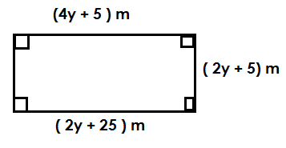4. The figure below is a garden. Study it carefully and answer the questions that follow.

The above garden is fenced using poles placed at an interval of 5 metres apart. Calculate the number of poles used to fence it.

5 A square garden of perimeter 40 metres was fenced with 20 poles. Calculate the interval at which the poles were planted.

6. A rectangular piece of land has a perimeter of 36 metres. It was fenced using poles placed at the intervals of 6 metres apart. How many poles were used?

7. The total distance round a squared field is 100m. if it was fenced using poles placed at the intervals of 25 metres apart. How many poles were used?

8. How many poles are needed to fence a rectangular garden which measures 30 m by 20 m. if the poles are placed at an interval of 5 metres apart?

**PLANTING POSTS / POLES AROUND A CURCULAR FIELD**

**Note:**

1. No. of spaces = No. of poles

No. of poles =

2. With circular objects, we don’t add the one (1) pole.

3. Circumference = No. of spaces x interval

**Examples**

1. Poles are planted round a circular flower garden of circumference 88m at an interval of 8 metres apart. How many poles are used?

Soln.

No. of poles =

=

**= 11**

2. A circular garden of radius 7cm is fenced using posts placed at intervals of 2 metres apart. Find the number of poles required to fence the garden.

Soln.

Circumference = $2πr$

= 2 x $\frac{22}{7}$ x 7m

= 44m

No. of poles = $\frac{circumference}{interval }$

= $\frac{44m}{2m}$

**= 22 posts**

**Activity:**

1. Poles are planted around a circular garden of circumference 154m at an interval of 7 metres apart. How many posts are used?
2. Short poles are to be planted around a circular pond of diameter 49m at an interval of 70cm.
3. How many poles are needed?
4. If each pole costs sh.1,100, how much money is needed for all the poles?
5. A circular garden is fenced using 22 posts placed at an interval of 2 metres apart. Find the circumference of the garden.
6. A circular garden of circumference 44m is fenced with poles placed at an interval of 4m apart. Find the number of poles used.
7. The shape below is Musisi’s garden. Study it and answer questions that follow.

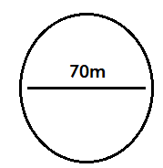

The above garden is fenced using poles placed at an interval of 20m apart. Calculate the number of poles used to fence it.

1. A circular flower garden of radius 28m is fenced using poles placed at an interval of 4 metres apart.
2. Find the number of poles used.
3. If each pole is bought at sh. 1200. Find the total cost.
4. A circular piece of land is fenced using 20 poles placed at an interval of 5 metres apart.
5. Find the circumference of the piece of land.

**PLANTING POLES AROUND EQUILATERALS**

**Note:**

a) Number of spaces = Number of poles

b) Distance around the figure = No. of spaces x internal

c) Number of poles = $\frac{perimeter}{interval}$

**Examples**

1. An equilateral triangular plot is fenced with 8 poles, on each side placed at an interval of 2 metres apart. Find the perimeter of the triangle.

**Soln.**

Length of one side = No. of spaces x interval.

No. of spaces = 8 – 1

= 7 spaces

Length = 4 x 2m

= 8m

Perimeter = 8m x 2

= 16m

1. An equilateral triangular plot of perimeter 36 metres is fenced with poles placed at an interval of 3 metres apart. Find the number of poles which were used to fence the garden.

**Soln**.

No. of poles = $\frac{Perimeter}{interval }$

= $\frac{36m}{3m}$

= 12 poles

1. How many poles are placed on each side?

**Soln.**

Poles on each side = $\frac{12 poles}{3}$

**= 4 poles**

**Activity:**

1. An eq at an interval of 4 metres apart. Find the perimeter of the garden.

2. The distance around an equilateral triangular house is 30 metres. It is constructed using poles placed at an interval of 2 metres apart.

a) Find the total number of poles a triangular garden is fenced with 5 poles on each side placed sed to construct the house.

b) How many poles are placed on each side?

3. The distance around an equilateral triangular plot is 36 metres. It is fenced using 7 poles on each side.

a) Find the interval at which the poles are fixed.

b) Find the length of each side of the plot.

4. Katunda designed an equilateral triangular compound which she fenced with 6 poles on each side placed at an interval of 5 metres apart.

5. An equilateral triangular plot is fenced with 10 poles on each side placed at an interval of 8m apart. Find the perimeter of the plot.

1. The distance round an equilateral triangular piece of land is 64 metres. It is fenced using 9 poles on each side. Find the interval at which the poles are fixed.
2. Below is Mr. Kintu’s equilateral triangular piece of land. Study it and answer questions that follow.

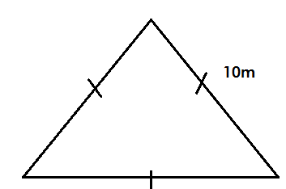

The above land is fenced using 6 poles on each side. Find the interval at which the poles are fixed.

**FINDING BASE OR HEIGHT OF A TRIANGLE BY COMPARING AREA**

**Example I**

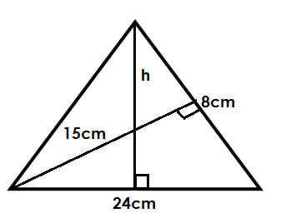**Below is a triangle use it to find A.**

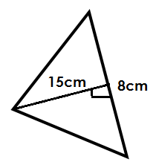

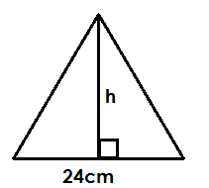**Soln.**

=

Area = Area

$\frac{1}{2}$ x b x h = $\frac{1}{2}$ x b x h

$\frac{1}{2}$ x 24cm x h = $\frac{1}{2}$ X 8cm x 15cm,

12cm x h = $\frac{1}{2}$ x 8cm x 15cm

$\frac{12cm x h}{12cm}$ = $\frac{4cm x 15}{12cm}$

**h = 5cm**

**Activity:**

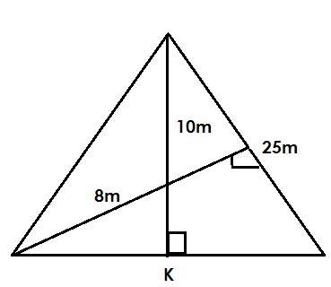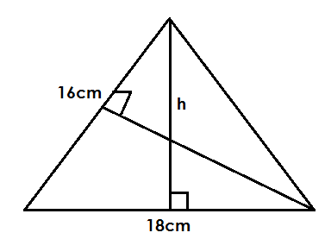Find the value of unknowns in the following figures.

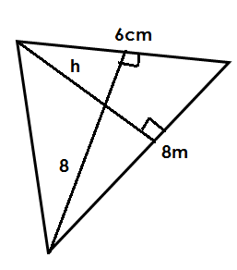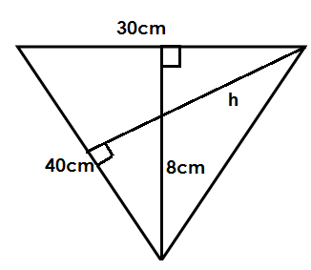

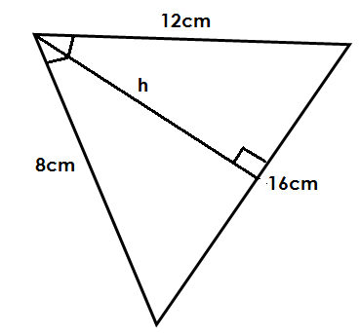

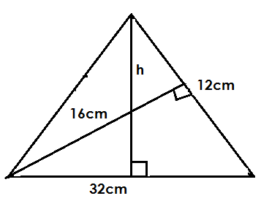

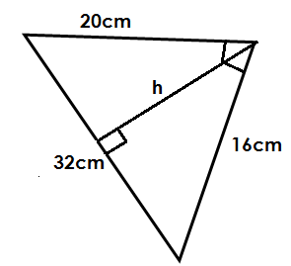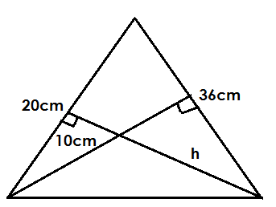

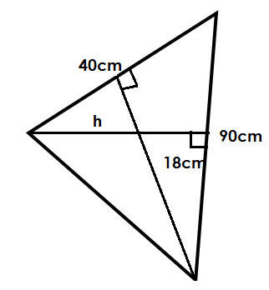

**FINDING HEIGHT OR BASE OF A PARALLELOGRAM BY COMPARING AREA**

**Example I**

Below is a parallelogram. Use it to find the value of h.

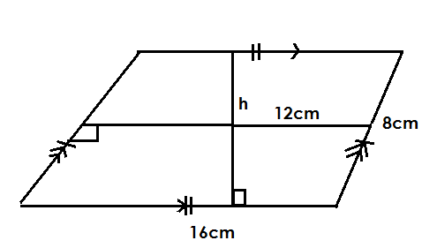

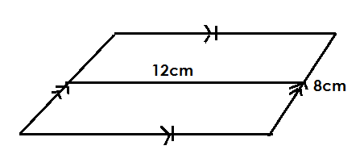

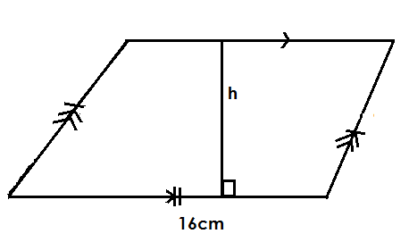Soln.

=

Rea = Area

B x H = B x H

16cm x h = 8cm x 12 cm

$\frac{16cm x h}{16cm}$ = $\frac{8cm x 12cm}{16cm}$

**h = 6cm**

Find the value of unknowns in the following diagrams.

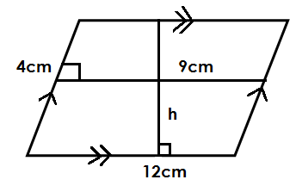**Activity:**

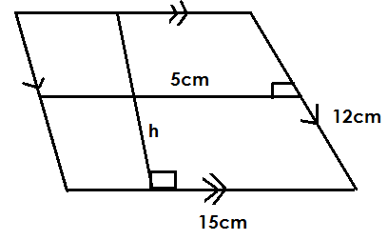

1.

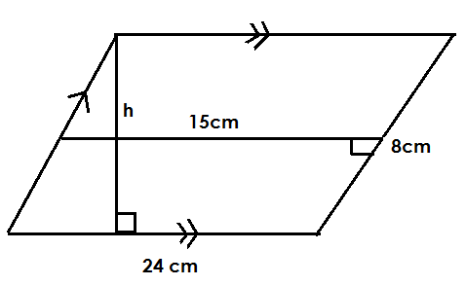

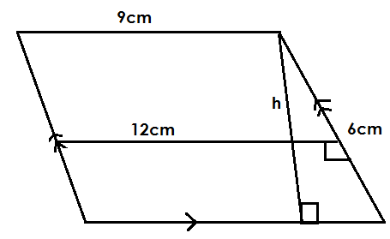

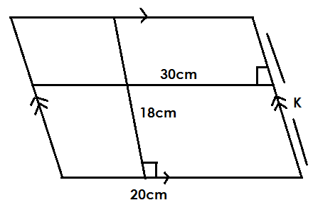

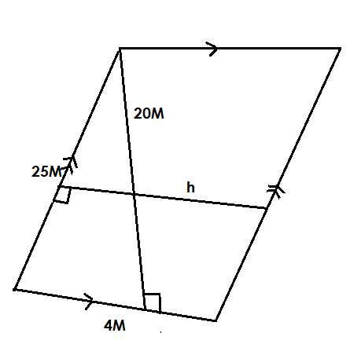

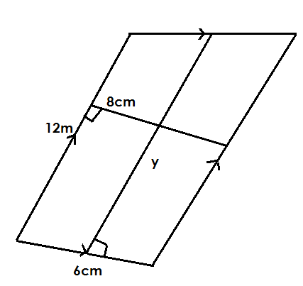

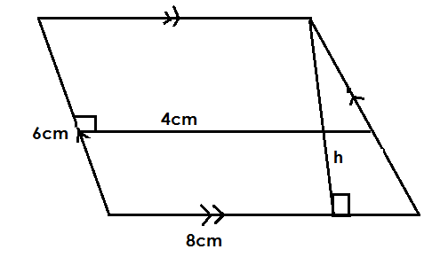

**PHYTHAGORAS THEOREM**

**Example I**

Below is a triangle. Use it to answer questions

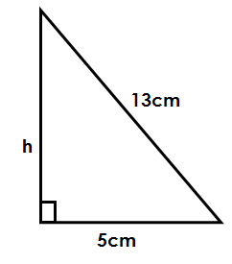

Find the value of h.

**Soln.**

a2 + b2 = c2

52 + h2 = 132

5 x 5 + h2 = 13 x 13

25 x h2 = 169

25 – 25 + h2 = 169 – 25

h2 = 144

2 =

h = 12cm

**Calculate its area**

Soln.

Area = $\frac{1}{2}$ x b x h

= $\frac{1}{2}$ x 5cm x 12cm

**= 30cm2**

Find its perimeter

**Soln.**

P = s + s + s

= 5cm + 12cm + 13cm

**= 30cm**

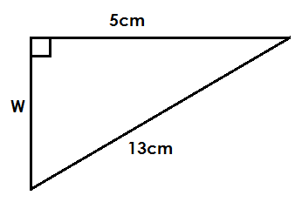The diagram below, find the unknown side, area and perimeter.

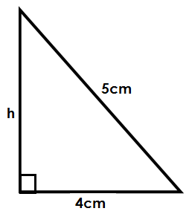

1. **2.**

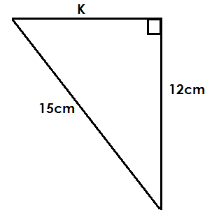

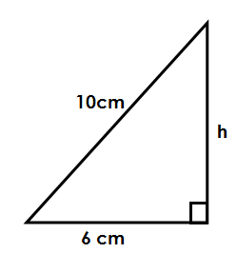

**3. 4.**

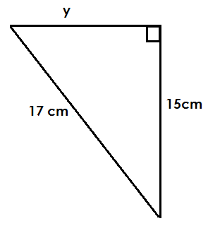

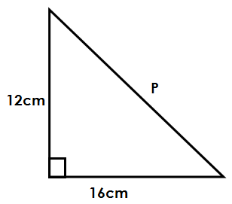

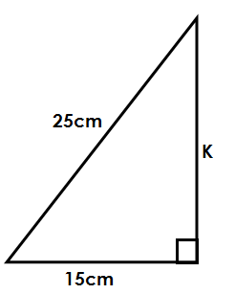

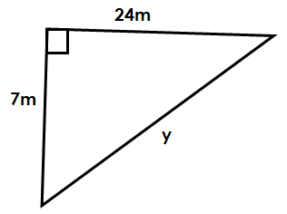

**AN ISOSCELES TRIANGLE AND PHYTHAGORAS THEOREM**

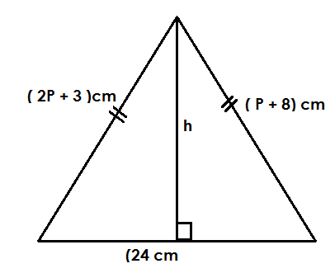Below is a triangle, use it to answer questions.

Find the value of P.

Side = side

2P + 3 = P + 8

2p + 3 – 3 = P + 8 – 3

2P = P + 5

2P – P = P – P + 5

**P = 5**

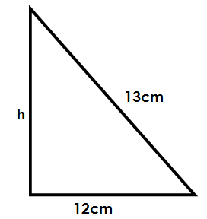Calculate the area of the figure.

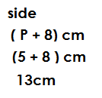

a2 + b2 = c2

122 +h2 = 1c2

(12 x 12) + h2 = 13 x 13

144 – 144 + h2 = 169 – 144

h2 = 25

2 = 2

**h =5 cm**

Area = $\frac{1}{2}$ x b x h

= $\frac{1}{2}$ x 24cm x 5cm

= 12cm x 5cm

**= 60cm2**

**Activity**

In the diagrams below, Find the value of unknown area and perimeter.

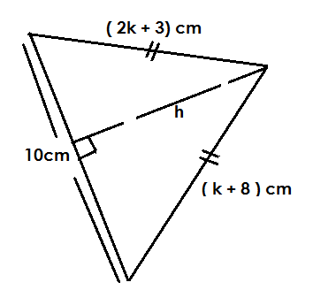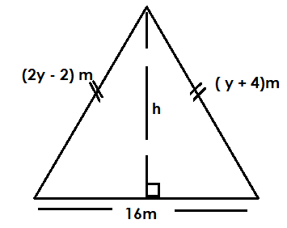

1. **2**
2. 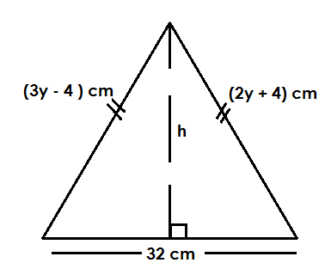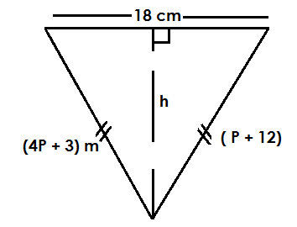 **4**

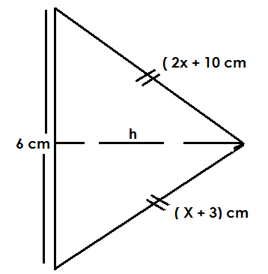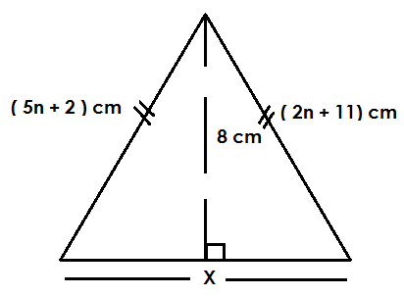

**5. 6**

**RHOMBUS**

**Note:**

* A rhombus is a slanted square i.e. all its sides are equal.
* A rhombus has its opposite side parallel to each other.
* A rhombus has two diagonals that bisect each other at an angle of 90o.
* A rhombus has two line of folding symmetry which are its diagonals.
* 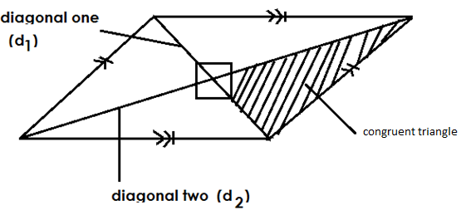The opposite angles of a rhombus are equal.

**FINDING AREA AND PERIMETER OF A RHOMBUS**

Area = $\frac{1}{2}$ x diagonal one x diagonal two

= × d1× d2

Perimeter = side +side +side +side +side

= s +s +s + s

**OR**

Perimeter = 4 x S

**Example 1**

Below is a rhombus use it to answer questions.

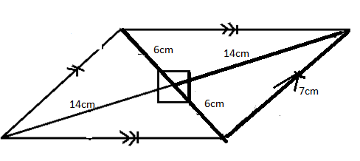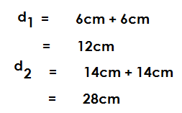a) Find its area.

Area = $\frac{1}{2}$ x 12cm x 28cm

= 6cm x 28cm

= 168cm2

b) Calculate its perimeter.

Perimeter = S + S + S + S

= 7cm + 7cm + 7cm + 7cm

**= 28cm**

**Activity:**

Find the area and perimeter of the following.

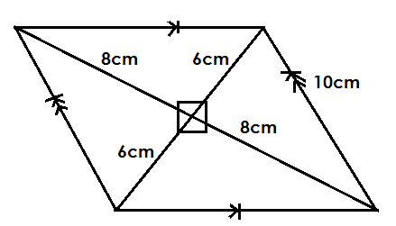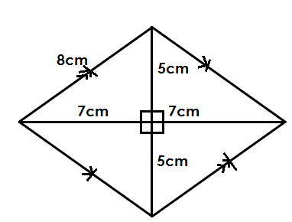

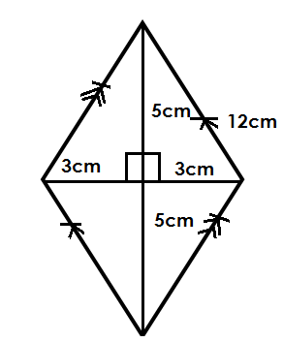

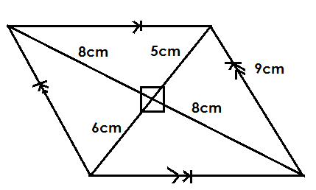

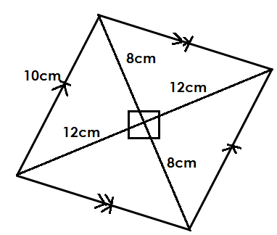

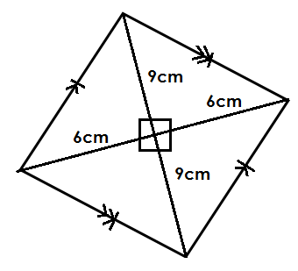

**A RHOMBUS AND PYTHAGORAS THEOREM**

The figure below is a rhombus

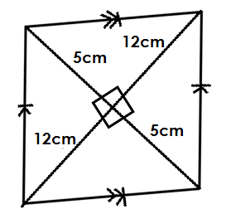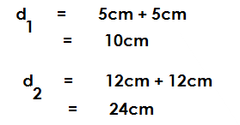

a) Find its area.

**Soln.**

A = x d1 x d2

= x 10cm x 24cm

= 120cm2

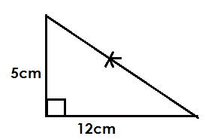b) Calculate its perimeter

a2 + b2 = c2

122 + 52 = c2

(12 x 12) + (5 x 5) =c2

144 + 25 = c2

169 = C2

= 2

13 = c

C = 13

P = S + S + S + S

= 13cm + 13cm + 13cm + 13cm

= 52cm

**Activity**

Find area and perimeter of the following figures.

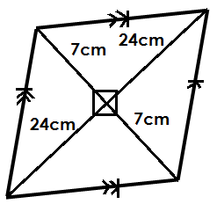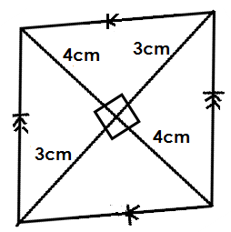

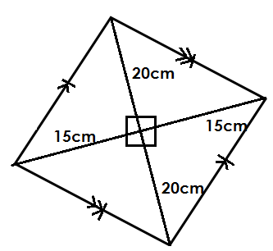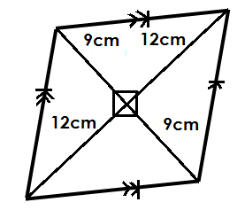

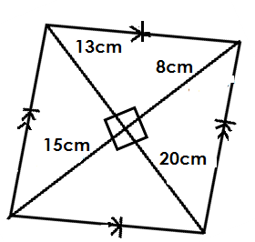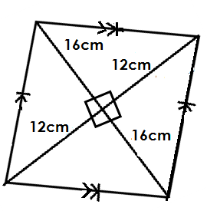

**MORE ABOUT ARHOMB**

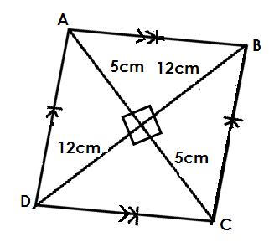Area of the figure below is 12cm2. If AC = 10cm. find line BD

D =

= 5cm

x d1 x d2  = Area

x 10cm x d2= 120cm2

5cm x d2 = 120cm2

=

d2 = 24cm

**∴BD = 24cm**

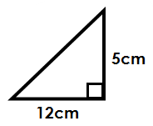b) Calculate its perimeter.

a2 + b2 = c2**= 52cm**

122 + 52 = c2

(12 x 12) + (5 x 5) =c2

144 + 25 = c2

169 = C2

169 = C2

= 2

13 = c

C = 13cm

P = S + S + S + S

=13CM + 13CM +13CM + 13CM

= 52cm

**Example II**

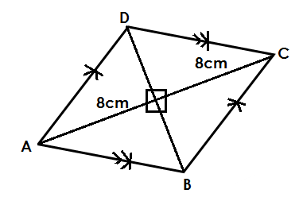Perimeter of the figure below is 68cm.

Find the area.

S + S + S + S = Perimeter

$\frac{45}{4}$ = $\frac{68}{4}$ cm

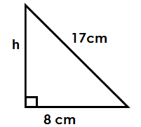**S =17cm**

a2 + b2 = c2

82+ h2 = c2

(8x 8) + h2 = 17 x 17

64 + h2= 289

64 – 64 + h2 = 289 – 64

h2 = 225

2 =

h = 15cm

Area = d1 x d2

**= 60cm2**

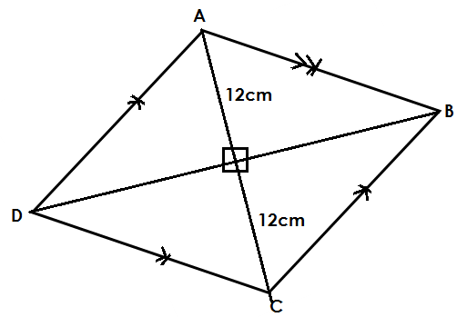Diagonal of the figure below is 3:4 if AC = 24cm. Calculate its area.

Total ratio = 3 + 4

= 7

Let the total length of the two diagonals be K

$\frac{3}{7}$ x k = 24cm

$\frac{3k}{7}$ = 24cm

$\frac{3k}{7}$ x 7 = 24cm x 7

$\frac{3k}{3}$ = $\frac{24cm}{3}$ x 7

K = 56cm

BD = $\frac{4}{7}$ x 56cm

= 32cm

Area = x d1 x d2

= x 24cm x 32cm

= 384cm2

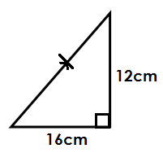b) Find its perimeter

a2 + b2 = c2

162 + 122 = c2

(16 x 16) + (12 x 12) =c2

256 + 144 = c2

400 =C2

=2

20 = c

C = 20cm

P = S + S + S + S

= 20 cm + 20cm + 20cm + 20cm

= 80cm

**Activity:**

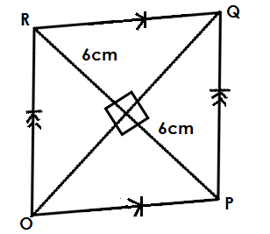1. The area of the figure below is 96cm2

a) If RP = 12cm, find diagonal OC

b) Calculate the perimeter of the figure above.

2. The area of the figure below is 240cm2.

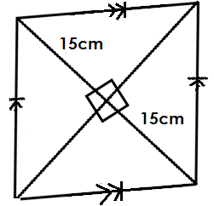

Find the perimeter of the figure above.

3. The perimeter of the figure below is 100cm.

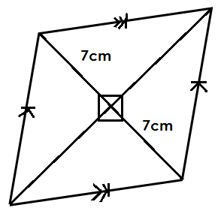

Find the area of the figure above.

1. 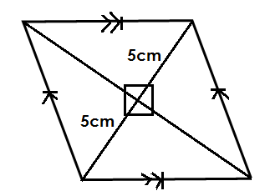The perimeter of the figure below is 52cm.

Find its area.

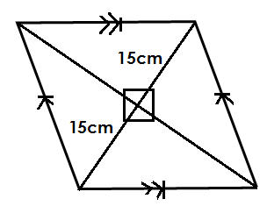5. The diagonal of the figure below are in a ratio of 3:4. Calculate its area.

b) Find the perimeter of the above figure.

6. The perimeter of the figure below is 68cm.

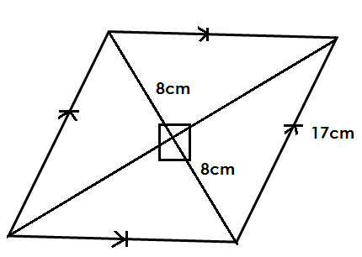

Calculate the area of the above figure

**KITE**

* A kite is a 4-sided polygon.
* It is made up of 2 different isosceles triangles.
* It has two diagonals.
* The longer diagonal bisects the shorter diagonal at an angle of 900
* It has one line of folding symmetry (longer diagonal)
* Its adjacent sides are equal.
* Diagonals of a kite are not equal.

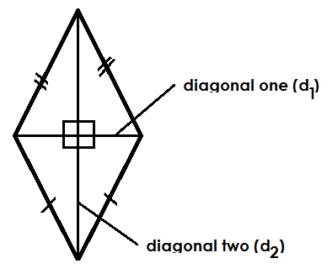**Illustration**

Area of a kite = x d1 x d2

or

Area = $\frac{1}{2}$ x bh x 2.

Perimeter of a kite = S + S + S + S

**Examples**

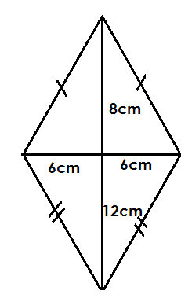1. Study the figure below and answer the questions that follow.

a) Find the area of the figure above,

soln.

d1 = 6cm + 6cm

= 12

d2 = 12cm + 8cm

= 20cm

Area = $\frac{1}{2}$ x 12cm x 12cm

= 6cm x 20

= 120cm2

b) Find the perimeter of the figure.

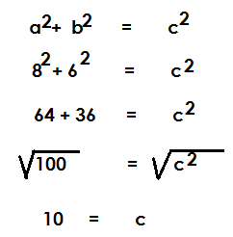Soln.

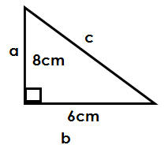

**∴** Perimeter = S + S + S + S

= 10cm + 10cm + 20cm + 20cm

= 60cm

2. Find the area of a kite whose diagonals are 16cm and 14cm.

Soln

Area = x d1 x d2

= x 16cm x 14cm

= 8cm x 14cm

**= 112cm2**

**Activity:**

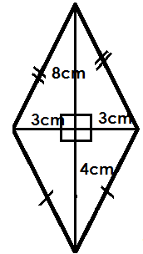1. Given the kite below:

Find the area of the figure above.

2. Study the figure below and answer the questions that follow.

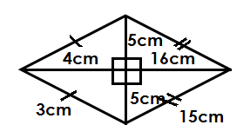

a) Find the area of the figure above.

b) What is the perimeter of the above figure.

3.Find the area of a kite whose diagonals are 10cm and 6cm.

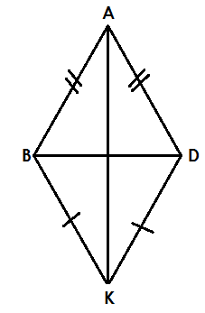4. In the figure below, AK = 30cm and BD = 6cm

Find the area of the above figure.

1. 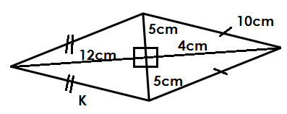Study the figure below and answer questions that follow.

a) Find the value of K.

b) Find the area of the above figure

c) Find the perimeter of the above figure.

1. Find the area of a kite whose diagonals are 18cm and 22cm.
2. 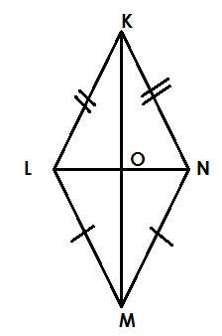The diagonals of the kite below measure 14cm and 22cm, KO = 8cm

a) Find the length of OM and LO.

b) Find the area of LMN

c) Find the area of the kite

**FINDING THE UNKNOWN SIDE AND AREA OF KITES**

Examples

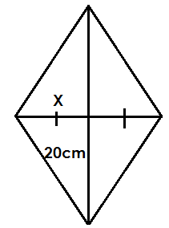1. The area of the kite below is 160cm2. One of the diagonals is 20cm. find the length of the second diagonal.

$\frac{1}{2}$ x d1 x d2 = Area

$\frac{1}{2}$ x 20 x d = 160cm

d2 =

d2 = 16cm

b) Find the value of X.

X = $\frac{d}{2}$

= $\frac{16}{2}$ cm

= 8cm

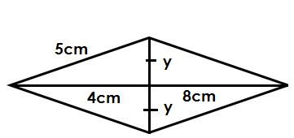2. The diagram below is a kite.

a) Find the value of y.

b) Calculate the area of the kite above.

**Activity:**

1. A kite has an area of 72cm2. One of its two diagonals is 8cm. find the length of the second diagonals.

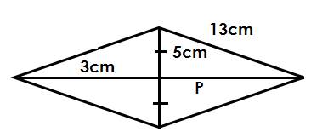2. Study the kite below and answer questions below.

a) Find the value of P.

b) Find the length of the longer diagonal.

c) Calculate the area of the kite.

3. The area of a kite is 120cm2. If one of its diagonals is 8cm, find the length of the second diagonal.

1. The figure below has an area of 45cm2.

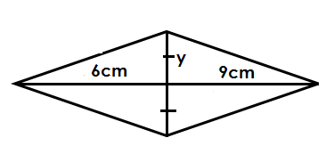

Find the length of the second diagonal.

1. Study the kite below and find the following: -

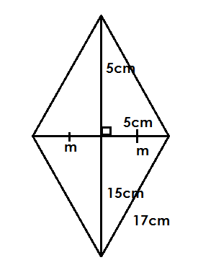

a) Find the value of m.

b) Find the length of the shorter diagonal.

c) Work out the area of the kite.

**TRIANGULAR PRISM**

**Note:**

* It has five faces (i.e., 3 rectangular faces, and 2 triangles).
* It has 6 vertices
* It has 9 edges

**Illustration**

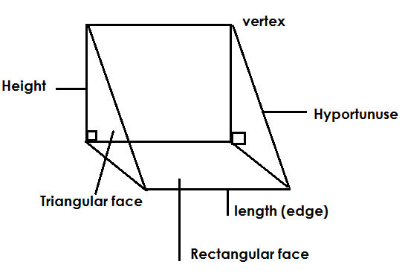

**Net of a triangular prism**

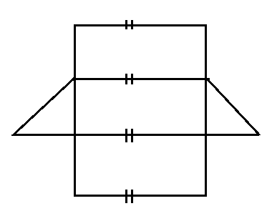

* Volume of a triangular prism = $\frac{1}{2}$ x b x h x L

**Examples**

Below is a triangular prism

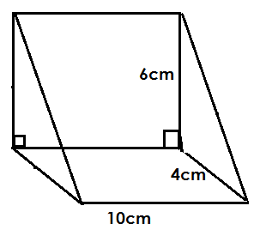

1. Find the volume of the prism

V = $\frac{1}{2}$ x b x h x L

= $\frac{1}{2}$ x 4cm x 6cm x 10cm

= 2cm x 6cm x 10cm

**= 120cm3**

1. Study the triangular prism below and answer questions that follow.

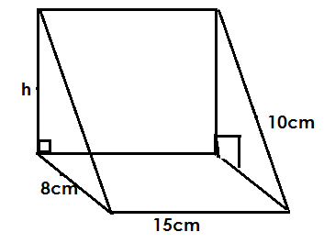

a) Find the value of h.

**soln**.

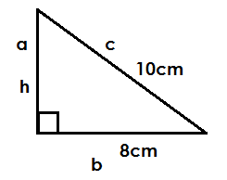

a2 + b2 = c2

h2 + 82 = 102

h2 + 8 x 8 = 10 x 10

h2 + 64 = 64 = 100 – 64

h2 = 36

2 =

**h = 6cm**

b) Find the volume of the above prism.

**Soln.**

V = $\frac{1}{2}$ X b x h x L

= $\frac{1}{2}$ x 8cm x 6cm x 15cm

= 4cm x 6cm x 15cm

**= 360cm3**

**Activity:**

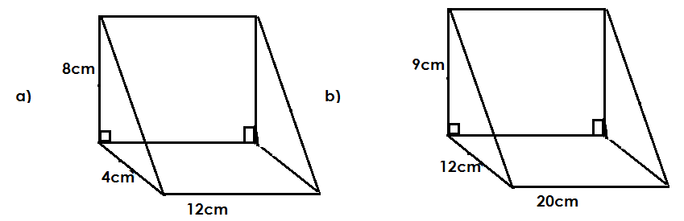1. Find the volume of the triangular prisms below

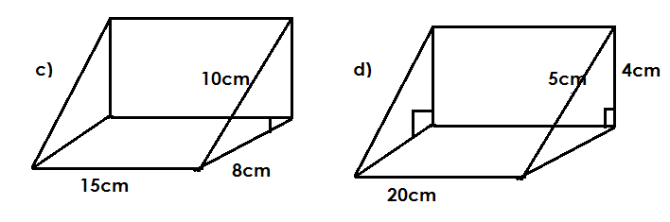

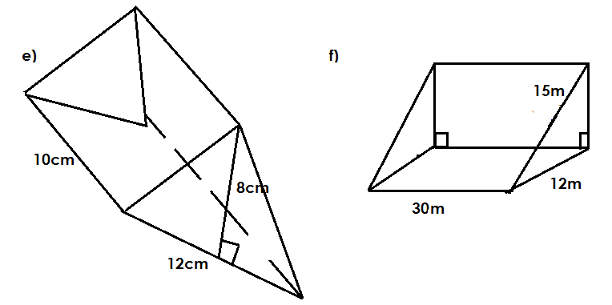

2. Study the prism below and answer questions that follow.

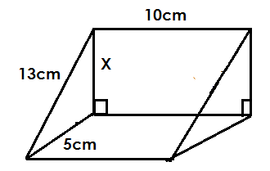

a) Find the value of X

b) Find the volume of the prism above.

**FINDING TOTAL SURFACE AREA OF A TRIANGULAR PRISM**

**A TRIANGULAR PRISM**

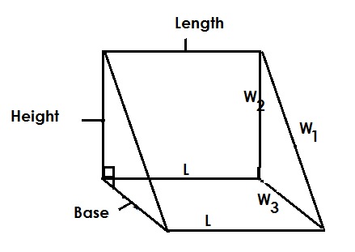

T.S. A = B x H **+** L (W1 + W2 + W3)

Where:

H = Height

B = Base

L = Length

W1 = Width one

W2 = width two

W3 = Width three

**Example I**

Below is a triangular prism, use it to answer questions.

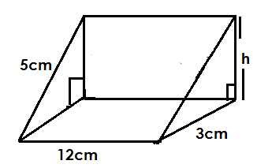

a) Find the value of h.

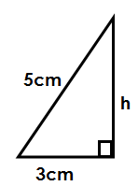**soln.**

a2 + b2 = c2

32 + h2 = 52

3 x 3 + h2 = 5 x 5

9 + h2 = 25

9 – 9 + h2 = 25 – 9

h2 = 16

2 =

**h = 4cm**

b) Calculate its total surface area.

Soln.

T.S. A = B x H + L (W1 +W2 + W3)

= (3cm x 4cm) + 12cm (5cm + 4cm + 3cm)

= 12cm2 + (12cm x 12cm)

= 12cm2 + 144cm2

= 156cm2

c) Find its volume.

Soln.

Vol. = $\frac{1}{2}$ x b x h x L

= $\frac{1}{2}$ x 3cm x 4cm x 12cm

= 72cm2

**Activity:**

Find the unknown sides and total surface area of the following figures.

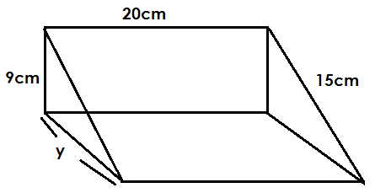

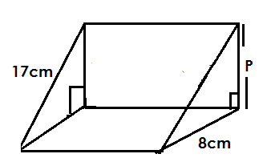

**30cm**

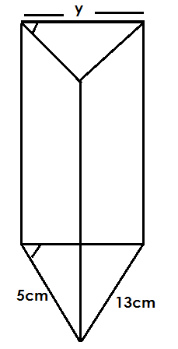

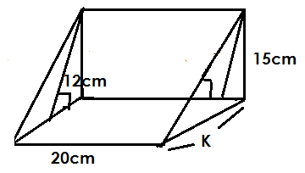

**40cm**

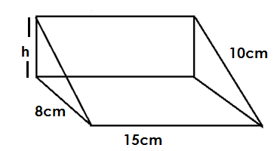

**CIRCULAR BASED PRISM / CYLINDER**

Note:

* It has three surfaces i.e. 2 circular ends and one curved surface (Rectangular surface).
* Net of a cylinder

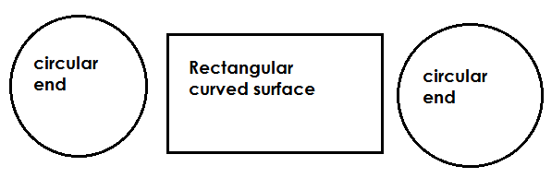

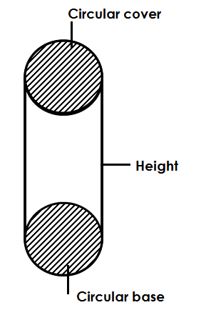**Cylinder**

**FINDING THE TOTAL SURFACE AREA OF A CYLINDER**

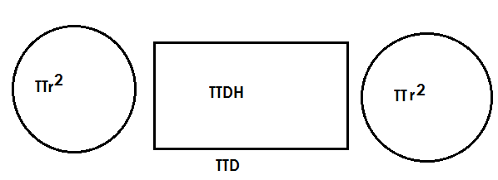

**Closed cylinder**

**Soln.**

+ +

+ +

+

**∴** T.S. A = $2πr^{2}$ + $πDH$

**Open (one end opened cylinder)**

T.S. A = $πr^{2}$ + $πDH$

**Examples**

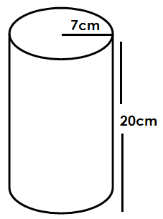1. Find the total surface area of the cylinder below.

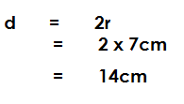

T.S. A = $2πr^{2}$ + $πDH$

= (2 x $\frac{22}{7}$ x 7cm x 7cm) + ( $\frac{22}{7}$ x 14cm x 20cm)

= 308cm2 + 880cm2

**= 118cm2**

2. Below is a cylinder. Use it to answer questions that follow.

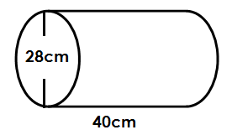

a) Find the area of the curved surface.

A = + $πDH$

= $\frac{22}{7}$ x 28cm x 40cm

= 22 x 4cm x 40cm

= 3520cm.

b) Calculate its total surface area.

T.S. A = $2πr^{2}$ + $πDH$

= (2 x $\frac{22}{7}$ x 14cm x 14cm) + ( $\frac{22}{7}$ x 28cm x 40cm)

= 1232cm2 + 3520cm2

**= 4752cm2**

1. Calculate the total surface area of an open cylinder whose radius is 14cm and height is 40cm.

Soln.

T.S. A = $2πr^{2}$ + $πDH$

= ( $\frac{22}{7}$ x 14cm x 14cm) + ( $\frac{22}{7}$ x 28cm x 40cm)

= 616cm2 + 3520cm2

**= 4136cm2**

1. The area of the shaded part in the figure below is 154cm2.

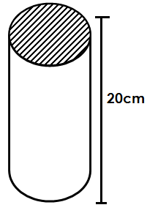

a) Calculate its T.S.A

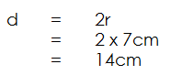soln.

= 154cm2 x 7

= 2 x 7

2 = 2

**r = 7cm**

T.S. A = $2πr^{2}$ + $πDH$

= (2 x $\frac{22}{7}$ x 7cm x 7cm) + ( $\frac{22}{7}$ x 14cm x 20cm)

= 2 x 22cm x 7cm + 22 x 2cm x 20cm

= 398cm2 + 880cm2

**= 1188cm2**

**Activity:**

1. Find the total surface area of the figure below.

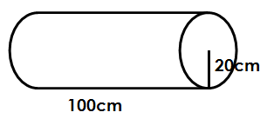

2. Find the total surface area of the cylinder below.

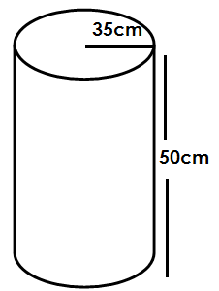

1. Find the total surface area of a cylinder with one open end whose diameter is 14cm and height is 20cm.

4. Calculate the total surface area of a cylinder whose radius is 28cm and height is 40cm.

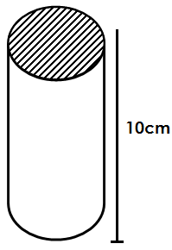5. The area of the shaded part in the figure below is 616cm2.

1. Find the total surface area of the figure.

6. The circumference of the shaded part in the figure below is 88cm.

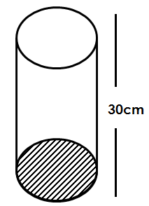

a) Find the radius of the figure above.

b) Find the area of the curved surface of the figure above.

c) Calculate the total surface area of the figure above.

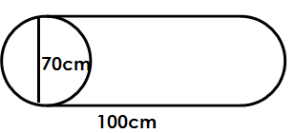7. The figure below is a cylinder drum.

a) If it was cut open to form a rectangular sheet of metal hat has used to form a rectangular door. Find the length of the door formed.

b) Calculate the perimeter of the rectangular door formed.

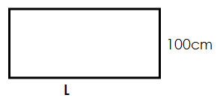8. Below is a rectangular sheet of metal that was cut from a cylinder drum of radius 70cm.

a) Find its length.

b) What was the total surface area of the cylinder drum before cutting it open?

9. The area of the curved surface of the cylinder below is 880cm2.

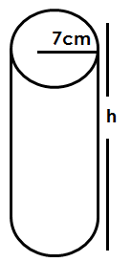

a) Calculate its height.

b) Find its curved surface

1. Calculate the total surface area of an open cylinder with a radius of 14cm and height 20cm.

**VOLUME AND CAPACITY**

**Note:**

* Volume is the amount of space occupies by an object.
* Capacity is the amount of contents that a given container can accommodate.
* To find capacity, you must have volume.

**Scale:**

* 1 litre = 1000cm3
* Volume of a prism = Base area x height
* Volume of a cylinder = $πr^{2}h$
* Volume of all prisms = Base area x height

**Examples:**

1. Find the volume of the cylinder below.

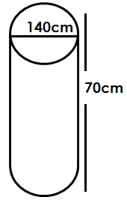

Soln.

Volume = $πr^{2}h$

= $\frac{22}{7}$ x $\frac{140cm}{2}$ x $\frac{140cm}{2}$ x 70

= 22 x 10cm x 70cm x 70cm

**= 1078000cm3.**

2. Below is a cylinder tank

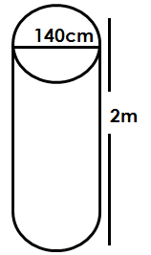

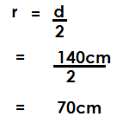

a) Find its volume.

Soln.

1m = 100cm

2m = 2 x 100cm

= 200cm

Volume = $πr^{2}h$

= $\frac{22}{7}$ x 70cm x 70cm x 200cm

= 22 x 10cm x 70cm x 200cm

**= 308000cm3**

b) How many litres of water can a tank hold when it is ½ full.

Soln.

1000cm3 = 1litre

1cm3 = L

3080000cm = ( $\frac{1}{1000}$ x 3080000) litres

= 3080 litres

When ½ full = $\frac{1}{2}$ x 3080 litres

**= 1540 litres**

**Activity:**

1. Find the volume of the cylinder below.

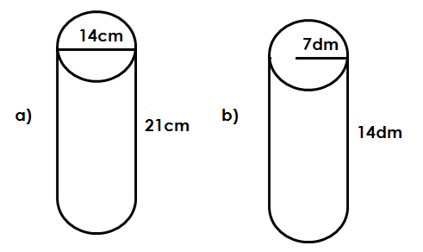

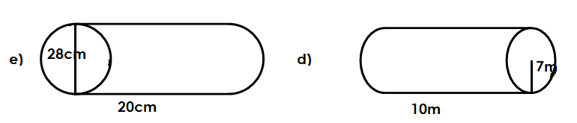

2. Below is a cylindrical tank.

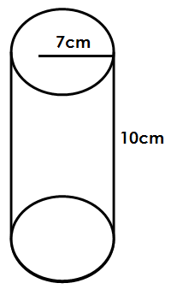

a) Find the volume of the tank.

b) How many litres of water can a tank above hold when $\frac{1}{2}$ full?

3a) Find the volume of a cylinder whose radius is 20cm and heigh is 50cm.

b). How many litres of water can the above cylinder hold?

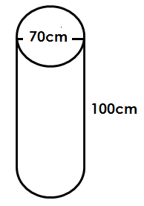c). Find the capacity of the tank below.

5. The tank below is holding some water.

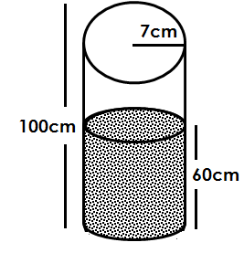

1. How many litres of water are in the tank?

b) How many litres of water are needed to fill the tank?

6. How many litres of water can a cylindrical tank of diameter 42cm and height of 100cm hold?

7. Below is a tank hold some water.

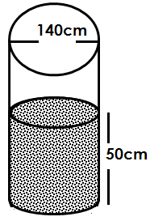

a) How many litres of water are in the tank?

b) If the tank above is $\frac{5}{8}$ full of water, how many litres of water can it hold when completely full?

**MORE ON FINDING CAPACITY**

**Examples:**

1. The tank below is $\frac{2}{3}$ full of water. How many litres of water can it hold when completely full. (Use $π$ as 3.14).

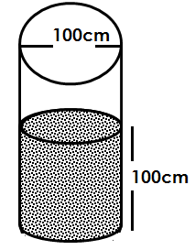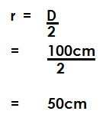

V = $πr^{2}h$

= 3.14 x 50cm x 50cm x 100cm

= $\frac{314}{100}$ x 50cm x 50cm x 100cm

= 314 x 5cm x 5cm x 100cm

**= 785000cm3**

But 1000cm**3** = 1 litre

1cm**3** = ( )Litres

785000cm3 = ( $\frac{1}{1000}$ x 785000) L

= 785 litres

Let the litres be m

$\frac{2}{3}$ of m = 785 litres

$\frac{2}{3}$ m = 785 L x 3

$\frac{2}{3}$ m = $\frac{785L x 3}{2}$

**m = 1177 $\frac{1}{2}$ litres**

2. The tank below is holding some water.

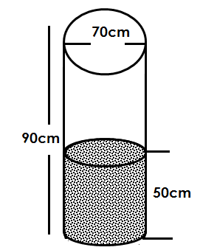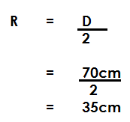

a) Find the volume of water in the tank.

**Soln.**

Volume = $πr^{2}h$

= $\frac{22}{7}$ x 35cm x 35cm x 50cm

= 22 x 5cm x 35cm x 50cm

= 192500cm3

1000cm3 = 1 litre

1cm3 = ( )litres

= 192.5 litres

1. How many litres of water are needed to fill the tank?

Soln.

Height of empty space = 90cm – 50cm

= 40cm

Volume = $πr^{2}h$ 5cm

= $\frac{22}{7}$ x 35cm x 35cm x 40cm

= 22 x 5cm x 35cm x 40cm

**= 154000cm3**

1000cm3 = 1 litre

1cm3 = ( ) litres

= ( $\frac{1}{1000}$ x 154000) litres

**= 154 litres**

**Activity:**

1. The tank below is $\frac{2}{3}$ full of water.

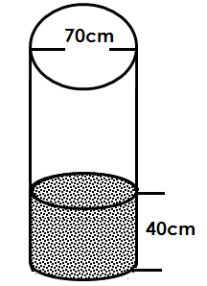

a) How many litres of water can the tank hold when capacity full of water?

b) How many litres of water are needed to fill the tank?

1. Below is a tank which is partly full of water.

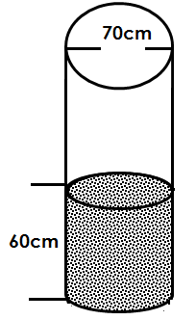

a) If it is $\frac{1}{3}$ full of water, how many litres can the tank hold when it is $\frac{1}{2}$ full?

1. How many litres of water are needed to fill the tank?
2. The tank below is $\frac{3}{4}$ full of water, find its full capacity.

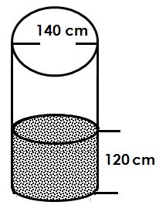

1. Use the tank below to answer questions.

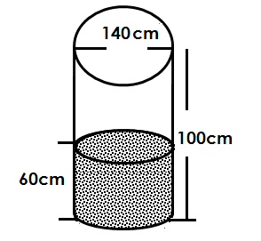

1. How many litres are in the tank?

b) How many litres of water are needed to fill the tank?

5. The tank below is holding some water.

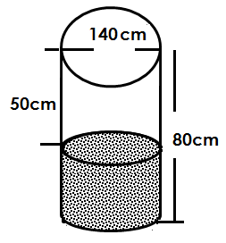

1. How many litres of water are in the tank?

b) How many litres of water are needed to fill the tank.

6) How many litres of water are in the tank below.

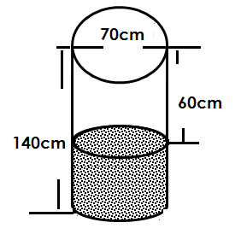

How many litres of water are needed to fill the tank below.

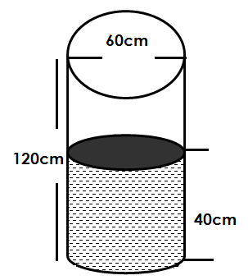

**FINDING HEIGHT OR RADIUS OF A CYLINDER GIVEN CAPACITY OF A CYLINDER**

**Example I**

A tank below is hold 154 litres.

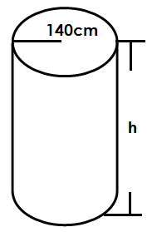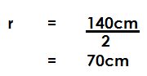

Find the height of the tank.

**Soln.**

1 L = (1540 x 100) cm3

1540 L = (1540 x 1000) cm3

= 1540000cm3

= vol

x 70cm x 70cm x h = 1540,000cm3.

22 x 10cm x 70 x h = 1540,000cm3

x x x h =

h = 100cm

**Example II**

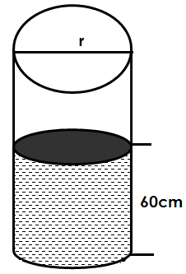Find the radius of the tank below holding 75.36 litres (Take $π$ as 3.14)

Soln.

$π{rh}^{2}$ = vol

3.14r2h = 75.360cm3

r2 x 60cm = 75360cm3.

x r2 x 60cm = 75360cm3 x 100

314r2 x 60cm = 75360cm3 x 100

r2 x 60cm =

r2 = 400cm2

2 = 2

r = 20cm

**Activity:**

1. Find the radius of the tank below if its capacity is 308 litres.

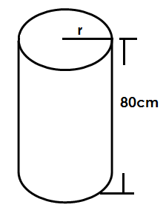

2. Find the height of a cylinder whose diameter is 28cm, if its volume is 6160cm3.

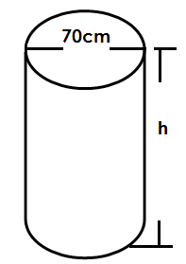3. Below is a cylinder. Find its height if its diameter is 70cm and capacity is 385 litres.

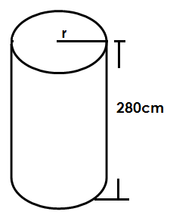4. Find the radius of the tank below. Take $π$ = $\frac{22}{7}$

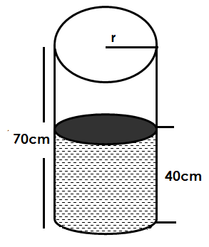5. Study the diagram below and answer questions that follow.

a) Find its radius

b) How many litres of water can the tank hold when completely full of water.

**COMPARING VOLUME**

**Examples**

1. The figure below shows a cylindrical hole pipe. Find the volume of the concrete.

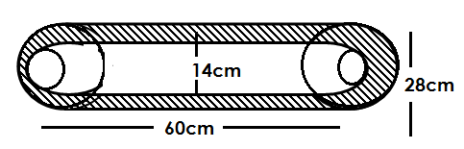

Soln

|  |  |  |
| --- | --- | --- |
| Volume of outer | Volume of inner | Volume of concrete |
| $πr^{2}$ h $\frac{22}{7}$ x $\frac{28cm}{2}\frac{28cm}{2}$ x 60cm  **36960cm3** | h  x x 60cm  **9240cm3** | 36960cm3  - 9240cm3  27720cm3 |

**Activity:**

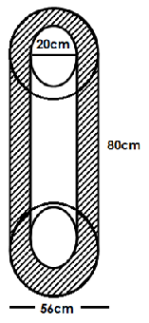1. Below is a hole pipe. Calculate the volume of the metal.

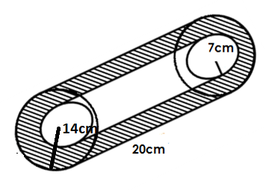

2.Find the volume of the concrete in the figure above.

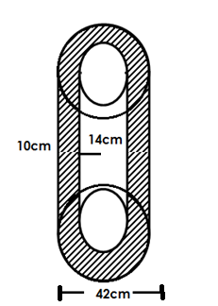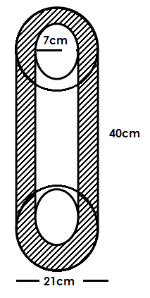3. Find the volume of the concrete in the figures below.

1. The figure below shows a cylindrical hollow pipe of concrete. Calculate the volume of the concrete.

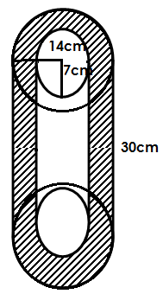

1. Below is a cylindrical hole pipe. Find the volume of the metal.

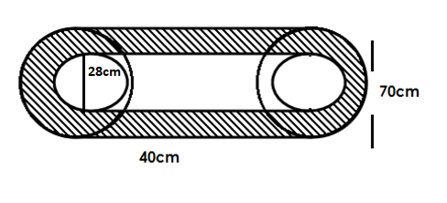

**COMPARING VOLUME OF DIFFERENT CONTAINERS**

**Example I**

Container X has the same volume with container Y. Find the volume of H.

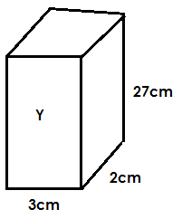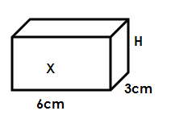

**Soln.**

Volume = volume

L X W X h = L X W X h

6cm x 3cm x h = 27cn x 2cm x 3cm

$\frac{6cm}{6cm}$ x $\frac{3cm}{3cm}$ x h = $\frac{27cm x 2cm x 3cm}{6cm x 3cm}$

**h = 9cm**

**Example II**

Tank A has the same volume with tank B. find the volume of P.

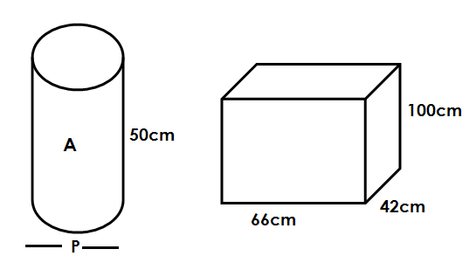

Volume = volume

$πr^{2}$ h = L X W X h

r2 x 50cm = 66cm x 42cm x 100cm

7 x r2 x 50cm = 66cm x 42cm x 100cm x7

22r2 x 50cm = 66cm x 42cm x 100cm x 7

r2x =

r2 = 3cm x 42cm x 2 x 7

r2 = 1764cm2

2 = 2

R = 42cm

P = r + r

= 42cm + 42cm

**= 84cm**

**Activity:**

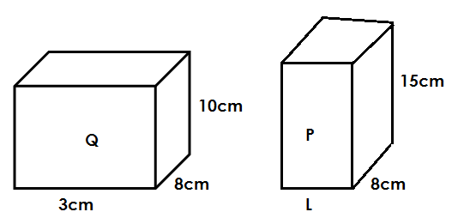1. Tank Q and tank P have the same capacity.

Find the value of L

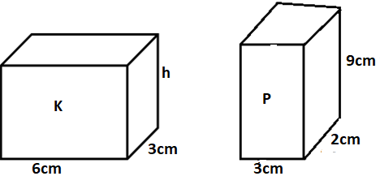2. Tank K and tank P have the same volume. Find the height of tank K.

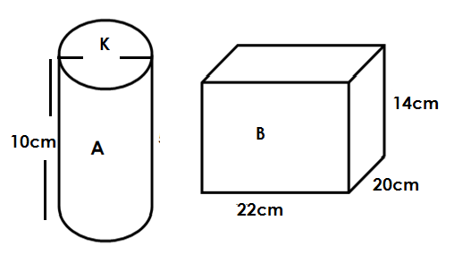3. Tank A and Tank B hold the same amount of water when completely full.

Find the value of P.

4. A trader poured cooking oil from tank A into tank B. if the two tanks hold the same capacity, what was the new height of cooking oil in tank B?

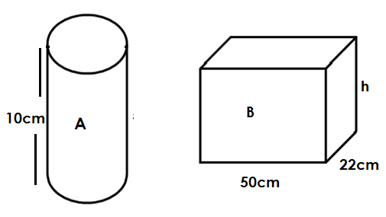

1. Find radius of tank K if the two tanks have the same capacity.

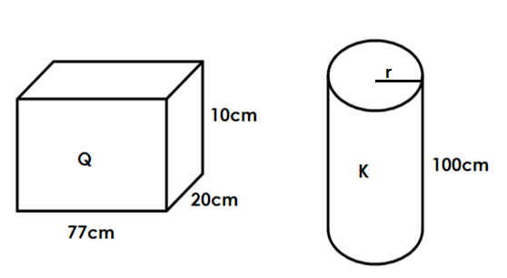

1. 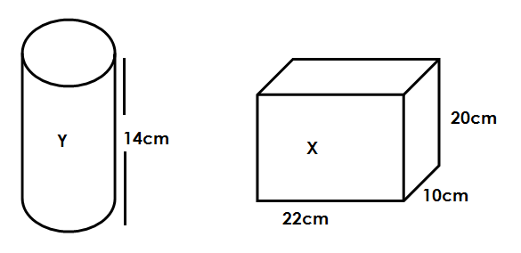Container X has the same volume with container Y. find the diameter of Y
2. The tank below contains 18480cm3 of water.

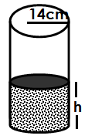

a) Find the value of h.

b) If Othieno used 2240cm3 of the water and poured the remaining in a rectangular tank of length 20cm and width 14cm, find the new height of water in the rectangular tank.

8. The tank below is holding some water.

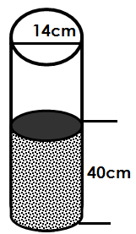

If water in the tank is poured in a rectangular tank measuring 22cm long, 20 cm wide. Find the height of the water in the rectangular tank.

**PACKING (AREA)**

**Note:**

* Remainder are not considered in packing; hence whole numbers are taken to be the final answers.
* Length is packed along length and width is packed along the width.
* Diameter is packed along the length and width.

**Example I**

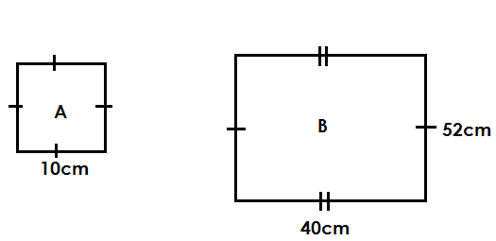Square tiles A were packed on the flow marked B

a) How many tiles were used altogether?

|  |  |  |
| --- | --- | --- |
| A long length | A long width | Total no. of files |
| $$\frac{40cm}{10cm}$$**4 tiles** | **5 rem 2 $$\frac{52cm}{10cm}$$**  **5 tiles** | (4 x 5) tiles  **20 tiles** |

Find the area left un covered with files.

|  |  |  |
| --- | --- | --- |
| Area of flow | Area of tiles | Area uncovered |
| L x W  40cm x 52cm  **2080cm2** | S x S x 20  10cm x 1mcm x 20  **2000cm2** | 2080cm2  -2000cm2  **80cm2** |

**Example II**

Rectangular tiles P were used to cover room Q. How many tiles are needed?

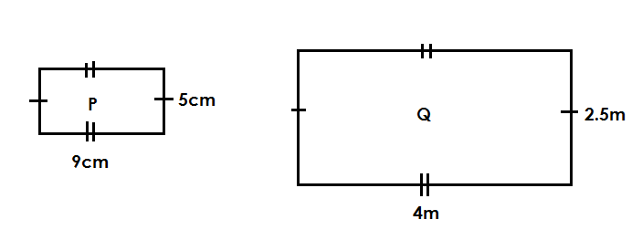

|  |  |
| --- | --- |
| 1m = 100cm  4m = 4 x 100cm  = 400cm | 1m = 100cm  2.5cm = $\frac{25}{10}$ x 100cm  **= 250cm** |

|  |  |  |
| --- | --- | --- |
| Along length | Along width | No. of tiles |
| $$\frac{400cm}{9}$$**44 tiles** | $$\frac{250cm}{5cm}$$ | (44 x 50) tiles  **2200 tiles** |

Find the area of the flow left un covered.

|  |  |  |
| --- | --- | --- |
| Area of room | Area of tiles | Area uncovered |
| L X W  400cm x 250cm  100,000cm2 | L x W x 2200  9cm x 5cm x 22cm  99000cm2 | 100,000cm2  - 99,000cm2  1,000cm2 |

**Example III**

Circular cards B were cut from rectangular manilla paper A.

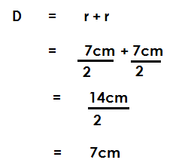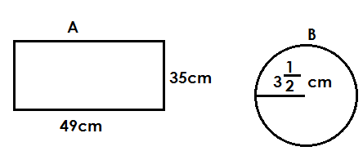

a) How many cards were made?

|  |  |  |
| --- | --- | --- |
| Along length | Along width | Total no. of cards |
| L x W  49cm x 35cm  **1715cm2** | **5cm** | (7 x 5) cards  **35 cards** |

b) Find the area of the parts wasted.

|  |  |  |
| --- | --- | --- |
| Area of manila | Area of all cards | Area wasted |
| L X W  49cm x 35cm  1715cm2 | $πr^{2}$ x 35 $\frac{22}{7}$ x 3 $\frac{1}{2}$ cm x 3 $\frac{1}{2}$ cm x 35 $\frac{22}{7}$ x $\frac{7}{2}$ cm x $\frac{7}{2}$ cm x 35  cm2 | (1715 – ) cm2    = **367½ cm2** |

**ACTIVITY:**

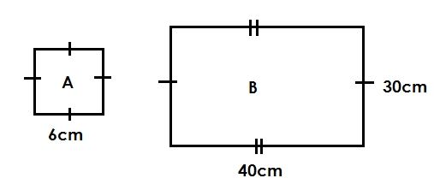1. How many square tiles A are needed to covered a floor B.

b) Find the area of the floor left uncovered.

2. How many squares tiles each 30cm are needed to cover a floor of 15cm long and 9m wide.

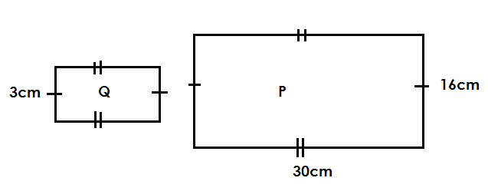3. Small cards Q were made from rectangular manilla paper P.

a) Find number of cards made.

b) Find area of the manilla paper wasted.

4. Square tiles A were used to cover rectangular room Q.

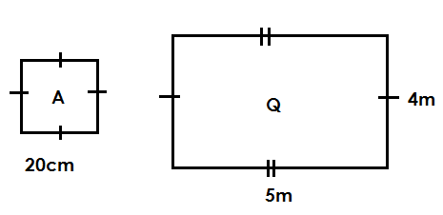

a) Find area of the room left uncovered.

5. The diagram below shows a rectangular piece of metal 150cm by 130cm. if circular table mats of diameter 28cm are to be cut, how many mats will be made?

1. How much material can remain after cutting out the mats?

6. Bwenjje made a rectangular designed mat measuring 70cm by 50cm, he later cut circular table mats of radius 14cm. how many circular table mats will be cut from rectangular mat?

b) Jacos designed a rectangular cloth measuring 350cm by 210cm. he designed it with circular parts of radius 3.5cm. what is the area of parts left undersigned?

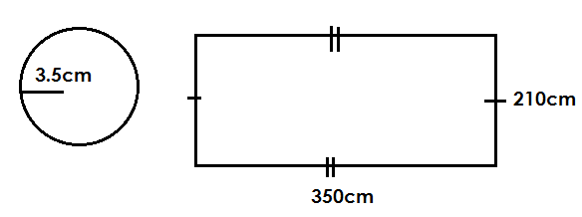

**PACKING (VOLUME)**

**Note:**

* Length is packed along length.
* Width is packed along width
* Height is packed along height.
* No. of tins = $\frac{L}{L}$ X $\frac{W}{W}$ x $\frac{h}{h}$
* Remainders are not considered.
* Number of layers is equal to the number of objects packed along the height.

= $\frac{H}{h}$

**Example I**

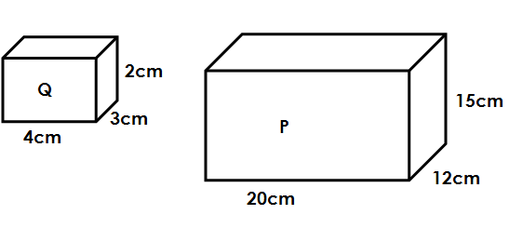1. Small pack Q are to be packed in big packed P.

a) How many packs can be packed altogether?

**Soln.**

|  |  |  |  |
| --- | --- | --- | --- |
| Along length | Along width | Along height | Total no. of packs. |
| $$\frac{L}{L}$$ $$\frac{20cm}{4cm}$$**5 cuboids** | $$\frac{W}{W}$$ $$\frac{12cm}{5cm}$$**4 cuboids** | $$\frac{h}{h}$$ $$\frac{15cm}{2cm}$$**7 cuboids** | (5 x 4 x 7) pack  **140 packets** |

b) How many packs are packed on the first layer?

|  |  |  |  |
| --- | --- | --- | --- |
| Length | Width | Height | Packs |
| 5 | 4 | 1 | 5 x 4 x 1  **20 packets** |

c) Find the volume of space left un occupied.

**Soln.**

|  |  |  |
| --- | --- | --- |
| Volume of box P | Volume of all packs | Volume un occupied |
| L X W X h  20cm x 12cm x 15cm  **3600cm3** | L X W X h x 140cm  4cm x 3cm x 2cm x 140cm  **3360cm3** | 3600cm3  -3360cm3  **240cm3** |

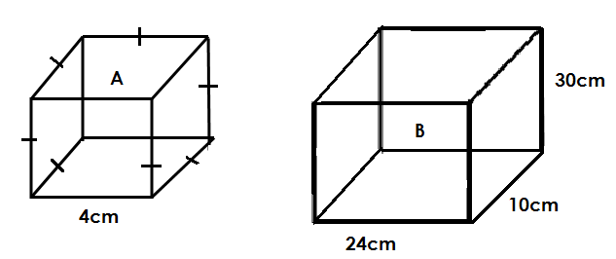**Activity:**

1.

a) Small cubes A are to be packed in big box B. how many cubes of A can fit in B?

b) Find the number of cubes that were packed up to the 4th layer.

c) Find the volume of space left un occupied.

2. Small boxes of chalk A were packed in big box T.

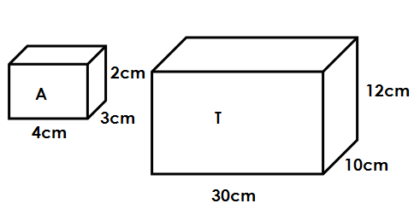

a) How may boxes are packed altogether?

b) Find the volume of space left un occupied.

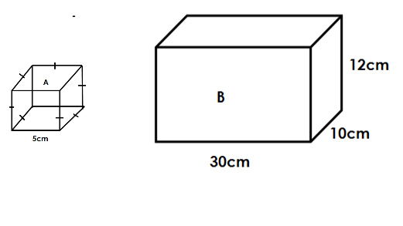3. Small boxes A are to be packed in big box B.

a) How many layers of small boxes A were packed in big box B?

b) Find the volume of the space left un occupied after packing all possible boxes in big box B,

4. Small boxes of match stick each measuring 4cm by 3cm by 2cm were packed in a certain box measuring 40cm by 28cm by 30cm.

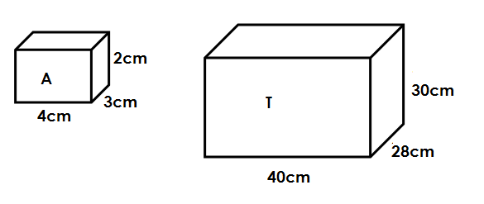

a) Find the volume of the space left un occupied after packing all possible boxes of match sticks.

5. Small tins K are to be packed in a big box Q.

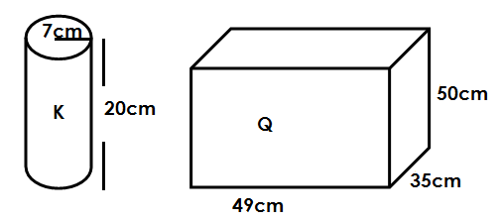

a) Find the number of tins that can be packed altogether.

b) Find the volume of space left un occupied.

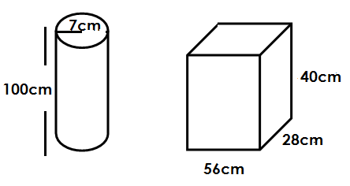6. Cylinder tins A were packed in box B.

a) How many cylindrical tins were packed altogether?

b) Find the volume of space left unoccupied.

8. Cylinder tins of blue band of radius 3.5cm and height 5cm were packed in a big measuring 70cm by 35cm by 30cm.

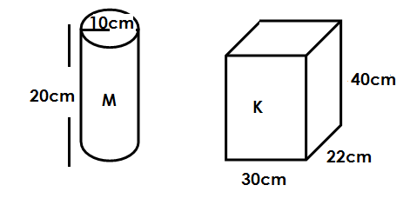

Find the volume of the space left unoccupied after packing all possible tins M in big box K.

**PACKING CAPACITY**

**Example**

1. a trader bought cooking oil in tank B and sold it using small tins A as shown below.

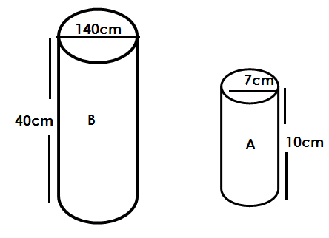

a) How many small tins A of cooking oil did he sell if all cooking oil was sold?

Soln.

No. of tins = $\frac{volume of B}{Volume of A}$

Volume of B = $πr^{2}$ h

= $\frac{22}{7}$ x $\frac{140cm}{2}$ x $\frac{140cm}{2}$ x 40cm

= 616000cm3

Volume of A = $πr^{2}$

= $\frac{22}{7}$ x 7cm x 7cm x 10cm

= 1540cm3

No. of tins = 3

**= 400 tins**

b) If each small tin of cooking oil was sold at sh. 2500, how much did he get after selling all the cooking oil?

Soln.

1 tin = sh. 2,500

400 tins = sh. 2500 x 400

**= sh. 100,000**

**Activity:**

1. Shell petrol station bought a rectangular container of petrol to its full capacity, measuring 440cm by 280cm by 100cm. later this petrol was sold in cylindrical drums of radius 70cm and height 40cm.

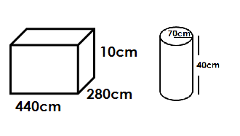

a) How many drums were sold if all petrol was sold?

b) If each litre was sold at sh.2500. how much was collected after selling all the petrol?

2. Malobo served visitors with water in a tank Q using cups B as shown below:

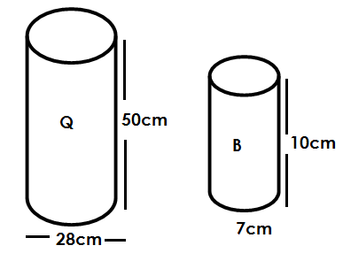

1. If all the water in tank Q was served to visitors and each visitor got a full cup of water. Find the number of visitors served.

3. A farmer poured milk in jerrycan T and sold it using small tins B.

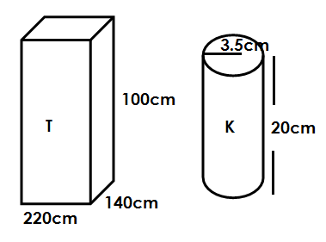

1. If all milk was sold using cups K each at sh. 1500. How much did the farmer get altogether?

4. Mulata served tea from big sauce pan A using small cups B as shown below.

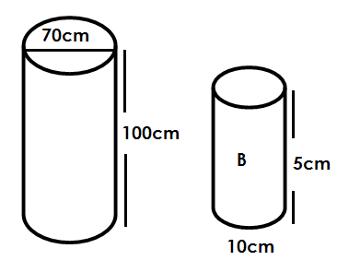

a) If each pupil was given a full cup of tea. How many pupils were served altogether if the saucepan was emptied?

**ALGEBRA**

**Definition**

Algebra is a branch of mathematics dealing with the use of symbols or unknown to represent quantity or value of something.

**Collecting like terms**

**Note:**

* Like terms are terms that are exactly the same.
* When collecting like terms each term must be transferred with its sign before and any term without a sign is a positive number.
* Terms are separated by a comma, a plus, minus signs or equal signs.
* Multiplication, division and a bracket make single terms.

**Examples**

1. Simplify: 4K – 3 + K + 8

**Soln.**

= 4k – 3 + k + 8

= 4k + k – 3 + 8

= 5k + 5

2. Simplify: 9 x y – 3 x y

**Soln**.

= 9x y – xy – 3xy

= 9 x y = 3 x y – xy

= 6 x y – xy

= 5xy

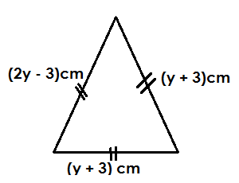3. Find the perimeter of the following:

**Soln.**

Perimeter = S + S + S

= (y + 3) cm + (y + 3) cm + (2y-3) cm

= y + 3cm + y + 3cm + 2y – 3cm

= y + y + 2y + 3cm + 3cm – 3cm

= 4y + 6cm – 3cm

= (4y + 3) cm

**Activity:**

**1. Simplify:**

a) a + a + a

b) Xy2 + xy2

c) 9 x y – xy – 3xy

d) 4p – 6p – 3p

e) 4 x m + 8 – xm

f) Pq2 + 4 + 3Pq – 8

g) 7y + 8 – 2y – 14

h) P + 4 + 3P – 13

i) Xy2 + 3 xy2 – 2xy2

j) 4 x m + 8 – xm– 10

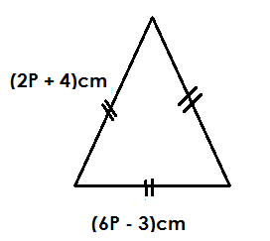**2. Find the perimeter of the figure below.**

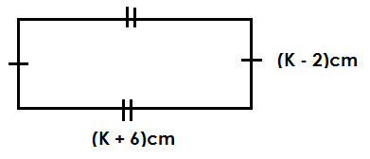3. Find the perimeter of the figure below.

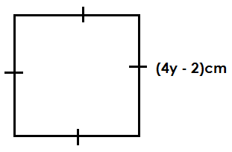4. Work out the perimeter of the figure below.

5. Find the perimeter of the figure below.

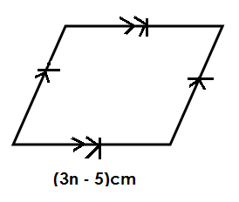

**FACTORIZING COMPLETELY**

**Examples**

1. Factorize completely: XP + MX

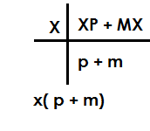Soln.

2. Factorize completely: PQ2y – MPQ

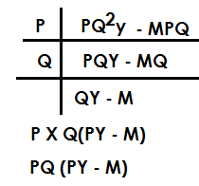**Soln**.

**ACTIVITY:**

**Factorize the following completely**

1. ma + my

2. 4ap + 18 x p

3. 3y2p – 12ym

4. 18wy – 12 x y

5. 12yp + 15px

6. am2p + pmQ

7. 14XM + 16ym

8. 20nx + 12pn

9. 4ay – 2ay

10. 18axy - 9yx

**OPENING BRACKETS**

**Note:**

To open brackets, multiply the figure outside by all items in brackets.

**Opening of brackets with positive sign outside**

**Examples**

1. Simplify: 4 (3k – 3)

**Soln.**

4 x 3k – 4 x3

12k – 12

2. Simplify: 2y (y – 2)

**Soln.**

2y x y – 2y x 2

2y2 – 4y

**Example III**

Simplify: 2 (P – 4) + 3 (P + 2)

**Soln.**

2 x p - 2 x 4 + 3xp + 2 x 3

2p – 8 + 3p + 6

2p + 3p – 8 + 6

5p – 2

**Activity:**

Simplify the following:

1. 3(k – 3)
2. 4(m + 6)
3. 2p (4- p)
4. 2(a – 4) + 2(a + 3)
5. 3(k + 2) + (4 (k2)
6. 4(y + 2) + 2 (y + 3)
7. 2y (y + 6) + 2(y + 4)
8. 4(m – 3) + 3 (2m + 4)

**OPENIONG BRACKETS WITH A NEGATIVE SIGN OUT SIDE**

**Note:**

* A negative sign outside brackets changes all signs inside brackets.
* After the third step, there is a check point about integers.

**Example 1**

Simplify: - 3(w + 8)

**Soln.**

-3 x w – 3 x 8

-3w – 24

**Example II**

Simplify: 4(k – 3) – 2(k + 4)

**Soln**.

4 xk – 3 x 4 – 2 x k – 2 x 4

4k – 12 – 2k – 8

4k – 2k – 12 – 8

**4k – 20**

**Example III**

Simplify: 3(2y – 6) – 4(y – 12)

**Soln.**

3 x 2y – 6 x 3 – 4 x y + 12 x 4

6y – 18 – 4y + 48

6y – 4y – 18 + 48

**2y + 30**

**Activity:**

Simplify the following:

1. 3(y – 2) – 2(y – 3)

2. 4(x + 4) – 2(x – 3)

3. 3(y + 4) – 2(y – 6)

4. 5(k + 3) – 4(k + 2)

5. 3(y – 2) – (y + 4)

6. 6(w – 2) – 3(w – 2)

7. 2(3p – 4) – 2(y – 4)

8. 5(y + 2) – 2(y – 4)

9. 5(m + 2) – 3(m + 7)

**ADDITION OF COMPOUND TERMS**

**Example I**

Add: 6P + 4 to 3p + 2

**Soln.**

(3p + 2) + (6p + 4)

3p + 2 + 6p + 4

3p + 6p + 2 + 4

9p + 6

**Example II**

Add: 3y – 6 to 3y + 16

**Soln.**

3y + 16 + 3y – 6

3y + 3y + 16 – 6

6y + 10

**Activity:**

Add the following:

1. 8k + 2 to 2k – 8

2. 4p + 6 to 2p – 12

3. 3y + 4 to 2y + 7

4. 3m – 6 to 2m – 4

5. 2w – 4 to w – 6

6. 4y + 3 to 2y – 11

7. 3y – 10 to 2y + 4

8. 16p + 10 to 2y + 4

9. 12y – 11 to 3y + 17

10. 6w – 12 to 2w + 20

**SUBTRACTION OF COMPOUND TERMS**

**Note:**

While subtracting compound terms, we first introduce brackets to the given terms and then we follow instructions.

**Example I**

Subtract 2p + 4 from 3p + 6

**Soln.**

(3p + 6) – (2p + 4)

3p + 6 – 2p – 4

3p – 2p + 6 – 4

**P + 2**

**Example II**

Subtract: 2y – 10 from 5y – 6

**Soln.**

(5y – 6) – (2y – 10)

5y – 6 – 2y + 10

5y – 2y – 6 + 10

**3y + 4**

**Activity:**

Subtract the following: -

1. y + 4 from 2y – 6

2. 3m + 2 from 5m + 6

3. 2(m + 4) from 3(m + 6)

4. y – 8 from y + 10

5. 6y – 10 from 10y – 13

6. 3p + 4 from 4p + 8

7. 4n + 4 from 6n – 4

8. x + 4 from 2x + 9

**ADDITION AND SUBTRACTION OF FRACTIONAL ALGEBRAIC TERMS**

**Example I**

Note:

Find the LCD which is 20.

Simplify: $\frac{K}{4}$ + $\frac{K}{5}$

**soln.**

$\frac{K}{4}$ + $\frac{K}{5}$

= $\frac{(Kx 20)}{4}$ + $\frac{(Kx 20)}{5}$

20

= 5k + 4k

20

= $\frac{ 9K}{20}$

**Example II**

Simplify: $\frac{3p}{5}$ + $\frac{P}{5}$

**Soln.** LCD =5

+ =   
=

**Example III**

Simplify: $\frac{2y }{4}$- $\frac{2y}{3}$

**Soln.** LCD = 12

- = - ()

12

= $\frac{9y-8y}{12}$

= y

12

**Example IV**

Simplify: $\frac{2y}{5}$- $\frac{y}{6}$

Soln = LCD = 30

- = ( x 30) – ( $\frac{4}{6}$ x 30)

30

= $\frac{12y-5y}{30}$

= $\frac{7y}{30}$

**Example V**

Simplify:

$\frac{k+2}{3}$ + $\frac{K-3}{4}$

**Soln**. LCD = 12

+ = 4(k + 2) + 3(k – 3)

12

=4 x K + 4 x 2 + 3 x K – 3 x 3

12

=4k + 8 + 3k – 9

12

=4K + 3K + 8 – 9

12

=7k – 1

12

**Example VI**

Simplify:

( P – 2)-(P – 3) = 4(P – 2) – 3 (P – 3)

3 4 12

= 4 x P – 2 x 4 – 3 x p + 3 x 3

12

= 4P – 8 – 3P + 9

12

= P + 1

12

**Activity:**

Simplify the following.

1. +

2. +

3. +

4. +

5. +

6. -

7. -

8. -

9. -

10. -

**REMOVING BRACKETS INVOLVING FRACTIONS**

**Example I**

Simplify: ¾ (12y – 8)

Soln.

¾ x 12y – ¾ - 8

3 x 3y – 3 x2

**9y – 6**

**Example II**

Simplify: 3/7 (14w + 28)

Soln.

$\frac{3}{7}$ (14w + 28)

= $\frac{3 x14w}{7}$ + $\frac{3 x 28}{7}$

= 3 x 2w + 3 4

= 6w + 12

**Example III**

Simplify: ¼ (8k – 12) + 1/3 (9k + 15)

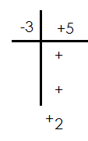Soln.

= ¼ x 8k – ¼ x 12 + 1/3 x 9k + 1/3 x 15

= 2k – 3 + 3k + 5

=` 2k + 3k – 3 + 5

= 5k + 2

**Example IV**

Simplify: 1/5( 15y – 10) – ¼ (8y – 12)

Soln.

1/5 x 15y – 1/8 x 10 – ¼ x 8y + ¼ x 12

3y – 2 – 2y + 3

3y – 2y – 2 + 3

Y + 1

**Activity:**

Simplify the following:

1. 2/3 (6m + 9)

2. ¼ (8k – 16)

3. 3/7 (7h + 14) + 2/9 (18h – 36)

4. 2/5 (15y + 20) + ¼ (16y + 4)

5. 3/8 (16p – 24) + 1/3 (9P + 12)

6. ¾ (12m – 4) – 1/3 (3m + 3)

7. ½ (2a – 4) – 1/3 (6a – 12b)

8. 2/5 (K + 4) – 1/3 (k + 4)

9. ¾ (12w – 16) – 1/5 (10w + 5)

**SUBSTITUTION**

Substitution means to replace.

Example I

Given that a = 4, b = 3 and c = 12, find the value of:

1. a + b

a + b = 4 + 3

**= 7**

1. a2 + b2

**soln**

a2 + b2 = (a x a) + (b x b)

= (4 x 4) + (3 x 3)

= 16 + 9

= 25

1. ½ ab + 1/3ca

**Soln.**

½ ab + 1/3 ca = (1/2 x a x b) + 1/3 x c x a

= (½ x 4 x 3) + 1/3 x 12 x 4

= 3 x 2 + 3 x 4

= 6 + 16

**= 22**

**Example II**

Given that a = -2, b = 4 and c = 3. Find;

i) ab+ c

**soln.**

ab + c = (a x b) + c

= (-2 x 4) + 3

=-8 + 3

**=-5**

ii) a2 + b2

a

**soln**.

a2 + b2 = a x a + b x b

a

= (-2 x -2) + (4 x 4)

= 4 + 16

**= 20**

iii) ab – c

ab – c = (a x b) - c

= (-2 x 4) – 3

= -8 – 3

**= -11**

1. bc – 2a

**soln.**

bc- 2a = b x c – 2 x a

= (4 x 3) – (2x – 2)

= 12 – (-4)

= 12 + 4

**= 16**

**Example III**

If k = 2x and x = 8. Find 2k + 8.

**Soln**.

2k + x = (2 × 2x) + x

= (2 × 2 × 8) +8

= 32 + 8

**= 40**

**Activity:**

1. Given that P = 12, Q = -3 and y = 4

Find

1. 2Q2 + 4y ii) 2 (P + Q) iii) ½ P + Q2

2. If a = 5,b =10,c =6, d =½ andc = 1/5

Find;

1. 4(a + b) ii) ad (b- c) iii) e (a + b) iv) -3(a + 3c)

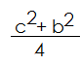

3. Find the value of if a =1,b = 2 and c = 4.

4. Given that p = a2 and a = 4. Find the value of 2p + 4a

**SUBSTITUTION INVOLVING FRACTIONS**

Example I

Given that y =½ b = ¾ and m = 1/3. Find the value of;

a) y + b – m

y + b – m = ½ + ¾ - 1/3

= (½ x 12) + (3/4 x 12) – (1/3 x 12)

12

= (6 + 9) - 4

12

= 15 - 4

12

=

**Activity:**

1. If a = ½, C = 2/3 and d = ¼. Find the value of ac +d.

2. Given that x =2/3, y = 1/3. Find the value of x + y

3. If a =3/10,b = 5/8 and c = 4/5. Find the value of a + bc.

4. Given that x = 1/8,y = 2/3 and Z = 4/5. Find the value of .

5. If P = 1 1/3,q = 2 1/3. Find the value of PQ – 1/3

6. Given that a = 1/8,b = ¼ and c = 2/5. Evaluate ac + bc.

**SOLVING SIMPLE EQUATIONS**

**Example I**

Solve: 3 + 4p = 15

Soln.

3 – 3 + 4p = 15 – 3

$\frac{4p}{4}$ = $\frac{12}{4}$

**P = 3**

**Example II**

Solve: 15 – 3w = 6

**Soln.**

15 – 15 – 3w = 6 – 15

-3w = -9

$\frac{-3w}{-3}$ = $\frac{-9}{-3}$

**W = 3**

**Activity:**

Solve the following equations below.

1. 2 + 4y = 18

2. 4 + 2p = 10

3. 8 – 2x = 12

4. 7 – 3p = 11

5. 13 – 2m = 3

6. 8 + 5n = 28

7. 10 – 2y = 12

8. 4 + 2p = 12

9. 9 – 3y = 18

10. 18 + 3k = 27

**SOLVING EQUATIONS INVOLVING UNKNOWNS ON BOTH SIDES**

**Examples:**

1.solve: 3m – 6 = m + 12.

**Soln.**

3m – 6 + 6 = m + 12 + 6

3m = m + 18

3m – m = m – m + 18

=

**M = 9**

2. solve: 4(m – 2) = 2(m + 6)

**Soln**.

4 x m – 4 x2 = 2 x m + 2 x 6

4m – 8 = 2m + 12

4m = 8 + 8 = 2m + 12 + 8

4m = 2m + 20

4m – 2m = 2m – 2m +20

$\frac{2m}{2}$ = $\frac{20}{2}$

**M = 10**

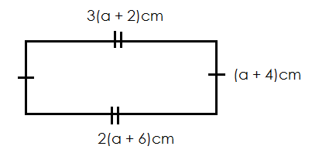3. Use the diagram below to answer questions that follow.

a) Find the value of a.

**soln.**

**length = length**

3(a + 2) = 2 (a + 6)

3a + 6 = 2a + 12

3a + 6 = 2a + 12 – 6

3a = 2a + 6

3a – 2a = 2a – 2a + 6

**a = 6**

b) Find its area.

|  |  |  |
| --- | --- | --- |
| Length | Width | Area |
| 2(a + 6) cm  2 x a +2 x 6  2 x 6 + 2 x 6  12 + 12  14cm | (a + 4) cm  (6 + 4) cm  10cm | L X W  14cm x 10cm  140cm2 |

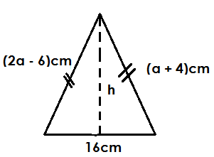4. Below is an isosceles triangle. Use it to answer questions below.

a) Find the value of a.

**soln.**

2a – 6 = a + 4

2a – 6 + 6 = a + 4 + 6

2a = a + 10

2a – a = a – a + 10

a = 10cm

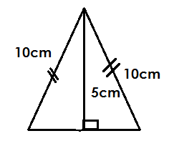b) Work out the area of the triangle above.

**Soln**.

A = ½ x b x h

= ½ x 16cm x 5cm

= 8cm x 5cm

**= 40cm2**

5. Below is a triangle. Use it answer questions below.

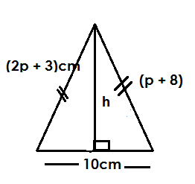

a) Find the value of P.

**Soln.**

2p + 3cm = p + 8cm

2p + 3cm – 3cm= p +8cm + 3cm

2p = P + 5cm

2p – p = p – p + 5cm

**P = 5cm**

b) Work out the area of the triangle.

**Soln.**

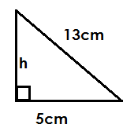First find the value of h.

a2 +b2 = c2

h2 + 52 = 132

h2 + 5 x 5 = 13 x 13

h2 + 25 = 169

h2 + 25 – 25 = 169 – 25

2 =

h = 12cm

area = ½ x b x h

= ½ x 10cm x 12cm

= 5cm x 12cm

**= 60cm2**

**Activity:**

1. Solve the equations below:

a) 5y + 4 = 3y + 8

b) 4(m – 3) = 2(m + 6)

c) 3p – 4 = p + 6

d) 3y – 2 = 2y + 4

e) 3(m + 2) = 2(m + 8)

f) 5(y – 2) = 3(y + 2)

g) 6m + 4 = m + 19

1. 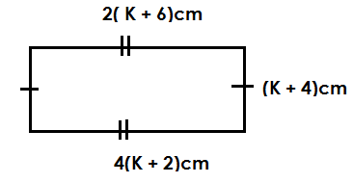Use the diagram below to answer questions that follow.

a) Find the value of K.

b) Find the area of the figure above.

3. Below is triangle. Use it to answer questions that follow.

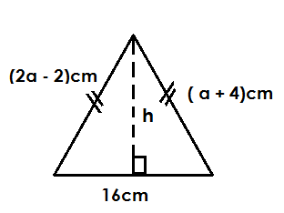

a) Find the value of a.

b) Find h.

c) Calculate the area of the triangle above.

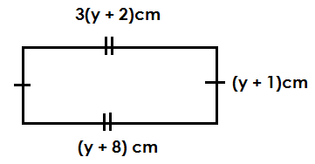4. Below is a rectangle. Use it to answer questions that follow.

a) Find the value of y.

b) Find the perimeter of the figure.

5. Study the figure below and answer the questions that follow.

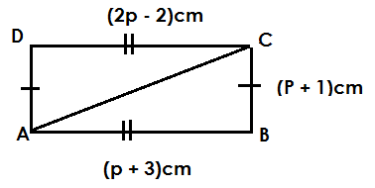

a) Find the value of P.

b) Find the length of AC.

**SOLVING EQUATIONS INVOLVING DOUBLE BRACKETS**

1. Solve: 3(p – 4) + 2(p + 3) = 14

**Soln.**

3 x p – 3 x 4 + 2 x p + 2 x 3 = 14

3p – 12 + 2p + 6 = 14

3p + 2p – 12 + 6 = 14

5p – 6 = 14

5p – 6 + 6 = 14 + 6

=

P = 4

2. Solve 3(y – 2)- 2( y + 4) = 3

**Soln.**

3 x y – 3 x 2 – 2xy – 2 x 4 = 3

3y – 6 – 2y – 8 = 3

3y – 2y – 6 – 8 = 3

y - 14 = 3

y - 14 + 14 = 3 + 14

**y = 17**

**Activity:**

Solve the following equations

1. 4(3y – 2) – 5(y – 3) = 28

2. 3 (2p + 1) + 4 (p + 3) = 35

3. 2(m + 1) + 3(m + 1) = 10

4. 3(2w + 1) – 2(w + 4) = 36

5. 2(2p – 1) – 2(p – 3) = 4

6. 2(3 x -1) – 4(x – 1) = 4

7. 5(x + 2) – 3(x – 3) = 27

8. 6(y + 1) + 3 (y +2) = 39

9. 4(p + 2) + 2(p - 3) = 16

10. 4(P +2) + 2(p + 3) = 12

**SOLVING EQUATIONS INVOLVING FRACTIONS**

**Examples**

Solve: $\frac{K}{3}$ = 4

$\frac{K}{3}$ x 3 = 4 x 3

K = 12

**Soln.**

4 x $\frac{1}{4}$ P – 6 x 4 = 7 x 4

P – 24 = 28

P – 24 + 24=28 + 24

P =52

3. Solve: 3 - $\frac{2m}{3}$ = 7

**Soln**.

3 x $\frac{3}{1}$- $\frac{2m}{3}$ x 3 = 7 x 3

9 – 2m = 21

9 – 9 – 2m = 21 – 9

$\frac{-2m}{-2}$ = $\frac{12}{-2}$

**m = -6**

**Activity:**

Solve the following equations.

1. = 12

2. 2 ½ K = 10

3. 1/4P = 2

4. P = 8

5. y +2 = 8

6. + 11 = 9

7. y– 13 = 14

8. + 8 = 12

9. +2m = 11

10. 4 – = 12

**SOLVING EQUATIONS INVOLVING DECIMALS**

**Examples**

1. Solve: 0.9p + 0.5 = 5.7

**Soln.**

$\frac{9}{10}$ P + $\frac{5}{10}$ = $\frac{57}{10}$ LCD=10

10 x $\frac{9}{10}$ P + $\frac{5}{10}$ x 10 = $\frac{57}{10}$ X 10

9p + 5 = 57

9p + 5 – 5 = 57 – 5

$\frac{9P}{9}$ = $\frac{52}{9}$

P = 5 $\frac{7}{9}$

**ACTIVITY:**

Solve the following equations

1. 0.6y – 0.3

2. 0.4x – 0.8 = 2.4

3. 0.4p + 0.5 = 2.1

4. 0.2m – 1.4 = 2.2

5. 0.3k + 0.4 = 1.9

6. 0.2n – 0.2 = 1.8

7. 0.4y – 0.8 = 3.4

8. 0.2x – 0.1 = 0.4

**SOLVING EQUATIONS INVOLVING COMPOUND FRACTIONS.**

**Examples:**

1. Solve:

+ P = $\frac{y}{8}$ = 13

**Soln.**

8 x $\frac{y-5}{2}$ + $\frac{y}{8}$ = 13 x 8

4(y – 5) + y = 104

4y – 20 + y = 104

4y + y - 20 = 104

5y – 20 = 104

5y – 20 + 20 = 104 + 20

=

Y = 24

2. Solve: = **soln.**

15 x ($\frac{m-2)}{3}$)= ( $\frac{m+4}{5} )$ x 15**LCD =15**

5(m – 2) = 3(m + 4)

5m – 10 = 3m + 12

5m – 10 + 10 = 3m + 12 + 10

5m = 3m + 22

$\frac{2m}{2}$ = $\frac{22}{2}$

m = 11

**Activity:**  
Solve the following equations.

1. + = 3

2. + = 4

3. + = 5

4. + = 2

5. + = 6

6. + = 10

7. - = 2

8. =   
9. =

10. =

**SOLVING EQUATIONS INVOLVING SQUARES**

**Examples**

1.solve:2 = 25

**Soln.**

4 x 2 = 25 x 4

P2 = 100

2 =

**P = 10**

2. Solve: 2 = 12

**Soln.**

6 x 2 = 12 x 6

=

P2 = 36

2  =

**k = 6**

3. Solve: 2 -2 = 22

**Soln.**

3 x 2 - x 3 = 22 x 3 LCD = 3

2p2 – 6 = 66

2p2 – 6 + 6 = 66 + 6

2 =

2 =

**P = 6**

**Activity:**

**Solve the following equations**

1. P2 = 4

2. m2 = 2

1. k2 = 28

4. m2 = 400

5. 2 = 15

6. 2 = 14

7. 2 = 12

8. - 1 = 14

9. 2 + 2 = 16

10. 2– 1 = 11

**APPLICATION OF ALGEBRA (ABOUT AGE)**

**Note:**

1. Older than (+)

2. Younger than (-)

3. In 10 years’, time (+ 10)

4. 5 years ago ( -5)

5. Twice (x2)

6. Four times (x4)

7. Difference (-)

**Examples**

1. Matama is 6 years older than Kabelga. If their total age is 38 years, how old is each?

**Soln.**

Let Kabalega’s age be m.

|  |  |  |
| --- | --- | --- |
| Kabalega | Matama | Sum |
| M | M + 6 | 38 years |

M + m + 6 = 38

2m + 6 = 38

2m + 6 – 6 = 38 – 6

$\frac{2m}{2}$ = $\frac{32}{2}$

m = 16

|  |  |
| --- | --- |
| Kabalega | Matama |
| = m  = 16 years | = m + 6  = (16 + 6) years  = 22 years |

2. Peter is 10 years younger than Musa. Their total age is 30 years. How old is each of them?

**Soln.**

Let Musa’s age be K.

|  |  |  |
| --- | --- | --- |
| Musa | Peter | Total age |
| K | (K – 10) | 30 years |

K + K – 10 = 30 years

2k – 10 = 30

2k – 10 + 10 = 30 + 10

$\frac{2k}{2}$ = $\frac{40}{2}$

K = 20 years

|  |  |
| --- | --- |
| Musa | Peter |
| =K  =20yrs | = (k – 10) yrs.  = (20 – 10) yrs.  = 10yrs |

3. Wandera is 10 yrs. older than Kakama. In 6 yrs.time their total age will be 46 yrs. How old is Wandera?

Let Kakamas’ age be M.

|  |  |  |  |
| --- | --- | --- | --- |
| Time | Kakama | Wandera | Total age |
| Now | M | M+ 10 | ------------------ |
| In 6yrs | M + 6 | M + 10 + 6  M + 16 | 46yrs |

M + 6 + m + 16 = 46yrs

2m + 22 = 46yrs

2m + 22 – 22 = 46 – 22

$\frac{2m}{2}$ = $\frac{24}{2}$ yrs

M = 12 yrs.

Wandera = (m + 10) yrs.

= (12 + 10) years

**= 22yrs**

b) How old will Kakama be then?

**Soln.**

Kakama = (m + 6) yrs.

= (12 + 6) yrs.

= 18 yrs.

4. Matama is 5 years older than Opio. 7 years ago, their total age was 19yrs. how old is each of them?

Let Opio’s age be m.

|  |  |  |  |
| --- | --- | --- | --- |
| Time | Opio | Matama | Sum |
| Now | M | M + 5 | - |
| 7yrs ago | M – 7 | (m + 5 – 7)  (m – 2) | 19 yrs. |

m – 7 + m – 2 = 19

m + m – 7 – 2 = 19

2m – 9 = 19

2m – 9 + 9 = 19 + 9

$\frac{2m}{2}$ = $\frac{28}{2}$

**m = 14**

|  |  |
| --- | --- |
| Opio. | Matama. |
| K  14yrs | (K + 5) yrs.  (14 + 5) yrs.  19 yrs. |

**Activity:**

1. Mandevu is 10 yrs. older than Kasule. In 5 yrs. time, their total age will be 40yrs. How old is each of them?

2. Mbaliga is 7 years older than Martha. In 9 years’ time their total age will be 45years. How old is Mbaliga?

3. Okello is 6 years older than Opio. If their total age is 20yrs, how old is each of them?

4. Kasira is 15yrs older than Mbede. In 5yrs time their total age will be 55yrs. How old is Kasira?

5. Owino is 6 yrs. younger than Matu. If their total age is 18 years, how old is Owino?

6. Koire is ten years younger than Kontwe. If their total age is 38 years, how old will Koire be in 6 years’ time?

7. Kasana is 4 years younger than Magabali. In 10 yrs time their total age will be 48yrs. How old is Kasna?

8. Wandera is 6 years younger than Wandhuru. 10 years ago, their total age was 14 years. How old were each of them by then?

9. James is 4 times as old as Martha. If their total age is 40 yrs. How old is each of them?

10. Nalule is 6 times as old as her daughter. The difference in their ages is 15 years in 10 years’ time to come. How old is Nalule?

**APPLICATION OF ALGEBRA WITHOUT TOTAL OR DIFFERENCE**

James is 11 years older than Kyamutwe. In 8 years’,timeJames will be twice as old as Kyamutwe. How old is James.

**Soln**.

Let Kyamutwe’s age be n.

|  |  |  |
| --- | --- | --- |
| Time | Kyamutwe | James |
| No | n | n + 11 |
| In 8 yrs | (n + 8) | n + 11 + 8  n + 19 |

2 (n + 8) = n + 19

2 x n + 2 x 8 = n + 19

2n + 16 = n + 19

2n + 16 – 16 = n +19 – 16

2n = n + 3

n = 3

**James** = (n + 11) yrs

= (3 + 11) yrs

= (3 + 11) yrs

**= 14 years**

**Example II**

Martha is 12 years older than Jane4 years ago Martha was four times as old as Jane. How old is Jane?

Let Jane be K.

|  |  |  |
| --- | --- | --- |
| Time | Jane | Martha |
| Now | K | K + 12 |
| 4 years ago, | K – 4 | K + 12 – 4  K + 8 |

4 (k – 4) = K + 8

4 x K – 4 x 4 = k + 8

4k – 16 = k + 8

4k – 16 + 16 = k + 8 + 16

4k = k + 24

4k – k = k – k + 24

3k = 24

$\frac{3k}{3}$ = $\frac{24}{3}$

**K = 8**

**Example III**

Okello is 11 years younger than Sarah in 7 years’ time he will be a half as old as Sarah. How old is Okello?

**Soln.**

Let Sarah’s age be y**.**

|  |  |  |
| --- | --- | --- |
| **Time** | **Sarah** | **Okello** |
| Now | Y | Y - 11 |
| 7yrs | y + 7 | y - 4 |

½ (y + 7)= y – 4

$\frac{y+7}{2}$ = y - 4

$\frac{y+7}{2}$ x 2 = 2 (y – 4)

y + 7 = 2 (y – 4)

y + 7 = 2 (y – 4)

y + 7 = 2y – 8

y – 2y + 7 = 2y – 2y – 8

-y + y = - 8

-y + 7 – 7 = 8 – 7

-y = 15

$\frac{-y}{-1}$ = $\frac{-15}{-1}$

y = 15

Okello = (y – 11) years

= 15 – 11 years

= 4 years

**Activity:**

1. Nakazi is 14 years older than Ssekazi in 7 years’ time, Nakazi will be twice as old as Ssekazi. How old is Nakazi?

2. Owinny is 12 years older than winne, in 2 years’ timeOwinny will be twice as old as Owinny. How old is each of them?

3. Matama is 20 years younger than Kalule, in 8 years’ time, she will be twice as old as Kalule. How old is Matama.

4. Kakama is 12 years younger than Kawala 5 years ago Kawala was 5 times as old as Kakama. How old is each of them?

5. John is 17 years young than Mukasa in 7 years’ time John will be twice as old as Mukasa. How old is Mukasa?

6. Wandera is 13 years younger than Fataki in 8 years’ timeWandera will be a half Fataki age. Find Fataki age.

**FINDING YEAR’S TIME**

**Example I**

Okello is 4 years and Moses is 15 years in how many years’ time will Moses be twice as old as Okello?

**Soln**.

Let the year time be K

|  |  |  |
| --- | --- | --- |
| **Time** | **Okello** | **Moses** |
| Now | 4 | 15 |
| K yrs | K + 4 | K + 15 |

2(K + 4) = K +15

2 x k + 2 x 4 = k + 15

2k + 8 = k + 15

2k + 8 – 8 = k + 15 – 8

2k = k + 7

2k – k = k – k + 7

K = 7

**Example II**

Marth is 6 years old and Owino is 20 years old in how many years’ time will Marth be a half Owino’s age?

**Soln.**

Let years’ time be M.

|  |  |  |
| --- | --- | --- |
| Time | Martha | Owino |
| New | 6 | 20 |
| M yrs | M + 6 | M + 20 |

$\frac{1}{2}$ (m + $\frac{20}{2}$) = m + 6

M + 20 = 2m + 12

M + 20 – 20 = 2m + 12 – 20

M = 2m – 8

M – 2m = 2m – 2m -8

-m = -8

$\frac{-m}{-1}$ = $\frac{8}{-1}$

M = 8

**Activity:**

1. Okello is 5 years and Peter is 17 years in how many years’ time will Peter be twice as old as Okello?

2. Nakato is 30 years and her son is 12 years. In how many years’ time will Nakato be twice as old as the son?

3. Alice is 18 years and Becca is 5 years. In how many years’ time will Alice be twice as old as Becca?

4. Betty is 7 years and Martha is 19 years old. After how many years will Betty be a half Martha’s age?

5. Wako is 26 years old and Panko is 9 years. After how many years will Panko be a half of Wako’s age?

6. Ronald is 10 years old and Moses is 4 years old, in how many years’ time will Moses be a half Ronald’s age?

**APPLICATION OF ALGEBRA IN SHOPPING**

**Example I**

At a supermarket, a book costs sh. 400 more than a pen and a set is thrice the price of a pen. If Mandevu bought all the three items at sh. 3,900. Find the cost of a set.

**Soln.**

Let the pen’s cost be m

|  |  |  |  |
| --- | --- | --- | --- |
| Pen | Book | Set | Sum |
| M | M + 400 | 3m | 3,900 |

M + m + 400 + 3m = 3900

M + m + 3m + 400 = 3900

5m + 400 = 3900

5m + 400 – 400 = 3900 – 400

5m = 3500

$\frac{5m}{5}$ = $\frac{3500}{5}$

**M = 700**

**Set** = 3m

= 3 x sh. 700

**= sh. 210**

**Example II**

At the shop of a set cost 5p and a book costs p +400. Okello bought 2 sets and 4 books if he paid sh. 7,200, how much did he spend on books?

**Soln**.

|  |  |  |  |
| --- | --- | --- | --- |
|  | **Set** | **Book** | **Sum** |
| **No.** | 2 | 4 | ………. |
| **Cost** | 5p x 2  10p | 4 (p +400)  4p + 600 | Sh. 7200 |

10p + 4p + 1600 = sh. 7200

14p + 1600 = sh. 7200

14P + 1600 – 1600 = sh. 7200 – sh. 1600

$\frac{14P}{14}$ = sh. $\frac{5600}{14}$

P = sh. 400

Books = 4p + 1600

= (4 x 400) + 600 = sh. 3200

**Activity:**

1. The cost of a book is sh. 400 less than that of a set and a pen costs twice the cost of a set. If the total cost is sh. 1200. Find the cost of a pen.

2. An apple costs sh.(92p – 200) and an orange costs sh. (p +300). If Mark bought 6 apples and 2 oranges at a cost of sh. 7800 altogether, Find the cost of an apple.

b) How much did he spend on oranges?

3. A pen costs sh. 700 less than the cost of a book and a set costs sh. 3700. Find the cost of each item.

4. In a market a shirt cost sh. y and a dress cost sh. (y – 500). If a man bought 7 shirts and 3 dresses at sh. 38500 altogether, how much did he spend on shirts?

1. In a market, a goal cost (3k + 2000) and a cock costs sh. 9k + 5000). If a trader bought 2 goats and3 cocks altogether at sh. 235000. Find the cost of a goat.

**MORE ABOUT APPLICATION OF ALGEBRA**

**Examples**

1. On a farm there are hens and cows altogether. There are 12 heads and 34 legs. How many cows are on the farm?

**Soln.**

Let the No. of cows be M

|  |  |  |  |
| --- | --- | --- | --- |
|  | Cows | Hens | Sum |
| Heads | M | 12 – m | 12 |
| Legs | 4 x m  4m | 2 (12 –m) | 34 |

4m + 2 (12 – m) = 34

4m + 24 – 2m = 34

4m – 2m + 24 = 34

2m + 24 = 34

2m _ 24 – 24 = 3y – 24

$\frac{2m}{2}$ = $\frac{10}{2 }$

**M = 5**

1. How many hens are on the farm?

No. of hens = 12 – m

= 12 – 5

= 7

1. A teacher awards 3 marks for every correct answer and subtracts 2 marks for every wrong answer. Out of the 20 questions, Nabusoko wrote 15 correct answers. How many marks did she get?

**Soln**.

Let the marks be K.

No. of marks = c – w

Wrong = 20 – 15

= 5

Marks = (3 x 15) – (2 x 5)

= 45 – 10

= 35 marks

b) Ndole got marks. How many correct answers did he write?

**Soln.**

Let the correct answers be K.

|  |  |  |  |
| --- | --- | --- | --- |
|  | Correct answer | Wrong answers | Sum |
| Question | K | 20 – k | 20 |
| Marks | 3 x k | 2 (20 – k) | 40 |

3k – 2(20 – k) = 40

3k – 40 + 2k = 40

3k – 2k – 40 = 40

5k – 40 = 40

5k – 40 + 40 = 40 + 40

$\frac{5k}{5}$ = $\frac{80}{5}$

**K = 16**

**Activity:**

1. A pen costs sh. 300 and every book costs sh. 400 Mandela bought five items and paid sh. 1700. How many book and pens did he buy?

2. On a farm, there are twenty animals. Some are birds and others are goats, altogether there are 56 legs. How many birds and goats are on the farm?

3. A teacher awards 3 marks for every correct answer and deducts 1 mark for every wrong answers. Out of 15 questions Wandera write 8 correct answers. How many marks did he get?

b) Joan scored 25 marks. How many wrong answers did she write?

4. A teacher awards 4 marks for every correct answer and deducts 2 marks for every wrong answer out of the 20 questions, Opio wrote 6 wrong answers. How many marks did he get?

b) A pupil got 50 marks. How many correct answers did he write?

5. In a test of 20 questions, a teacher awards 4 marks for every correct answer and deducts 2 marks for every wrong answer. Wandera got 32 marks. How many wrong answers did he write?

**INEQUALITIES AND SOLUTION SETS**

Symbols

- Greater than

- Greater than or equal to

- less than

- less than or equal to.

**Note:**

A solution set is a set of all possible values and integers that satisfies, a given inequality.

**Examples**

1. Given that Y $≤$ 6. Find the solution set for Y.

**Soln.**

Y = {5,4,3,2,1, 0, -1, …}

2. If 3> k < 8. Find the solution set for K.

**Soln**.

K ={4,5,6,7}

**Activity:**

1. If M < 8. Find the solution set form if M is a positive integer.

2. Given that Y > 1. Find the solution set for Y if Y is a prime number less than 10.

3. If P 7 give a solution set for Y if Y is a positive number less than 12.

4. If Y 7, give a solution set for Y if it is an odd number less than 12.

5. If 3 < k 6, find a solution set for K.

6. Given that 5 $≤$ Q < 12. Find the solution set for Q.

7. 3 < x < 10. If X is an even number, find the solution set for X.

8. -2 W 5. Write down the solution set for W.

9. 3 K < 7, find the solution set for K.

10. If -2 Y 4;

a) Find the solution set for Y.

b) Find n (Y)

**SOLVING INEQUALITIES**

**Note:**

* When dividing both sides by a negative, the sign changes to its opposite.

That is to say;

-2 x  - 8

-2x $≥$-8

-2 -2

**X $≥$ 4**

**Examples.**

1. Solve the inequality.2X 8

**Soln.**

**X = 4**

2. Solve the inequality.

4X + 3 $≤$ 5X + 2 – 3

4X $≤$ 5X – 1

4X – 5X

-X -1

**X = 1**

3. Solve and give the solution set for the following:

P + 4 $≤$ 6

Soln.

P + 4 – 4 $≤$ 6 – 4

P $≤$ 2

P = {…, -1,0,1,2}

4. Solve and find the solution set.

3 – 3p $≤$ 9

Soln.

3 -3 – 3p $≤$ 9 – 3

-3p $≤$ 6

$$\frac{-3P}{-3}≥\frac{6}{-3}$$

P -2

P = { -2, -1,0,1,2,3, …}

**Activity:**

Solve and give the solution sets for the following inequalities: -

1. P + 2 < 6.

2. 4 – P > 7

3. Y – 4 > 3

4. m + 6 4

5. 2P – 6 8

6. 4y – 4 < 8

7. 6 – 5k 16.

8. 3 – 6X > 21

9. 3K + 6 5K + 8

10. 4n – 2 6n – 8

**SOLVING INEQUALITIES INVOLVING FRACTIONS**

**Examples**

1. Solve and find the solution set

+ 2 $≤$ 5

**Soln**

5 x $\frac{3m}{5}$ + $\frac{2X5}{1}≤\frac{5 x 5}{1}$ LCD = 5

3m + 10 $≤$ 25

3m + 10 – 10 $≤$ 25 – 10

$$\frac{3m}{3}≤\frac{15}{3}$$

M $≤$ 5

M= {5,4,3,…}

**Activity:**

Solve and find the solution set

1. + 6 2

2. - 8 10

3. - 3 - 6

4. - 2 4

5. - 4 < 6

6. - 2 4

7. + 1 2.

**Compound inequalities**

**Examples**

1. Solve and give the solution set.

4 < 4P < 20.

$\frac{4}{4}$ < $\frac{4P}{4}$ < $\frac{20}{4}$

1 < P < 5

P ={ 2, 3 , 4 }

2. Solve and give the solution set for 4 $≤$ 2X + 6 < 12.

**Soln.**

4 $≤$ 2X + 6 < 12.

4 - 6 $≤$ 2X + 6 – 6 < 12 – 6

-2 $≤$ 2X < 6

<

-1 $≤$ X < 3

X = { -1,0,1,2}

3. Solve and give the solution set.

8 $≤$ 2x - 4 $≤$ 10

8 + 4 $≤$ 2X – 4 + 4 $≤$ 10 + 4

$$\frac{12}{2}≤\frac{2X}{2}≤\frac{14}{2}$$

$$\frac{12}{2}≤\frac{2X}{2}≤\frac{14}{2}$$

6 x 7

X = {6,7}

4. Solve and give the solution set.

12 < 2 (m + 2) $≤$ 20.

**Soln.**

12 < 2m + 4 $≤$ 20

12 – 4 < 2m + 4 – 4 $≤$ 20 – 4

8 < 2m $≤$ 16

$\frac{8}{2}$ < $\frac{2m}{2}≤\frac{16}{2}$

4 < m $≤$ 8

M ={5,6,7,8}

**Activity:**

Solve and find the solution set.

1. 6 3m < 15

2. 8 < 4y 20

3. 2 6 – 2P 20

4. 2 < 3P – 1 8

5. 3 < X – 3 < 6

6. 4 > P + 6 > 10

7. 6 2(2X + 1) 14

8. 4 < + 2 < 8

9. 16 2X + 4 10

10. 10 2X – 6 $≤$ 4

**SOLVING INEQUALITIES INVOLVING UNKNOWNS ON BOTH SIDES**

**Examples**

1. Solve and give the solution set for K if K is a composite number less than15; 2K – 2 + 2 $≥$ K + 2

**Soln.**

2K – 2 + 2 $≥$ K + 2

2K $≥$ K + 4

2K – K $≥$ K – K + 4

K $≥$ 4

K = {4,6,8,9,10,12,14}

**Activity**

Solve and give the solution set for the following inequalities.

1. 2(m – 3) 2 (2m + 4)

2. 3X + 4 < 4X + 2

3. 5Y 6Y + 3

4. 3(n + 2) 2 (n + 2)

5. 4(2y + 2) > 3(3y + 2)

6. 2(4P – 3) 2(2P – 9)

7. 2(2X – 2) 2(X + 2)

8. 3(P – 1) 2(P + 2)

**GEOMETRY**

**FINDING SUPPLIMENTS AND COMPLEMENTS OF COMPOUND ANGLES**

**Note:**

* An angle is the amount of turning between two straight lines meeting at a fixed point.
* Complementary angles are two or more angles that add up to 90o.

**Illustration**

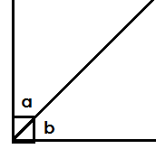

*L* a and *L*b are complementary angles.

* Supplementary angles are two or more angles on a straight line that add up to 180o.

**Illustration**

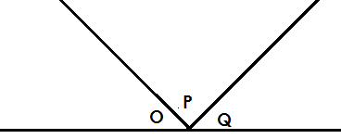

*L*O,*L* p and *L*Q are supplementary angles.

**Example I**

Find the supplement of M + 40o

**Soln**

180o– (m + 40o

180 o – m – 40 o

180 o– 40 o – m

140 o– m

**Example II**

Find the complement of 2y + 80o.

**Soln.**

90o – (2y + 80o)

90o – 2y – 80o

90o – 80o – 2y

10o – 2y

**Example III**

Calculate the supplement of 3p – 60o.

**Soln.**

180o – (3p – 60o)

180o + 60 – 3p

240o – 3p

**Example IV**

Find the complement of 4y – 20o.

90o – (4y – 20o)

90o – 4y + 20o

90o + 20o – 4y

110o – 4y

**Activity:**

A Find the supplements of the following angles:

1. 2k + 40o

2. 3m - 42o

3. 2y + 36

4. m + 70o

5. 3p + 110o

6. 2y – 120o

B Find the complementary angles of the following:

1. 3p – 20o

2. 60o – p

3. 4k + 50o

4. m + 30o

5. 2w – 10o

6. 5y + 30o

**MORE ABOUT COMPLEMENTS AND SUPPLEMENTS**

**Example I**

Find the angle which is ½ of its supplement

Angles

**Soln.**

½ = 1:2 supplements

Total ratio = 1 + 2

= 3

Angle = 1/3x 180o

= 60o

**Example II**

What angle is $\frac{1}{5}$ of its complement?

**Soln.**

$\frac{1}{5}$ = 1:5

Total ratio = 1+ 5

= 6

Angle = 1/6 x 90o

= 15o

**Activity:**

1. Find the angle which is of its supplement.

2. What angle is of its complement?

3. Which angle is $\frac{1}{4}$ of its supplement?

4. What angle is of its complement?

5. What angle is on $\frac{1}{8}$ of its supplements?

6. Find the angle which is of its supplement

7. Which angle is a $\frac{1}{9}$ of its complement?

**GEOMETRY (ANGLES AND LINES)**

**PARALLEL LINES**

* Parallel lines are lines that do not meet due to the same distance apart.

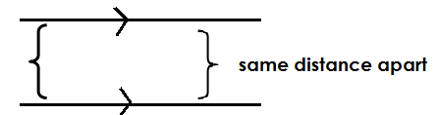

When a transversal line intersects two parallel lines the different angles are formed and these include:

* Co-interior angles
* Co-exterior angles
* Alternating angles
* Corresponding angles
* Vertically opposite angles
* Supplementary angles
* Complementary angles

**Illustration**

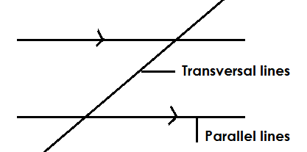

**Co – interior angles**

* They add up to 180o
* They are found inside parallel lines.
* They are formed on the same side of the transversal line
* One angle is acute and another angle is obtuse.

**Illustration**

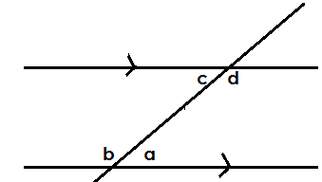

*L* a + *L*d = 180o (co-int.*L*s)

*L*c + *L*b = 1800 (co-int.*L*s)

**Example I**

Find the value of y.

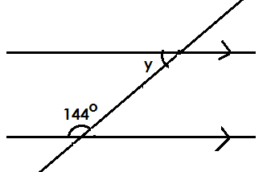

Soln

Y + 144o = 180o

Y + 144 o – 144o = 180 o – 144 o

Y = 36 o

**Example I**

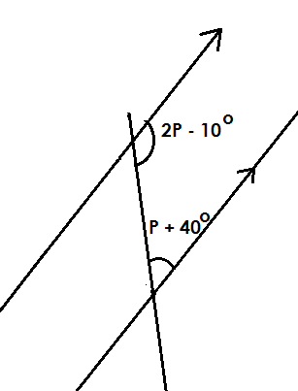Find the value of P.

**Soln**

2P – 100 + P + 400 = 1800 (co-int Ls)

2p + P – 10o + 40 o = 180 o

3p +30 o = 180o

3p + 30 o – 30 o = 180 o – 30 o

3p = 150 o

=  o

**P = 50 o**

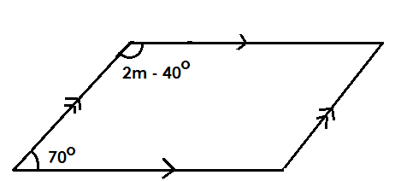In the figure below, find the value of M.

2m – 40o + 70 o = 180 o (co-int Ls)

2m + 30 o = 180 o

2m + 30 o – 30 o = 180o – 30 o

2m = 150o

=

**m = 75 o**

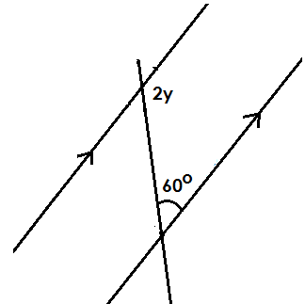**Activity:**

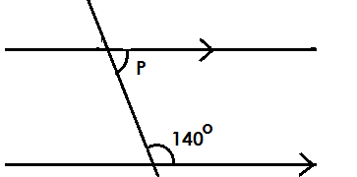Find the value of unknowns in the following:-

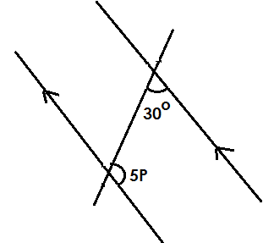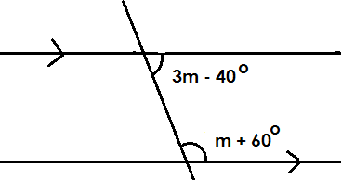

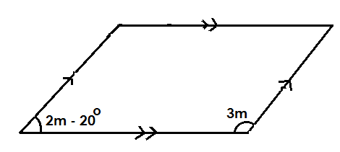

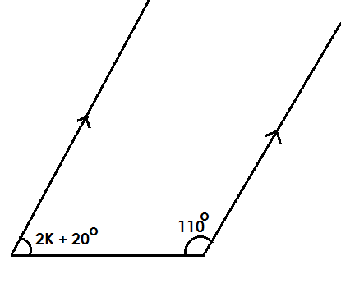

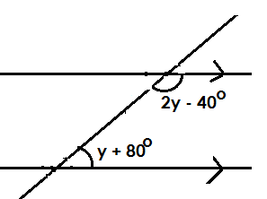

**CO-EXTERIOR ANGLES**

* Co-exterior angles add up to 1800
* They are found outside the parallel lines.
* They are formed on the same side of the transversal line.
* One angle is obtuse and another angle is acute.

**Illustration**

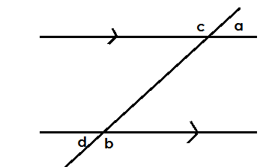

*L* a + *L* b = 1800 (co-exterior angles)

*L* d + *L* c = 1800 (co-exterior angles)

**Example I**

Find the size of angle y.

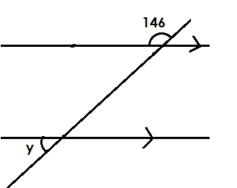

Soln

y + 146o= 1800 (co-exterior *L*s)

y + 146 o – 146o = 180 o – 146 o

y = 34 o

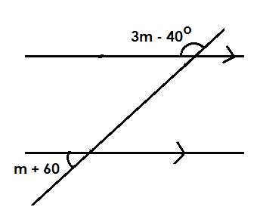**Example II**

Find the value of m

Soln

3m – 40o + m + 60 o = 180o(co-ext Ls).

3m + m – 40 o + 60 o = 180 o

4m + 20 o = 180 o

4m + 20 o – 20 o = 1800 – 20 o

4m = 160 o

=

**m = 40 o**

**Activity:**

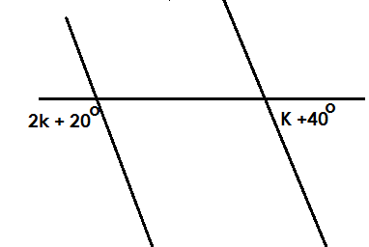Find the value of unknowns in the following:

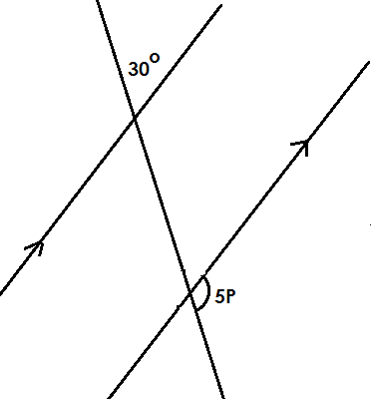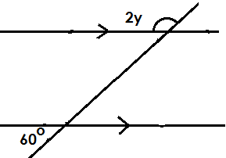

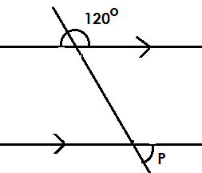

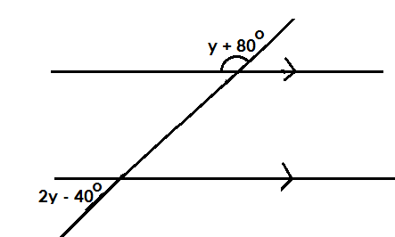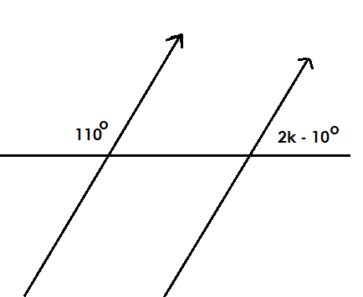

**CORRESPONDING ANGLES**

**Note:**

* Corresponding angles are equal in degrees.
* Corresponding angles are formed on the same side of the transversal line.
* One is found inside and another one is found outside parallel lines.
* One angle is formed on the lower parallel line and another angle on the upper parallel line.

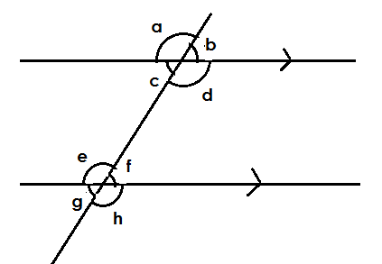**Illustration**

*L* a = *L* e

Pair of corresponding angles

*L* b = *L* f

*L*c = *L* g

*L* d = *L* h

**Examples**

1. Find the value of Y

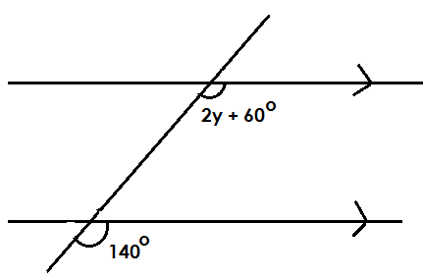

**Soln**

2y + 60o = 140o (corresponding angles)

2y + 60o –60o = 140o – 60o

=

y = 40o

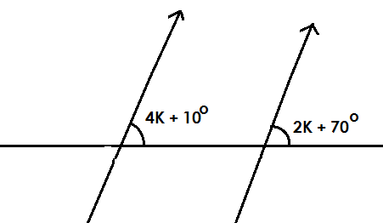2. Find the value of K in the diagram below.

Soln

4K + 10o = 2K + 70o (corresponding angles)

4k + 10o – 10 o = 2K + 70o – 10 o

4K = 2k + 60 o

4k – 2k = 2k – 2k + 60 o

=

**K = 30o**

**Activity:**

Find the unknown in each of the following diagrams:-

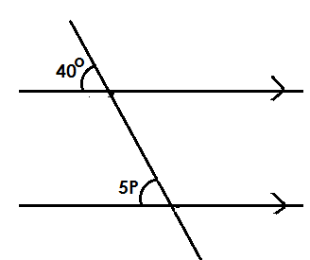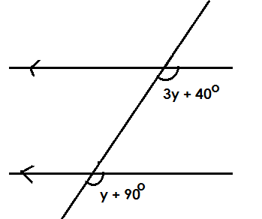

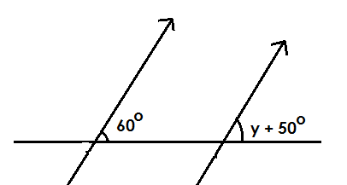

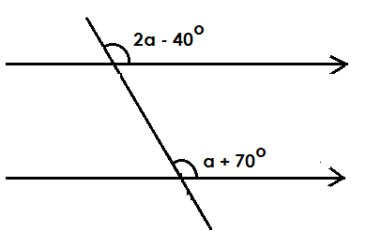

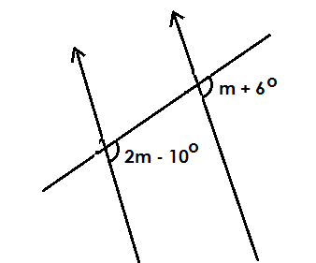

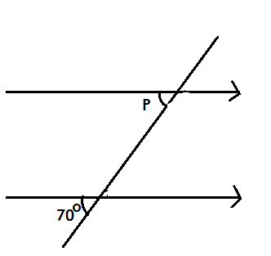

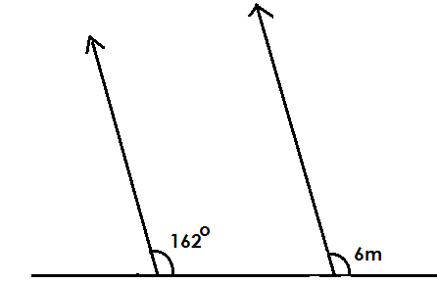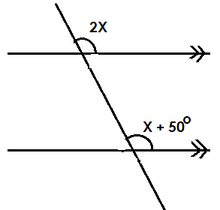

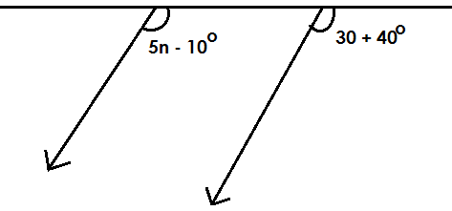

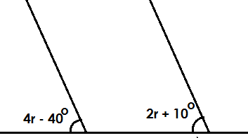

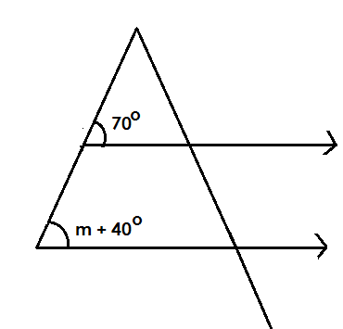

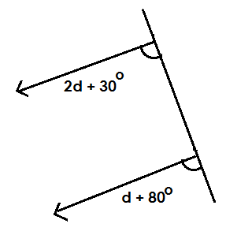

**ALTERNATING ANGLES**

(Alternate interior and alternate exterior angles)

**Note**

* Alternating angles are equal.
* Alternating angles are formed on the opposite sides of the transversal line.
* If they are inside they are called alternate interior and if they are outside the called alternate exterior.

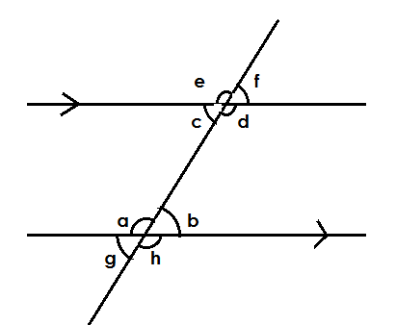**Illustration**

*L* a = *L* d Alternate interior angles.

*L* c = *L* b

Then

L f = L g Alternate exterior angles.

L e = L h

**Examples**

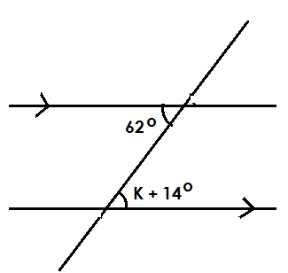1. Find the value of K in the diagram below.

**Soln**

K + 14o = 62 o (alternating interior angles)

K + 14o – 14 o = 62 o – 14 o

K = 48 o

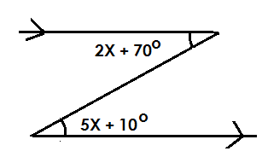2. Find the value of X

Soln

5X + 10o = 2X + 70o (alternating interior angles)

5X + 10o – 10o = 2X + 70o – 10o

5X = 2X + 60o

5X – 2X = 2X – 2X + 60o

=

**K = 20o**

1. Find the value of the unknown in the diagram below.

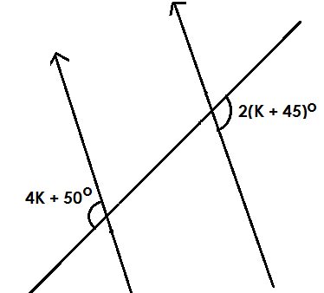

**Soln**

4K + 50o = 2(K + 45o) alternate exterior angles

4k + 50o = 2k + 90o

4k + 50o – 50o = 2k + 90o – 50o

4k = 2k + 40o

4k – 2k = 2k – 2k + 40o

=

**K = 20o**

4. Find the value of the unknown.

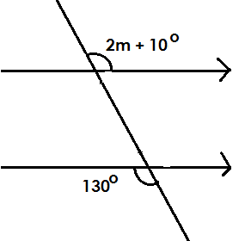

**Soln**

2m + 10 o = 1300 (alternate exterior angles)

2m + 10 o – 10 o = 130 o – 10 o

=

**m = 60o**

**Activity:**

Find the value of the unknown in each of the diagrams below.

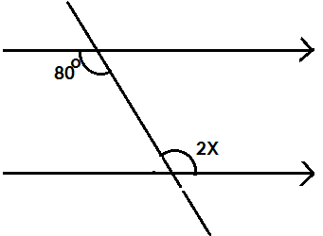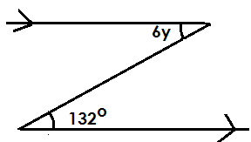

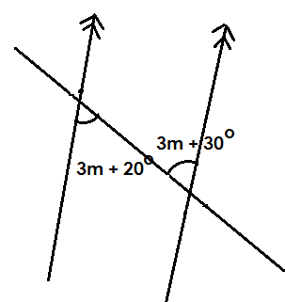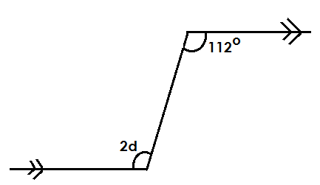

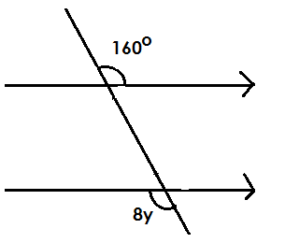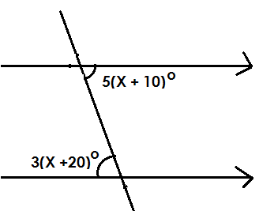

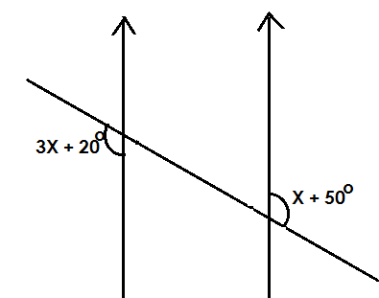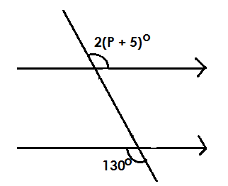

**VERTICALLY OPPOSITE ANGLES**

* Vertically opposite angles are equal in degrees.
* They are formed by letter X (X – angles)

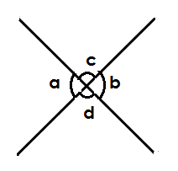**Illustration**

*L* a = *L*b Vertically opposite angles

*L*c = *L* d

**Examples**

Find the value of P in the figure below

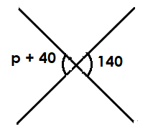

Soln

P + 40o = 140 o

P + 40 o – 40 o

**P = 100 o**

**Activity**

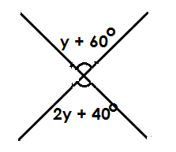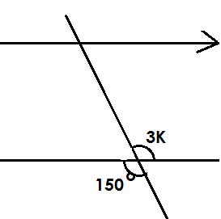Find the unknown in each of the diagrams below.

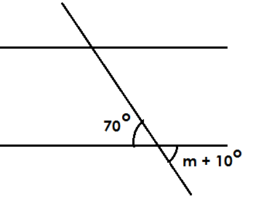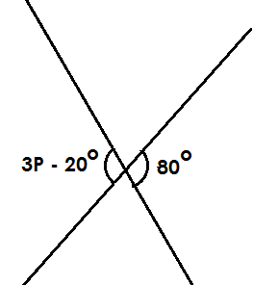

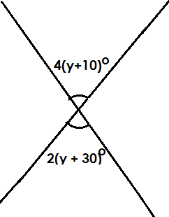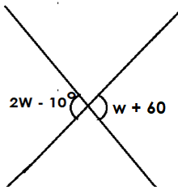

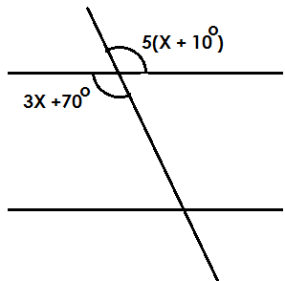

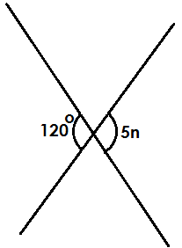

**APPLICATION OF PARALLEL LINES**

1. In the diagram below, find the value of y.

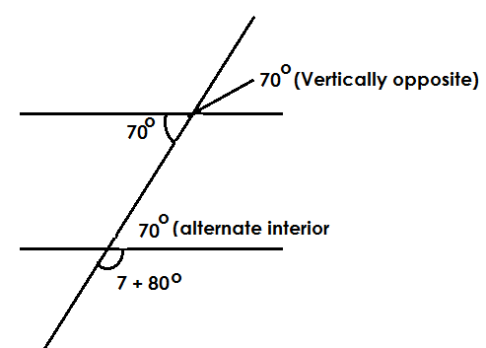

**Soln**

Y + 80o + 70 o = 180 o (Co-exterior angles)

Y + 150 o = 180 o

Y + 150 o – 150 o = 180 o – 150 o

Y = 30 o

**2. Example 2**

Find the value of K

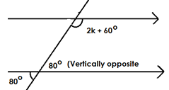

**Soln**

2k + 60o+80 o = 180o (Co-interior angles)

2k + 140 o = 180 o

2k + 140 o – 140 o = 1800 – 140 o

=

**K = 20 o**

1. Find the value of a.

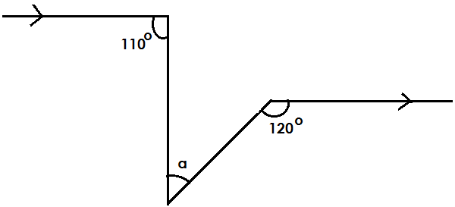

**Soln**

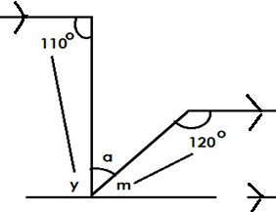

Y + 110o = 180 o (Co-interior angle)

Y + 110 o – 110 o = 110 o

**Y = 70 o**

m+ 120 o = 180 o (Co-interior angle)

m + 120 o – 120 o = 180 o – 120 o

**m = 60 o**

Therefore:

a + y + m = 180o (Supplementary angles)

a + 70 o + 60 o = 180 o

a + 130 o = 180 o

a + 130 o – 130 o = 180 o – 130 o

**a = 50 o**

**ACTIVITY:**

Find the value of the unknown in each of the diagrams below: -

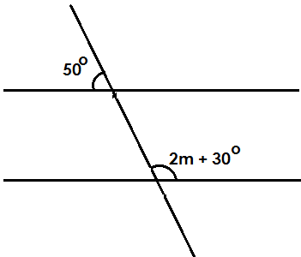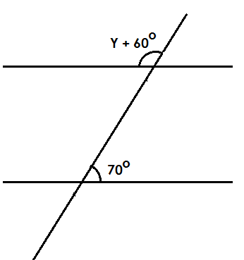

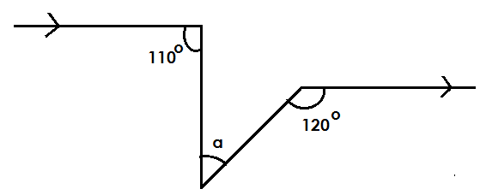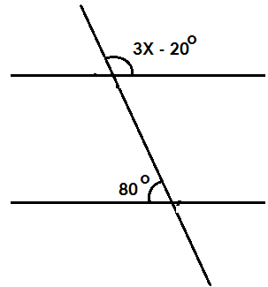

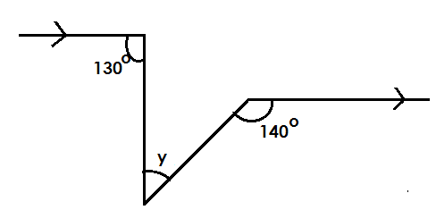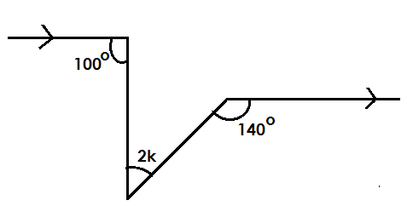

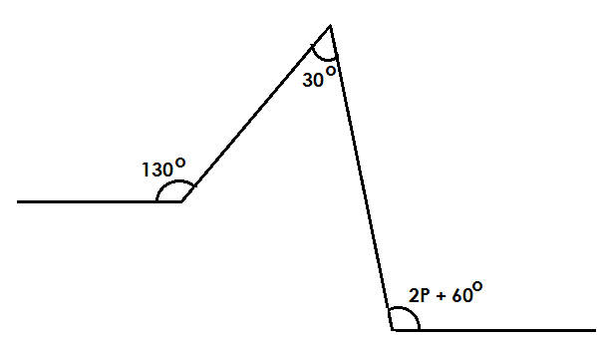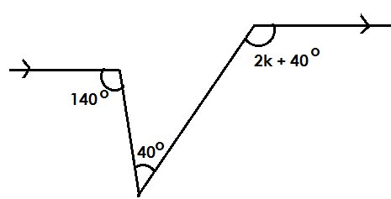

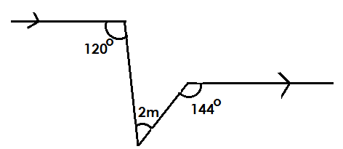

**MORE ON APPLICATION OF PARALLEL LINES**

**Examples**

Find the value of 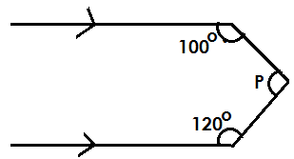

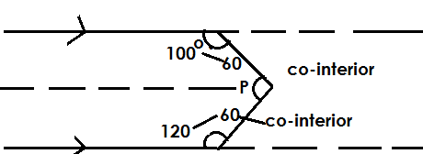 soln

P = 60o + 80o

**P = 140o**

2. Find the value of P.

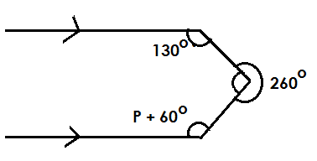

Soln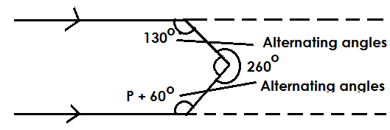

P + 60o + 130 o = 260 o

P + 190 o = 260 o

P + 190o  – 190 o = 260 o  – 190 o

**P = 70 o**

**ACTIVITY**

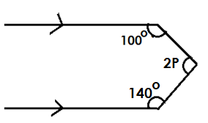Find the unknown in each of the figures below.

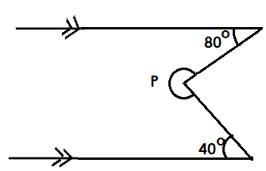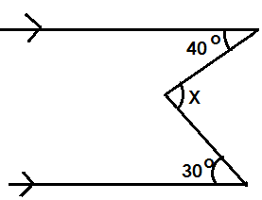

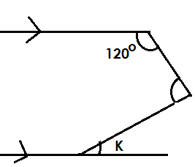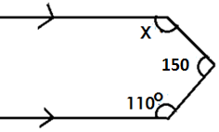

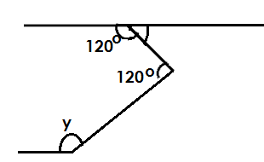

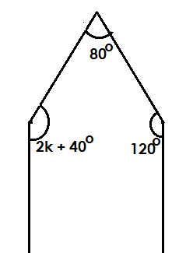

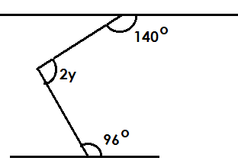

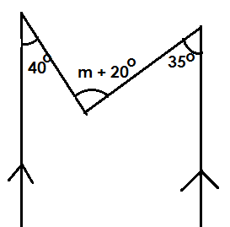

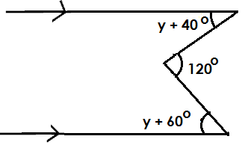

**PARALLEL LINES AND TRIANGLES**

**Examples**

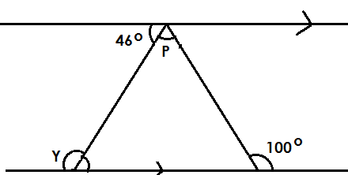1. Find the value of P.

Soln

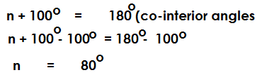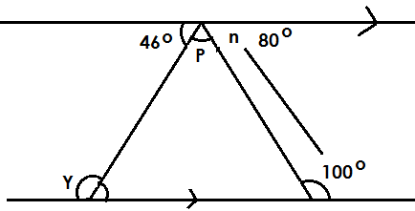

a) P + 80o + 46 o = 180 o (straight line angles)

P + 126 o = 180 o

P + 126 o – 126 o = 180 o – 126 o

**P =54 o**

b) Find the value of Y

Y + 46o = 180o (Co-interior angles)

Y + 46o- 46o = 180o – 46o

Y = 134o

2. Given the figure below:-

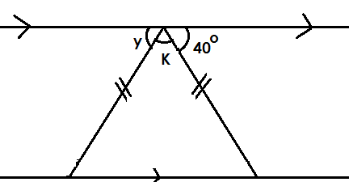

a) Find the value of K.

soln

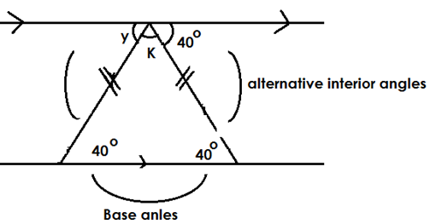

K = 40o + 40 o = 180 o (interior angles sum of a triangle)

K + 80 o = 180 o

K + 80 o – 80 o = 180 o – 80 o

K = 100 o

b) Find the value of y

**soln**

Y = 400 (Alternate interior angles)

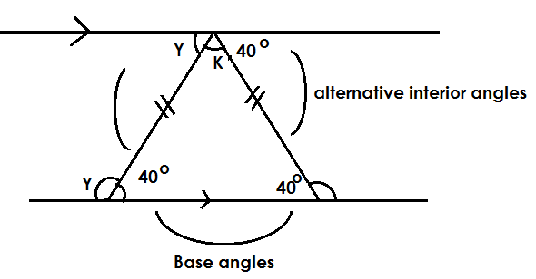3. Find the values of Y and K in the figure below.

K + 40o + 40o = 180 o 9interior angle sum of a triangle)

K + 80 o = 180 o

K + 80 o – 80 o = 180o – 80 o

K = 100 o

b) Find the value of y

soln

Y = 40o (alternate interior angles)

3. Find the value of Y and K in the figure below;

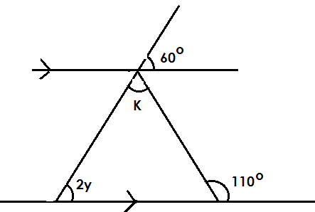

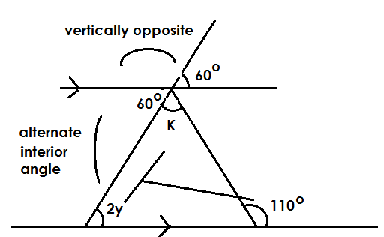Soln

2y = 600 (alternate interior angle)

=

Y =30o

K + 2y = 1100 (sum of 2 opposite interior angles)

K + 60o = 110o

K + 60o – 60o = 110o- 60o

K = 50o

**Activity:**

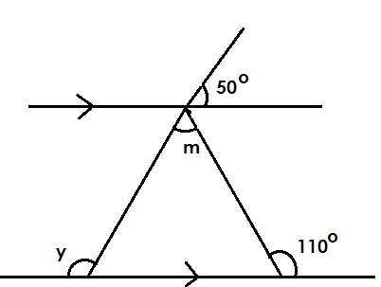Find the unknowns in each of the diagrams below.

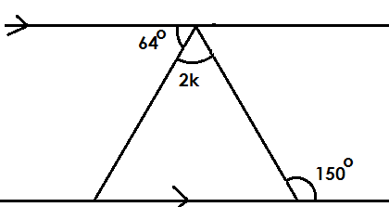

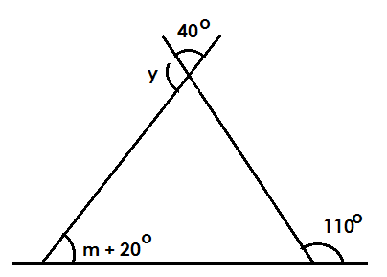

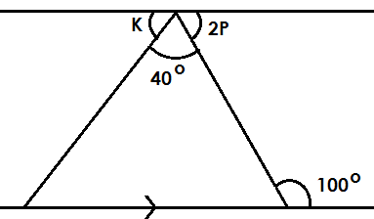

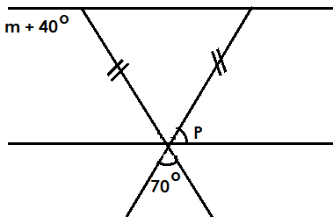

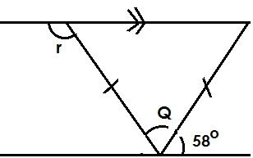

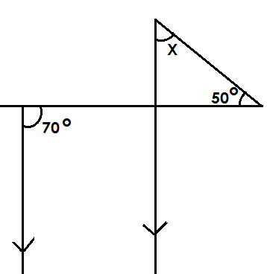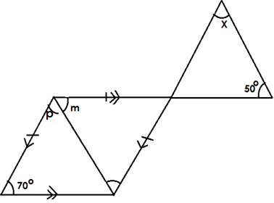

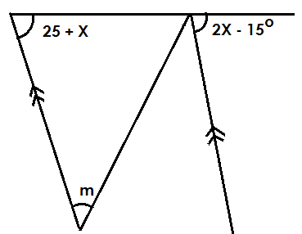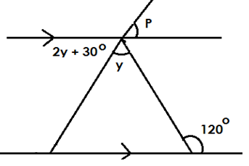

**ANGLE PROPERTIES ON TRIANGLES**

**1. ISOSCELES TRIANGLES**

* These are triangles with two sides equal.
* Their base angles are equal.
* An isosceles triangle has one line of folding symmetry.

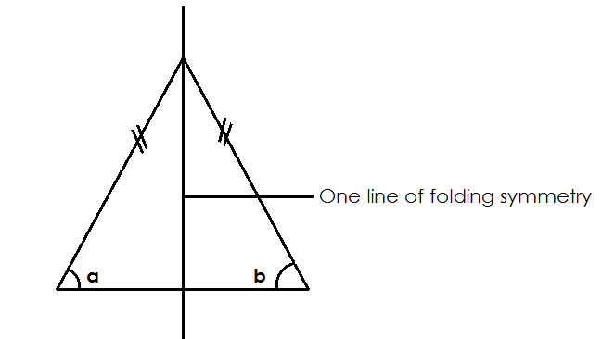**Illustration**

***L***a = ***L*** b (base angles of a triangle)

**Example I**

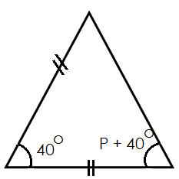Find the value of unknowns in the figure below.

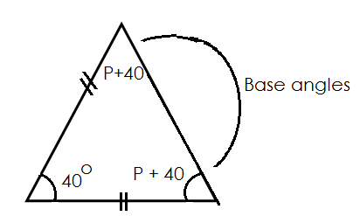Soln

P + 40o + P + 40 o +40 o = 180 o (interior angle sum of a triangle)

P + P + 40 o + 40 o + 40 o = 180 o

2P + 120 o = 180 o

2P + 120 o = 180 o

2P + 120 o – 120 o = 180 o – 120 o

2P = 60 o

=

**P = 30** o

**Activity:**

Find the value of unknowns in the following diagrams.

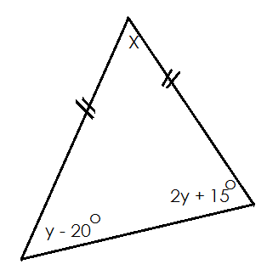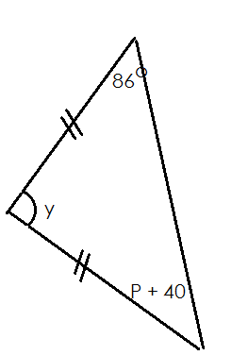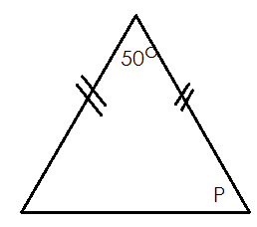

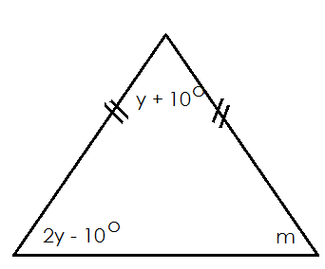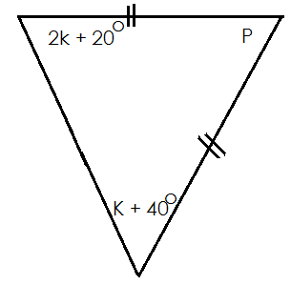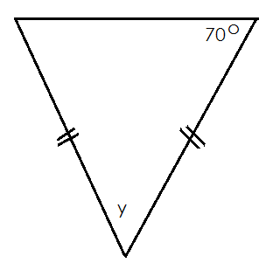

**THE SUM OF TWO INTERIOR ANGLES BEING EQUAL TO ONE OPPOSITE EXTERIOR ANGLE**

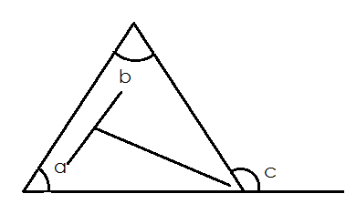

*L* a + *L* b = *L*c(sum of 2 int.*Ls* of =1 opp. Ext.*L*)

**Example I**

Find the value of y in the triangle below.

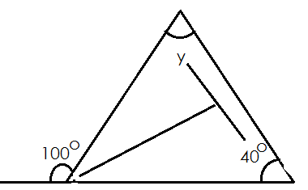

Soln

Y + 40o = 100 o (sum of 2 interior angles = 1 opposite exterior angle)

Y + 40 o – 40 o = 100 o – 40 o

**Y = 60 o**

**Example II**

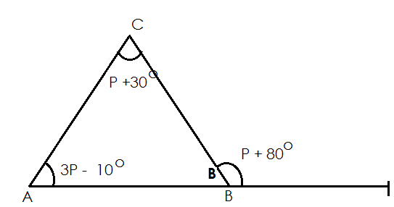Use the diagram below to answer questions.

a) Find the value of P

**soln**

3P – 10 o + P + 30 o = P + 80 o (sum of 2 interior angles = 10 opposite exterior angles)

3P + P – 10 o + 30 o = P + 80 o

4P + 20 o = P + 80 o

4P + 20 o = P + 80 o

4P + 20 o – 20o= P + 80 o – 20 o

4P = P + 60 o

4P – P = P – P + 60 o

3P = 60 o

=

**P = 20o**

b) Find the size of angle ABC

soln

***L***B + P + 80o = 180 o (supp ***L***s)

L b + 20o + 80o = 180o

B + 100o = 180o

**B = 80 o**

**Activity:**

1. Find the value of y.

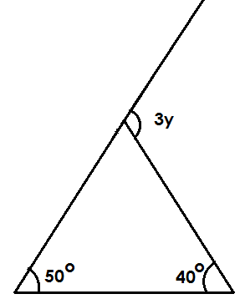

2. In the diagram below, find the value of K.

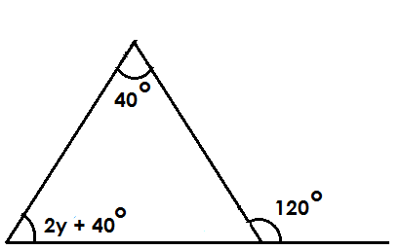

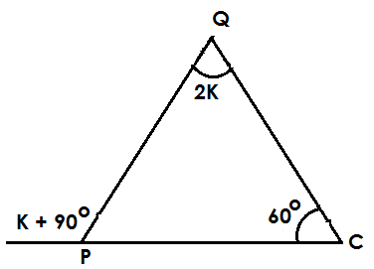3. Use the diagram below to find the size of angle(C)P(Q).

4. Find the value of X

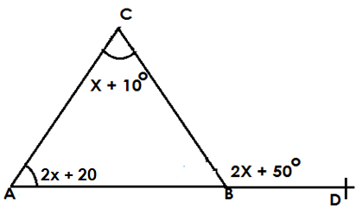

b) Find the size of angle ABC

5. Use the diagram below to answer questions.

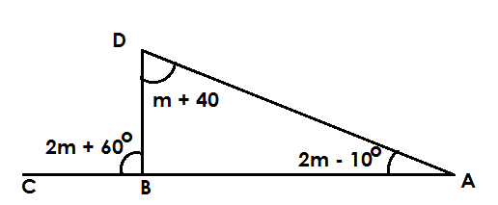

a) Find the value of M.

b) Calculate the size of ***L*** BCA.

Use the diagram below to find the value of M.

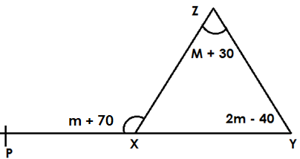

**MORE ABOUT SUM OF TWO INTERIOR ANGLES EQUAL TO ONE OPPOSITE EXTERIOR ANGLES**

**Example I**

Find the value of M.

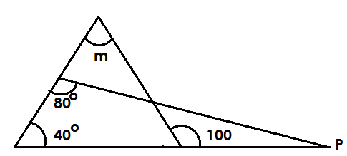

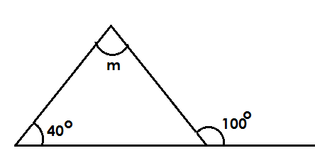soln

m + 40o = 100o (Sum of 2 int. angles = 1 opp.Ext. angle)

m + 40 – 40 = 100 – 40o

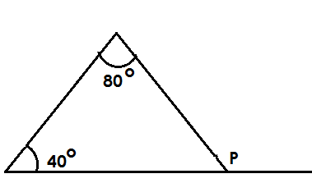**m = 60o**

Soln

p = 80 + 40 (sum of 2 m + ***L*** = 1 oppext***L***)

**P = 120 o**

**Example II**

Find the value of y.

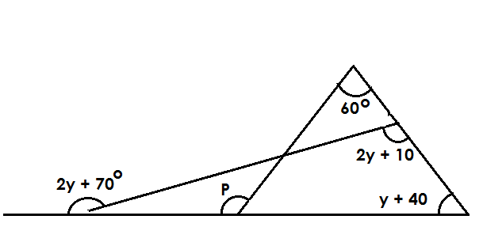

Soln

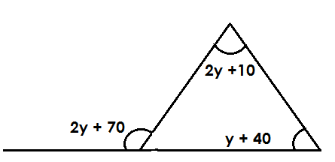

2y + 10o + y + 40 o = 2y + 70 o (sum of 2 int. angles = 1opp. ext. angle)

2y + y + 10 o + 40 o = 2y + 70 o

3y + 50 o = 2y + 70 o

3y + 50 o – 50 o = 2y + 70 o – 50 o

3y = 2y + 20 o

3y – 2y = 2y – 2y + 20 o

**Y = 20o**

b) Find the value of P

P = 60 + y + 40o (Sum of 2m + ***L***s = 1opp ext***L***)

P = 60 + 20o +40o

**P = 120o**

**Activity:**

Find the value of unknowns in the following;

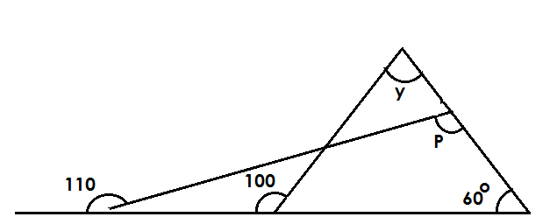

2.

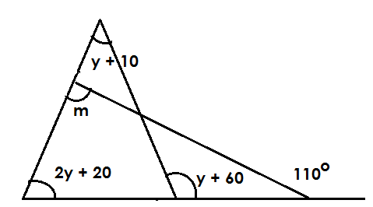

3.

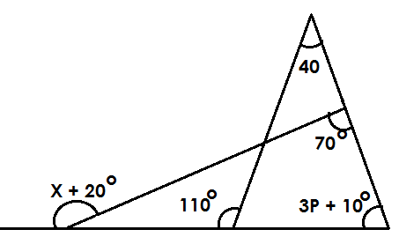

4.

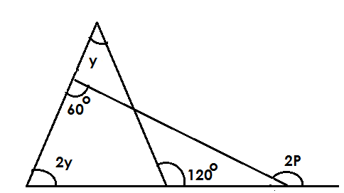5.

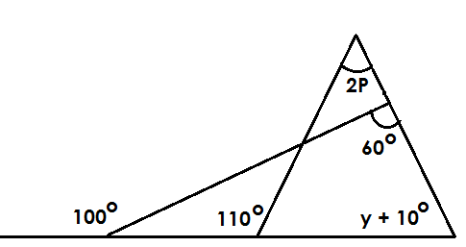

**EXTERIOR ANGLES OF REGULAR POLYGON**

**Note:**

* The sum of all exterior angles of a regular polygon is 360o.

**Example I**

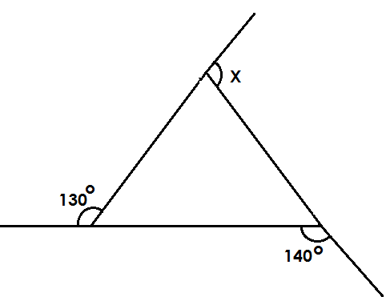Find the value of X.

X + 130o + 140 o = 360 o (sum of all exterior angles)

X + 270 o = 360 o

X + 270 o – 270 o = 360 o – 270 o

**X = 90 o**

**Example II**

Find the value of m in the diagram below.

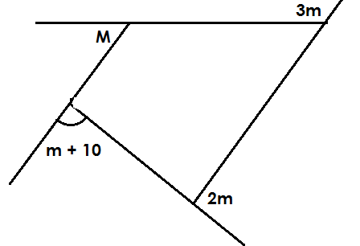

2m + m + 10 **o** + m + 3m = 360 **o** (sum of all exterior angles)

2m + m +m + 3m + 10 **o** = 360 **o**

7m + 10 **o** = 360o

7m + 10 **o** – 10 **o** = 360o – 10 **o**

7m = 350 **o**

=

**m = 50o**

**Activity:**

Find the value of unknown in the following.

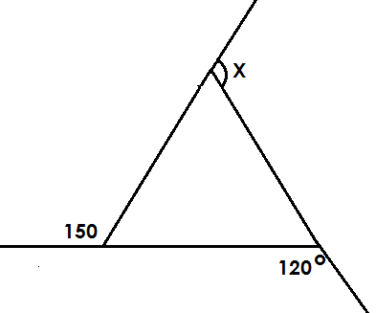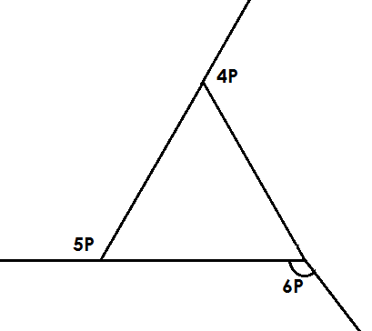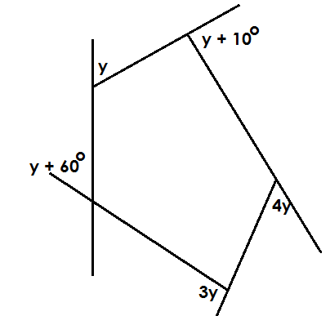

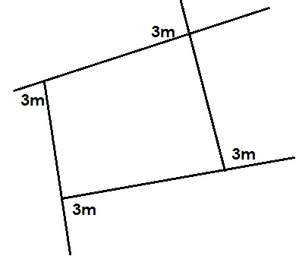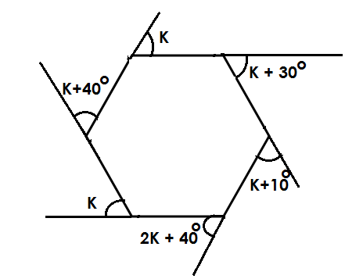

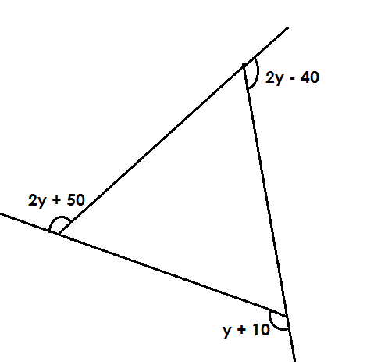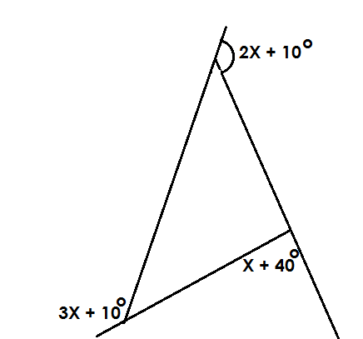

**POLYGONS**

* A polygon is a closed sided figure.
* The word poly means many and gon means sides.
* All polygons are named according to their number of sides.

|  |  |
| --- | --- |
| **Name of polygon** | **Number of sides** |
| Triangle | 3 |
| Quadrilateral | 4 |
| Pentagon | 5 |
| Hexagon | 6 |
| Septagon / Heptagon | 7 |
| Octagon | 8 |
| Nonagon | 9 |
| Decagon | 10 |
| Nuo-decagon / Hendecagon | 11 |
| Duodecagon | 12 |

**FINDING EXTERIOR ANGLE OR CENTRE ANGLES OF POLYGONS**

* The sum of all exterior angles of any polygon is 3600
* The sum of all centre angles of any polygon is 3600

One exterior angle = $\frac{sum of ext Ls}{no.of sides}$

One centre angle= $\frac{Sum of all centres Ls}{No.of sides}$

**Example I**

Find the size of each exterior angle of a regular pentagon.

Exterior L =

= **o**

**= 70o**

**Example II**

Find the size of each exterior angle of a polygon with 30 sides.

**Soln**

Each ext.angle =

=

**= 12o**

**Activity:**

1. Find the size of each exterior angle of a regular octagon.

2. Calculate the size of each exterior angle of a regular.

a) decagon

b) Equilateral triangle

c) Nonagon

d) Duo decagon

1. A regular polygon has 10 sides. What is the measure of each of its exterior angle?
2. What is the size of each centre angle of a regular polygon with 18 sides?
3. Calculate the size of each centre angle of a regular hexagon.

6. If a regular polygon has 20 sides, what is the size of each exterior angle?

**FINDING THE NUMBER OF SIDES AND NAMING THE POLYGON**

**Note:**

No. of sides = $\frac{360}{Ext.L}$

**Examples**

1. Calculate the number of sides of a regular polygon whose exterior angle is 20o?

**Soln**

No. of sides =

=

= 18o

1. What name is given to a regular polygon whose exterior angle is 60o.

**Soln.**

No. of sides= $\frac{360}{Ext.L}$

= $\frac{360}{60}$

= 6.

The polygon is hexagon.

**Activity:**

1. Name the regular polygon whose exterior angles are given below.

a) 72o

b) 36o

c) 90 o

d) 45 o

e) 30 o

2. Each exterior angle of a regular polygon is 120. Calculate the number of sides of the polygon.

3. The figure below shows the exterior angle of a regular polygon. Calculate the number of sides.

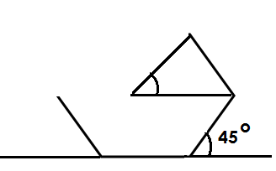

4. One of the exterior angles of a regular polygon is18. How many sides has the polygon?

5. How many sides has a polygon whose exterior angle is 30o?

6. Calculate the number of sides of a regular polygon whose exterior angle is 40o.

**FINDING EXTERIOR OR INTERIOR ANGLES OF REGULAR POLYGON**

**Note:**

Exterior and interior angles of a regular polygon add up to 180o (They are supplementary)

**Example I**

The interior angle of a regular polygon is 144o.

Find the size of each exterior angle.

Let the exterior angle be K

|  |  |  |
| --- | --- | --- |
| Ext ***L*** | int ***L*** | sum |
| K | 1440 | 1800 |

K + 144 o = 180o

K + 144 o – 144 o = 180 o – 144

K = 36o

b) Name the polygon

No. of sides = $\frac{sum of all ext. Ls}{No.of sides}$

= $\frac{360}{36}$

**= 10 sides**

**∴ It is a decagon**

**Example II**

The interior angle of a regular polygon is 1200 more than its exterior angle. Name the polygon

**Soln.**

Let the ext. ***L*** be K

|  |  |  |
| --- | --- | --- |
| Ext. ***L*** | Int ***L*** | sum |
| K | K + 120o | 180o |

K + K + 120 o = 180 o

2K + 120 o = 180 o

2K + 120 o – 120o = 180 o – 120 o

2K = 60 **o**

=

K = 30o

No. of sides = $\frac{Sum of all ext.L}{Ext.L}$

= $\frac{360}{30}$

**= 12 sides**

**∴ It’s a duo-decagon.**

**Example III**

The interior angle of a regular polygon is twice its exterior.

1. Find the size of the exterior angle.

Let the exterior angle be M.

|  |  |  |
| --- | --- | --- |
| **Ext. L** | **Int. L** | **Sum** |
| m | 2 x m  12m | 180 |

m + 2m = 180 **o**

3m = 180 **o**

=

**m = 60o**

b) Name the polygon

Number of sides = $\frac{Sum of all ext.L}{No.of sides}$

= $\frac{360}{60}$

**= 6 sides**

**∴ It is a hexagon**

**Activity:**

1. The interior angle of a regular polygon is 150o.

a) Find its exterior angle.

b) Nam the polygon.

2. If the interior angle of a regular polygon is 120o more than the exterior angle.

a) Find the exterior angle.

b) How many sides has the polygon.

3. The interior angle of a regular polygon is 90o more than its exterior.

a) Find the exterior angle.

b) Name the polygon

4. The interior angle of a regular polygon is 100o more than its exterior angle.

a) Calculate its exterior angle.

b) Name the polygon

5. The interior angle of a regular polygon is 4 times its exterior angle.

a) Find the size of each exterior angle.

b) Name the polygon

6. The exterior angle of a regular polygon is a ninth of its interior angle.

a) Find the exterior angle.

b) Name the polygon

7. If the interior angle of a regular polygon is 5 times its exterior angle. Name the polygon.

**FINDING EXTERIOR ANGLE OR INTERIOR ANGLE GIVEN RATIOS**

Examples

The interior and exterior angles of a regular polygon are in the ratio of 5: 1 respectively.

a) Find the size of its exterior angle.

**Soln.**

Total ratio = 5 + 1

= 6

Exterior angle = x 180o

= 300

1. Name the polygon

**Soln**

Number of sides = $\frac{sum of all exterior angles}{1 exterior alnge}$

= $\frac{360}{30}$

= 12 sides

**∴It’s a duo-decagon**

**Activity:**

1. The interior and exterior angles of a regular polygon are in the ratio 7:2 respectively.

a) Find the size of the exterior angle.

b) Name the polygon

2. The interior and exterior angles of a regular polygon are in a ratio of 4:1 respectively.

a) Find the exterior and interior angle.

b) Name the polygon.

3. The interior and exterior angles of a regular polygon are in a ratio of 3;2 respectively.

a) Find the size of the exterior angle.

b) Name the polygon

4. The interior and exterior angles of a regular polygon are in a ratio of 1:2 respectively. Name the polygon.

5. Name the polygon whose interior and exterior angles are in a ratio of 3:1 respectively.

6. The interior and exterior angles of a regular polygon are in a ratio of 2:1 respectively. Name the polygon.

**FINDING INTERIOR ANGLE SUM OF POLYGONS**

**Note:**

* Interior angle sum = 1800 (n – 2)

Where;

* 1800 is the interior angle sum of a triangle.
* n is number of sides.
* n – 2 is number of triangles in a regular polygon.

**Example**

Find the interior angle sum of a hexagon.

Soln.

Interior angle sum = 180o (n – 2)

= 180o (6 - 2)

= 180o x 4

= 720o

**Example II**

Find the interior angle sum of a regular polygon whose exterior angle is 900.

Soln

No. of sides = $\frac{sum of all exterior angles}{1 exterior angle}$

= $\frac{360}{8}$

**= 6 sides**

Interior angle sum = 180o (4 – 2)

= 180o (4 – 2)

= 180 o x 2

**= 360 o**

**Activity:**

1. Calculate the interior angle sum of the following polygons.

a) Quadrilateral

b) Octagon

c) Heptagon

d) Hendecagon

e) Decagon

f) Septagon

2. The interior angle of a regular polygon is 140o.

1. Name the polygon
2. Calculate its interior angle sum.

3. Given that the interior angle of a regular polygon is 144 o.

a) Name the polygon

b) Calculate its interior angle sum.

4. The interior angle of a regular polygon is 1350.

a) Name the polygon

b) Find its interior angle sum

5. The interior angle of a regular polygon is 90 more than its exterior angle. Calculate its interior angle sum.

**NAMING POLYGON GIVEN INTERIOR ANGLE SUM**

**Examples**

The interior angle sum of a regular polygon is 5400. Name the polygon.

Soln.

1800 (n – 2) = interior angle sum

1800 (n – 2) = 5400

=

**n – 2 = 3**

n – 2 = 3

n – 2 + 2 = 3 + 2

n = 5 sides

**∴The polygon is a pentagon.**

**Activity:**

1.Name the polygon whose interior angle sum is given below: -

1. 360o

2. 900 o

3. 180 o

4. 720 o

5. 1080 o

6. 1620 o

7. 1440 o

8. 1260 o

2.Find the number of sides of a regular polygon whose interior angle sum are;

a) 2880o

b) 2520o

c) 3240o

**FINDING NUMBER OF TRIANGLES AND NUMBER OF RIGHT ANGLES.**

**Example I**

**Note:**

* Number of triangles = n – 2
* Number of right angles = 2(n – 2)
* Where n is number of sides of a regular polygon.

**Example I**

How many triangles are in a regular octagon.

Soln

Number of triangles = n – 2

= 8 – 2

**= 6 triangles**

**Example II**

How many right angles are in a regular septagon.

**Soln**

Number of right angles = 2 (n – 2)

= 2(7 – 2)

= 2 x 5

**= 10 right angles**

**Activity:**

a) Find the number of triangles in the following polygons.

1. Pentagon

2. Triangle

3. Quadrilateral

4. Hexagon

5. Nonagon

6. Hendecagon

7. Duo decagon

8. Decagon

b) Calculate the number of right angles in the following polygons.

1. Pentagon

2. Triangle

3. Quadrilateral

4. Hexagon

5. Nonagon

6. Decagon

7. Hendecagon

8. Duo decagon

**CONSTRUCTION**

**CONSTRUCTING PERPENDICULAR LINES AND PERPENDICULAR BISECTORS**

* A perpendicular line is a line meeting another line at an angle of 90o.

**Example I**

* Construct a perpendicular line through line AB using a pair of compasses, pencil and a ruler only.

**Procedure**

* Place the needle of the pair of compasses at A.
* Adjust it to cover $\frac{3}{4}$ of the given line.
* Construct the upper arc and the lower arc.
* Transfer the needle to point B.
* Intersect the upper and lower arc made.
* Join the two points of intersection using a pencil and a ruler.

**Example II**

Using a pair of compasses, a ruler and a pencil only, construct a perpendicular line at point K.

**Procedure:**

* Place the needle of the pair of compasses at point K.
* Adjust it to a suitable size and then make arcs to enclose point K.
* Place the needle at any arc closing point K and adjust it to cover $\frac{3}{4}$ of the line between closed arcs.
* Construct upper and lower arcs.
* Transfer the needle to another arc closing point K and then intersect the upper and lower arcs made.
* Join the two points of intersection through the given point K.

**ACTIVITY:**

Construct perpendicular bisectors through the following lines using a pair of compasses, ruler and a pencil only.

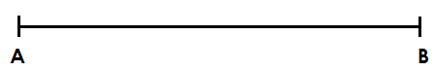

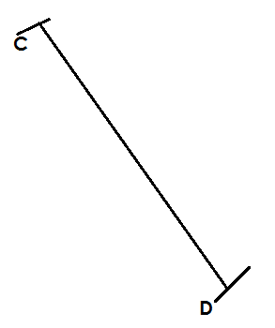

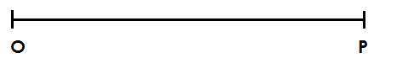

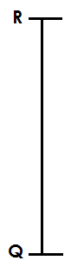

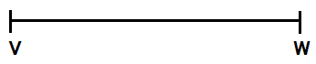

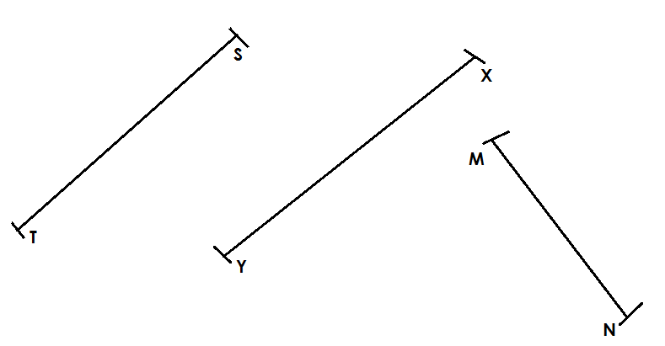

2. Using a pair of compasses, a ruler and a pencil only, construct perpendiculars at the given points (O)

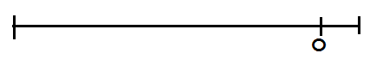

a)

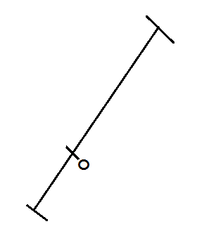

b)

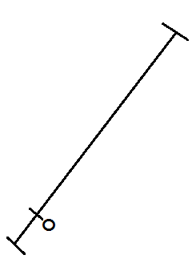

e)

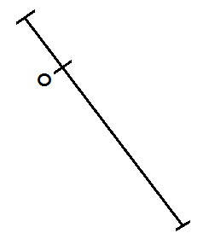

c)

d)

**DROPPING A PERPENDICULAR FROM A GIVEN POINT**

**Example I**

Using a pair of compasses, a ruler and a pencil only, drop a perpendicular from point P through line AB at point.

**Procedure**

* Place the needle at point P.
* Adjust the compass such that you make two arcs on the given line AB.
* Transfer the needle of the pair of compasses to any of the arcs made and construct the lower arc.
* Transfer the needle of the pair of compasses to the second arc and intersect the first arc to form a point of intersection.
* Join the point of intersection to point P using a pencil and a ruler.

**Activity:**

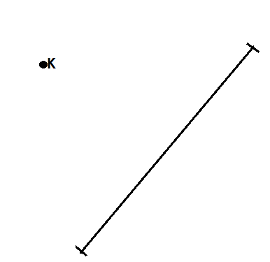Using a pair of compasses, a ruler and a pencil only, drop a perpendicular from the given points through the given lines below: -

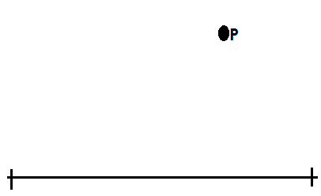

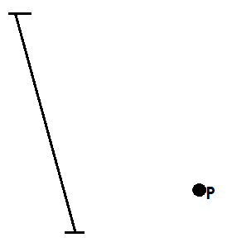

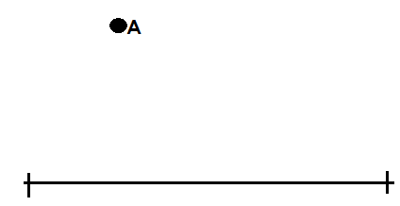

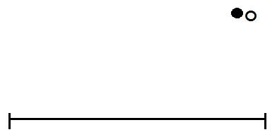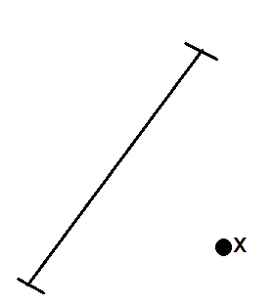

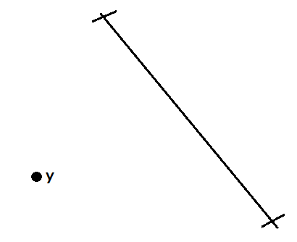

**BISECTING ANGLES**

Bisecting an angle is to divide the given angle into two equal parts.

**Example I**

Using a pair of compasses, a ruler and a pencil only. Bisect the given angle below.

**Procedure**

* Place the needle of the pair of compasses at the fixed point.
* Make two arcs on the two lines that are meeting at the fixed point.
* Transfer the needle to any arc made and make the upper arc.
* Transfer the needle to the second arc and intersect the arc made to form the point of intersection of point of bisection.
* Join the point of intersection to the point of original using a ruler and a pencil only.

**Example II**

Using a pair of compasses, a ruler and a pencil only, biscet the obtuse angle in the diagram below.

**Activity:**

Using a pair of compasses, a ruler and a pencil only bisect the following angles:-

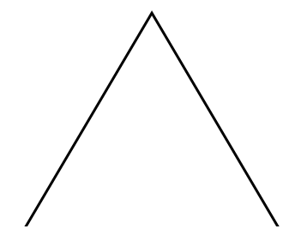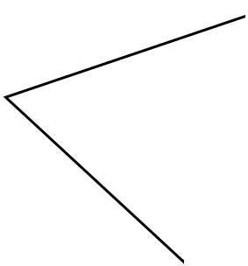





Bisect the obtuse angles in the following diagrams.

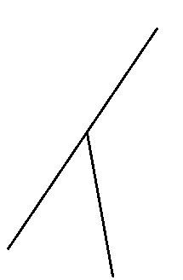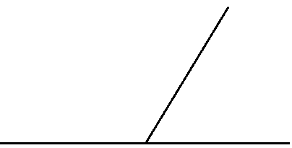

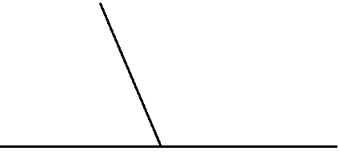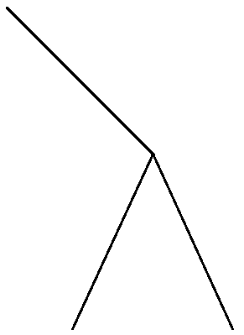

**CONSTRUCTION OF TRIANGLES**

**Example I**

Using a pair of compasses, a ruler and a pencil only, construct a triangle ABC where ***line*** AB = 8cm, ***L*** ABC = 600 and ***L*** BAC = 450. Drop a perpendicular from C to meet AB at K.

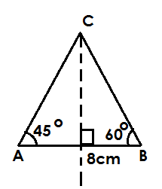 sketch

1. Measure OK and calculate area of the triangle constructed.

CK = 5.2cm

Area = ½ x b x h

= ½ x 8cm x 5.2cm

= ½ x 8cm x cm

= cm2

**= 20.8cm2**

**Example II**

Using a pair of compasses, a ruler and a pencil only, construct a triangle OPQ where OP = 8cm. **L**OPQ = 1200 and line PQ = 5cm.

Drop a perpendicular from Q to meet OP at T.

Sketch

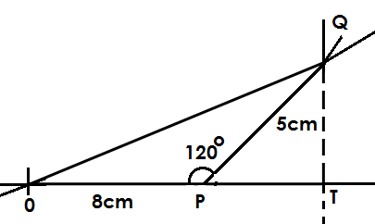

Measure QT

Soln.

QT = 4.4cm

**Activity:**

Using a pair of compasses, a ruler and a pencil only, construct the following triangles:-

1. ABC , where AC = 7cm, ***L*** B AC = 450 and ***L*** ABC = 90o.

ii) Measure BC

1. XYZ where XY = 6.5cm angle YXZ = 60o and ***L*** XYZ = 45o. Drop a perpendicular from Z to meet XY at K.

ii) Find the area of the triangle constructed.

1. MNO , where ***L*** M = 600, ***L*** N = 750, MN = 7cm. Drop a perpendicular from O to meet NM at Y.
2. RST where ST = 5cm. ***L***S = 1200 and ***L***T = 300. Drop a perpendicular from R to meet ST at V.
3. Measure VR.
4. ABC where BC = 6cm ***L***ABC = 1350 and BA = 4cm. Drop a perpendicular from A to meet BC at T.
5. Measure AT
6. XYZ where XY = 8cm angle XYZ = 1500 and YZ = 5cm. Drop a perpendicular from Y to meet ZX at W.
7. Measure YW.

**CONSTRUCTION OF TRIANGLES AFTER CALCULATIONS**

**Example I**

1. Using a ruler, a pencil and a pair of compasses only, construct a triangle ABC where AB = 8cm ***L*** A = 900, L C = 60o.

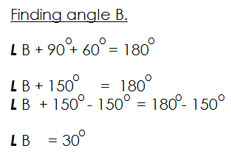Soln

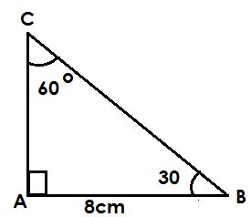Sketch

b)Measure:

i) AC = 4.5cm

ii) BC = 9.4cm

**Activity:**

Using a ruler, a pencil and a pair of compasses only, construct the following triangles:-

1. Triangle PQR, where PQ = 7cm, ***L*** P = 600, ***L*** R = 750. Measure lines PR and QR in cm.

2. Triangle EFG, where EF = 6cm, ***L*** E = 900, ***L*** G = 450. Measure GF in cm.

3. Triangle ABC, where AB = 55cm, ***L*** A = 450, ***L*** C = 900.

1. Triangle MNO, where MN = 4cm, ***L*** M = 1200, ***L***O = 300. Measure QN in cm.

5. Triangle XYZ, where XY= 5cm , ***L***X = 600, ***L*** Z = 450. Measure lines XZ and YZ.

6. Triangle MNL , where MN = 6cm , ***L***M = 600 and ***L***L = 450. measure ML and LN in cm.

7. Triangle KLM in which KL = 6.5cm, ***L*** K = 300 and angle KML = 750.

i) KM in cm

ii) ML in cm

8. Triangle RST in which RS = 6.8cm, **L**R = 300, **L**T = 750.

Measure:TS in cm

**CONSTRUCTING A SQUARE USING DIAGONALS**

Note:

* Diagonals of a square are equal they bisect each other at a right angle.

Example

Using a ruler, a pencil and pair of compasses only, construct a square SRQP where diagonal PR = QS = 4cm.

**Soln.**

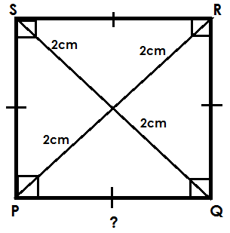**Sketch**

**ACTIVITY:**

Using a ruler and a pair of compasses only, construct the following squares: -

ABCD of diagonals: -

a) 6cm

b) 8cm

c) 10cm

d) 12cm

e) 9cm

f) 15cm

**CONSTRUCTION OF A RHOMBUS GIVEN SIDE AND ANGLES**

**Note:**

* Opposite sides of a rhombus are parallel and equal.
* Opposite angles of a rhombus are equal.

**Example**

Using a ruler, pencil and a pair of compasses only, construct a rhombus ABCD of sides 6cm and angle ABC = 600.

Soln.

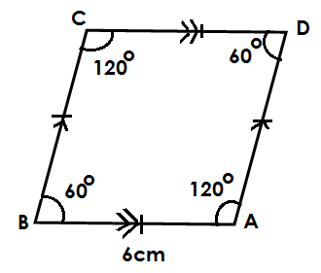**Sketch**

**Activity:**

1. Construct a rhombus PQRS of side 5cm and angle PQR = 120o.

2. Construct a rhombus RPNS of side 6.8cm and angle RPN = 60o.

3. Construct a rhombus STNR of sides 5.8cm and angle TNS = 135o.

4. Construct a rhombus STUV of side 6.4cm and angle TSV = 120o.

5. Construct a rhombus ABC of side 6.5cm and angle DAB = 60o.

6. Construct a rhombus RMNO of side 7cm and angle RMN = 120o.

**CONSTRUCTING A RHOMBUS GIVEN DIAGONALS AND SIDE**

**Note:**

1. Diagonals of a rhombus bisect each other at a right angle.

2. Diagonals of a rhombus are not equal.

**Example**

Using a ruler and a pair of compasses only. Construct a rhombus ABCD of sides 5cm with diagonal AC = 8cm and BD = 6cm.

Soln.

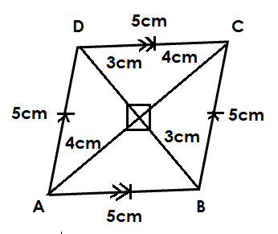Sketch

**Activity:**

Using a ruler, pencil and a pair of compasses only, construct:

1.A rhombus PQRS of side 6cm and diagonals PR = 9cm and QS = 8cm.

2.A rhombus ABCD of side 6.5cm and diagonals AC = 10cm, DB = 6cm.

3.A rhombus RSTU of side 6cm and diagonal RT = 7cm, SU = 6cm

4.A rhombus XYZP of side 5.8cm and diagonal XZ = 8cm, PY = 6cm.

5.A rhombus AYZX of side 7cm and diagonals AZ = 10cm, XY = 8cm.

**CONSTRUCTING A RHOMBUS GIVEN DIAGONAL ONLY**

**Example**

Using a ruler, pencil and a pair of compasses only, construct a

rhombus ABCD with diagonal BD = 10cm and AC = 8cm.

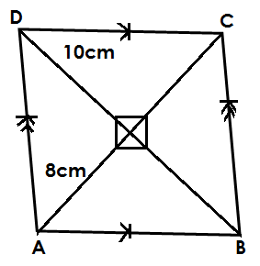Sketch

b) Measure AB in cm.

AB = 6.3cm

**Activity:**

**Construct the following rhombus below.**

1. A rhombus PQRS of diagonal PR = 8cm and SQ = 6cm.
2. A rhombus PNSR with diagonal PS = 12cm and RN = 10cm.
3. A rhombus STUV with diagonal SU = 9cm and VT = 7cm.
4. A rhombus RMNO with diagonal RN = 6cm and Mo = 4cm.

5. A rhombus AYZX with diagonal AZ = 8cm and XY = 6cm.

**CONSTRUCTING A PARALLELOGRAM**

1. **Constructing a parallelogram given angles and side.**

**Note:**

* Opposite sides of a parallelogram are equal and parallel.
* Opposite angles of a parallelogram are equal.

**Illustration**

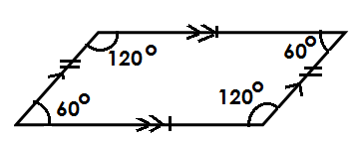

**Example**

Using a ruler, pencil and a pair of compasses only, construct a parallelogram PQRS where QR = 7cm, PQ = 4cm and angle PQR = 60.

**Soln.**

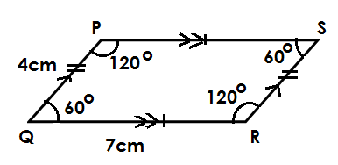Sketch

**Activity:**

Using a ruler, pencil and a pair of compasses only, construct:

1. A parallelogram JKLM where JK = 8cm, JM =4cm and angle MJK = 60o.

2. A parallelogram EFGH where EF=7.5cm, EH=6cm and angle HEF = 120o.

3. A parallelogram PQRS where QR = 7cm, PQ=3.5cm and angle PQR = 45o.

4. A parallelogram ABCD with AB = 6.8cm, BC = 5cm and angle ABC = 120o.

5. A parallelogram XYVM where XY=7.8cm YV = 6cm and angle XYV = 135o.

6. A parallelogram RMNO where RM=7cm, MN = 6cm and angle RMN = 75o.

**CONSTRUCTING TRAPEZIUM**

**Example I**

1. Using a pair of compasses, a ruler and a pencil only, construct a trapezium ABCD where AB = 9cm ***L***ABC = 90o, ***L***DAB = 60o and BC = 5cm.

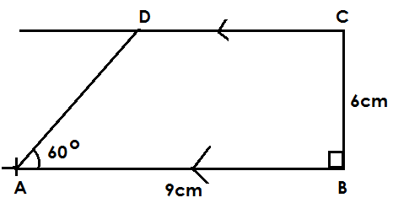Sketch

b) Measure DC

**DC = 5.4cm**

**Example II**

Using a pair of compasses, a ruler and a pencil only construct a quadrilateral OPQR where OP = 10 cm, L OPQ = L P

QOP = 45cm and QP = 4cm.

**Sketch**

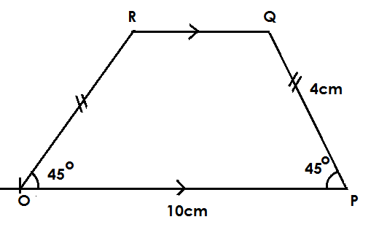

**Activity:**

Using a ruler, pencil and a pair of compasses only, construct:-

1a) a trapezium PQRS where PQ = 8 cm angle PQR = 90o, angle = 60o and QR = 6.5cm.

b) Measure RS in cm.

2. A trapezium OPQR in which OP = 10cm, PQ = 6cm, angle ROP = 45o and OPQ = 90o.

b) Measure RQ in cm.

3. A trapezium WXYZ where WX = 11cm, and XY = ZW = 5.5cm, angle ZWX = 600 and angle YXW = 600.

b) Measure ZY.

c) Drop a perpendicular height from Z to meet WX at K.

d) Measure ZK in cm.

4. A quadrilateral MNOP in which MN = 9cm NO = PM = 5CM and angle MNO = 750.

b) Measure PQ in cm.

**CONSTRUCTION OF A KITE**

**Note:**

* Adjacent sides are equal.
* Two of the opposite angles are equal.
* Diagonals are not equal but they bisect at right angles.

**Example**

1. using a pair of compasses, a ruler and a pencil only, construct a kite ABCD where AC meet BD at point O, AO = 4cm OC = 7cm and BD = 6cm.

**Sketch**

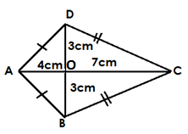

b) Measure AB

**Soln.**

AB =5cm

2. Using a pair of compasses, a ruler and a pencil only, construct a kite OPQR where OQ = 10cm, PR = 6cm and OP = OR = 350

**Soln.**

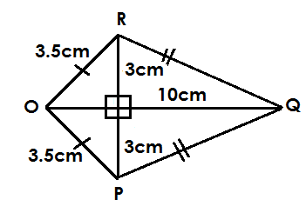**Sketch**

1. Measure OR in cm.

OR = 4cm

**Activity:**

Using a ruler and a pair of compasses only, construct the following kites:

1. A kite ABCD where AK = 3cm, KC = 7cm and BK = KD = 4cm.

Measure AD and DC in cm.

2. A kite POQR where PX = 10cm and XQ = 5cm, OX = XR = 5cm.

Measure OP and RQ in cm.

3. A kite WXYZ where WY = 12cm and XZ = 8cm. measure XY in cm.

4. A kite OPMN where PN = 14cm and OM = 10cm.

Measure PM and MN in cm.

**BEARINGS**

**Note:**

* Bearing is the direction / angle turned from a fixed point.
* In bearing, North is taken to be the fixed point.
* Bearing is measured from the last point mentioned.

**ROTATION / REVOLUTION.**

* A rotation is a complete turn from a fixed point and back to the very point.
* A complete revolution adds up to 360o.

**FINDING PARTS OF A REVOLUTION**

**Examples**

1. What is of a revolution?

**Soln.**

x 360o

2 x 120o

**240o**

2. What is the supplement of $\frac{1}{12}$ of a revolution?

**Soln.**

x 3600

**30 o**

Let the supplement be K

K + 30o = 180 o

K + 30 o – 30 o = 180 o – 30 o

**K =150 o**

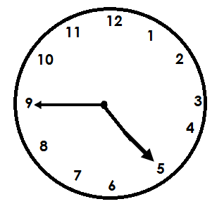3. Below is a clock face.

Finding the angle turned by the minute hand.

**Soln.**

Angle turned **=** x 360o

= x 360o

**=** 45 x 6o

**= 270o**

**Activity:**

1. Find of a revolution.

2. Find the complement of a revolution.

3. Find 20% of a revolution.

4. Below is a clock face

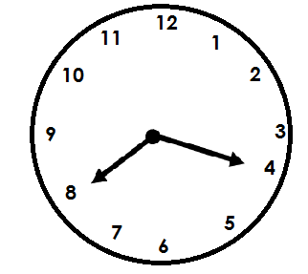

Find the angle turned by the minute hand.

1. What angle is turned by the hour hand on a clock face at 7 o’clock?
2. Find the supplement of the angle turned on the minute hand 25 minutes on the clock face.
3. What is $\frac{1}{5}$ of the angle formed by the minute hand on a clock face at 30 minutes?

Below is a clock face.

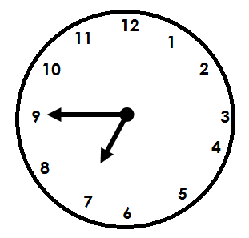

1. Find the complement of $\frac{1}{2}$ a revolution
2. Find the supplement of the angle turned by the minute hand of a clock in 30 minutes.

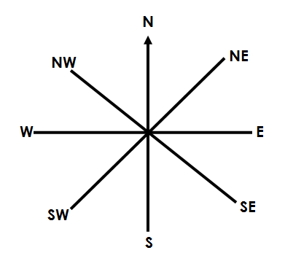**ANGLES ON A COMPASS DIRECTION**

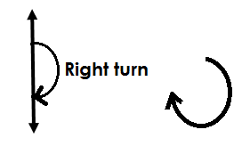**CLOCK WISE TURN**

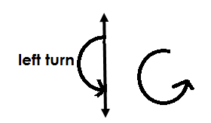**ANTI CLOCK WISE TURN**

**Example I**

Musa turned from North to South West.

Find the smaller angle turned.

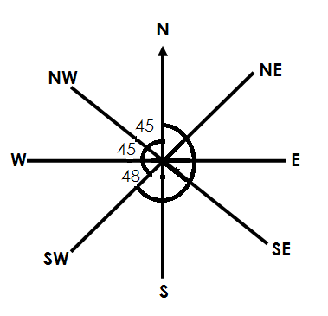**Soln.**

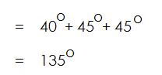

b) Find the larger angle turned.

**Soln.**

1 Sector = 45o

5 Sectors = 45o x 5

**= 225o**

**Example II**

Musa turned from North clockwise to face South East.

Through what angle did he go?

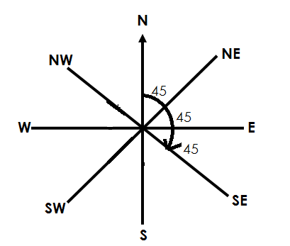Soln

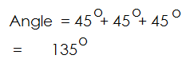

Annet turned from East anticlockwise through an angle of 900.

In what direction is she facing now?

Soln.

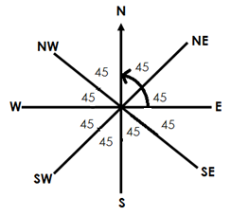

**Activity:**

1. Kato turned from NE to SE. find the smaller angle he turned through.

2. Kumbe turned from North Clockwise to West. Through what angle did he turn?

3. A boy turned from North West anticlock wise through an angle 0f 270o.

What is his new direction?

1. Find the smaller angle between North and South East.

5. Find the angle from East to West Clock Wise.

6. Mary was standing facing South Eastern direction. She turned clockwise through an angle of 90o.

In which direction is she facing now?

7. Ssembatya is facing North East. If he turned through an angle of 135o anti clock wise. Find his new direction.

8. Find the larger angle formed between North and East.

9. In which direction will I face if I turned anti clock wise from NE through 180o?

**ORDINARY BEARINGS**

**Note:**

* Ordinary bearing is the description of direction starting from North or South but not East or West.
* If two directions take North, then they will have N 00oN.

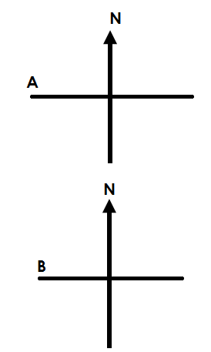**Illustration**

a) What is the direction of town A from B?

soln

N 00 ON

* 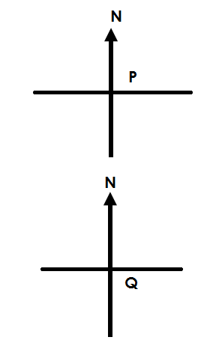If two towns take South direction then they will have S 00oS

What is the direction of Q from P.?

Soln.

S00oS

* If the two compasses are parallel to each other, angle properties of parallel lines will be applied.

**Examples**

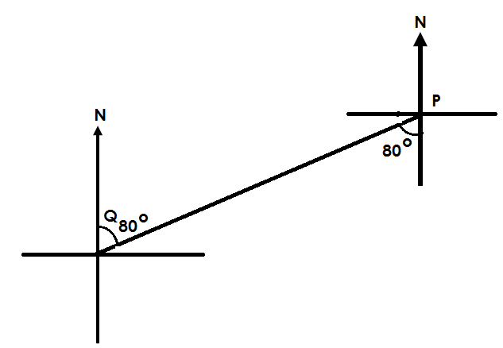1. The diagram below shows the location of two towns.

a) What is the direction of P from Q?

Soln.

N80oE

b) What is the direction of Q from P

Soln.

S 80oW

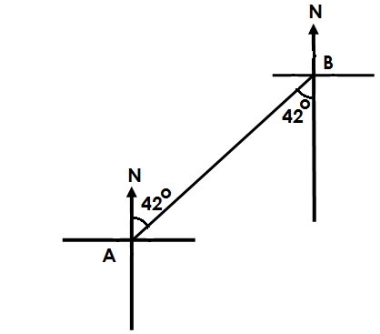2. What is the direction of A from B?

Soln.

S 42oW

3. The direction of Kampala from Jinja is N 450 E. What is the direction of Jinja from Kampala?

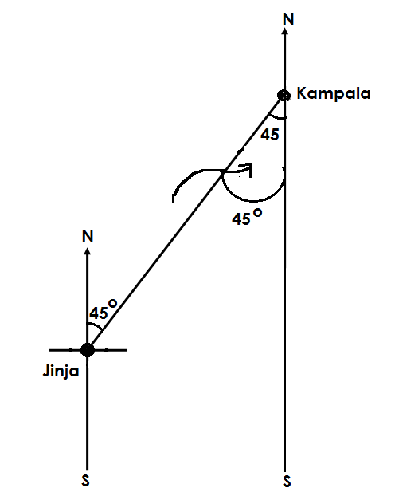

Soln.

Direction of Jinja from Kampala is S 450W.

**Activity:**

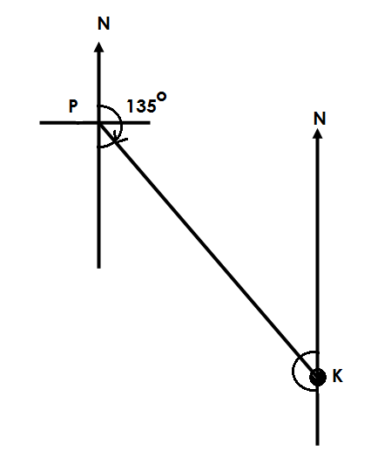1. The diagram below shows location of two towns.

a) Find the direction of K from P.

b) Find the direction of P from K.

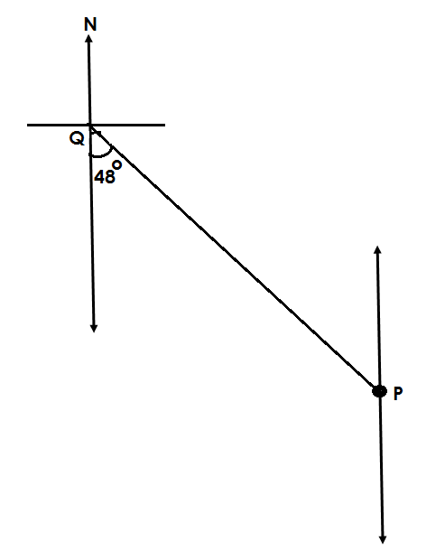2. What is the direction of P from Q in the diagram below.

a) What is the direction of Q from P.

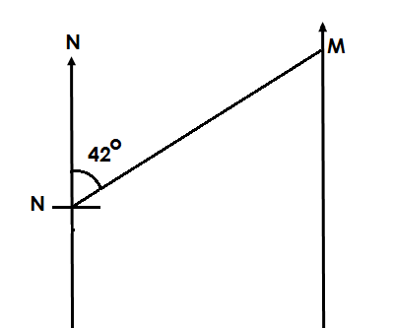3. Use the diagram below to answer questions that follow.

a) What is the direction of M from N?

b) What is the direction of N from M.

4. The direction of K from P is N 400 E. Find the direction of P from K.

5. The direction of Kampala from Jinja is S 520W. What is the direction of Jinja from Kampala?

6. The diagram below shows the location of three different towns.

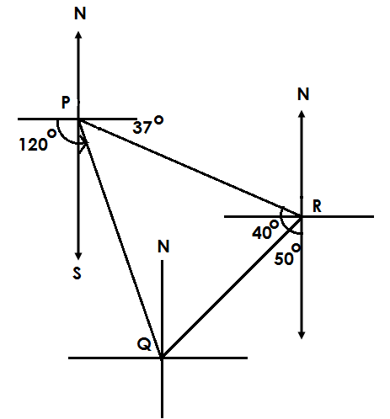

a) What is the direction of Q from R.

b) What is the direction of P from R.

c) Find the direction of Q from P.

7. The diagram below shows the location of three places.

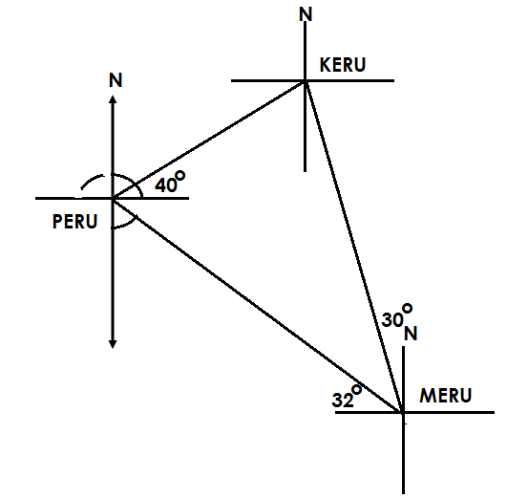

1. Find the direction of;
2. Keru from Peru
3. Peru from Meru
4. Keru from Meru

**TRUE BEARINGS**

**Note**

* In true bearing, the point of origin is **North** only.
* In true bearing all angles **must** be written in three digits.
* In true bearing angles are obtained by measuring from North moving in a clockwise direction only.

**Examples**

1. Given the diagram below.

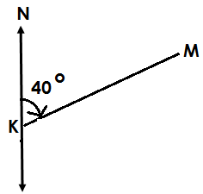

Find the bearing of M from K

Soln.

Bearing = 040o

2. Given the diagram below.

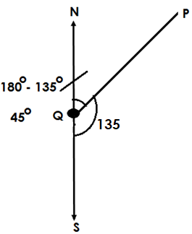

Finding the bearing of P from Q

Soln

Bearing = 180o – 135o

**= 045o**

1. 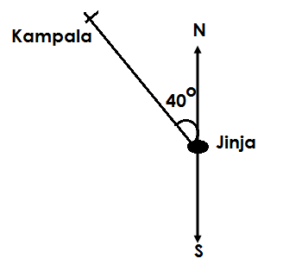Use the diagram below to Find the bearing of Kampala from Jinja.

**Soln**

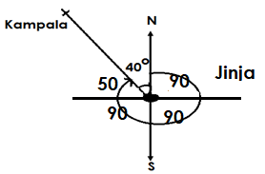

Bearing = 900 + 900 + 900 + 500

=220o.

**Activity:**

1.On the diagram below:

Find the bearing of B from A

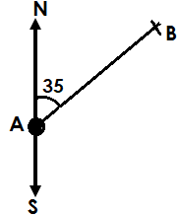

2. Find the bearing of N from T

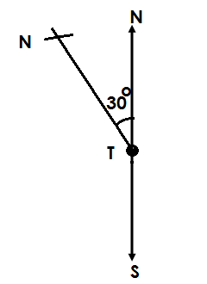

3. Find the bearing of Kampala from Jinja.

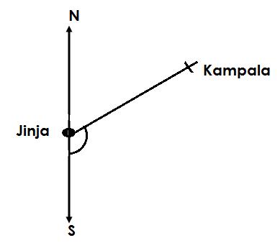

4. Find the bearing of S from T

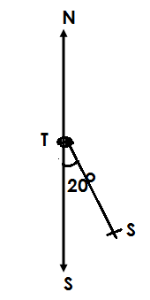

5. Draw a diagram to show that the bearing of Entebbe from Kajjansi is 135o.

1. 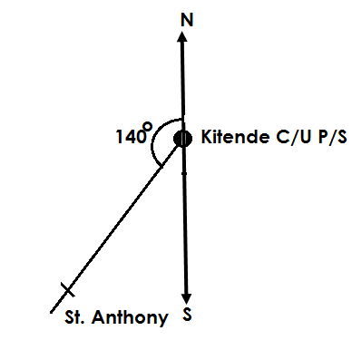Use the diagram below to find the bearing of St. Anthony Primary School from Kitende C/U primary school.

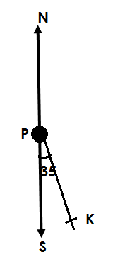7. What is the bearing of K from P in the diagram below.

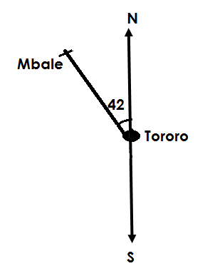8. What is the bearing of Mbale from Tororo in the diagram below?

**FINDING OPPOSITE BEARINGS**

**Note:**

* In opposite bearing, if the given angle is more than 180o, its opposite bearing is less by 180o

That is to say, subtract 1800 from the given angle.

* If the given angle is less than 180o, its opposite bearing is greater than 180 o

That is to say, add 180 o to the given angle.

**Examples**

1. The bearing of town Q from B is 1400. What is the bearing of B from Q?

**Soln.**

Bearing of B from Q = 140o

+ 180 o

**320 o**

2. The bearing of Mulu from Pulu is 272o. What is the bearing of Pulu from Mulu?

**Soln.**

Bearing of Mulu from Pulu = 272o

- 180o

**092o**

3. Use the diagram below to find the bearing of K from P.

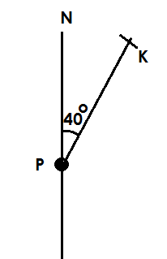

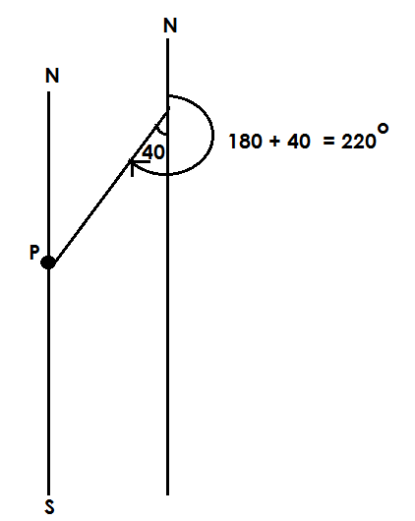**Soln**

Bearing of P from K = 180o + 40o

= 220o.

**Activity:**

1. The bearing of town A from Kampala is 0430. Find the bearing of B from A.

2. The bearing of Karamoja from Kampala is 2400. What is the bearing of Kampala from Karamoja?

3. The bearing of the Kitchen from class is 1500. What is the bearing of class from the kitchen?

4. The bearing of Maya from Mukono is 1100. What is the bearing of Mukono from Maya?

5. The bearing of A from K is 0380. what is the bearing of K from A?

6. The diagram below shows the location of two different towns.

What is the bearing of Pemba from Zanzibar?

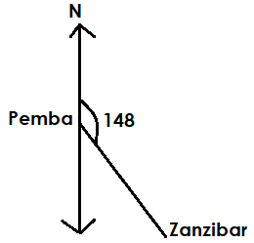

1. Given the diagram below:

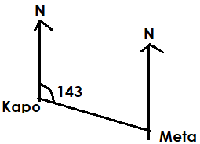

What is the bearing of Kapo from Meta?

8. In the diagram below, find the bearing of A from B?

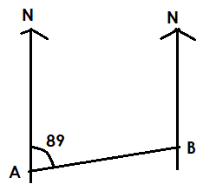

9. Find the bearing of C from D in the diagram given below.

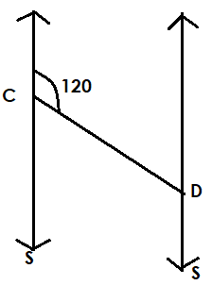

**SCALE DRAWING**

* A sketch must be drawn.
* Kilometers or metres must be changed to centimetres using the given scale before drawing the accurate diagram.
* North has to be indicated on each compass
* Compasses drawn must be parallel to each other.

**Scale drawing is categorized into three: -**

* Given directions and distance.
* Given bearing and distance
* Given direction, distance and bearing

**A) GIVEN DIRECTION AND DISTANCE**

**Note:**

* If semi/secondary cardinal points are given i.e., NE, NW, SE, SW, then they are got after bisecting.

**Example.**

Kampala is 70km East of Kamwenge and Mitimiti is 60km South East of Kampala. Using a scale of 1cm to represent 10km, show the location of the three towns on an accurate diagram.

**Sketch**

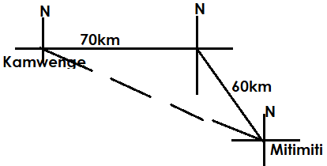

|  |  |
| --- | --- |
| Kampala – Kamwenge | Kampala – Mitimiti |
| 10km = 1cm  1km = $\frac{1}{10}$ cm  70km = ( $\frac{1}{10}$ x 70)cm  **= 7cm** | 10km = 1cm  1km = $\frac{1}{10}$ cm  60km = ( $\frac{1}{10}$ x 60)cm  **= 6cm** |

**Accurate.**

Find the shortest distance from Kamwenge to Mitimiti.

**Soln**

Distance in cm = 12cm

1cm = 10km

12cm = (12 x 10) km

**= 120km**

**Activity:**

1. Town A is in the West of town B a distance of 65km and C is in the South of town A a distance of 50km.

Using a scale of 1cm to represent 10km, show the location of three towns on an accurate diagram.

1. Town Q is in the East of P a distance of 100km and R is in the South West of Q a distance of 120km. Using a scale of 1cm to represent 10km, show the location of the three places on an accurate diagram.
2. Find the shortest distance from R to P.

3. Town Q is in the West of town P a distance of 70km and town R is in the North East of town P a distance of 45km. Using a scale of1:10 show the location of three towns on an accurate diagram.

4. Gulu town is in the South East of Kampala a distance of 140km and Mbale is in the North East of Gulu a distance of 100km. Using a scale of 1cm to represent 20km, show the location of the three towns on an accurate diagram.

1. St. Anthony Primary School is 620km West of Kawooto primary school and Disney primary school is 560km South of Kawooto primary school. Using a scale of 1cm to 100km, draw an accurate diagram to show the location of the three schools.

**B). Given bearing and distance**

**Example I**

1. Town A is on a bearing of 0700 from B a distance of 50km and town C is on a bearing of 1500 from A a distance of 60km. Using a scale of 1cm to 10km. show the location of the three towns on an accurate diagram.

**Sketch**

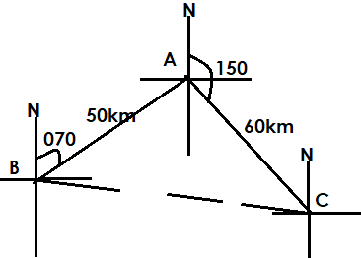

**Accurate**

|  |  |
| --- | --- |
| A to B | A to C |
| 10km = 1cm  1km = ( $\frac{1}{10}$) cm  **5cm** | 10km = 1cm  1km = ($\frac{1}{10}$) cm  1km = ( $\frac{1}{10}$)cm  60km = $\frac{1}{10}$ x 60  **= 6cm** |

b) Find the shortest distance from C to B.

1cm = 10km

8.2cm = (8.2 x 10) km

= ( $\frac{82}{18}$ X 10) km

**= 82km**

**Example 2**

Jinja on a bearing of 1350 from Bukwiri, a distance of 0450from Jinja a distance of 550km, using a scale of 1cm to represent 100km, show the location of the three places on an accurate diagram.

**Sketch**

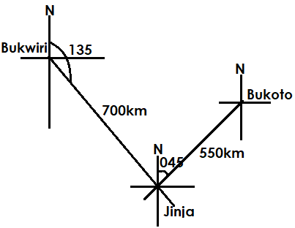

|  |  |
| --- | --- |
| Bukwiri – Jinja | Jinja - Bukoto |
| 100km = 1cm  1km = ( $\frac{1}{100}$) cm  1km ( $\frac{1}{100}$)cm  **7cm** | 100km = 1cm  1km = ($\frac{1}{100}$) cm  1km = ( $\frac{1}{10}$)cm  550km = $\frac{1}{100}$ x 550) cm  **5.5cm** |

**Activity:**

1. Town Q is on a bearing of 120 from R a distance of 120km. town P is on a bearing of 240o from Q a distance of 100km. using a scale of 1cm to represent 20km. Show the location of the three towns on an accurate diagram.

b) Find the shortest distance from town P to R.

c) Find the bearing of town R from P.

2. A plane flew from airport K to airport T on a bearing of 120o. the distance from K to T is 600km. it then left airport T for airport on a bearing of 210o a distance of 500km. Using a scale of 1cm to represent 100km. draw an accurate diagram to show the journey made by the place.

b) Find the bearing of airport R from K.

3. Town Q is on a bearing of 140o from P a distance of 140o from P a distance of 140km and town R is on a bearing of 250o from Q a distance of 100km. Using a scale of 1cm to 20km, show the location of the three towns on an accurate diagram.

1. Find the bearing of town R from P.
2. What is the shortest distance between P and R?

4. The bearing of town B from A is 240o and town B is 40km from A. the bearing of town C from B is 330o and town C is 50km from B. construct an accurate route showing the position of the three towns and measure the shortest distance.

**MORE ABOUT BEARINGS WHEN GIVEN TIME AND SPEED**

A bus travelled from Gulu on a bearing of 1200 to Kumi at an average speed of 40km/hr. in 2 hours. It then turned on a bearing of 220o travelling towards Kampala at an average speed of 55km/hr. for 2 hours.

1. Using a scale of 1cm to 20km, draw a sketch showing the three towns.

|  |  |  |
| --- | --- | --- |
| Time | Speed | Distance |
| 2hrs | 40km/hr. | D = S x T  D = 40km x 2hrs  hr.  = 80kms |
| 2hrs | 55km/hrs. | D = S X T  D = 55km x 2hrs  Hr.  D = 110km |

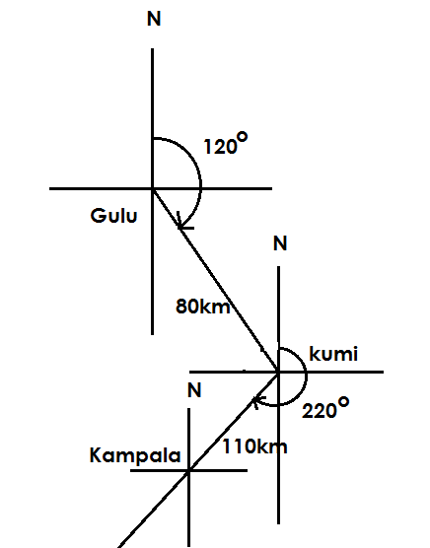**Sketch.**

b) Draw an accurate diagram to show the position of the three towns.

|  |  |
| --- | --- |
| Distance | Length |
| 80km | $$= \frac{80km}{20km}$$ = 4cm |
| 110km | $$= \frac{110km}{20km}$$ = 5.5cm |

**Accurate diagram**

c)Calculate the shortest distance between Kampala and Gulu.

Gulu to Kampala = 6cm

1cm rep 20km

6cm rep (20 x 6)cm

120km

**sActivity:**

1. Iganga is a bearing of 1300 from Lira. A motorist left Lira to an average speed of 30km / hr to Iganga. At Iganga he turned on a bearing of 0450 travelling at an average speed of 45km/hr for 2 hours to Tororo town.

a) Draw a sketch showing the three towns.

b) Using a scale of 1cm to represent 15km, draw an accurate diagram showing the three town.

c) Calculate the shortest distance between Lira and Tororo.

2. An army helicopter flew from airbase B on a bearing of 1200 at 100km / hr for 2 hrs and then flew for 4 hrs at the same speed in the NE direction to airbase C. From C, it flew in West direction at a speed of 200km/hr for 1 ½ hrs to air base D. construct an accurate route of the helicopter showing the air bases.

3. Alax left town Z and drove East ward at a speed of 30 km/hr for 2 hrs to town Y. He then changed direction and travelled on a bearing of 1200 to town X at 40km / hr for 2 hrs. Using a scale of 1cm to represent 10km, construct an accurate diagram showing Alex’sJourneys.

4. A motorist left town K on a bearing of 0600 travelling at an average speed of 60km/hr for 1 ½ hrs to town M. At town M, he moved West wards at a speed of 50km/hr for 2hrs to town R.

a) Draw a sketch to represent the three towns.

b) Using a scale of 1cm to represent 10km, draw an accurate diagram showing the three towns.

c) Calculate the shortest distance between R and K.

**COORDINATE GRAPHS**

* The coordinate graph has two axes; vertical axis (Y–axis) and Horizontal axis (X–axis)
* A co-ordinate is a pair of ordered integers that can be used to plat a point.
* Co-ordinates are in form of (X, Y) where X is an integer plotted on the x-axis and Y is an integer plotted on the y-axis.
* 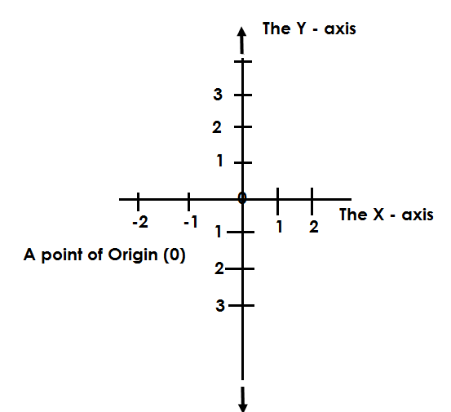The two axes cross each other at a point of origin mark O.

**Illustration**

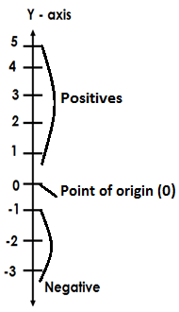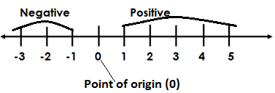

**NAMING CO-ORDINATES PLOTTED**

**Note:**

**(X, Y)**

Starting point of X-axis Steps to be moved on the y-axis

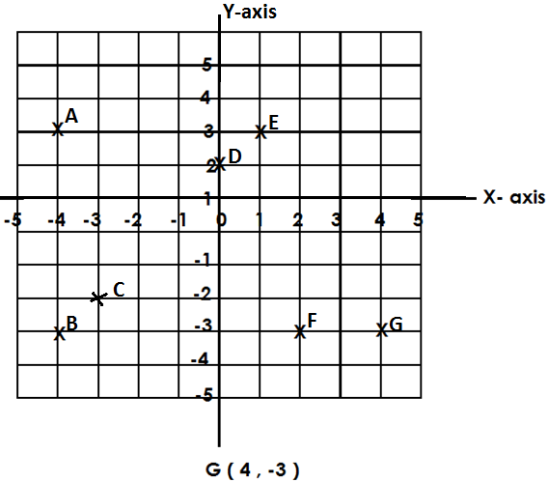

A (-4 , 3)

B (-4 , b)

C (-2 , -2)

D (0 , 2)

E (1 , 3)

F (2 , -3)

**Exercise:**

Use the graph below to name the co-ordinates for the given points.

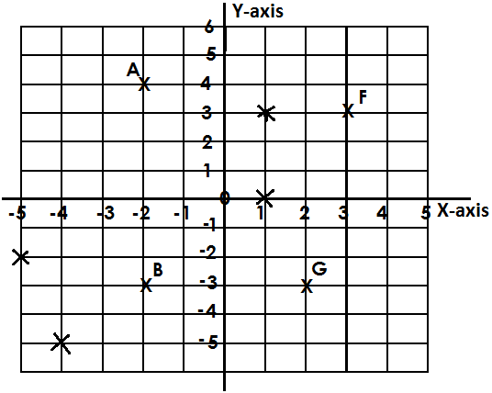

**FORMATION OF FIGURE BY PLOTTING**

**Example**

Using a 10 by 10 grid graphs plot the following points.

A( 3 , 3 ) , B (3 , -1) , D ( -1 , 3) C (-1 , -1)

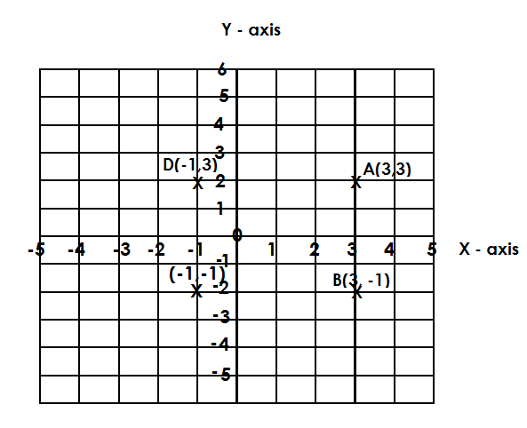

b) Join A to B to C and C to D and D to A.

c) Name the figure formed.

It’s a square

d) Find its area

soln.

Area = 5 x 5

= 4sq X 4sq

= 16 Sq units

Activity:

1. Draw a grid coordinate graph and plot the following points

a) A ( 4 , 4) , B ( 0 , 0) , C (4 , 0)

b) P (-5 , 2) , Q (-5 , -5) , R(3 , -5) , s (3, -2)

c) U (-6 , 0 ) , V (-3 , 0) , W (-3 , -2) X (2 , -2) Y (2 , -4) , Z(-6 , -4)

d) D(-7 , 1) E (-3 , 1) F(-4 , 5) G(0 ,5)

2. Draw co-ordinate graph and plot the given ordered pairs, name the figure formed and work out their area.

a) A( -1 , 2) , B (-4 , -3) , C(3 , -3)

b) P( -1 , 1) Q (-1 , 4) R(5 , 1) S(5,4)

c) W(-2 , -2) X(-2 , 3) ,Y (1 , 3) Z (4 , -2)

d) A(-3 , 2) B(0,0) , C(0,4) D(5, 2)

e) K(-4 , -2) I(-1 , 1) M(4 , -2) , N(7 , 1)

f) O(2 , -1) , P(5, -1) Q(2 , -5) , R(5 , -5) S(9 , -3)

**PLOTTING COORDINATES THAT FORM LINES**

**Example I**

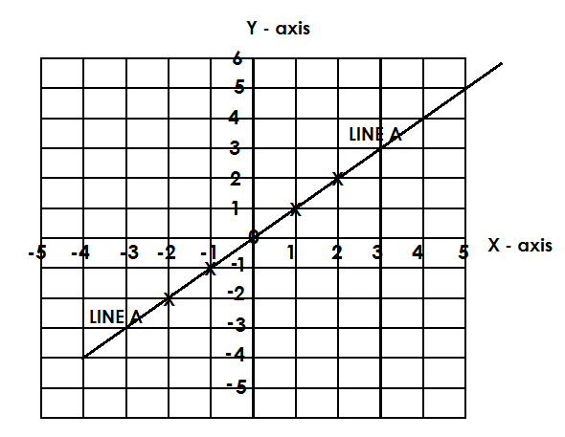Plot line A(2,2) , (1, 1) , (0 , 0) , (1 , 1) , (2 , 2)

**Example 2**

Plot line C = (1 , 2), (1,1) , (1,-1) , (1, -2) , (1 , -3)

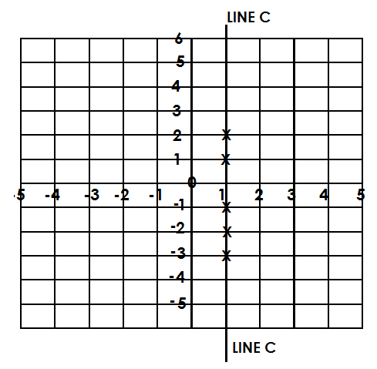

**Activity:**

Draw coordinate graphs, plot the given coordinates and join to form the given lines below:-

1. Plot line D = (-3, 1), (-2, 0), (-1, -1), (0, -2), (1, -3)

2. Line B = (-3, 2), (-2,2), (-1, 2), (0,2), (1, 2), (2,2)

3. Line P = (-3 , 3) , (-2 , 2) , (-1 , 1) (0,0) , (1 , -1) , (2 , -2)

4. Line Q = (-2, -4), (-1, -3), (0,-2), (1, -1), (2, 0), (3, 1)

5. Line F = (3, -3), (-2,-3), (-1, -3), (0, -3), (1, -3)

6. Line M = (-3, -4), (-3,3), (-3, 2), (-3,1), (-3,0), (-3, -1)

**INTERPRETING COORDINATES THAT FORM LINES**

**Example**

Write the coordinates of Line A.

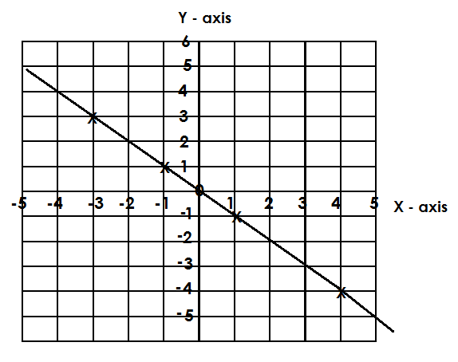

Soln.

Line A = (-3, 3), (-1 ,1), (1, -1), (4, -4)

**Activity:**

1. Write the coordinates of the lines drawn in each of the coordinate graphs below.

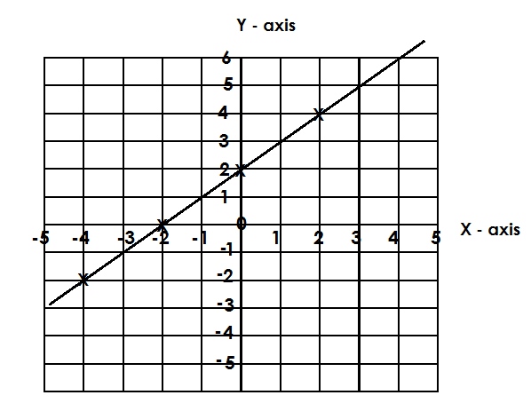

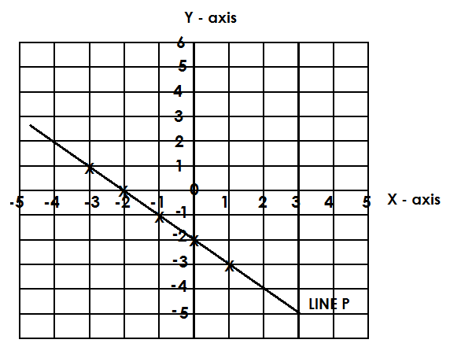

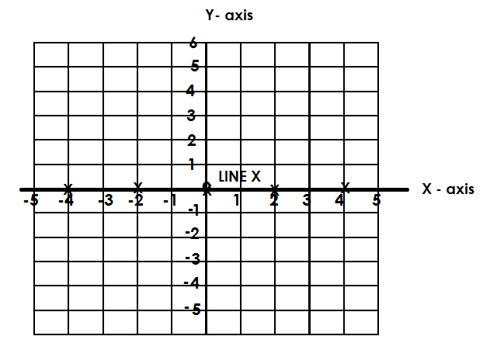

**LINE X**

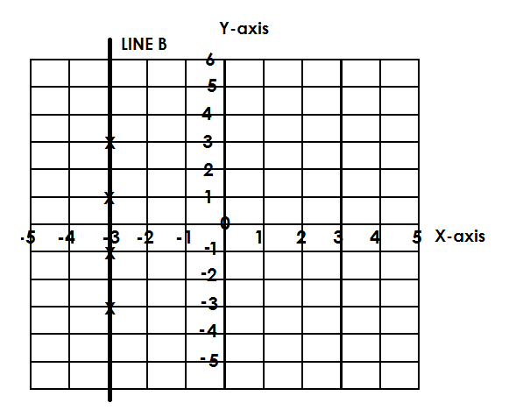

**FORMING EQUATIONS OF GIVEN LINES ON A GRAPH**

**Example I**

Given Lines A and B.

Line A passes through (-3 , -3), (-2 , -2), (-1 , -1), (0,0), (1, 1) among others.

Line B passes through (-2 , -4) , (-1 , -3 ) , (0 , -2), (1,-1), (2,0), (3,1).

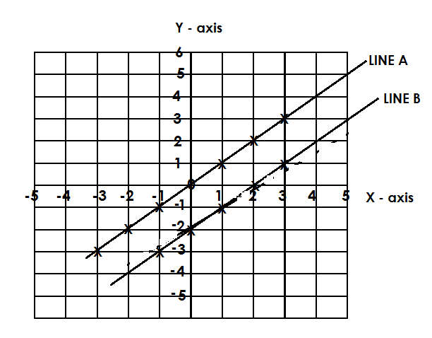

|  |  |  |  |  |  |  |  |
| --- | --- | --- | --- | --- | --- | --- | --- |
| X | -3 | -2 | -1 | 0 | 1 | 2 | 3 |
| Y | -3 | -2 | -1 | 0 | 1 | 2 | 3 |

|  |  |  |  |  |  |  |
| --- | --- | --- | --- | --- | --- | --- |
| X | -2 | -1 | 0 | 1 | 2 | 3 |
| Y | -4 | -3 | -2 | -1 | 0 | 1 |

The equation of line A is the equation of Line B.

Line A is Y = X – 3

**Activity:**

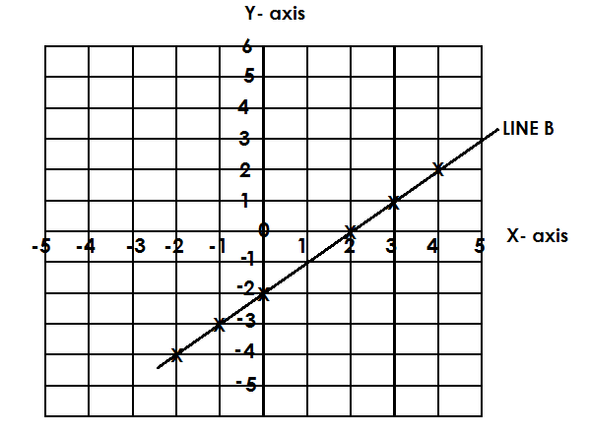Study the graphs below and write the coordinates for each Line and form the equation of each line from the coordinates.

1.

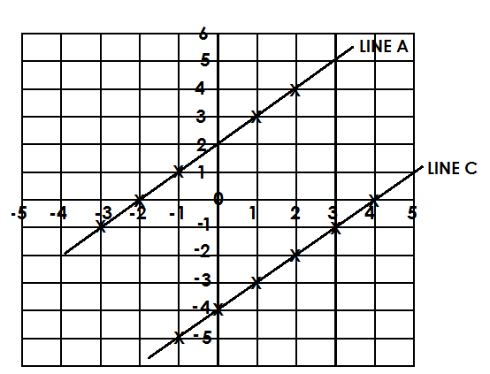

2.

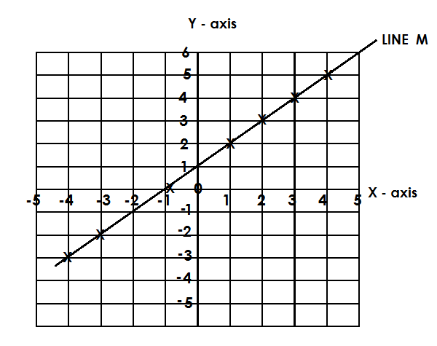3.

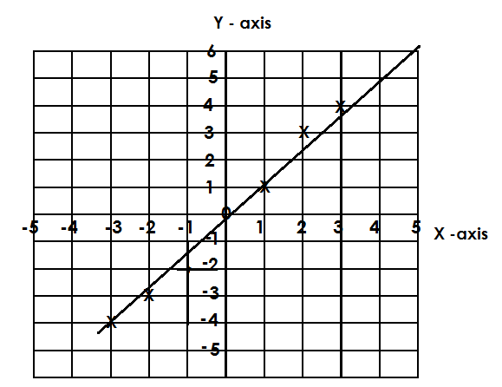4.

**DRAWING LINES FROM THE GIVEN EQUATIONS.**

**Example I**

Given the equation Y = X +1

1. Complete the table below

|  |  |  |  |  |  |  |  |  |
| --- | --- | --- | --- | --- | --- | --- | --- | --- |
| **X** | -1 | 0 | 1 | 2 | 3 | -3 | -2 | -1 |
| **Y** | 0 | 1 | 2 | 3 | 4 | -2 | -1 | 0 |

**Soln**.

|  |  |  |  |
| --- | --- | --- | --- |
| **When x=-1** | **When Y=1** | **When X=1** | **When Y=3** |
| Y=X+1  Y=-1+1  Y=0 | 1=X+1  1-1=X+1-1  0=X  X=0 | Y=X+1  Y=1+1  Y=2 | Y=X+1  3=X+1  3-1=X+1-1  2=X  X=2 |
| **When X=3** | **When X=-3** | **When Y=-1** | **When X=-1** |
| Y=X+1  Y=3+1  Y=4 | Y=X+1  Y=-3+1  Y=-2 | Y=X+1  -1=X+1  -1-1=X+1-1  -2=X  X=-2 | Y=X+1  Y=-1+1  Y=0 |

Draws a graph for the above equation.

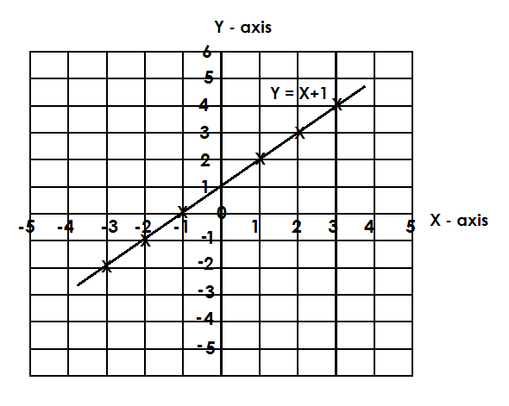

**Example 2**

Given the equation Y = X – 2

a) Complete the table below.

|  |  |  |  |  |  |  |
| --- | --- | --- | --- | --- | --- | --- |
| X | 0 | -1 | 2 | 3 | -1 | -2 |
| Y | -2 | -1 | 0 | 1 | -3 | -4 |

**Soln.**

|  |  |  |
| --- | --- | --- |
| **When X=0** | **When Y= -1** | **When X=2** |
| Y=X-2  Y=0-2  Y=-2 | Y=X-2  -1=X-2  -1+2=X-2+2  -1=X  X= -1 | Y=X-2  Y=2-2  Y=0 |
| **When Y=1** | **When X= -1** | **When Y= -4** |
| Y=X-2  1=X-2  1+2=X-2+2  3=X  X=3 | Y=X-2  Y= -1-2  Y= -3 | Y=X-2  -4=X-2  -4+2=X-2+2  -2=X  X= -2 |

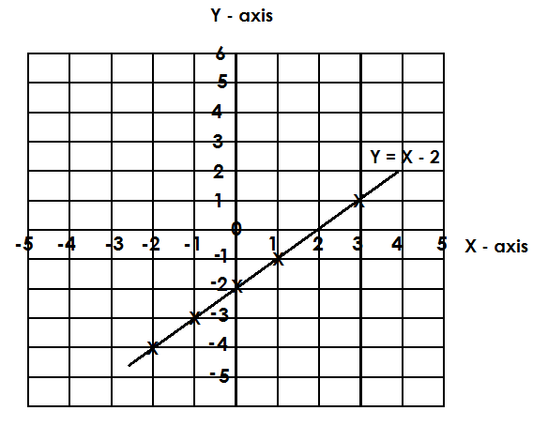Below is a graph for the above equation Y = X – 2

**Activity:**

1. Draw graphs for each of the following equations: -

a) Y = X + 2

b) Y = X – 3

c) Y = X + 4

d) Y = 2 x -3

e) Y = 2x – 1

2. Given the equation Y = 2x + 2

a) Complete the table below.

|  |  |  |  |  |  |  |
| --- | --- | --- | --- | --- | --- | --- |
| X | 0 | -1 | - | -3 | 1 | 2 |
| Y | 2 | - | -2 | - | - | - |

b) Draw a graph for the above equation

**TRAVEL GRAPHS**

A travel graph is a distance, time graph where distance is plotted against time.

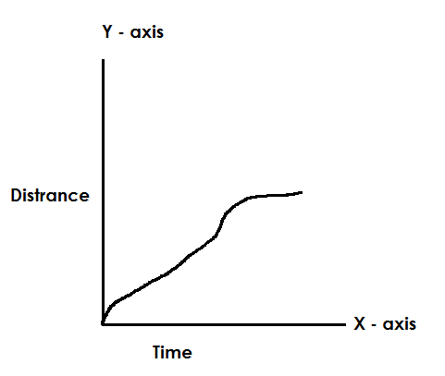**Illustration**

* Distance is plotted on the Y- axis (vertical axis)
* Time is plotted on the x-axis (horizontal axis)

**INTERPRETATION OF TRAVEL GRAPHS**

**Note:**

Before answering any question about a travel graph, identify both the vertical and horizontal scales used.

**Example I**

The graph below shows Mandela’s journey. Use it to answer questions below.

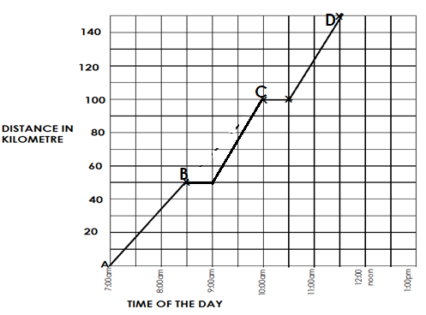

a). State the vertical scale

**Soln**

2 squares = 20km

1 square = $\frac{\left(20\right)km}{2}$

=10km

∴ 1 square rep. 10km

b) State the horizontal axis

**soln**

2 squares rep one hour.

1 square rep ( ½) hrs

**∴ 1 square rep. ½ hrs**

c) For how long was the journey from town A to town B?

**soln**

1 square = ½ hr.

3 squares = ( ½ x 3) hrs

= $\frac{3}{2}$ hrs

=1 ½ hrs

**∴ It was for 1 ½ hrs.**

d) How far is town B from town D?

square= 10km

squares = (10 x 9)km

= 90km

**∴Town B is 90km far from Town D.**

e) At what time did he leave town C?

**soln**

At 10:30a.m

f) Calculate his average speed for the whole journey.

**Soln**

Average speed = $\frac{Total distance}{total time }$

= $\frac{140km}{1\frac{1}{2}hrs+\frac{1}{2}hrs+1 hr+\frac{1}{2}hrs+1 hr}$

= $\frac{140km}{4\frac{1}{2}hrs}$

= 140km ÷ $\frac{9}{2}$ hrs

= 15 $\frac{5}{9}$ km / hr.

1. What was his average speed for the whole journey while travelling?

**Note:**

* When finding average speed for the whole journey while travelling, exclude the resting time.

**Soln**

Average speed = $\frac{Total distance}{Total time}$

= $\frac{140km}{4\frac{1}{2}hrs-1 hr}$

= $\frac{140km}{3\frac{1}{2}hrs}$

= 140km ÷ 3 ½ hrs

= 140km ÷ $\frac{2hrs}{7}$

= 20km x $\frac{2hrs}{7}$

= 20km x 2hrs

= 40km / hrs.

**Example 2**

The graph below shows Mukulu’s journey.

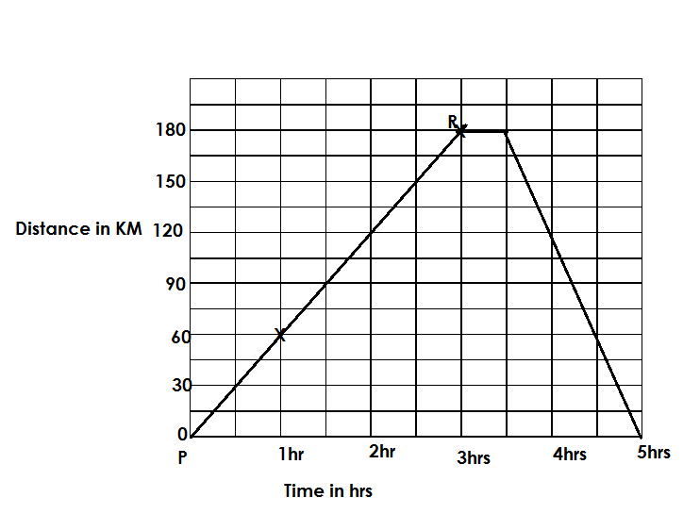

a) Calculate his speed from P to Q

**soln**

S = $\frac{D}{T}$

= 60km ÷ 1 hr

= 60km x $\frac{1}{1}$ hr

= 60km/hr.

b) For how long was the stop over for the whole journey?

**Soln**

1. squares = 1hr

1 square =(½) h0urs

∴1 square = ½ hours

1 sq = ½ hr

2 squares = (1/2 x ½) hours

**= 1hr**

c) Calculate his average speed for the whole journey?

**Soln.**

Average speed = $\frac{total distance}{total time}$

= $\frac{180km+180km}{5hrs}$

= $\frac{360km}{5hrs}$

= 72km/hrs

d) Calculate his average speed for the whole journey while moving.

**Soln.**

Average speed = $\frac{total distance}{total time}$

= $\frac{180km+180km}{5 hrs-1 hr}$

= $\frac{360km}{4 hrs}$

= 90 km/hr.

**Activity:**

1. The graph below shows Mandela’s journey.

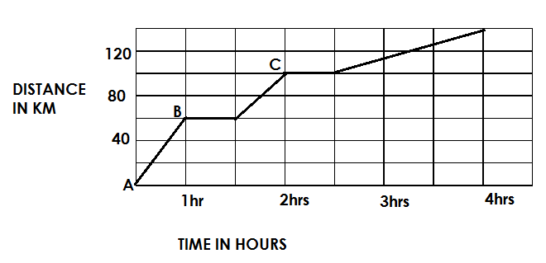

a) State the vertical scale.

b) What is the horizontal scale?

c) How far is Town B from A?

d) Calculate his average speed from Town A to town B.

e) For how long was the stop overs for the whole journey.

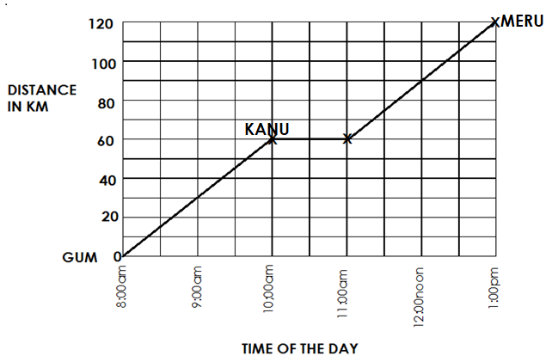2. The graph below shows a tax’s journey. Use it to answer questions.

a) State the vertical scale.

b) At what time did the taxi leave Gumu town?

c) Find the distance between Kanu and Meru.

d) For how long did the taxi stay at Kanu?

e) Find the time taken by a taxi to move from Gumu to Kanu.

f) Calculate the taxi’s average speed for the whole journey.

g) Find the taxi’s average speed for the whole journey while traveling.

3. The graph below shows a bus’ journey. Use it to answer questions.

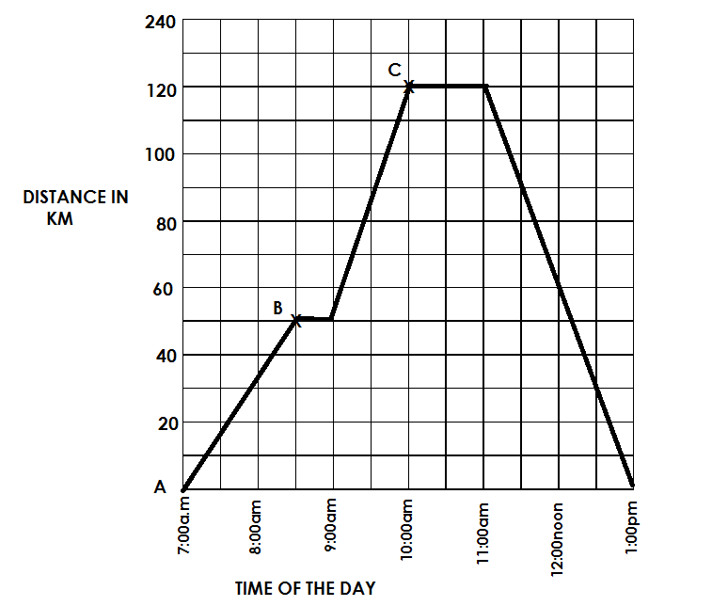

1. How far is town C from B?
2. At what time did the bus set for B?
3. For how long was the stop over at C?
4. Calculate the bus’ speed for the journey from A TO C.
5. For how long was the journey from C to A.
6. Calculate the bus’s average speed while travelling.

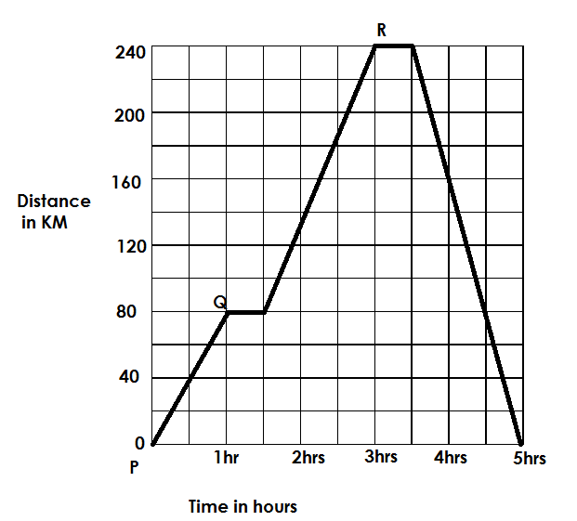4. The graph below shows Mukulu’s journey. Use it to answer questions.

1. At what time did Mukulu leave town P?
2. Calculate Mukulu’s speed from P to Q.
3. For how long was the stop over at R.
4. Calculate his average speed for the whole journey.
5. Calculate Mukulu’s average speed for the whole journey while travelling.

**REPRESENTING INFORMATION ON A TRAVEL GRAPH.**

**Note:**

* Both vertical and horizontal scales have to be formed.
* A scale is a unit measure of something.
* Journeys moved have be labeled.

**Example I**

Matama left Town A at 8:00am travelling at an average speed of 40km/hr in 2 hours to town B. He rested for ½ hours and later continued to C at a speed of 60km/hr in 1 ½ hours.

1. Represent Matama’s journey on a graph.

|  |  |  |
| --- | --- | --- |
| **Journey** | **Time** | **Distance** |
| A to B | 2hrs | D = S X T  = $\frac{40km x 2 hrs}{1hr}$ = 80km |
| Rest | ½ hours |  |
| B to C | 1 ½ hrs | D = S x T  = 60km x $\frac{3}{2}$ hr  hr  = 90km |

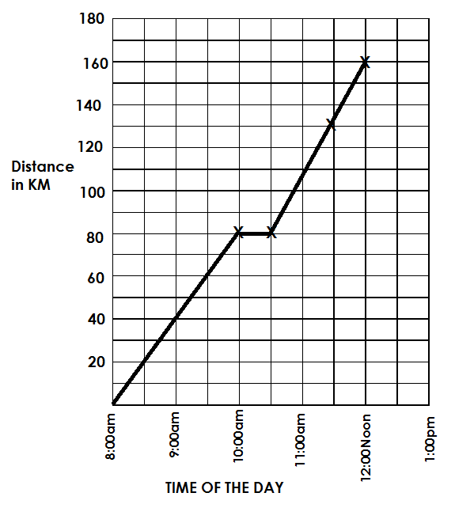

b) At what time did she reach Town B at 10:00a.m.

c) Calculate her average speed for the whole journey while travelling.

**Soln.**

A.S = $\frac{Total distance}{Total time}$

= $\frac{170km}{3\frac{1}{2}hr.}$

= 170km ÷ $\frac{7hr}{2}$

= 170km x $\frac{2}{7}$ hr

= $\frac{340km}{7hr}$

= 48 $\frac{4}{7}$ km / hr

**Example II**

A cyclist left Town P at 7:00a.m travelling at a speed of 40km / hr for 1 ½ to Q. He rested for ½ hrs and later continued to Town K which is 120km away at a speed of 60km/hr. He rested for ½ hrs and later returned to P at a speed of 120km/hr. Represent his journey on a graph.

**Soln**

|  |  |  |
| --- | --- | --- |
| Journey | Time | Distance |
| P - Q | 1 ½ hr | D = S X T  = $\frac{40km}{1hr}$ x $\frac{3}{2}$ hrs  = 60km |
| Rest | ½ hrs | ----- |
| Q to R | T = D ÷ S  = 120km ÷ $\frac{60km}{1hr}$ = 120km x $\frac{1hr }{60km}$ = 2hrs | 120km |
| Rest | ½ hrs | ------- |
| R to P | T = D ÷ S  = 180km ÷ $\frac{120km}{1hr}$ = 120 km  = $\frac{180km}{120}$ 1 ½ hrs | 120km + 60km  180km |

**A cyclist’s journey**

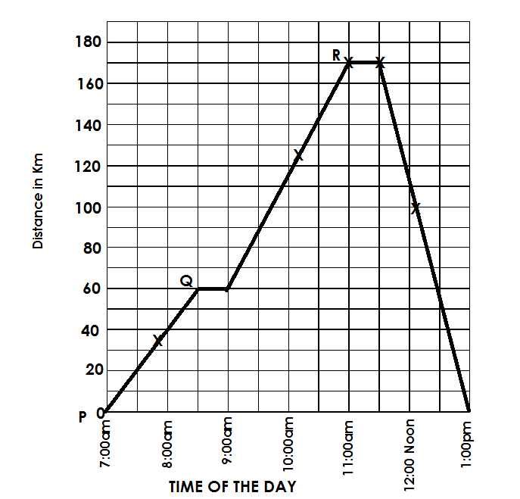

b) Find his average speed for the whole journey.

**Soln**

Average speed = $\frac{Total distance}{Total time}$

= $\frac{180 km+180km}{6hrs}$

= $\frac{360km}{6hrs}$

**= 60km/hr**

**Activity:**

1. A motorist left town A at 8:00am travelling at a speed of 40km/hr for 1 ½ hr to town B. He rested at town B for ½ hr. and then travelled to Town C at an average speed of 45km/hr for 2 hrs. he rested for an hour at town C before returning to Town A at a speed of 50km/hr.

Show the above journey in the grid below.

**A motorist’s journey**

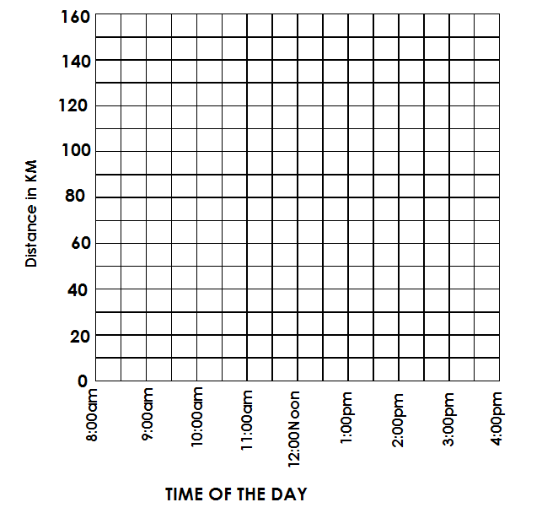

1. Calculate his average speed for the whole journey.

2. Kamu left Town A at 9:00am travelling at a speed of 20km/hrs in 2 hrs. he rested for one hour and later continued with his journey at a speed of 10km/hr for 5hrs. Aisha also left town A at noon and goes after Kamu. She catch up with him at 2:00pm. Show Aisha and Kamu’s journey on a travel graph using the grid below.

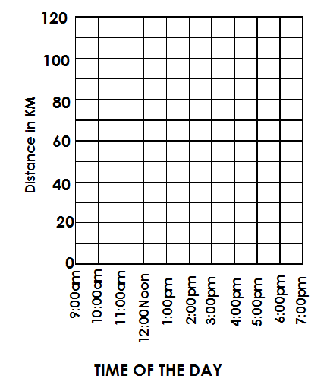

3. A and B are two towns which are 160km apart. Sarah leaves town A at 8:00am travelling to town B. After 1 ½ hrs while travelling at a speed of 60km/hr, she rests for 30 min and then continues to B at 35 km/hr. On the same day Peter leaves town B at 9:00am travelling at a steady speed of 80km/hr travelling to Town A.

a) Draw a graph to show the two journeys in the grid below.

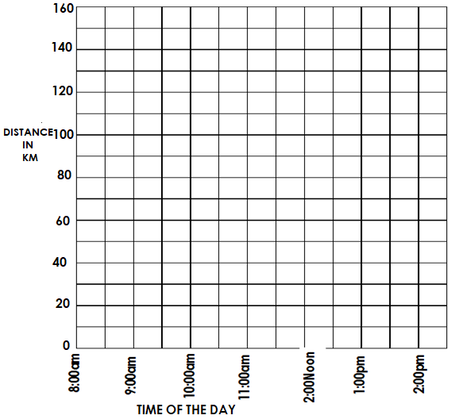

b) At what time did they meet?

c) Calculate Sarah’s average speed for the whole journey.

d) At what time did Peter reach town A?

e) What distance from A was Peter when Sarah started her second journey to B?

**MORE ON TRAVEL GRAPHS**

Kamu left town A at 7:00am travelling to town B which is 120km apart. After covering a distance of 40km. He rested for 1 ½ hrs and later continued for the rest of the journey at 40km/hr. Meanwhile, Betty also left town A at 8:00 am going after Kamu at a speed of 60km/hr.

Show the above journeys on a travel graph.

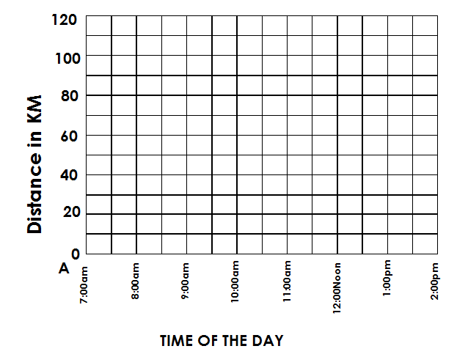

1. At what time did Betty meet Kamu?

2. Town T and Town M are 200km apart. A car left town T at 7:00am travelling at a speed of 60km/hr. After some time, it got a puncture and the repair took 30 minutes. It continued at 100km/hr for the rest of the journey. On the same day a lorry left Town M at 7:30 am travelling at steady speed of 50km/hr.

1. Show the two journeys on a travel graph. Using the grid below.

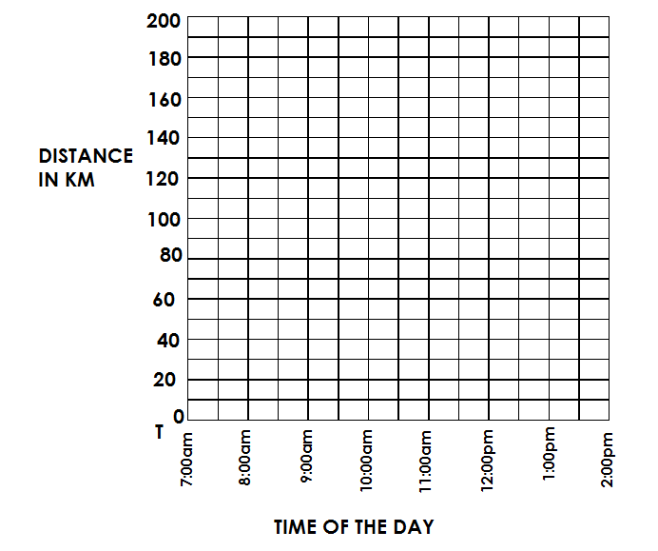

1. Town K and M are 180km apart. A car left town K at 7:00am for M while travelling at an average speed of 40km/hr for 2 ½ hrs. It got a puncture and the repair took 2hrs and later it continued at 80km/hr for the rest of the journey. On the same day a bus left town M at 8:00am travelling at a speed of 40km/hr for 2hrs. it stopped for 1 hr and later it continued to town K in 2 hours.

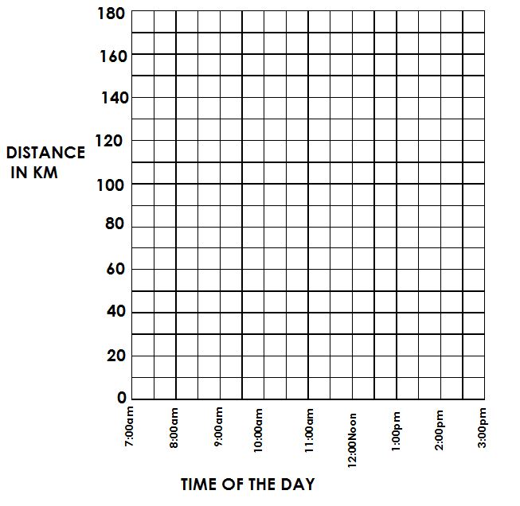Show the two journeys on a travel graph. Using the grid below.

***CORRECTION AND FINDINGS.***

|  |  |
| --- | --- |
| ***CONTENT*** | ***PAGE*** |
|  |  |
|  |  |
|  |  |
|  |  |
|  |  |
|  |  |
|  |  |
|  |  |
|  |  |
|  |  |
|  |  |
|  |  |
|  |  |
|  |  |
|  |  |
|  |  |
|  |  |
|  |  |
|  |  |
|  |  |
|  |  |
|  |  |
|  |  |

***GOOD LUCK.***